# Step 1: Create tables

CREATE TABLE SUPPLIERS (

SUPPLIER_ID NUMBER(3) NOT NULL,

SUPPLIER_NAME VARCHAR2(50) NOT NULL,

CONTACT_NAME VARCHAR2(50) NOT NULL,

ADDRESS VARCHAR2(200) NOT NULL,

CONTACT_NUMBER VARCHAR2(50) NOT NULL,

EMAIL VARCHAR2(50),

CREATED_DATE DATE,

CREATED_BY VARCHAR2(10),

CONSTRAINT SUPP_PK PRIMARY KEY ( SUPPLIER_ID )

);

CREATE TABLE ORDERS (

ORDER_REF VARCHAR2(5) NOT NULL,

SUPPLIER_ID NUMBER(3) NOT NULL,

ORDER_DATE DATE,

TOTAL_AMOUNT NUMBER(10),

ORD_DESCRIPTION VARCHAR2(200),

ORD_STATUS VARCHAR2(10),

CREATED_DATE DATE,

CREATED_BY VARCHAR2(10),

CONSTRAINT ORDERS_PK PRIMARY KEY ( ORDER_REF )

);

CREATE TABLE ORDER_LINES (

ORD_LINE_SEQ NUMBER(5) NOT NULL,

ORDER_REF VARCHAR2(5) NOT NULL,

ORDER_REF_LINE_ID NUMBER(2),

LINE_DESCRIPTION VARCHAR2(200),

LINE_STATUS VARCHAR2(10),

LINE_AMOUNT NUMBER(10),

INV_SEQ NUMBER(5),

INV_REFERENCE VARCHAR2(9),

CREATED_DATE DATE,

CREATED_BY VARCHAR2(10),

CONSTRAINT ORDER_LINES_PK PRIMARY KEY ( ORD_LINE_SEQ,

ORDER_REF,

ORDER_REF_LINE_ID )

);

CREATE TABLE INVOICES (

INV_SEQ NUMBER(5) NOT NULL,

INV_REFERENCE VARCHAR2(9) NOT NULL,

INV_REF_PAY NUMBER(3),

INV_DATE DATE,

INV_STATUS VARCHAR2(10),

INV_HOLD_REASON VARCHAR2(100),

INV_AMOUNT NUMBER(10),

INV_DESCRIPTION VARCHAR2(200),

INV_CREATED_DATE DATE,

INV_CREATED_BY VARCHAR2(10),

CONSTRAINT INVOICES_PK PRIMARY KEY ( INV_SEQ,

INV_REFERENCE )

);

ALTER TABLE ORDERS

ADD CONSTRAINT SUPP_ID_FK_ORDERS

FOREIGN KEY (SUPPLIER_ID)

REFERENCES SUPPLIERS (SUPPLIER_ID);

ALTER TABLE ORDER_LINES

ADD CONSTRAINT ORDER_REF_FK_ORDER_LINES

FOREIGN KEY (ORDER_REF)

REFERENCES ORDERS (ORDER_REF);

ALTER TABLE ORDER_LINES

ADD CONSTRAINT INV_SEQ_FK_ORDER_LINES

FOREIGN KEY (INV_SEQ,INV_REFERENCE)

REFERENCES INVOICES (INV_SEQ,INV_REFERENCE);

# Step 2: Create package: ord_pck and compile

Header:

create or replace package ord_pck as

/******************************************************************************/

Procedure clear_all_tables;

/******************************************************************************/

Function get_amount_number(p_amount in varchar2) return number;

/******************************************************************************/

Function get_date_from_string(p_date in varchar2) return date ;

/******************************************************************************/

Function get_payment_from_inv(p_invoice_reference in varchar2) return number ;

/******************************************************************************/

Procedure create_order_lines(p_order_ref in varchar2);

/******************************************************************************/

Procedure create_invoices(p_invoice_reference in varchar2,p_invoice_date in date,p_invoice_status in varchar2,

p_invoice_hold_reason in varchar2,p_invoice_amount in number,p_invoice_description in varchar2,p_inv_seq out number,

p_inv_reference out varchar2);

/******************************************************************************/

Procedure create_suppliers ;

/******************************************************************************/

Procedure migration_process;

/******************************************************************************/

Procedure distinct_invoices_with_total ;

/******************************************************************************/

Procedure get_nth_highest_order_amount(p_number in number);

/******************************************************************************/

Function get_invoices(p_order_ref in varchar2) return varchar2;

/******************************************************************************/

Procedure list_suppliers_with_orders(p_date_from in date,p_date_to in date) ;

/******************************************************************************/

Procedure get_detailed_contact(p_contact_number in varchar2,p_out_contact1 out varchar2,p_out_contact2 out varchar2);

/******************************************************************************/

Function get_action_status (p_order_ref in varchar2) return varchar2;

/******************************************************************************/

end ord_pck;

Package body:

create or replace PACKAGE BODY ord_pck AS

/*****************************************************************************

ASEESURUN Package to import from XXBCM_ORDER_MGT raw format data into their respective tables

/******************************************************************************/

PROCEDURE clear_all_tables AS

--This procedure is used to clear all the tables before the migration occurs.

BEGIN

DELETE FROM order_lines;

DELETE FROM orders;

DELETE FROM invoices;

DELETE FROM suppliers;

COMMIT;

END clear_all_tables;

/******************************************************************************/

FUNCTION get_amount_number (p_amount IN VARCHAR2) RETURN NUMBER AS

--This function will take the varchar2 and convert into number

--Replace , by '' and 'S' by 5 and O by 0 and I by 1 for typo errors

m_amount NUMBER ;

BEGIN

if p_amount is not null then

SELECT

to_number(replace(replace(replace(replace(upper(p_amount), ',', ''), 'S', 5), 'O', 0), 'I', 1))

INTO m_amount

FROM

dual;

end if;

return(m_amount);

END get_amount_number;

/******************************************************************************/

FUNCTION get_date_from_string (p_date IN VARCHAR2) RETURN DATE AS

--This function will reformat the date accordingly and return it into a date format

--The file contains only two formats, DD-MON-YYYY and DD-MM-YYYY

--More formats can be added

BEGIN

IF p_date IS NOT NULL THEN

BEGIN

RETURN to_date(p_date, 'DD-MON-YYYY');

EXCEPTION

WHEN OTHERS THEN

NULL;

END;

BEGIN

RETURN to_date(p_date, 'DD-MM-YYYY');

EXCEPTION

WHEN OTHERS THEN

NULL;

END;

END IF;

RETURN NULL;

END get_date_from_string;

/******************************************************************************/

Function get_payment_from_inv(p_invoice_reference in varchar2) return number as

m_inv_ref_pay number:=0;

begin

if length(p_invoice_reference)> 9 then

--therefore it contains a payment number

select to_number(replace(p_invoice_reference,substr(p_invoice_reference, 1, 9)||'.',''))

into m_inv_ref_pay

from dual;

return(m_inv_ref_pay);

else --it does not have any payment number return null

return(null);

end if;

end get_payment_from_inv;

/******************************************************************************/

PROCEDURE create_suppliers AS

CURSOR c_suppliers IS

SELECT DISTINCT

supplier_name,

supp_contact_name,

supp_address,

replace(replace(replace(replace(replace(TRIM(upper(supp_contact_number)), 'O', 0), 'S', 5), ' ', ''), '.', ''), 'I', 1

) contact_number,

supp_email

FROM

xxbcm_order_mgt

ORDER BY

supplier_name;

m_cnt NUMBER := 0;

BEGIN

FOR r1 IN c_suppliers LOOP

m_cnt := m_cnt + 1;

INSERT INTO suppliers VALUES (

m_cnt,

r1.supplier_name,

r1.supp_contact_name,

r1.supp_address,

r1.contact_number,

r1.supp_email,

sysdate,

user

);

END LOOP;

COMMIT;

EXCEPTION

WHEN OTHERS THEN

ROLLBACK;

raise_application_error(-20201, sqlerrm(sqlcode));

END create_suppliers;

/******************************************************************************/

PROCEDURE create_orders AS

CURSOR c_ord IS

SELECT

order_ref,

b.supplier_id,

ord_pck.get_date_from_string(a.order_date) order_date,

a.order_total_amount,

a.order_description,

a.order_status

FROM

xxbcm_order_mgt a,

suppliers b

WHERE

a.order_line_amount IS NULL

AND a.supplier_name = b.supplier_name

ORDER BY

a.order_ref;

BEGIN

FOR r1 IN c_ord LOOP

INSERT INTO orders (

order_ref,

supplier_id,

order_date,

total_amount,

ord_description,

ord_status,

created_date,

created_by

) VALUES (

r1.order_ref,

r1.supplier_id,

r1.order_date,

get_amount_number(r1.order_total_amount),

r1.order_description,

r1.order_status,

sysdate,

user

);

create_order_lines(r1.order_ref);

END LOOP;

COMMIT;

END;

/******************************************************************************/

PROCEDURE create_order_lines (

p_order_ref IN VARCHAR2

) AS

CURSOR c_ord_lines IS

SELECT

a.order_ref order_ref_line_id,

a.order_description line_description,

order_status line_status,

ord_pck.get_amount_number(order_line_amount) line_amount,

invoice_reference,

invoice_date,

invoice_status,

invoice_hold_reason,

invoice_amount,

invoice_description

FROM

xxbcm_order_mgt a

WHERE

order_line_amount IS NOT NULL

AND substr(a.order_ref, 1, 5) = p_order_ref

ORDER BY

order_ref;

m_cnt_seq NUMBER := 1;

m_inv_seq invoices.inv_seq%type;

m_inv_reference invoices.inv_reference%type;

BEGIN

FOR r1 IN c_ord_lines LOOP

INSERT INTO order_lines (

ord_line_seq,

order_ref,

order_ref_line_id,

line_description,

line_status,

line_amount,

created_date,

created_by

) VALUES (

m_cnt_seq,

p_order_ref,

to_number(replace(r1.order_ref_line_id, p_order_ref || '-', '')),

r1.line_description,

r1.line_status,

r1.line_amount,

sysdate,

user

);

--create the invoice

if r1.invoice_reference is not null then

create_invoices (r1.invoice_reference,get_date_from_string(r1.invoice_date),r1.invoice_status,r1.invoice_hold_reason,

ord_pck.get_amount_number(r1.invoice_amount),r1.invoice_description,m_inv_seq,m_inv_reference);

update order_lines

set inv_seq=m_inv_seq,inv_reference=m_inv_reference

where ord_line_seq=m_cnt_seq

and order_ref=p_order_ref;

end if;

m_cnt_seq := m_cnt_seq + 1;

END LOOP;

END create_order_lines;

/******************************************************************************/

PROCEDURE create_invoices (

p_invoice_reference IN VARCHAR2,

p_invoice_date IN DATE,

p_invoice_status IN VARCHAR2,

p_invoice_hold_reason IN VARCHAR2,

p_invoice_amount IN NUMBER,

p_invoice_description IN VARCHAR2,

p_inv_seq OUT NUMBER,

p_inv_reference OUT VARCHAR2

) AS

m_inv_seq NUMBER := 0;

BEGIN

--check if invoice_exists in invoice table

SELECT

nvl(MAX(inv_seq),0)

INTO m_inv_seq

FROM

invoices

WHERE

inv_reference = substr(p_invoice_reference, 1, 9);

--add 1 before insert

m_inv_seq := m_inv_seq + 1;

INSERT INTO invoices (

inv_seq,

inv_reference,

inv_ref_pay,

inv_date,

inv_status,

inv_hold_reason,

inv_amount,

inv_description,

inv_created_date,

inv_created_by

) VALUES (

m_inv_seq,

substr(p_invoice_reference, 1, 9),

get_payment_from_inv(p_invoice_reference),

p_invoice_date,

p_invoice_status,

p_invoice_hold_reason,

p_invoice_amount,

p_invoice_description,

sysdate,

user

);

p_inv_seq:=m_inv_seq;

p_inv_reference:=substr(p_invoice_reference, 1, 9);

END create_invoices;

/******************************************************************************/

PROCEDURE migration_process AS

BEGIN

dbms_output.put_line('Start migration process');

clear_all_tables;

dbms_output.put_line('All tables cleared');

create_suppliers;

dbms_output.put_line('All suppliers created');

create_orders;

dbms_output.put_line('Orders successfully created');

dbms_output.put_line('Migration over');

exception when others then

raise_application_error(-20201,sqlerrm(sqlcode));

END migration_process;

/******************************************************************************/

Procedure distinct_invoices_with_total as

--summary of Orders with their corresponding list of distinct invoices and their total amount

cursor c_results is

SELECT

a.order_ref,

to_number(substr(a.order_ref, - 3, 5)) ord_ref,

to_char(a.order_date, 'MON-YY') order_period,

initcap(b.supplier_name) supp_name,

to_char(a.total_amount, '99,999,990.00') tot_amt,

ord_status ord_status,

c.inv_reference inv_ref,

to_char(c.invoice_amount, '99,999,990.00') inv_amt

FROM

orders a,

suppliers b,

(

SELECT DISTINCT

( inv_reference ),

SUM(inv_amount) invoice_amount

FROM

invoices

GROUP BY

inv_reference

) c

WHERE

a.supplier_id = b.supplier_id

AND substr(c.inv_reference, 5, 5) = a.order_ref

ORDER BY

order_date DESC;

m_action varchar2(25);

begin

dbms_output.put_line('-----------------------------------------------LIST OF DISTINCT INVOICES AND THEIR TOTAL AMOUNT------------------------------------------------------------------------------');

dbms_output.put_line('Order Reference Order Period Supplier Name Order Total Amount Order Status Invoice Reference Invoice Total Amount Action');

dbms_output.put_line('------------------------------------------------------------------------------------------------------------------------------------------------------------------------------');

for r1 in c_results loop

m_action:=get_action_status(r1.order_ref);

dbms_output.put_line(RPAD(r1.ord_ref,18)||RPAD(r1.order_period,13)||RPAD(r1.supp_name,30)||RPAD(r1.tot_amt,22)||RPAD(r1.ord_status,17)||rpad(r1.inv_ref,20)||rpad(r1.inv_amt,22)||m_action);

dbms_output.put_line('------------------------------------------------------------------------------------------------------------------------------------------------------------------------------');

end loop;

end distinct_invoices_with_total;

/*******************************************************************************/

Procedure get_nth_highest_order_amount(p_number in number) as

--Return details for the Nth highest Order Total Amount from the list.

cursor c_output is

select a.order_ref,upper(b.supplier_name) supp_name,to_char(a.order_date,'fmMonth DD,YYYY') ord_date,a.ord_status,to_char(a.total_amount,'99,999,990.00') amt

from orders a,suppliers b

where a.supplier_id=b.supplier_id

order by total_amount desc;

m_count number:=0;

m_invref varchar2(500);

begin

for r1 in c_output loop

m_count:=m_count+1;

if m_count=p_number then

--get all invoices for that order

m_invref:=get_invoices(r1.order_ref);

dbms_output.put_line('-----------------------------------------------'||to_char(to_date(p_number,'DD'),'DDSPTH')||' HIGHEST ORDER TOTAL AMOUNT----------------------------------------------------------');

dbms_output.put_line('Order Reference Order Date Supplier Name Order Total Amount Order Status Invoice References');

dbms_output.put_line('--------------------------------------------------------------------------------------------------------------------------------------------------');

dbms_output.put_line(RPAD(r1.order_ref,18)||RPAD(r1.ord_date,21)||RPAD(r1.supp_name,20)||RPAD(r1.amt,25)||RPAD(r1.ord_status,15)||m_invref);

exit;

end if;

end loop;

end get_nth_highest_order_amount;

/*******************************************************************************/

Function get_invoices(p_order_ref in varchar2) return varchar2 as

--Get list of invoices per order

cursor c1 is

select distinct(decode(a.inv_ref_pay,null,a.inv_reference,a.inv_reference||'.'||a.inv_ref_pay)) inv

from invoices a,order_lines b

where a.inv_seq=b.inv_seq

and a.inv_reference=b.inv_reference

and b.order_ref=p_order_ref;

m_invoicerefs varchar2(500);

begin

for r1 in c1 loop

if m_invoicerefs is null then

m_invoicerefs :=r1.inv;

else

m_invoicerefs :=m_invoicerefs||','||r1.inv;

end if;

end loop;

return(m_invoicerefs);

end get_invoices;

/*******************************************************************************/

Procedure list_suppliers_with_orders(p_date_from in date,p_date_to in date) as

--List all suppliers with their respective number of orders and total amount ordered from them between any period

cursor c_suppliers is

select a.supplier_name,a.contact_name,contact_number,count('*') total_orders,to_char(sum(b.total_amount),'99,999,990.00') total_amt

from suppliers a,orders b

where a.supplier_id=b.supplier_id

and b.order_date between p_date_from and p_date_to

group by a.supplier_name,a.contact_name,contact_number;

m_contact1 varchar2(15);

m_contact2 varchar2(15);

begin

dbms_output.put_line('--------------------NUMBER OF ORDERS AND TOTAL AMOUNT ORDERED FROM PERIOD '||p_date_from||' to '||p_date_to||'----------------------------------------------------------');

dbms_output.put_line('--------------------------------------------------------------------------------------------------------------------------------------------------');

dbms_output.put_line(' Supplier Name Supplier Contact Name Supplier Contact No.1 Supplier Contact No.2 Total Orders Order Total Amount');

for r1 in c_suppliers loop

get_detailed_contact(r1.contact_number,m_contact1,m_contact2);

dbms_output.put_line('--------------------------------------------------------------------------------------------------------------------------------------------------');

dbms_output.put_line(RPAD(r1.supplier_name,30)||RPAD(r1.contact_name,25)||RPAD(m_contact1,25)||RPAD(m_contact2,25)||RPAD(r1.total_orders,10)||r1.total_amt);

end loop;

end list_suppliers_with_orders;

/*******************************************************************************/

Procedure get_detailed_contact(p_contact_number in varchar2,p_out_contact1 out varchar2,p_out_contact2 out varchar2) as

--This procedure will check if there is a , in the phone number

--It will then extract the phone numbers and format them accordingly.

m_contact1 varchar2(15):='';

m_contact2 varchar2(15):='';

begin

if instr(p_contact_number,',')=0 then

m_contact1:=p_contact_number;

m_contact2:=' ';

else

m_contact1:=replace(substr(p_contact_number,1,instr(p_contact_number,',')),',','');

m_contact2:=replace(substr(p_contact_number,instr(p_contact_number,','),length(p_contact_number)),',','');

end if;

if length(m_contact1) = 7 then

m_contact1:=to_char(substr(m_contact1, 1, 3) || '-' || substr(m_contact1, 4, 4));

elsif length(m_contact1)=8 then

m_contact1:=to_char(substr(m_contact1, 1, 4) || '-' || substr(m_contact1, 4, 5));

else

m_contact1:=' ';

end if;

if length(m_contact2) = 7 then

m_contact2:=to_char(substr(m_contact2, 1, 3) || '-' || substr(m_contact2, 4, 4));

elsif length(m_contact2)=8 then

m_contact2:=to_char(substr(m_contact2, 1, 4) || '-' || substr(m_contact2, 4, 5));

else

m_contact2:=' ';

end if;

p_out_contact1:=m_contact1;

p_out_contact2:=m_contact2;

end get_detailed_contact;

/*******************************************************************************/

Function get_action_status (p_order_ref in varchar2) return varchar2 as

m_action varchar2(25);

m_blank number:=0;

m_paid number:=0;

m_pending number:=0;

begin

select count('*')

into m_blank

from order_lines

where order_ref=p_order_ref

and inv_reference is null; --This means there is no invoice attached to this line, status is blank

if m_blank >0 then

return('To verify');

else

select sum(decode(upper(inv_status),'PAID',1,0)) PAID,sum(decode(upper(inv_status),'PENDING',1,0)) PENDING

into m_paid ,m_pending

from invoices

where substr(inv_reference,5,5) = p_order_ref;

end if;

if m_pending>0 then --if any invoice is pending then

return('To follow up');

else --all must thave been paid

return('OK');

end if;

return(m_action);

end get_action_status;

END ord_pck;

# Step 3:

Migration process:

set serveroutput on;

begin

ord_pck.migration_process;

end;

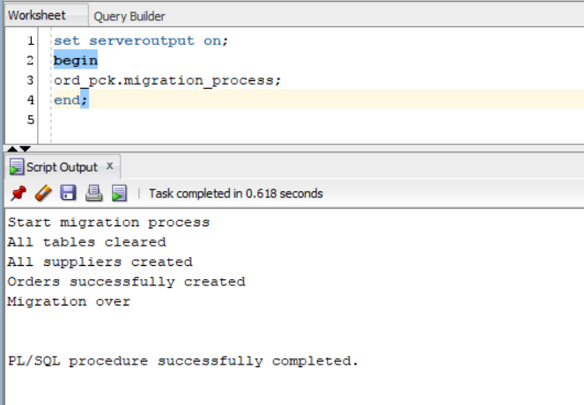

4.The owner wishes to have a report displaying a summary of Orders with their corresponding list of ***distinct*** ***invoices and their total amount*** to be able to reconcile his orders and payments. The report shall contain the details as per table below ordered by latest *Order Date* on top. Implement a Stored Procedure or Function to return the required information.

|  |  |
| --- | --- |
| **Column Name** | **Specifications** |
| Order Reference | Exclude prefix PO and return only numeric value, e.g. PO001 shall return value 1. |
| Order Period | Period based on *Order Date*. Example of expected format “JAN-17”. |
| Supplier Name | First character in each word to uppercase and the rest to lowercase. |
| Order Total Amount | Format “99,999,990.00”. |
| Order Status | As per record. |
| Invoice Reference | As per record. |
| Invoice Total Amount | Format “99,999,990.00”. |
| Action | Return the following value based on the invoice statuses.  If all invoice statuses are Paid, display “OK”.  If any of the invoice statuses is Pending, display “To follow up”.  If any of the invoice Statuses is Blank, display “To verify”. |

Answer:

set serveroutput on;

begin

ord_pck.distinct_invoices_with_total;

end;

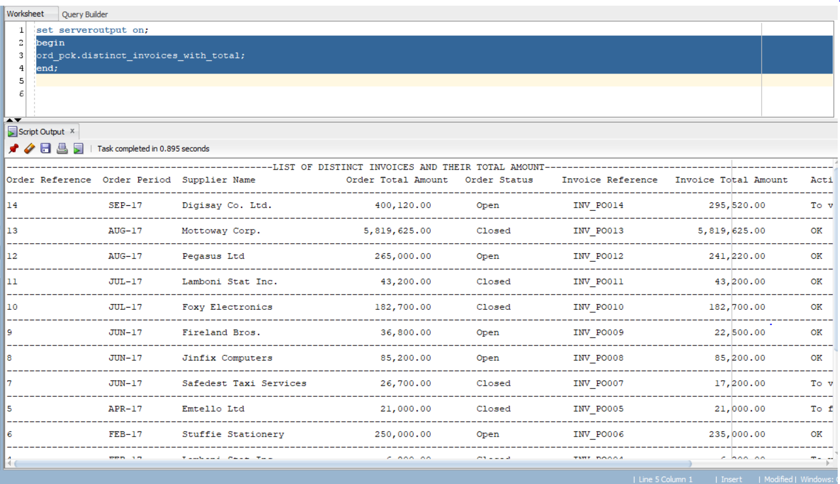

5.Return details for the ***THIRD (3rd) highest Order Total Amount*** from the list. Only one record is expected with the following information. Implement a Stored Procedure or Function to return the required information.

|  |  |
| --- | --- |
| **Column Name** | **Specifications** |
| Order Reference | Exclude prefix PO and return only numeric value, e.g. PO001 shall return value 1. |
| Order Date | Example of expected format “January 01, 2017”. |
| Supplier Name | In upper case. |
| Order Total Amount | Format “99,999,990.00”. |
| Order Status | As per record. |
| Invoice References | For that specific Order, list all invoice references *delimited by comma*. For example., “INV_PO999.1, INV_PO999.2, INV_PO999.3” |

Answer:

set serveroutput on;

begin

ord_pck.get_nth_highest_order_amount(3);

end;

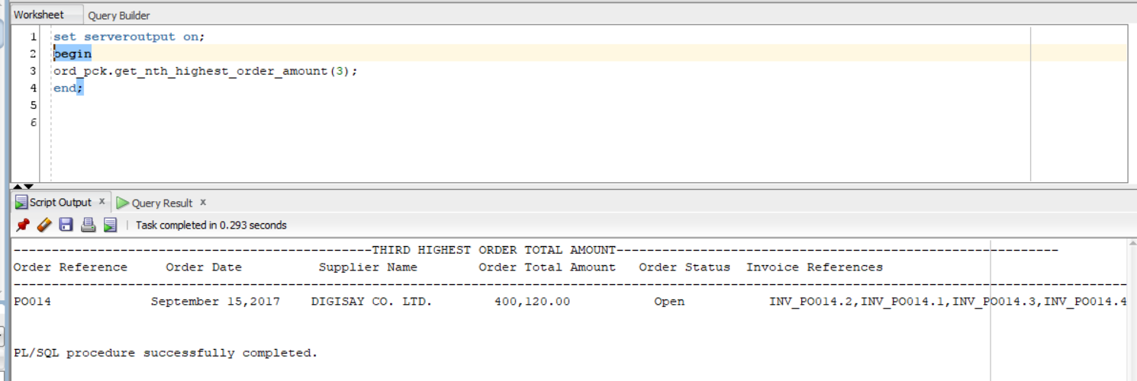

6.List all suppliers with their respective ***number of orders and total amount ordered*** from them between the period of ***01 January 2017 and 31 August 2017***. Output details as per below. Implement a Stored Procedure or Function to return the required information.

|  |  |
| --- | --- |
| **Column Name** | **Specifications** |
| Supplier Name | As per record. |
| Supplier Contact Name | As per record. |
| Supplier Contact No. 1 | First contact number formatted as “999-9999” or “5999-9999”. |
| Supplier Contact No. 2 | Second contact number formatted as “999-9999” or “5999-9999”. |
| Total Orders | Total number of orders. |
| Order Total Amount | Format “99,999,990.00”. |

Answer:

set serveroutput on;

begin

ord_pck.list_suppliers_with_orders('01-JAN-2017','31-AUG-2017');

end;

