|  |
| --- |
|  |
| Complete the Spring tutorial found here: http://spring.io/guides/gs/rest-service/ |
|  |

|  |
| --- |
|  |
| For your research, upload a document with screenshots of: |
|  |

|  |  |
| --- | --- |
|  | For your research, upload a document with screenshots of: |
|  | 1. your code |
|  | 2. sending 3 different requests to the greeting service and the responses via postman |
|  | Write a paragraph describing what issues you encountered in this tutorial and how you overcame them. |
|  | Write another paragraph about what you learned. |

1.

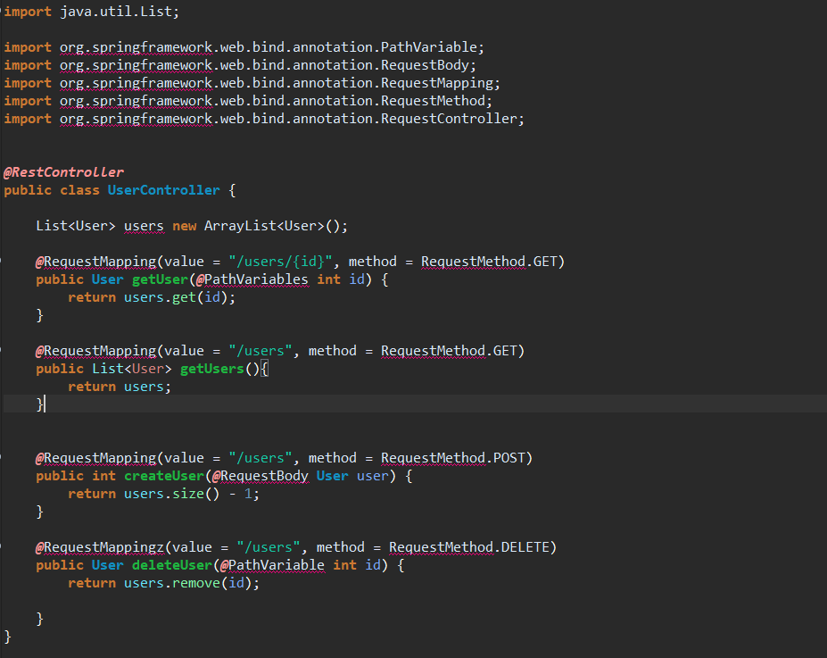

2.3.The issues I encountered but continued to encounter with were with Spring-Boot I did check my environment variables and my dependencies to see why it wouldn’t access and haven’t figured it out yet. I kept getting this issue.



I don’t believe this error message occurred because I didn’t have a database though, I believe it was to be because my computer had a system update.

Besides that, I learned through the video tutorial how to get and post through postman even though my application needs more work. Even though this was a major setback for me I did continue my coding for what would connect to Postman.