**EXERCISE**

1. **Write Java code to define List . Insert 5 floating point numbers in List, and using an iterator, find the sum of the numbers in List.**

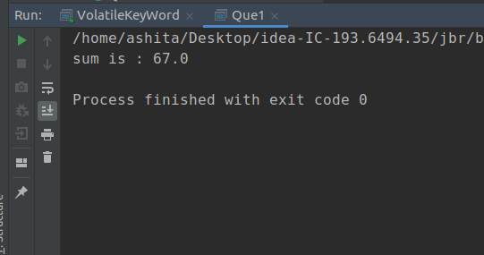

1. **Write a method that takes a string and returns the number of unique characters in the string.**

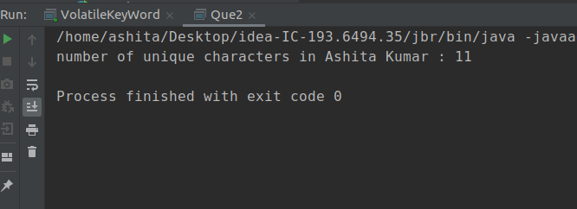

1. **Write a method that takes a string and print the number of occurrences of each character characters in the string.**

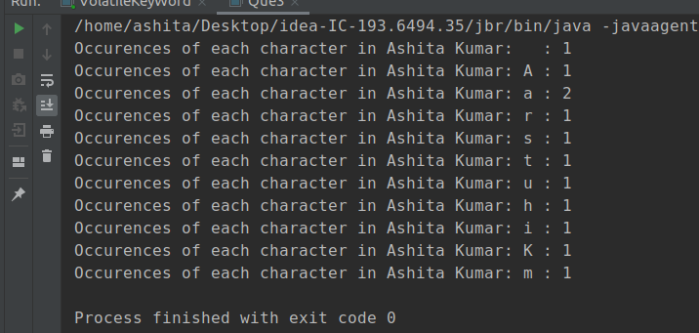

1. **Write a program to sort HashMap by value.**

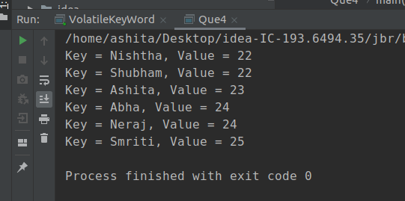

1. **Write a program to sort Employee objects based on highest salary using Comparator. Employee class{ Double Age; Double Salary; String Name}**

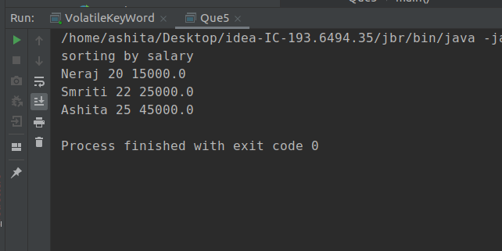

**6. Write a program to sort the Student objects based on Score , if the score are same then sort on First Name . Class Student{ String Name; Double Score; Double Age}**

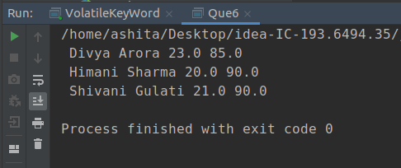

1. **Print the elements of an array in the decreasing frequency if 2 numbers have same frequency then print the one which came first.**

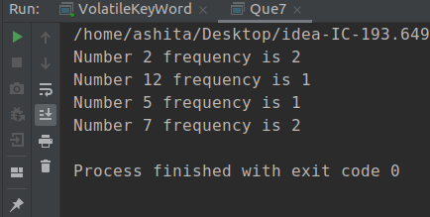

1. **Design a Data Structure SpecialStack that supports all the stack operations like push(), pop(), isEmpty(), isFull() and an additional operation getMin() which should return minimum element from the SpecialStack. (Expected complexity ­ O(1))**

