**Exercise**

**Q1. Write a program to replace a substring inside a string with other string ?**

**package com.first;**

**public class q1 {**

**public static void main(String args[]) {**

**String str="Ashita Kumar";**

**System.*out*.println( str.replace( 'h','k' ) );**

**System.*out*.println( str.replaceFirst("sh", "hs") );**

**System.*out*.println( str.replaceAll("Ku", "at") );**

**}**

**}**

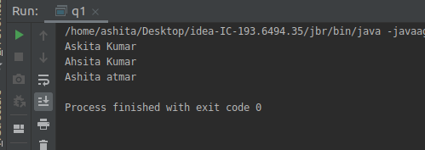

**Q2. Write a program to find the number of occurrences of the duplicate words in a string and print them ?**

**package com.first;**

**public class q2 {**

**public static void main(String[] args) {**

**String string = "Big black bug bit a big black dog on his big black nose";**

**int count;**

**//Converts the string into lowercase**

**string = string.toLowerCase();**

**//Split the string into words using built-in function**

**String words[] = string.split(" ");**

**System.*out*.println("Duplicate words in a given string : ");**

**for(int word = 0; word < words.length; word++) {**

**count = 1;**

**for (int nxtword = word+1 ; nxtword < words.length; nxtword++) {**

**if (words[word].equals(words[nxtword])) {**

**if(words[nxtword]!="0")**

**count++;**

**words[nxtword]="0";**

**}**

**}**

**if (count > 1 )**

**System.*out*.println(words[word]+"=duplicate word and no of occurence="+count);**

**}**

**}**

**}**

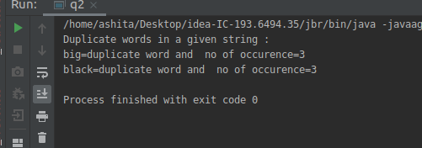

**Q3. Write a program to find the number of occurrences of a character in a string without using loop?**

**package com.first;**

**public class q3 {**

**public static void main(String[] args) {**

**String str = "Ashitaaaaaaaaaaaaaaaaa";**

**int count = str.length() - str.replace("a", "").length();**

**System.*out*.println("Number of occurances of 'a' in "+str+" = "+count);**

**}**

**}**

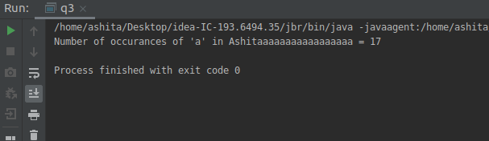

**Q4. Calculate the number & Percentage Of Lowercase Letters,Uppercase Letters, Digits And Other Special Characters In A String.**

**Code added to git.**

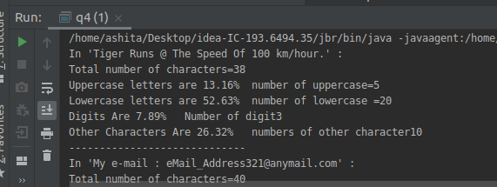

**Q5. Find common elements between two arrays.**

**package com.first;**

**import java.util.Arrays;**

**public class q5 {**

**public static void main(String[] args) {**

**int[] array1 = {1, 2, 5, 5, 8, 9, 7, 10};**

**int[] array2 = {1, 0, 6, 15, 6, 4, 7, 0};**

**System.*out*.println("Array1 : "+Arrays.*toString*(array1));**

**System.*out*.println("Array2 : "+Arrays.*toString*(array2));**

**for (int ele1 = 0; ele1 < array1.length; ele1++) {**

**for (int ele2 = 0; ele2 < array2.length; ele2++) {**

**if(array1[ele1] == (array2[ele2])) {**

**System.*out*.println("Common element is : "+(array1[ele1]));**

**}**

**}**

**}**

**}**

**}**

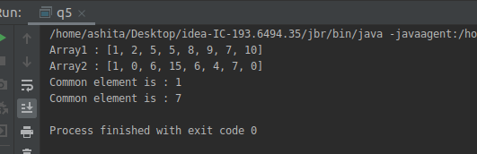

**Q6. There is an array with every element repeated twice except one. Find that element.**

**package com.first;**

**public class q6 {**

**public static void main(String[] args) {**

**int arr[]={1,2,2,1,4,4,5,5,6};**

**int count=0;**

**for(int element=0;element<arr.length;element++) {**

**for(int nxtelement=0;nxtelement<arr.length;nxtelement++) {**

**if(arr[element]==arr[nxtelement])**

**count++;**

**}**

**if(count==1)**

**System.*out*.println("once in an array="+arr[element]);**

**count=0;**

**}**

**}**

**}**

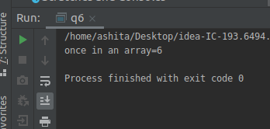

**Q7. Write a program to print your Firstname,LastName & age using static block,static method & static variable respectively.**

**class Outer{**

**static String *firstname*;**

**static String *lastname*;**

**static int *age*;**

**static {**

***firstname*="Ashita";**

***lastname*="Kumar";**

***age*=23;**

**}**

**static void statm(){**

**System.*out*.println("first name is:"+*firstname*);**

**System.*out*.println("last name is:"+*lastname*);**

**System.*out*.println("age is:"+*age*);**

**}**

**}**

**public class q7 {**

**public static void main(String[] args) {**

**Outer.*statm*();**

**}**

**}**

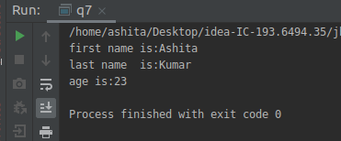

**Q8. Write a program to reverse a string and remove character from index 4 to index 9 from the reversed string using String Buffer.**

**public class q8 {**

**public static void main(String[] args) {**

**String s="ashitakumar";**

**System.*out*.println("original string:"+s);**

**StringBuffer sb=new StringBuffer(s);**

**System.*out*.println("after reverse and delete index from 4 to 9");**

**System.*out*.println(sb.reverse().delete(4,9));**

**}**

**}**

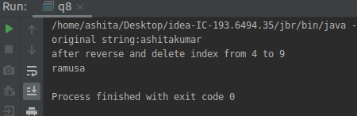

**Q9.Write a program to display values of enums using a constructor & getPrice() method (Example display house & their prices).**

**package com.first;**

**enum HOME{**

***SMALLHOME*("1bhk","200000"),**

***MEDIUMHOME*("2bhk", "40000"),**

***LARGEHOME*("3bhk", "3000000");**

**private String type;**

**private String price;**

**HOME(String type, String price) {**

**this.type = type;**

**this.price = price;**

**}**

**public String getType() {**

**return type;**

**}**

**public String getPrice() {**

**return price;**

**}**

**}**

**public class q9 {**

**public static void main(String[] args) {**

**String home1price=HOME.*SMALLHOME*.getPrice();**

**String home1type=HOME.*SMALLHOME*.getType();**

**System.*out*.println("Price of smallHose="+home1price+" type of smallhouse="+home1type);**

**String home2price=HOME.*MEDIUMHOME*.getPrice();**

**String home2type=HOME.*MEDIUMHOME*.getType();**

**System.*out*.println("Price of smallHose="+home2price+" type of smallhouse="+home2type);**

**String home3price=HOME.*LARGEHOME*.getPrice();**

**String home3type=HOME.*LARGEHOME*.getType();**

**System.*out*.println("Price of smallHose="+home3price+" type of smallhouse="+home3type);**

**}**

**}**

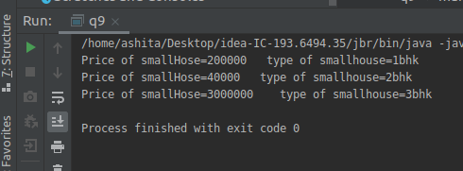

**Q10.Write a single program for following operation using overloading**

**A) Adding 2 integer number**

**B) Adding 2 double**

**C) multiplying 2 float**

**D) multiplying 2 int**

**E) concate 2 string**

**F) Concate 3 String**

**package com.first;**

**class Calculator {**

**int Operation(int num1, int num2) {**

**return num1 + num2;**

**}**

**double Operation(double num1, double num2) {**

**return num1 +num2;**

**}**

**float Operation(float num1, float num2) {**

**return num1 * num2;**

**}**

**String Operation(String s1, String s2) {**

**return s1+s2;**

**}**

**String Operation(String s1, String s2,String s3) {**

**return s1+s2+s3;**

**}**

**}**

**public class q10**

**{**

**public static void main(String[] args) {**

**Calculator cal=new Calculator();**

**System.*out*.println("adding of two integer number:1 +2="+cal.Operation(1,2));**

**System.*out*.println("adding of two float:4.5d +6.6d="+cal.Operation(4.5d,6.6d));**

**System.*out*.println("multipication of two float :4.5f*7.4f="+cal.Operation(4.5f,7.4f));**

**System.*out*.println("concation of two string:ashita+kumar="+cal.Operation("ashita","kumar"));**

**System.*out*.println("cancation of three strinng:smriti+ashita+kumar="+cal.Operation("smriti","ashita","kumar"));**

**}**

**}**

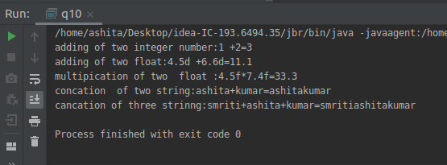

**Q11.Create 3 sub class of bank SBI,BOI,ICICI all 4 should have method called getDetails which provide there specific details like rateofinterest etc,print details of every banks.**

**Code added to git.**

