**EXERCISE**

1. **Write a program do to demonstrate the use of volatile keyword.**

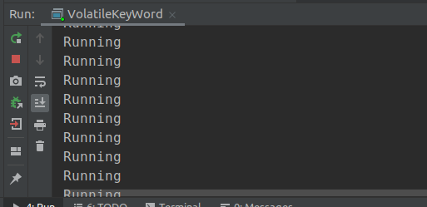

1. **Write a program to create a thread using Thread class and Runnable interface each.**

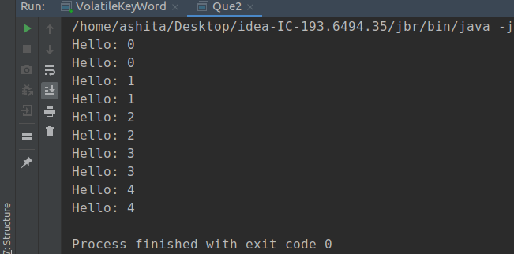

1. **Write a program using synchronization block and synchronization method.**

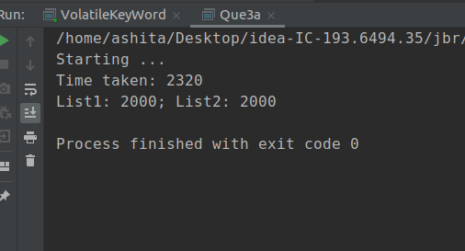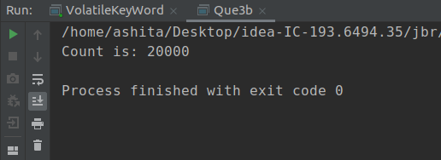

1. **Write a program to create a Thread pool of 2 threads where one Thread will print even numbers and other will print odd numbers.**

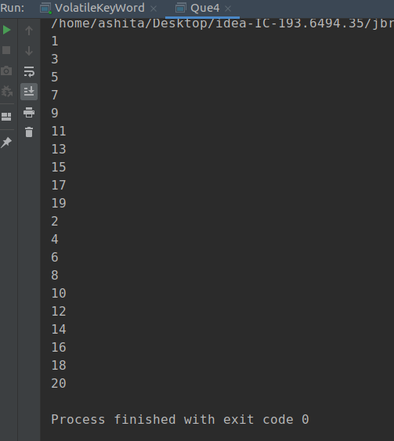

1. **Write a program to demonstrate wait and notify methods.**

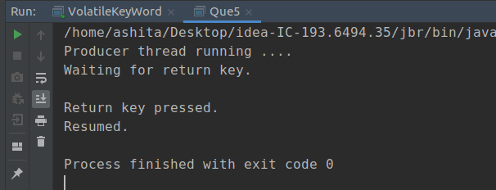

1. **Write a program to demonstrate sleep and join methods.**

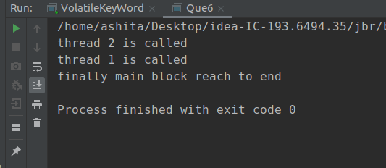

1. **Run a task with the help of callable and store it's result in the Future.**

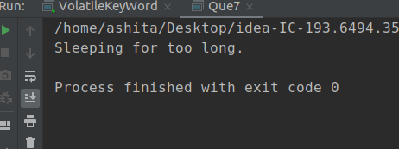

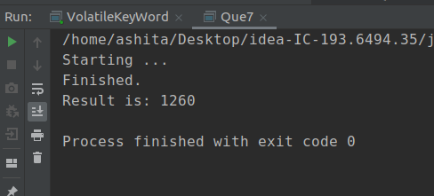

1. **Write a program to demonstrate the use of semaphore**

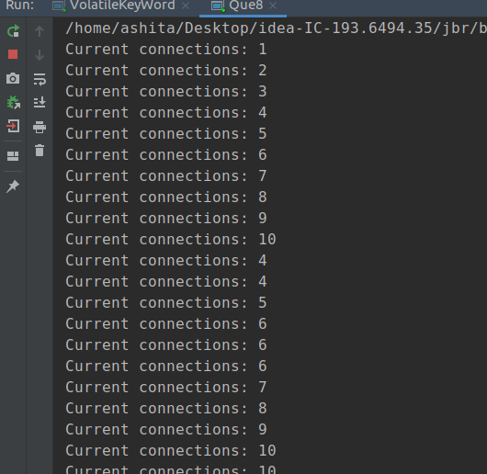

1. **Write a program to demonstrate the use of CountDownLatch**

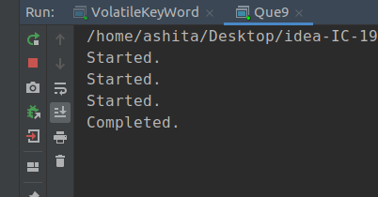

1. **Write a program which creates deadlock between 2 threads.**

