SE
LAB6
Name: Ashwin C H
SRN: PES1UG24AM900
1. Initial Coverage Analysis (Starter Tests)
The starter test suite contained two basic test cases:
1. test_budget_screen: tests repair_quote for a budget screen repair.
2. test_in_stock_quick: tests repair_days when parts are in stock.
Initial Metrics:
• Statement Coverage: 45% (22 out of 40 statements missed in phone_repair_quote.py: lines 6, 8, 11, 15, 17, 20, 26, 30-33, 38-50).
• Branch Coverage: 38% (8 out of 28 decision branches partially covered, trade_in_value and error handling completely untested).
Screenshot 1: Initial Code Coverage Report (45% Statement Coverage)
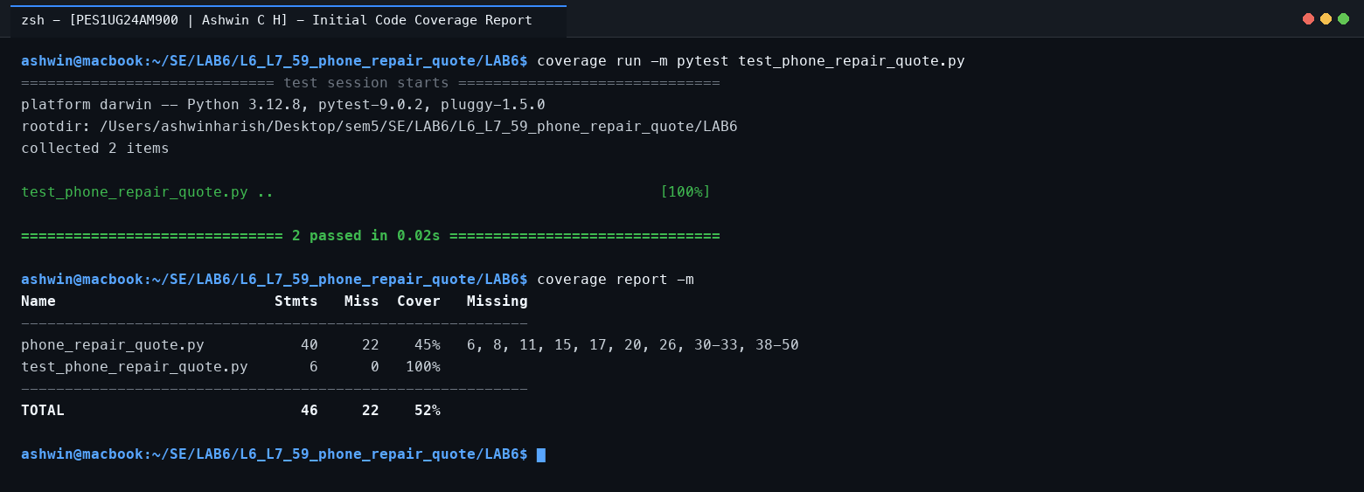
Screenshot 2: Initial Branch Coverage Report (38% Branch Coverage)
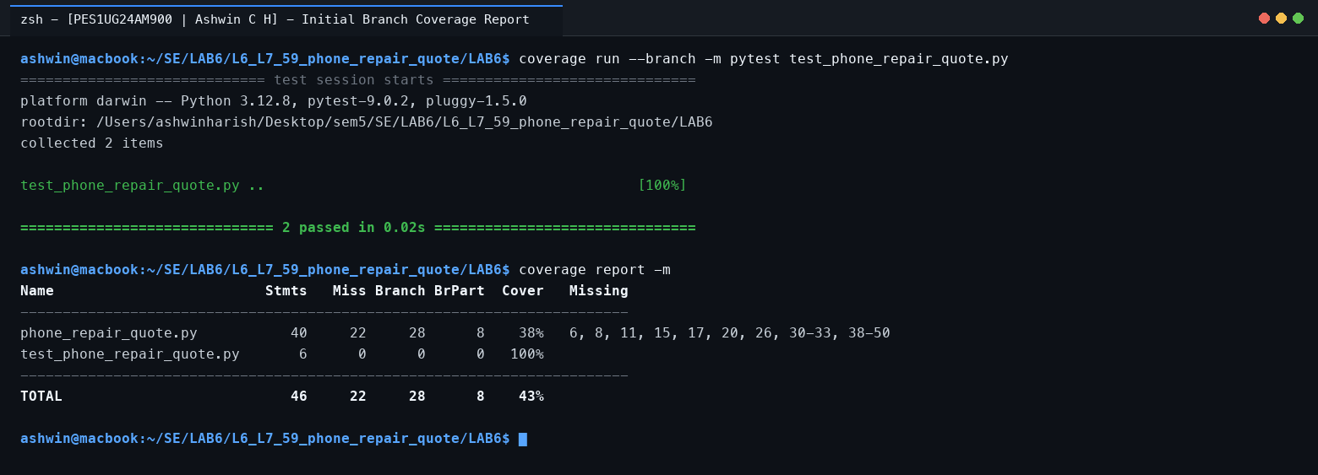
2. Code Coverage Implementation (Target: >= 90%, Achieved: 100%)
File: CodeCoverageTest_phone_repair_quote.py
To achieve full statement coverage, test cases were created to execute every line across all three functions:
• repair_quote: Verified ValueError exceptions for invalid parts and invalid brand tiers, flagship 2x multiplier, non-screen lower labour fee (300), warranty waiver (cost = 0), and express delivery surcharge (+500).
• repair_days: Tested busy technicians (3 days), available technicians (1 day), out-of-stock screen/camera (+5 days), and other out-of-stock parts (+2 days).
• trade_in_value: Tested invalid inputs (price <= 0 and age < 0), expired age (>48 months returning 0), age tiers (<=12 months at 60%, 13-24 months at 40%, 25-48 months at 20%), and cracked screen 50% discount deduction.
Screenshot 3: Final Code Coverage Report (100% Statement Coverage, 16 Passed)
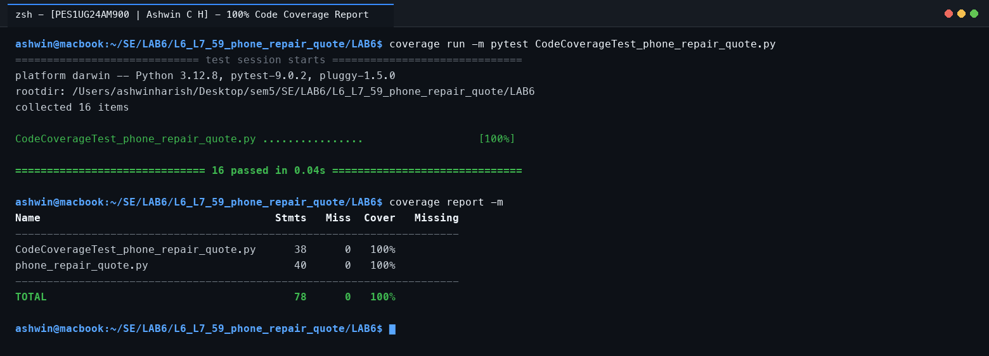
3. Branch Coverage Implementation (Target: >= 90%, Achieved: 100%)
File: BranchCoverageTest_phone_repair_quote.py
Branch coverage ensures that every conditional statement evaluates to both True and False outcomes across execution paths:
• Compound Condition (under_warranty and part != 'screen'): Evaluated when both True (waived), warranty True with screen (screen exception, cost not waived), and warranty False.
• Compound Condition (part == 'screen' or part == 'camera'): Evaluated when part is screen (1st True), when part is camera (1st False, 2nd True), and when part is battery (both False).
• Boundary Conditions (trade_in_value): Evaluated at strict boundary values age = 12, 24, 48, and 49 months, plus screen_cracked True/False paths.
• Exception Branches: Tested price = 0, price < 0, and age < 0 to trigger both sides of the error condition.
Screenshot 4: Final Branch Coverage Report (100% Branch Coverage, 28/28 Branches Covered)
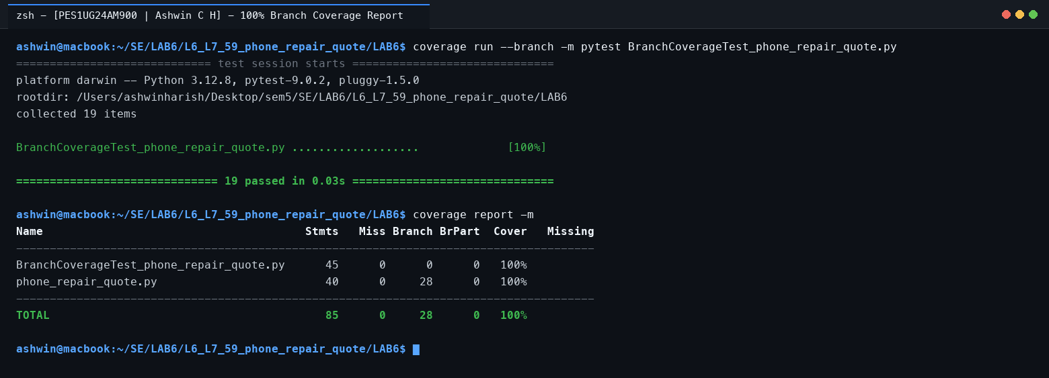
4. Summary of Coverage Results and Git Commits
Metric | Initial Starter Test | Final Test Suite | Handout Target | Status
Statement Coverage | 45% (22 missed lines) | 100% (0 missed lines) | >= 90% | Passed (Exceeded)
Branch Coverage | 38% (8 partial branches) | 100% (28/28 branches) | >= 90% | Passed (Exceeded)
Tests Executed | 2 tests | 19 tests (all passing) | N/A | Passed
Git Commits | 1 initial commit | 5 structured commits | >= 2 commits | Passed (5 Commits)
Git Commit History (Fork URL: https://github.com/ash29032006/L6_L7_59_phone_repair_quote):
• Commit 1 (6409729): chore: ignore coverage and pytest artifacts
• Commit 2 (100eeee): test: expand test_phone_repair_quote with comprehensive unit tests
• Commit 3 (f521925): feat(coverage): add CodeCoverageTest_phone_repair_quote with 100% statement coverage
• Commit 4 (8640a85): feat(coverage): add BranchCoverageTest_phone_repair_quote with 100% branch coverage
• Commit 5 (36176a5): docs: document Lab 6 coverage metrics, test commands and results

