NIZHAL
System Architecture & Deployment Specification
PS 08 · Safer Urban Mobility for Women & Vulnerable Citizens
“Every safety app asks you to press a button. We built one you never touch.”
1 · Executive summary
NIZHAL is a client-heavy, server-minimal system. A street-risk map is computed offline from open data and shipped inside the application. On the phone, five sensing layers produce twelve features; a fusion function and a trained autoencoder collapse those into a single score from 0 to 1, which drives a five-state machine. Only the terminal state transmits, and what it transmits is an AES-256-GCM encrypted blob that our own server cannot read.
The architecture is itself the product argument: we are not asking to be trusted, we have made ourselves incapable of betraying that trust.
Metric | Value | Meaning
Time to detection | under 90 seconds | with zero user action
Users needed for the map | 0 | computed, not crowdsourced
Audio bytes transmitted | 0 | analysis is on-device, buffer overwritten
Offline capability | 100% of core alerting | service worker + SMS fallback
External AI services | none | no API keys exist in this project

2 · Layered architecture
Five layers. Solid borders are running in the prototype you can open today. Dashed borders are on the roadmap and are labelled as such everywhere, including in the product UI.

Figure 1 — The five layers, with shipped vs roadmap status per component.

3 · Layer detail
A · City Risk Pipeline
Input is an Overpass extract of Thiruvanmiyur and Adyar, Chennai: 2,970 street segments, 2,322 junctions, 212.5 km of road and 213 mapped amenities.
r(segment, hour) = f(lighting, frontage, footpath, enclosure,
topological isolation, segment length)
× night and late-night multipliers
Provenance is tracked per segment and surfaced in the dashboard. The OSM lit tag exists on 209 segments; frontage is measured from real points of interest on 835; the remainder uses a road-class prior. We display which is which rather than implying the whole map is measured.
Output is a 477 KB bundle compiled into the application, which is why routing and risk scoring continue to work with the network switched off.
B · On-Device Engine
- Motion — RMS, jerk and spectral entropy from a Goertzel bank over 0.5–12 Hz. Walking is periodic and scores low entropy; a struggle is broadband and aperiodic.
- Audio (opt-in) — fundamental frequency, share of energy in 1–4 kHz, and roughness (amplitude modulation). Two-second RAM ring buffer, continuously overwritten, never stored or transmitted.
- Anomaly — a 9-5-3-5-9 dense autoencoder trained on normal behaviour only: 24,000 samples of walking, vehicle rides, pocket jostle and stationary use. A calm walk scores 0.01; being pulled into a vehicle scores 1.00. No assault data was used, or needed.
- Fusion — twelve features become weighted evidence, saturated into 0–1, multiplied by a context term derived from street risk, hour and isolation.
- States — OFF, ARMED, HEIGHTENED, CHECK-IN, ALERT at thresholds 0.38, 0.62 and 0.80. Only ALERT transmits. Biometric unlock is an automatic stand-down.
Why not a rule table? Twelve binary signals is 2^12 = 4,096 cases to hand-author and maintain. A learned function over a feature vector is one function.
C · Zero-Knowledge Relay
Identity is an ECDSA plus ECDH P-256 keypair generated on the device. Contacts pair by QR code. Alerts are sealed with ECDH to HKDF-SHA256 to AES-256-GCM, signed, and posted with a random per-alert recipient tag so two alerts from the same person cannot be linked.
The reference relay implementation is under 60 lines of Python. It has no user table because there are no users. Seize the server and you obtain a queue of ciphertext and a rate-limit counter.
D · Escalation ladder
T+ | Audience | Condition
0 s | Device only | silent arming, breadcrumb buffer begins
10 s | The user | silent vibrate; tap, biometric or voice cancels
30 s | Nearby guardians | verified users within 400 m
60 s | Trusted contacts | live location plus 10-minute breadcrumb
90 s | 112 / police | requires three or more corroborating layers

A false alarm is one friend receiving a notification. A missed alarm is a life. We therefore tune for sensitivity and make cancelling trivial.
E · City Data Layer
Aggregate and anonymous. Ranks interventions by risk reduction per rupee against a streetlight budget, using a counterfactual re-score of each segment as if it were lit. Buyers are municipal corporations, transport authorities, night-shift employers and campuses.
The app helps one woman avoid one street tonight. The dashboard fixes the street so that nobody has to avoid it next year.

4 · The alert sequence
This is the only sequence in the entire product that causes a network request.
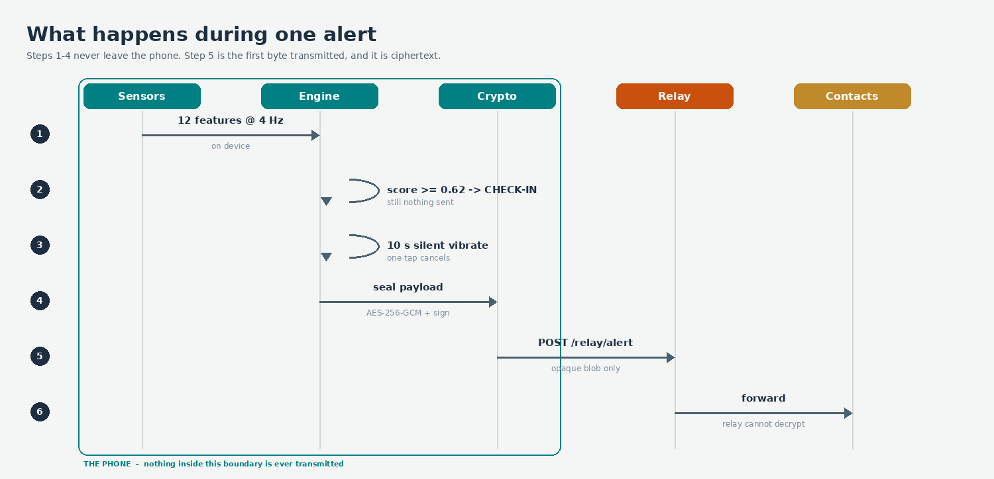
Figure 2 — Steps 1 to 4 never leave the device. Step 5 is the first byte transmitted, and it is ciphertext.
5 · Code architecture
Two rules keep the codebase legible, and everything else follows from them.
- core/ never imports React. It is pure, testable logic that would port to React Native or a Node worker unchanged.
- No screen imports an API implementation. Screens import the contract; the build decides whether that resolves to the in-browser adapter or an HTTP client.
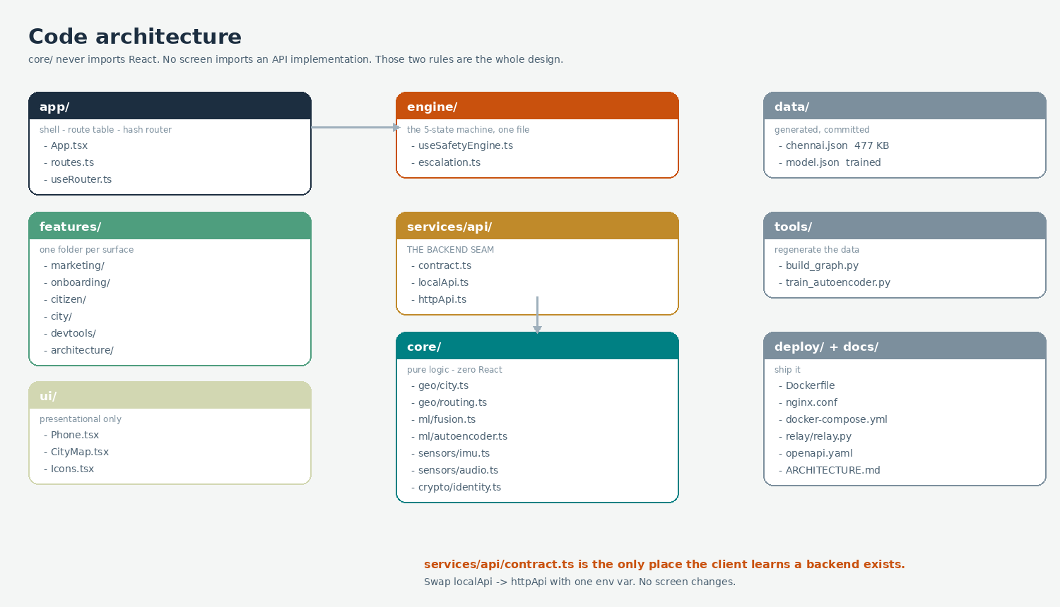
Figure 3 — Module layout. services/api/contract.ts is the seam where a real backend plugs in.

6 · API contract
The entire backend surface is five endpoints, specified in docs/openapi.yaml. No endpoint accepts or returns anything that identifies a person. There is no /users, no /login and no /location.
Endpoint | Purpose | Contains identity?
POST /risk/tiles | scored street segments for a bbox and hour | no
POST /routes | Pareto-optimal routes over time vs risk | no
POST /relay/alert | submit an opaque encrypted envelope | no — ciphertext only
GET /city/works | interventions ranked by risk reduction per rupee | no — aggregate
GET /places | open, lit, staffed places near a point | no

The same contract is satisfied in the browser today, which is why the product deploys as a static bundle and keeps working in airplane mode. Switching to a real server is one environment variable.
VITE_API_MODE=local # default — computed in the browser, static deploy
VITE_API_MODE=http # talk to a FastAPI service implementing openapi.yaml
7 · Deployment
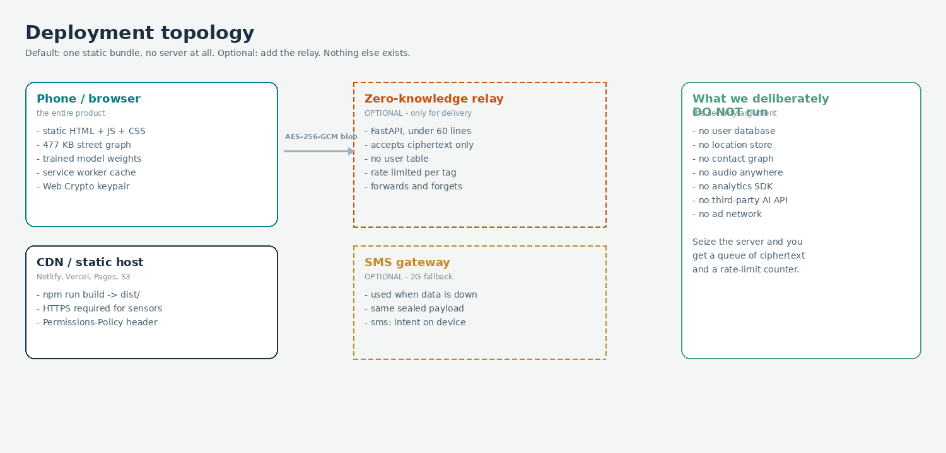
Figure 4 — Deployment topology. The dashed services are optional; the product works without them.
Target | Command | Result
Local development | npm run dev | http://localhost:5173
Static build | npm run build | dist/ — deploy anywhere
Netlify / Vercel | git push | netlify.toml / vercel.json included
GitHub Pages | git push to main | .github/workflows/deploy.yml
Docker | npm run docker | nginx on :8080, optional relay on :8000

Sensors require a secure context. The accelerometer, geolocation and microphone will not initialise over plain HTTP on a LAN address. Deploy to HTTPS or use a tunnel, then open on a phone.
Permissions-Policy: accelerometer=(self), gyroscope=(self),
geolocation=(self), microphone=(self)

8 · Threat model
Mitigated
- Server compromise — there is nothing of value stored to steal.
- Network interception — payloads are end-to-end encrypted and signed.
- Alert spoofing — envelopes are ECDSA signed and rate limited per tag.
- Stalkerware repurposing — no silent monitoring mode, a persistent armed indicator, contacts removable without notification, and a duress PIN that shows a convincing all-clear while alerting.
Not mitigated — stated openly
- A compromised operating system defeats any user-space application.
- The relay still observes connection metadata such as IP address and timing.
- A phone that is already powered off cannot alert; we can only alert on the silence.
- Indoor GPS is unreliable, which degrades trajectory features.
- A familiar route with a known attacker produces no behavioural anomaly.
We never claim to prevent crime. We claim to reduce time-to-detection from hours to roughly 90 seconds, with zero user action.
9 · What is real in the current build
Component | Status
Chennai street graph (2,970 segments, 213 POIs) | Real — OpenStreetMap, bundled
Risk model r(segment, hour) | Real algorithm, provenance shown
Pareto routing (Dijkstra, 6-alpha sweep) | Real
Accelerometer feature extraction | Real — DeviceMotion on any phone browser
GPS speed and vehicle onset | Real — watchPosition
Scream detection | Real — Web Audio, on-device, nothing recorded
Autoencoder anomaly model | Real — trained, weights committed
Fusion and five-state machine | Real
ECDH + AES-256-GCM sealing and signing | Real — Web Crypto
Offline operation and SMS payload | Real — service worker, sms: intent
VIIRS, Mapillary CNN, GNN, PU-learning | Roadmap
Production relay, guardian network, BLE density | Roadmap

Street data © OpenStreetMap contributors, ODbL · Built for the Crescent Project Expo

