Prompt given:
You are software expert and architect. I have to design an application with following requirement
1) User upload a PDF document that is government tender
2) A program would extract key info from the tender document and put it in excel
3) The user would receive an excel file that would contain the extracted info.
4) Do not use API gateway
5) I will use this as POC to show the client
6) I want to use Azure here.
7) Give me directory structure
Give me architecture this for this application. I want to make this application that I can sell it.
RESPONSE:
High-Level Architecture
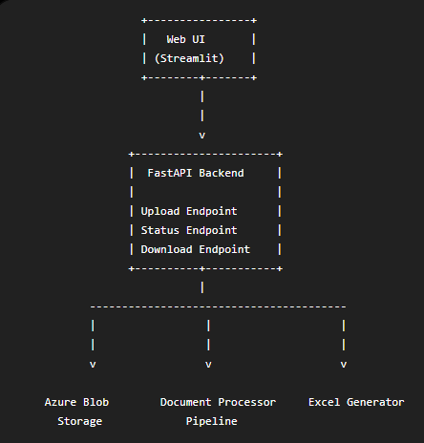
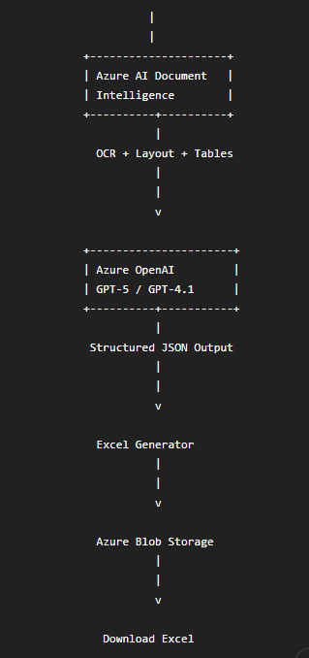

Processing Flow
User uploads Tender PDF
↓
Store PDF in Azure Blob Storage
↓
Azure Document Intelligence
- OCR
- Tables
- Layout
- Paragraphs
↓
Extract text
↓
Azure OpenAI

Prompt:
Extract following fields...
Return JSON only.
↓
JSON Validator
↓
Excel Generator
↓
Store Excel in Blob
↓
User downloads Excel

Azure Services
Purpose | Azure Service
Upload PDF | Azure Blob Storage
OCR | Azure AI Document Intelligence
LLM | Azure OpenAI
Backend | FastAPI
Frontend | Streamlit
Excel Generation | openpyxl
Deployment | Azure App Service
Authentication (Later) | Azure Entra ID
Monitoring | Azure Application Insights

Why Azure Document Intelligence?
Government tenders usually contain
- scanned pages
- tables
- signatures
- stamps
- multi-column text
- headers
- footers
Traditional PDF libraries cannot reliably extract these.
Document Intelligence returns
- paragraphs
- tables
- page numbers
- key-value pairs
- coordinates
which makes GPT extraction much better.

Suggested Prompt
You are an expert government tender analyst.
Extract the following fields.
Tender Number
Tender Title
Organization
Department
Tender Value
EMD Amount
Bid Submission Date
Bid Opening Date
Eligibility
Experience Required
Required Certificates
Contact Person
Email
Phone
Location
Work Description
Duration
Return ONLY JSON.
If missing return null.

Directory Structure
TenderExtractor/

│
├── app/
│ │
│ ├── main.py
│ ├── config.py
│ ├── settings.py
│ │
│ ├── api/
│ │ upload.py
│ │ download.py
│ │ health.py
│ │
│ ├── services/
│ │ blob_service.py
│ │ document_ai.py
│ │ openai_service.py
│ │ excel_service.py
│ │ validation_service.py
│ │
│ ├── models/
│ │ tender_model.py
│ │
│ ├── prompts/
│ │ tender_prompt.txt
│ │
│ ├── utils/
│ │ logger.py
│ │ helper.py
│ │
│ ├── pipeline/
│ │ extract_pipeline.py
│ │
│ └── schemas/
│ response.py
│
├── frontend/
│ streamlit_app.py
│
├── uploads/
│
├── output/
│
├── tests/
│
├── requirements.txt
│
├── Dockerfile
│
└── README.md

Pipeline
extract_pipeline.py
↓
1. Upload PDF
↓
2. Blob Storage
↓
3.Document Intelligence
↓
4. Extract text
↓
5. Azure OpenAI
↓
6. Parse JSON
↓
7. Validate
↓
8. Create Excel
↓
9. Save Excel
↓
10. Return download URL

Internal Class Design
DocumentProcessor
process(pdf)
↓
DocumentAIService
↓
OpenAIExtractor
↓
JSONValidator
↓
ExcelWriter
↓
BlobUploader

Each class has one responsibility.

Excel Output
Field | Value
Tender Number | GEM/2026/B/2345
Tender Title | Supply of UPS
Organization | Ministry of Railways
Department | Northern Railway
Tender Value | ₹2,50,00,000
EMD | ₹5,00,000
Closing Date | 15 Aug 2026
Opening Date | 16 Aug 2026
Duration | 180 Days
Contact | ABC Sharma
Email | abc@gov.in

POC Folder Flow
PDF
↓
Blob
↓
Document Intelligence
↓
Raw Text
↓
Azure OpenAI
↓
Structured JSON
↓
Excel
↓
Download

Future Production Architecture
Once the client approves the POC, you can evolve it into an enterprise-grade system:

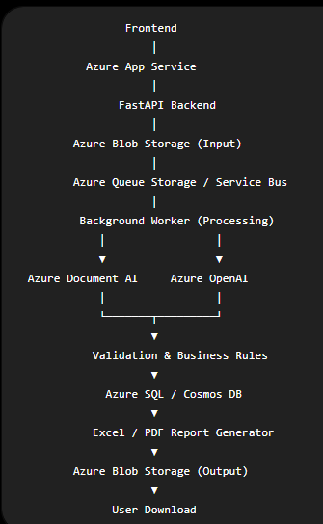

This asynchronous design lets you process many tenders concurrently, retry failed jobs, maintain audit logs, and add new output formats without changing the frontend.
Why this architecture is commercially viable
It is modular, cloud-native, and easy to extend. New document types (contracts, invoices, purchase orders, legal notices) can reuse the same pipeline by changing the extraction prompt and output schema. It also keeps Azure services focused on what they do best: Blob Storage for files, Document Intelligence for OCR and layout understanding, Azure OpenAI for semantic extraction, and FastAPI for orchestration.
For a POC, you can keep everything synchronous in a single FastAPI application to minimize complexity. After client acceptance, introducing queues, background workers, authentication, databases, and monitoring requires minimal refactoring because the service boundaries are already defined. This makes it a strong foundation for a product that can scale from a demo to an enterprise deployment.

