A Proof of Concept (POC), without API Gateway, and using an event-driven workflow.

High-Level Architecture
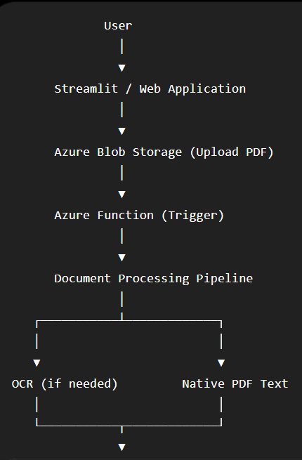

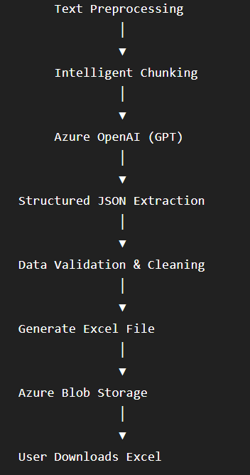

Complete Workflow
Step 1. User uploads Tender PDF
The user uploads the tender document through
- Streamlit
- React
- ASP.NET
- Any Web UI
The application immediately stores the PDF inside
Azure Blob Storage
Reason:
- Cheap
- Durable
- Scalable
- Trigger for Azure Function

Step 2. Azure Function Starts Automatically
Blob upload triggers an Azure Function.
This function becomes the orchestrator.
Its job is NOT to perform extraction itself.
Instead it coordinates the pipeline.

Step 3. Read PDF
The function downloads the uploaded PDF.
Now determine
Is PDF digital?
OR
Is PDF scanned?
If digital Extract text directly
If scanned Run OCR
Azure AI Document Intelligence is excellent here because government tenders often contain
- Tables
- Headers
- Footers
- Stamps
- Multiple columns

Step 4. Clean the Text
Government tenders usually contain
- page numbers
- headers
- footers
- repeated logos
- unnecessary whitespace
- broken lines
Example
Government of India
Tender No...

----------------

Page 7
becomes
Tender No...

Technical Qualification...
This dramatically improves LLM accuracy.

Step 5. Intelligent Chunking
Tender PDFs can easily exceed 100 pages, 200 pages or 500 pages.
You cannot send the entire PDF to GPT.
Instead split into meaningful sections. Examples:
- Notice Inviting Tender
- Eligibility Criteria
- Technical Qualification
- Financial Qualification
- Scope of Work
- EMD
- Performance Security
- Important Dates
- Commercial Terms
- Annexures
Chunk by headings rather than fixed token size whenever possible.

Step 6. Information Extraction using Azure OpenAI
Each chunk is sent to GPT.
Instead of asking
Summarize this
Ask
Extract ONLY these fields
Example
Tender Number
Tender Name
Department
Organization
Bid Submission Date
Opening Date
EMD
Tender Value
Completion Time
Eligibility
Contact Person
Address
Email
Phone
Document Fee
Performance Guarantee
Scope of Work
Required Certifications
Payment Terms
Penalty

Experience Requirement
GPT returns structured JSON.
Example
{
"Tender Number":"PWD/2026/14",
"Department":"Public Works Department",
"EMD":"₹2,00,000",
"Tender Value":"₹1.5 Crore"
}
Repeat this for every chunk.

Step 7. Merge Results
Multiple chunks may produce
Tender Number
multiple times.
Merge intelligently.
Rules like
- First non-empty value
- Prefer longest value
- Prefer latest occurrence
- Confidence score

Step 8. Validation Layer
Now validate extracted data.
Examples
Dates - 31/02/2026 -> Invalid.
Money: 2 lakh, ₹200000, Rs.2,00,000 ->Normalize.
Phone numbers. Normalize.
Email Validate.
GST Validate.
PAN Validate.

Step 9. Create Excel
Generate Excel.
Example
Field | Value
Tender Number | XYZ123
Department | PWD
Tender Value | ₹1.2 Cr
EMD | ₹1 Lakh
Submission Date | 12/10/2026
Or
One row per tender
Tender No | Department | Value | EMD | Closing Date

Step 10. Store Output
Store Excel
Azure Blob Storage
Optionally
Store extracted JSON also.
JSON becomes useful later for
- searching
- analytics
- dashboards

Step 11. Notify User
Application receives completion status.
User clicks
Download Excel
Done.

Azure Services Mapping
Purpose | Azure Service
Upload PDF | Azure Blob Storage
Event Trigger | Azure Function
OCR & Layout Extraction | Azure AI Document Intelligence
LLM Extraction | Azure OpenAI
Secret Management | Azure Key Vault
Output Storage | Azure Blob Storage
Monitoring | Azure Application Insights
Logging | Azure Monitor

Recommended Processing Pipeline
Upload PDF
│
▼
Blob Storage
│
▼
Azure Function
│
▼
Read PDF
│
▼
OCR (if required)
│
▼
Clean Text
│
▼
Section Detection
│
▼
Chunking
│
▼
Azure OpenAI
│
▼
Structured JSON
│
▼
Merge Results
│
▼
Validation
│
▼
Excel Generator
│
▼
Blob Storage
│
▼
Download

Why This Architecture Works Well
- Modular: Each stage (OCR, preprocessing, extraction, validation, export) can be improved independently.
- Scalable: Azure Functions scale automatically as more PDFs arrive.
- Cost-effective for a POC: You only pay for storage, function execution, OCR (when needed), and Azure OpenAI usage.
- Reliable: Blob Storage provides durable storage and decouples upload from processing.
- Extensible: You can later add features such as confidence scoring, extraction review, support for multiple tender formats, or storing results in Azure SQL or Cosmos DB without redesigning the pipeline.
This workflow closely matches how enterprise intelligent document processing (IDP) solutions are built while remaining simple enough for a client-facing proof of concept.

