We would run manual first, followed by a scheduled run using ChatGPT Work with access to a local folder. You describe the rules in plain English and review the resulting Excel file.
Official OpenAI documentation states that Desktop Work can use approved local files, and scheduled tasks can run against local projects. Your computer must stay on with the app running.

Approach | How it starts | Suitable for your demo
Manual | You ask ChatGPT to process incoming files | Best starting point
Scheduled | ChatGPT checks the folder at a chosen time | Best automation demonstration

“No code” here means you don’t write or maintain a script. ChatGPT may use code internally to create the workbook.
1. Create a separate demonstration folder
Keep your existing Python project intact. Create this new folder using File Explorer:
finance_no_code_demo/
- incoming
- outgoing
- archive
Copy your dummy CSV into incoming.

MANUAL AUTOMATION
2. Open ChatGPT Work with local folder access
In the desktop app:
- Start a new Work chat.
- Create a new project (or Select local computer access, if available.)
- Add or select finance_no_code_demo as the working folder.
- Allow access to that folder when prompted.
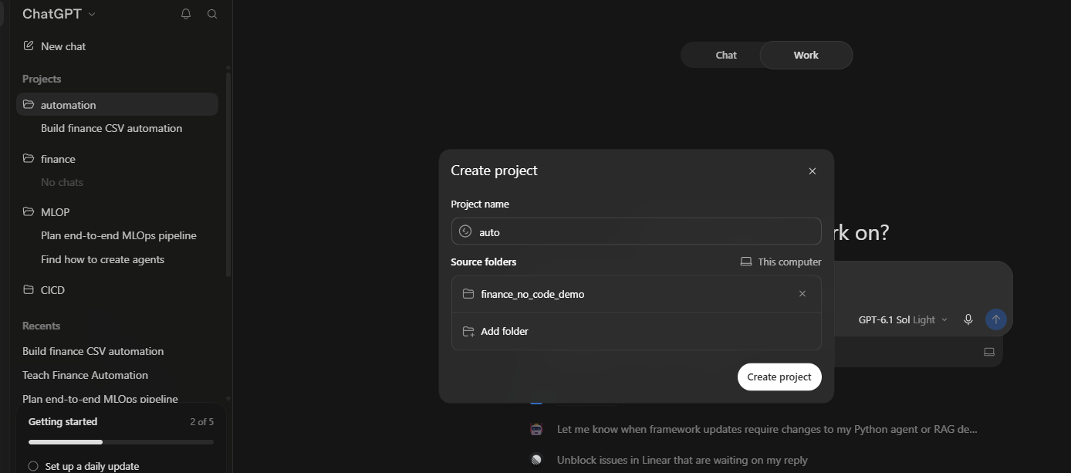
The exact controls can vary by app version. If you don’t see Work or local folder access, use the manual-upload alternative below.
3. Paste these reusable instructions
Process the CSV files in the incoming folder into Excel reports. Complete the work using the available tools. I do not want to write, install or run a Python script myself.
For each CSV:
- Preserve all original records in a worksheet named "raw data".
- Validate these required columns:
transaction_id, date, department, category, units, unit_price, unit_cost.
Require valid YYYY-MM-DD dates, positive whole-number units, and finite nonnegative prices and costs. Reject missing required values and duplicate transaction IDs within the file. Accept the first valid occurrence of an ID.
- Put rejected records in "invalid sheet". Add source_line and comments columns explaining rejection reason.
- Put accepted records in "processed". Add Excel formulas for:
- Revenue = units × unit_price
- Cost = units × unit_cost
- Profit = revenue − cost
- Margin = profit ÷ revenue, using zero when revenue is zero
- Add clearly labelled total revenue and total profit cells.
- Create three editable Excel charts on the processed sheet:
- Revenue versus cost by department
- Profit by department, expressed in INR lakh
- Revenue share by department
- Apply readable headers, alternating table rows, filters, INR currency formats, date and percentage formats, and loss highlighting. Do not freeze columns or create a divider between columns B and C.
- Save the completed XLSX in outgoing. Verify the sheets, totals, formulas and charts before reporting completion.
- After successful completion, move the original CSV to archive. Skip files already archived or recorded as processed. Keep a processing record to prevent duplicate reports. Leave failed inputs available for review and explain the problem.

Show brief progress updates for important steps only. Finish with the report location and the number of accepted and rejected records. If there are no new CSVs, say so without recreating reports.

4. Test the manual demonstration
Send:
Process the new CSV files in incoming now.
Then inspect the workbook in outgoing. For our original sample, expect 28 source rows, 20 accepted and 8 invalid.
Check that the profit chart uses lakh and that the rejected rows have explanations. This proves the workflow before you schedule it.

Scheduled Automation (BUGGY)
5. Add a schedule
In the same local Work chat, ask:
Schedule this workflow to check the incoming folder every weekday at 9:00 AM Asia/Kolkata. Use the processing instructions in this chat. Process only new files. Notify me when reports are ready or when processing needs attention.

Review the schedule confirmation and its folder context. Open Scheduled to manage or pause it.
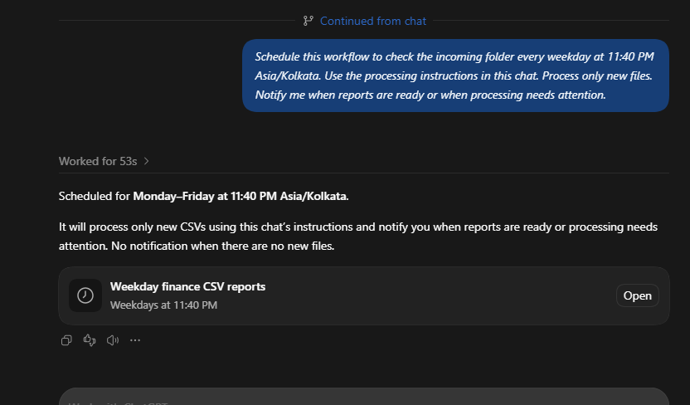
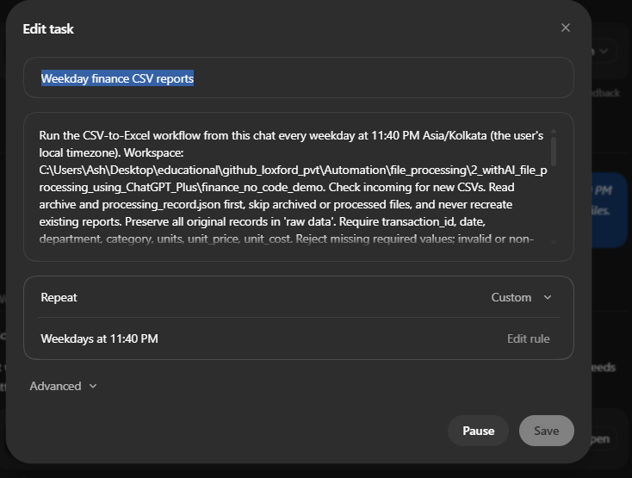
For a live demonstration, choose a one-time run a few minutes ahead, then place a fresh CSV in incoming. Local scheduled runs require the computer and desktop app to remain running.

