Deploying a Self-Hosted LLM via Hugging Face Transformers and FastAPI​

Objective: To deploy a local language model using Hugging Face’s transformers library and expose it as an API using FastAPI. This setup mimics the deployment stage in an LLMOps pipeline.

Tools required: Python 3.8 or higher installed

Prerequisites: None

Steps to be followed:

- Create a project directory
- Create and activate a virtual environment
- Create requirements.txt
- Install dependencies
- Build the FastAPI App (app.py)
- Run the API server and test the /generate endpoint

Step 1: Create a project directory
Create a direcotry: self_hosted_llm and then “cd self_hosted_llm”

Step 2: Create and activate a virtual environment

  - Run the following commands in the terminal (Konsole):
python3 -m venv venv
venv/Scripts/activate

Step 3: Create requirements.txt put following package in it.

fastapi
uvicorn
transformers
torch

Step 4: Install dependencies

pip install -r requirements.txt

Step 5: Build the FastAPI App (app.py)

(add code there)

Note: distilgpt2 is a lightweight model. For better outputs, you can try tiiuae/falcon-7b-instruct (requires GPU and more RAM).

Step 6: Run the API server and test the /generate endpoint

uvicorn app:app --reload

  - Visit the following link using your browser:
http://127.0.0.1:8000/docs

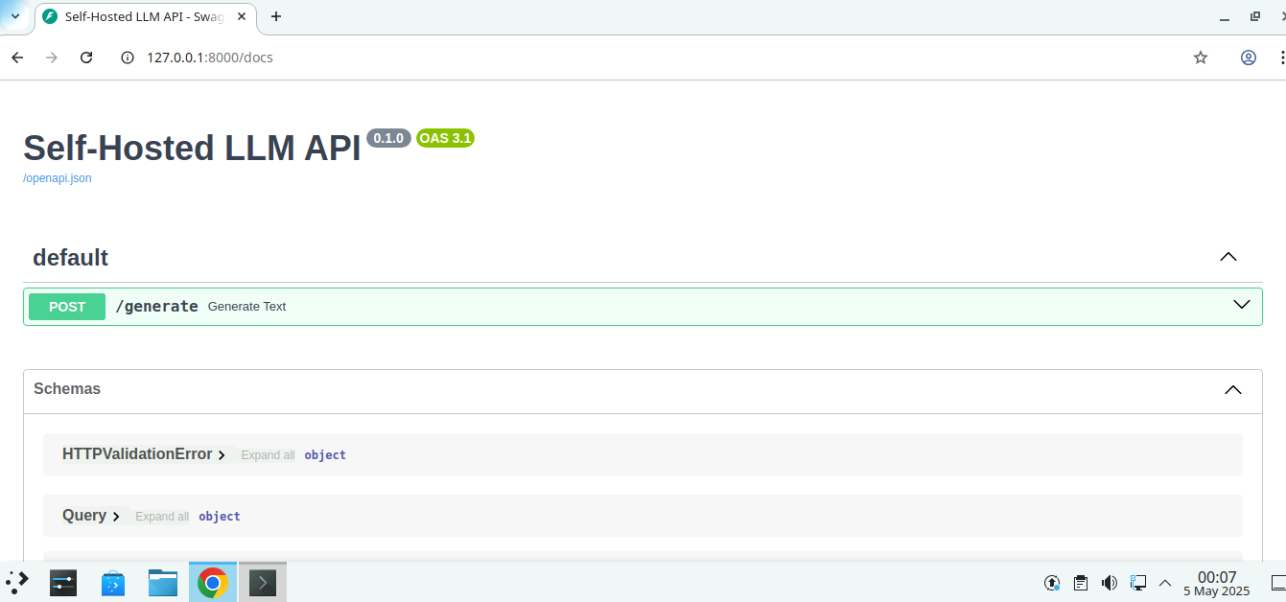

  - Click the drop-down menu for /generate and click on Try it out

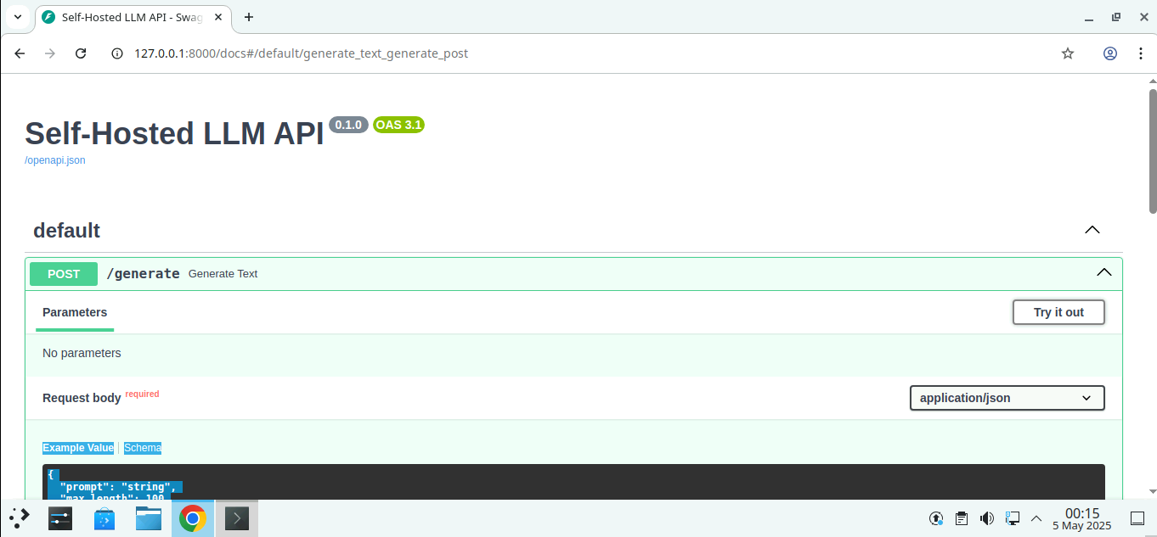

  - Paste the following under the Request body section and click on Execute:
{
"prompt": "The future of AI in healthcare is",
"max_length": 50
}

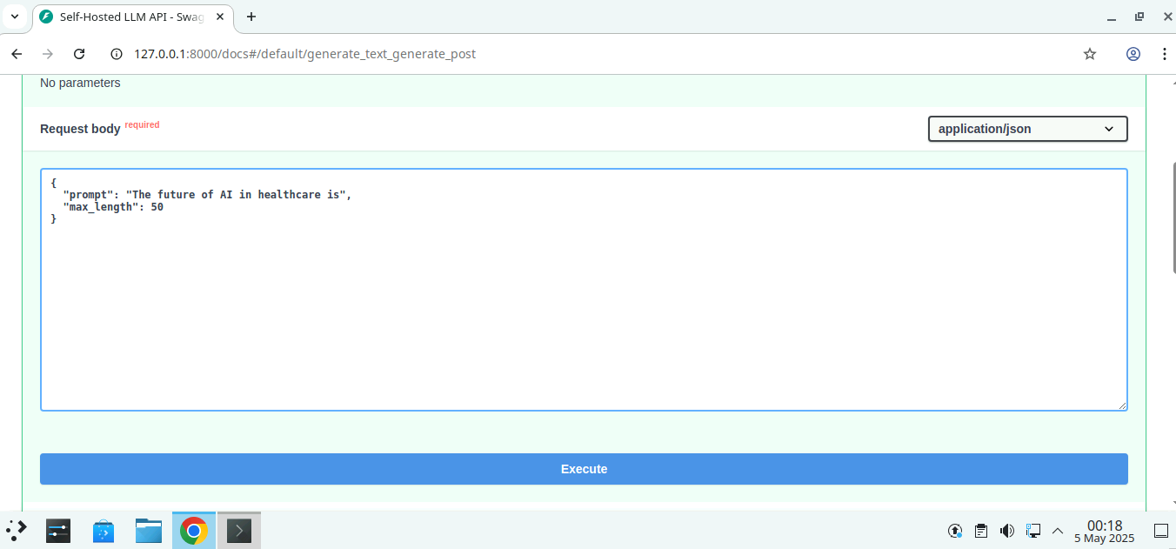

  - Scroll down and find the response in the Response body

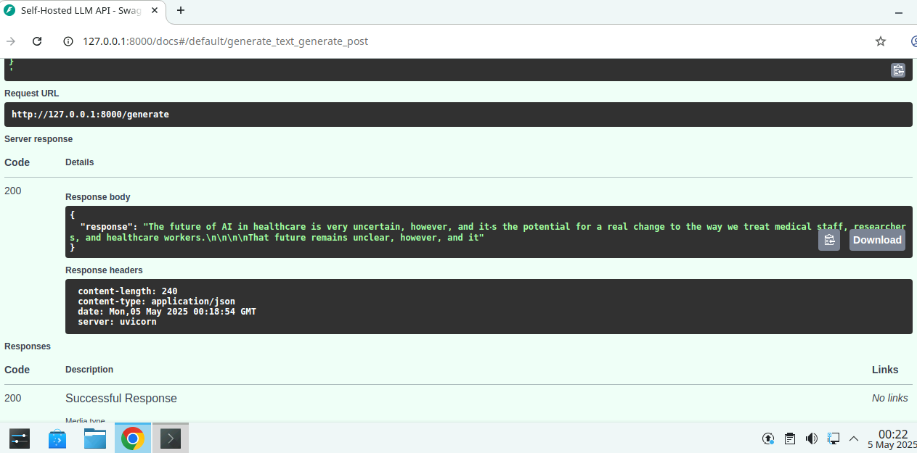

By following the above steps, you have successfully deployed a local language model (distilgpt2) using FastAPI and served it through a REST API. You used Hugging Face’s pipeline() utility to generate sentence completions based on user prompts and tested the API using Swagger documentation. This exercise demonstrates how to transition from model experimentation to a deployable API endpoint, representing a key milestone in the deployment stage of the LLMOps lifecycle.

