TEACHING GUIDE | AI AT WORK
AI Governance in Practice
A no-code, discussion-based session for business students and professionals
Duration | About 2 hours (see session plan in Section 8)
Format | Short lecture, case discussion, classification quiz, group mini-project
Prerequisites | None. No programming needed. Basic familiarity with AI chatbots helps.

1. Learning Objectives
By the end of the session, learners will be able to:
- Define AI governance and explain why organizations need it.
- Identify the five practical governance topics and give a workplace example of each.
- Classify everyday AI use cases as acceptable, acceptable with safeguards, or not acceptable.
- Draft a simple governance plan: risks, controls and an accountable owner.

2. What Is AI Governance?
Definition
AI governance is the set of rules, responsibilities and checks an organization uses to make sure AI is used safely, fairly, legally and responsibly.

3. Case Study: AI Recruitment Screening
A company receives 5,000 job applications. The HR department uses an AI system to shortlist candidates.
Benefits | Risks
- Saves HR time.  - Processes every application consistently. | - Qualified candidates may be rejected unfairly.  - HR may trust the AI without checking its decisions.  - Personal data may be exposed.  - The AI may favour certain backgrounds.

Governance questions to discuss
- Accountability: Who is accountable for the shortlist?
- Bias: How do we check whether the AI is biased?
- Data: What candidate data may the system use?
- Oversight: Must a human review rejection?
- Redress: How can a candidate challenge a decision?

4. The Five Practical Topics
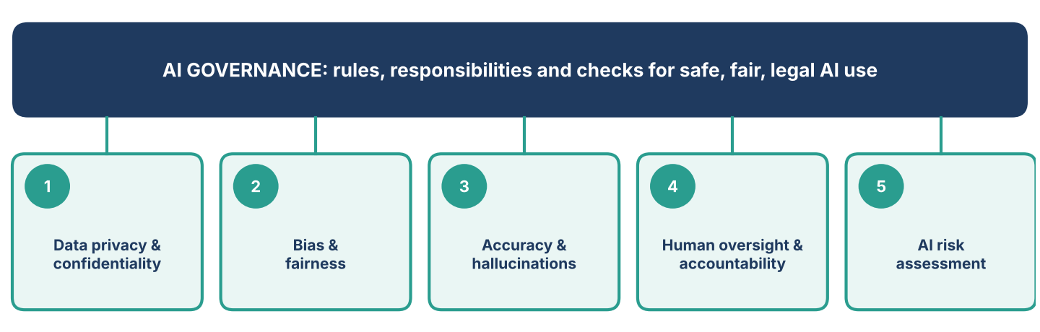
Figure 1. The five topics that make governance practical.

# | Topic | Key question | Practical exercise
1 | Data privacy and confidentiality | What information can employees enter into AI tools? | Give 10 examples of business information. Learners decide which can safely go into a public AI chatbot.
2 | Bias and fairness | How can AI produce unfair results? | Hand out a hypothetical recruitment shortlist. Learners spot unfair patterns and design a fairer review process.
3 | Accuracy and hallucinations | AI can produce convincing but incorrect information. How do we catch it? | Ask AI to analyse a small sales dataset, then compare its claims with actual Excel calculations.
4 | Human oversight and accountability | Who is responsible for how AI output is used? | Sort tasks into: AI may complete automatically vs. needs manager approval.
5 | AI risk assessment | How do managers weigh benefits and risks before adopting an AI solution? | Evaluate whether a company should use AI for customer support, loan approvals or employee performance reviews.

5. Classroom Activity: Can We Trust AI With Company Data?
Read each situation aloud (or show it on screen). Learners classify it, then justify their choice in one sentence. No programming is needed.
A | Generally acceptable | B | Acceptable with safeguards | C | Not acceptable as described

# | Situation | Answer (A / B / C)
1 | An employee asks AI to improve the wording of a generic meeting agenda.
2 | An HR employee uploads resumes containing names, phone numbers and salary history to a public AI chatbot without approval.
3 | A marketing team uses AI to draft an advertisement, then checks all claims before publishing.
4 | A manager uses an AI-generated report to fire an employee without checking the evidence.
5 | A finance team uses an organization-approved AI tool to summarize financial reports, with access controls and human verification.
6 | A company uses AI to shortlist candidates and tests its outcomes for unfair patterns before deployment and periodically afterward.

6. Group Mini-Project: Create an AI Governance Plan
Scenario. A retail company wants to use AI for customer service, sales forecasting, employee recruitment and marketing. Each group acts as the company's AI governance committee and completes the worksheet below for one use case.
Task. Tick your choices, justify them, and list what extra information you would need before a real deployment decision.
AI governance planning worksheet
Company type | ☐ Retail company  ☐ Bank  ☐ University  ☐ HR consultancy
Proposed AI use case | ☐ Customer support chatbot  ☐ Recruitment screening  ☐ Sales forecasting  ☐ Employee performance evaluation
What could go wrong?  (select all that apply) | ☐ Incorrect AI answers  ☐ Customer data privacy  ☐ Unfair or biased outcomes  ☐ Unauthorized access  ☐ Over-reliance on AI
What controls should the company introduce? | ☐ Human review for high-impact cases  ☐ Verify AI answers against approved sources  ☐ Restrict access to sensitive data  ☐ Test for bias and accuracy  ☐ Log incidents and review performance
Who owns the risk? | ☐ Department Manager  ☐ IT / Information Security  ☐ HR Manager  ☐ Customer Service Manager

Quiz answer key (instructor only)
Suggested answers; accept a different answer if the learner's reasoning is sound.
# | Answer | Why
1 | A | A generic agenda contains no confidential information and low-stakes output.
2 | C | Personal and salary data went into a public tool without approval. Breaches both privacy and policy.
3 | B | Acceptable because claims are checked before publishing. The check is the safeguard.
4 | C | High-impact decision with no human verification. Accountability is missing.
5 | B | Approved tool, access controls and human verification are the safeguards.
6 | B | Testing before launch and periodically afterward is the safeguard against bias.

