Northwind Supply Co.
Q3 2026 Business Performance Report
Prepared by Finance & Strategy | Reporting period: July to September 2026 | Internal use only
Note: Northwind Supply Co. and all figures are fictional and for training use only.

1. Executive Summary
Northwind Supply Co. closed Q3 with revenue of $13.9M, up 5.3% on Q2 and 1.4% ahead of the quarterly target of $13.7M. Net profit rose 11.1% to $2.0M, helped by a gross margin improvement from 57.1% to 58.4% after supplier renegotiations in July.
Growth was strongest in the West and Midwest regions. The Southwest region declined 4.5% following the loss of two large distribution accounts. Customer churn rose to 2.9%, above our 2.5% ceiling, and is the main risk heading into Q4.

2. Key Metrics
Metric | Q3 2026 | Q2 2026 | Change
Revenue | $13.9M | $13.2M | +5.3%
Gross margin | 58.4% | 57.1% | +1.3 pts
Operating expenses | $6.1M | $5.8M | +5.2%
Net profit | $2.0M | $1.8M | +11.1%
Active customers | 4,820 | 4,610 | +4.6%
Customer churn | 2.9% | 2.4% | +0.5 pts

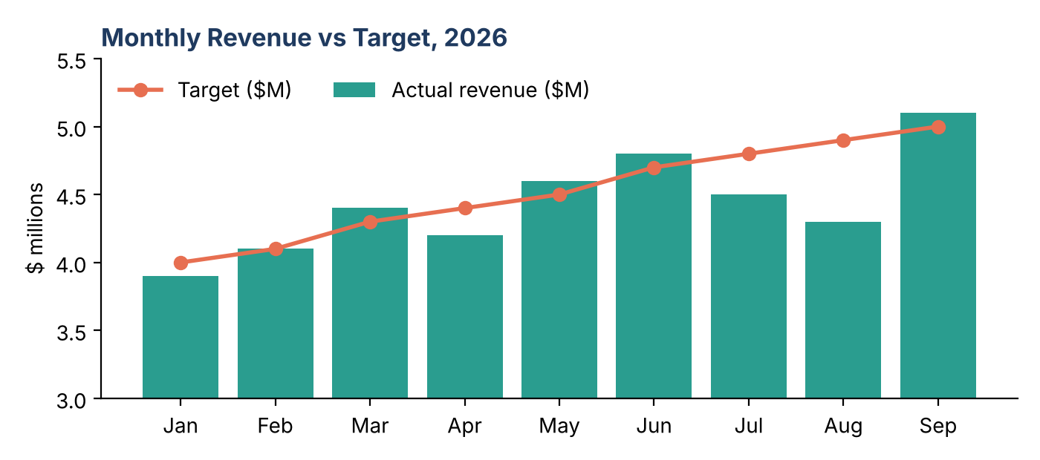
Figure 1. Monthly revenue against target. September was the strongest month of the year.

3. Regional Performance
Four of five regions grew quarter on quarter. The West led with 12.4% growth, driven by the launch of the Pacific Direct programme in August. The Southwest is the only region in decline.
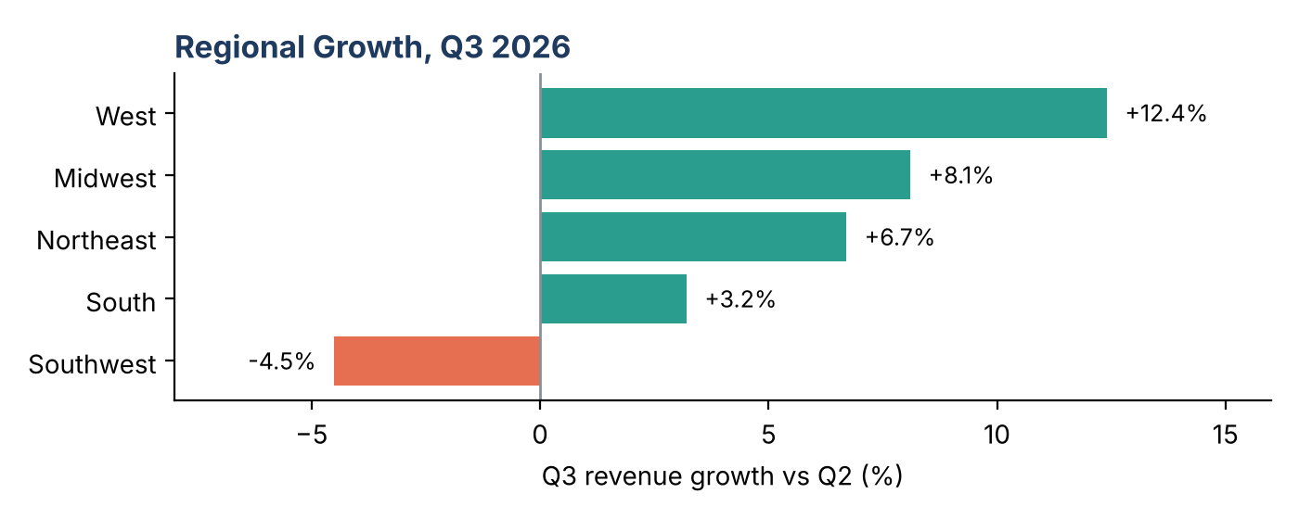
Figure 2. Q3 revenue growth by region versus Q2.

4. Highlights
- Pacific Direct launch: 148 new accounts signed in six weeks, contributing $0.9M in Q3 revenue.
- Supplier savings: renegotiated contracts cut unit costs by 3.8%, worth about $0.4M per quarter.
- Delivery performance: on-time delivery reached 96.2%, the highest in company history.
- Team growth: hired 14 staff, mostly in sales and customer success.

5. Challenges and Risks
- Southwest decline: revenue fell 4.5% after Desert Freight Ltd. and Mesa Wholesale ended their contracts, together worth $0.6M per quarter.
- Rising churn: churn increased from 2.4% to 2.9%. Exit surveys cite slower support response times (average 9.1 hours versus a 6 hour target).
- Cost pressure: operating expenses grew 5.2% on higher headcount and a 7% rise in freight costs.

6. Q4 Outlook and Targets
Management expects Q4 revenue of $14.8M, supported by the seasonal peak in October and November and the full-quarter effect of Pacific Direct. The following targets have been set:
- Revenue: $14.8M (+6.5% on Q3).
- Churn: reduce to 2.5% or below by 31 December.
- Support response time: cut to 6 hours through two new support hires and a revised ticket triage process.
- Southwest recovery: win back or replace $0.3M of lost quarterly revenue.

7. Decisions Needed and Next Steps
Approval required by 24 October: a $120,000 budget to fund the Southwest recovery plan, covering a regional account manager and a targeted promotion for 60 dormant accounts.
Owners and dates:
- Maria Chen, VP Sales: submit the Southwest recovery plan by 17 October.
- David Okafor, Head of Support: present the support staffing proposal by 20 October.
- Priya Raman, CFO: confirm the Q4 budget reforecast by 31 October.

8. Appendix: Contacts
Questions on this report can be directed to Priya Raman (CFO, priya.raman@northwind-example.com) or Maria Chen (VP Sales, maria.chen@northwind-example.com).

