FINANCE & CREDIT RISK
Loan Portfolio Analysis, Credit Risk Assessment, and Loan Approval Performance Report
Management report based solely on the current loan application workbook

Report attribute | Detail
Prepared for | Finance Manager, Credit Risk Manager, Loan Operations Manager and Senior Management
Report date | 10 October 2026
Source | data_bank_loan.xlsx
Population analysed | 614 application records
Classification | Confidential – aggregated management information

Table of Contents
This document uses Word heading styles. In Microsoft Word, right-click the table of contents below and select Update Field if page references are not displayed automatically.

1. Executive Summary
This report analyses 614 loan applications to describe approval performance, applicant financial profiles, data quality and potential underwriting review areas. Loan_Status is treated strictly as the application decision, not as evidence of an outstanding loan, repayment, delinquency or default.
Metric | Observed result
Applications | 614
Approved | 422 (68.7%)
Rejected | 192 (31.3%)
Unique Loan_ID | 614
Duplicate Loan_ID | 0
Average ApplicantIncome | 5,403.5
Average LoanAmount | 146.4
Observed facts: approval was 79.6% for recorded Credit_History = 1 and 7.9% for Credit_History = 0. Semiurban recorded the highest property-area approval rate at 76.8%.
Interpretation: credit history is the clearest observed separator of application outcomes. This is association, not causation, and the workbook does not contain policy rules or underwriting reasons.
Recommended action: prioritise mandatory-field controls, investigate structurally incomplete records, monitor approval rates with minimum sample thresholds, and link future reporting to repayment and processing data.
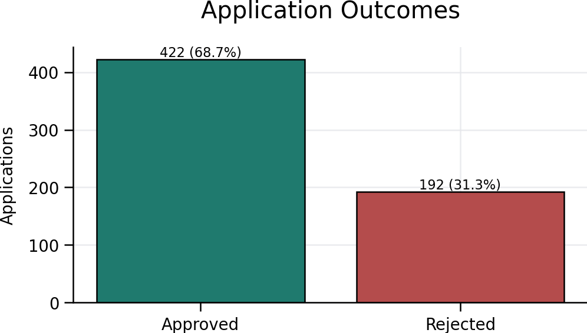
Figure 1. Application outcomes
Interpretation: The dataset records a higher number of approvals than rejections; this describes decisions only, not subsequent performance.

2. Dataset Overview and Data Quality
The dataset contains applicant demographics, reported income, requested loan amount and term, credit-history indicator, property area, application outcome and a Risk_Category field. No unit documentation was found in the workbook; therefore monetary fields are reported as dataset units.
Field | Missing values | Missing %
Loan_ID | 0 | 0.0%
Gender | 13 | 2.1%
Married | 3 | 0.5%
Dependents | 15 | 2.4%
Education | 0 | 0.0%
Self_Employed | 32 | 5.2%
ApplicantIncome | 0 | 0.0%
CoapplicantIncome | 0 | 0.0%
LoanAmount | 22 | 3.6%
Loan_Amount_Term | 14 | 2.3%
Credit_History | 50 | 8.1%
Property_Area | 0 | 0.0%
Loan_Status | 0 | 0.0%
Risk_Category | 0 | 0.0%
Issue | Affected field | Potential impact | Recommended corrective action
Missing values | Multiple fields including LoanAmount, Credit_History and demographics | Biased denominators; incomplete underwriting evidence | Validate source, retain missing flag, and complete before final decisions
Structurally shifted/incomplete rows | Records with blank intermediate fields | Values may appear under wrong conceptual field if imported positionally | Reconcile against source form and enforce schema validation
Dependents category | Dependents includes 3+ | Represents an open-ended band, not exact count | Keep as categorical 3+ unless exact value is collected
Unusual numerical values | Income, LoanAmount and term extremes; term values including 0 or 1 | May reflect valid cases, unit issues or keying errors | Perform range and unit checks; do not auto-delete
Undocumented units | Income and LoanAmount | Prevents currency and definitive affordability interpretation | Add data dictionary with unit and reporting period
Outcome-derived Risk_Category | Risk_Category appears related to status/credit fields | May create circular reporting if treated as independent risk result | Document derivation and exclude from predictive claims
Duplicate testing identified 0 repeated Loan_ID values. Unique IDs total 614 against 614 rows. Missing values were excluded only from calculations requiring that field; no missing value was imputed and no application was assumed rejected because information was missing.
Sufficiency assessment: the workbook is adequate for descriptive approval-pattern analysis, but insufficient for comprehensive credit risk, loss, profitability or affordability assessment.

3. Loan Application Portfolio Overview

Education distribution
Education | Applications | Share of all applications
Graduate | 480 | 78.2%
Not Graduate | 134 | 21.8%

Marital status distribution
Marital status | Applications | Share of all applications
No | 213 | 34.7%
Yes | 398 | 64.8%
Missing | 3 | 0.5%

Gender distribution
Gender | Applications | Share of all applications
Female | 112 | 18.2%
Male | 489 | 79.6%
Missing | 13 | 2.1%

Self-employment distribution
Self-employment | Applications | Share of all applications
No | 500 | 81.4%
Yes | 82 | 13.4%
Missing | 32 | 5.2%

Property area distribution
Property area | Applications | Share of all applications
Rural | 179 | 29.2%
Semiurban | 233 | 37.9%
Urban | 202 | 32.9%

Credit history distribution
Credit history | Applications | Share of all applications
0.0 | 89 | 14.5%
1.0 | 475 | 77.4%
Missing | 50 | 8.1%
Field | Valid n | Mean | Median | Minimum | Maximum
ApplicantIncome | 614 | 5,403.5 | 3,812.5 | 150.0 | 81,000.0
CoapplicantIncome | 614 | 1,621.2 | 1,188.5 | 0.0 | 41,667.0
CombinedIncome | 614 | 7,024.7 | 5,416.5 | 1,442.0 | 81,000.0
LoanAmount | 592 | 146.4 | 128.0 | 9.0 | 700.0
Loan_Amount_Term | 600 | 342.0 | 360.0 | 12.0 | 480.0
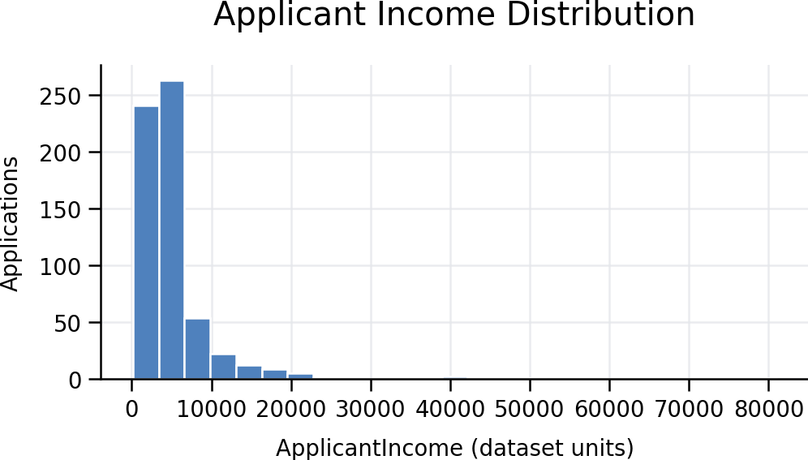
Figure 2. Applicant income distribution
Interpretation: The distribution is right-skewed; a small number of high reported values raise the mean above the median.

4. Loan Approval and Rejection Analysis

Credit history
Credit history | Applications | Approved | Rejected | Approval rate | Rejection rate | Caution
0.0 | 89 | 7 | 82 | 7.9% | 92.1%
1.0 | 475 | 378 | 97 | 79.6% | 20.4%
Missing | 50 | 37 | 13 | 74.0% | 26.0%

Property area
Property area | Applications | Approved | Rejected | Approval rate | Rejection rate | Caution
Rural | 179 | 110 | 69 | 61.5% | 38.5%
Semiurban | 233 | 179 | 54 | 76.8% | 23.2%
Urban | 202 | 133 | 69 | 65.8% | 34.2%

Education
Education | Applications | Approved | Rejected | Approval rate | Rejection rate | Caution
Graduate | 480 | 340 | 140 | 70.8% | 29.2%
Not Graduate | 134 | 82 | 52 | 61.2% | 38.8%

Applicant income quartiles
Applicant income quartiles | Applications | Approved | Rejected | Approval rate | Rejection rate | Caution
Q1 (Lowest) | 154 | 106 | 48 | 68.8% | 31.2%
Q2 | 153 | 105 | 48 | 68.6% | 31.4%
Q3 | 153 | 106 | 47 | 69.3% | 30.7%
Q4 (Highest) | 154 | 105 | 49 | 68.2% | 31.8%

Combined income quartiles
Combined income quartiles | Applications | Approved | Rejected | Approval rate | Rejection rate | Caution
Q1 (Lowest) | 155 | 105 | 50 | 67.7% | 32.3%
Q2 | 152 | 104 | 48 | 68.4% | 31.6%
Q3 | 153 | 109 | 44 | 71.2% | 28.8%
Q4 (Highest) | 154 | 104 | 50 | 67.5% | 32.5%

Self-employment
Self-employment | Applications | Approved | Rejected | Approval rate | Rejection rate | Caution
No | 500 | 343 | 157 | 68.6% | 31.4%
Yes | 82 | 56 | 26 | 68.3% | 31.7%
Missing | 32 | 23 | 9 | 71.9% | 28.1%

Loan amount quartiles
Loan amount quartiles | Applications | Approved | Rejected | Approval rate | Rejection rate | Caution
Q1 (Lowest) | 154 | 107 | 47 | 69.5% | 30.5%
Q2 | 152 | 109 | 43 | 71.7% | 28.3%
Q3 | 140 | 101 | 39 | 72.1% | 27.9%
Q4 (Highest) | 146 | 94 | 52 | 64.4% | 35.6%
Missing | 22 | 11 | 11 | 50.0% | 50.0% | Small sample

Loan term
Loan term | Applications | Approved | Rejected | Approval rate | Rejection rate | Caution
12.0 | 1 | 1 | 0 | 100.0% | 0.0% | Small sample
36.0 | 2 | 0 | 2 | 0.0% | 100.0% | Small sample
60.0 | 2 | 2 | 0 | 100.0% | 0.0% | Small sample
84.0 | 4 | 3 | 1 | 75.0% | 25.0% | Small sample
120.0 | 3 | 3 | 0 | 100.0% | 0.0% | Small sample
180.0 | 44 | 29 | 15 | 65.9% | 34.1%
240.0 | 4 | 3 | 1 | 75.0% | 25.0% | Small sample
300.0 | 13 | 8 | 5 | 61.5% | 38.5% | Small sample
360.0 | 512 | 359 | 153 | 70.1% | 29.9%
480.0 | 15 | 6 | 9 | 40.0% | 60.0% | Small sample
Missing | 14 | 8 | 6 | 57.1% | 42.9% | Small sample
Quartile bands are data-driven and contain approximately equal numbers of valid observations. Comparisons are descriptive. Demographic attributes are not presented as causal drivers and should not be used to label individuals as risky.
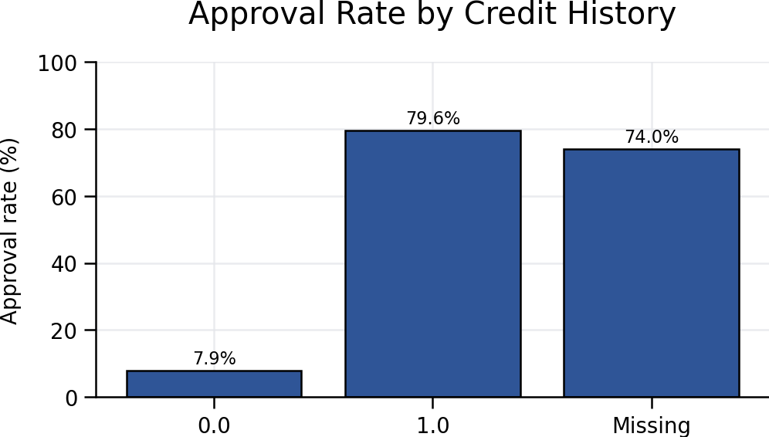
Figure 3. Approval rate by credit history
Interpretation: Recorded credit history shows a substantial outcome difference. Missing credit history remains a separate category and should not be inferred as good or poor.
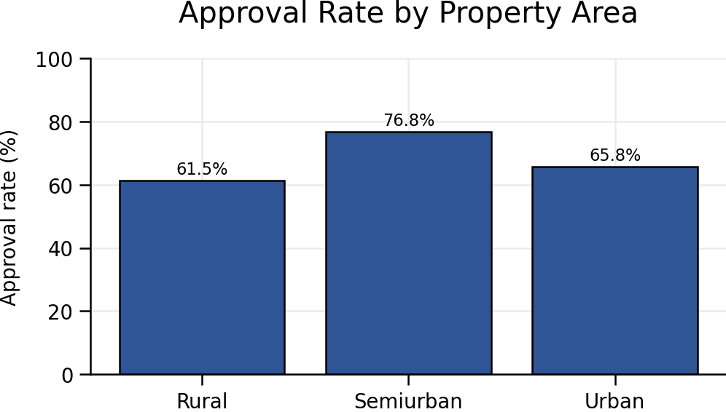
Figure 4. Approval rate by property area
Interpretation: Semiurban applications show the highest observed approval rate, but this does not establish that location causes approval.
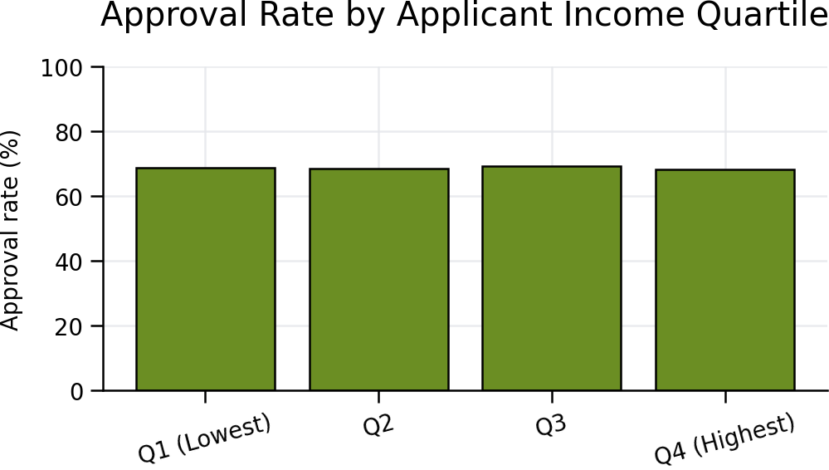
Figure 5. Approval rate by applicant-income quartile
Interpretation: Approval rates vary across income quartiles, but income alone is not a complete affordability or creditworthiness measure.

5. Income, Loan Amount, and Repayment Affordability
ApplicantIncome averages 5,403.5 with median 3,812.5; CoapplicantIncome averages 1,621.2; CombinedIncome averages 7,024.7. LoanAmount averages 146.4 and has median 128.0, all in undocumented dataset units.
Outcome | Valid n | Average LoanAmount | Median LoanAmount
Rejected | 181 | 151.2 | 129.0
Approved | 411 | 144.3 | 126.0
Outlier screen: using the conventional 1.5 × IQR rule, the upper threshold is 270.0 dataset units and 39 valid LoanAmount observations exceed it. These are review flags, not errors.
Loan-to-income index = LoanAmount ÷ (ApplicantIncome + CoapplicantIncome). It was calculable for 592 records; median 0.0241. Because amount and income units/periods are undocumented, this index is only a relative screening indicator and is not a debt-service ratio.
The workbook lacks interest rates, instalments, living expenses, existing debts and verified repayment histories. Consequently, definitive affordability, debt-service coverage and repayment capacity cannot be assessed.
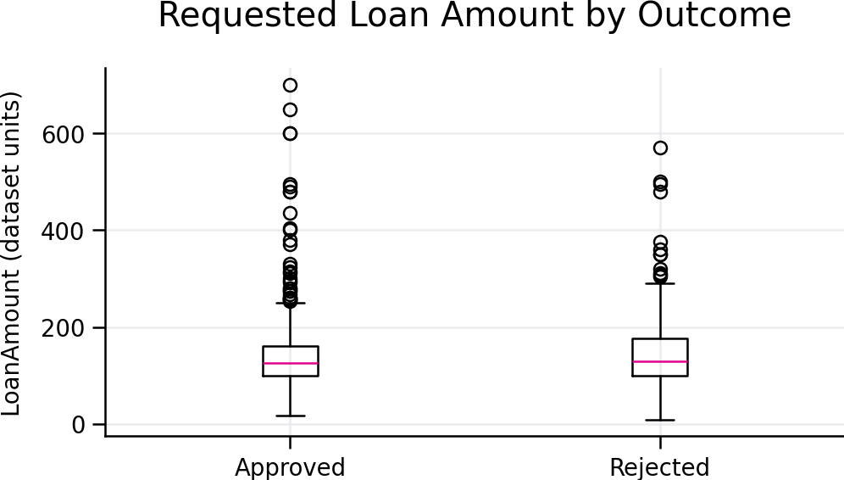
Figure 6. Requested loan amount by application outcome
Interpretation: The chart compares distributions and outliers by decision; differences should not be interpreted as causal.

6. Credit Risk Assessment
Credit_History has the strongest observed association with Loan_Status. However, rejection is not evidence of default. The dataset contains no defaults, delinquencies, recoveries, exposure at default or loss-given-default observations.
Income and loan-amount groups show differences in approval rates, but they do not capture verified expenses, existing debt, collateral quality or policy exceptions. Missing and potentially shifted values may materially affect underwriting analysis.
Fair-lending principle: gender, marital status, education and similar demographic characteristics are reported only for monitoring. They should not be used to label an individual as risky without a lawful, documented and evidence-based lending framework.

7. Financial and Operational Implications
• Introduce mandatory-field and schema controls at application capture.
• Create approval-rate monitoring by credit history, property area and financial bands with sample-size warnings.
• Track processing timestamps and reason codes to identify operational bottlenecks.
• Standardise units, definitions and missing-value conventions for Finance reporting.
• Develop outcome-to-performance linkage once disbursement and repayment data are available.
Lost revenue, profitability, expected credit loss and regulatory capital cannot be estimated. These require, at minimum, pricing, disbursement, exposure, probability of default, loss-given-default, recovery, cost and historical performance data.

8. Key Performance Indicators (KPIs)
KPI | Definition or Formula | Calculated Value | Business Interpretation | Limitation
Total applications | Count of rows | 614 | Application workload represented | Not unique customers
Approval rate | Approved ÷ all applications | 68.7% | Decision conversion indicator | Not disbursement rate
Rejection rate | Rejected ÷ all applications | 31.3% | Non-approval share | Not default rate
Dataset missing-cell rate | Missing cells ÷ cells in original 14 fields | 1.7% | Overall completeness signal | Can mask field-level concentration
Average applicant income | Mean ApplicantIncome | 5,403.5 | Reported applicant financial profile | Unit/period undocumented
Average combined income | Mean (Applicant + Coapplicant) | 7,024.7 | Household-income proxy | Reported, not verified
Average requested loan amount | Mean LoanAmount | 146.4 | Average request size | Unit undocumented
Median requested loan amount | Median LoanAmount | 128.0 | Typical request less affected by extremes | Missing values excluded
Average loan amount – Rejected | Mean LoanAmount for outcome | 151.2 | Requested size by decision | No causal conclusion
Average loan amount – Approved | Mean LoanAmount for outcome | 144.3 | Requested size by decision | No causal conclusion
Approval rate – Credit_History 0.0 | Approved ÷ group applications | 7.9% | Credit-history outcome monitoring | n=89
Approval rate – Credit_History 1.0 | Approved ÷ group applications | 79.6% | Credit-history outcome monitoring | n=475
Approval rate – Credit_History Missing | Approved ÷ group applications | 74.0% | Credit-history outcome monitoring | n=50
Approval rate – Rural | Approved ÷ area applications | 61.5% | Geographic outcome monitoring | n=179; association only
Approval rate – Semiurban | Approved ÷ area applications | 76.8% | Geographic outcome monitoring | n=233; association only
Approval rate – Urban | Approved ÷ area applications | 65.8% | Geographic outcome monitoring | n=202; association only

9. Management Recommendations and Action Plan
Priority | Recommended action | Business justification | Responsible role | Timeframe | Success indicator
High | Reconcile incomplete/shifted records and enforce schema validation | Observed blanks and positional inconsistencies can distort metrics | Loan Operations + Data Management | 0–30 days | ≥99% mandatory-field completeness
High | Document units and field definitions | Income and loan units are not confirmed | Finance Data Owner | 0–30 days | Approved data dictionary issued
High | Require reason codes for decisions | Outcome alone does not explain underwriting judgement | Credit Risk + Operations | 30–60 days | ≥95% decisions with valid reason code
High | Link applications to disbursement and repayment performance | Current file cannot measure default or loss | Credit Risk + IT | 60–120 days | Monthly performance-linked dataset
Medium | Implement approval monitoring with minimum n thresholds | Group differences need controlled interpretation | Finance MI | 30–60 days | Dashboard includes n, missingness and alerts
Medium | Build a verified affordability assessment | Current ratio lacks instalments, debts and expenses | Credit Policy | 60–120 days | Documented affordability methodology
Medium | Capture processing timestamps | No turnaround or bottleneck analysis is possible | Loan Operations | 30–90 days | ≥95% applications with stage timestamps
Low | Perform periodic fair-lending outcome review | Demographic outcome patterns require responsible monitoring | Compliance + Credit Risk | Quarterly | Documented review and remediation log

10. Additional Data Required
Additional data | Future metrics enabled
Historical repayment performance | Vintage curves, roll rates and realised default rates
Delinquency/default records | PD estimation and arrears monitoring
Interest rates and schedules | Instalments, yield and debt-service measures
Existing debt and verified expenses | Debt-to-income and residual-income affordability
Processing dates | Turnaround time and bottleneck analysis
Disbursed amounts and balances | Exposure and utilisation measures
Recoveries and collection costs | LGD, net recovery and collection efficiency
Larger historical samples | Stable segmentation and back-testing

11. Conclusion
The workbook contains 614 applications, of which 422 were approved and 192 rejected. Credit history and property area show notable differences in approval outcomes, while reported financial values are skewed and include review-worthy extremes. These are descriptive patterns only.
Management should first improve data definitions, completeness and reason-code capture, then develop linked application, disbursement, repayment and loss datasets. Until those controls and data are available, the workbook should not be used for definitive default-risk, affordability, profitability or capital conclusions.

12. Appendix

12.1 Data dictionary
Field | Definition / treatment
Loan_ID | Application identifier
Gender, Married, Dependents, Education, Self_Employed | Applicant profile fields; missingness retained
ApplicantIncome | Reported applicant income; unit/period undocumented
CoapplicantIncome | Reported co-applicant income; unit/period undocumented
LoanAmount | Requested amount; unit undocumented
Loan_Amount_Term | Reported term, apparently numeric; workbook documentation absent
Credit_History | Recorded indicator: 1, 0 or missing
Property_Area | Urban, Semiurban or Rural
Loan_Status | Application decision: Y approved, N rejected
Risk_Category | Workbook-supplied category; derivation not documented
CombinedIncome | Calculated: ApplicantIncome + CoapplicantIncome
Loan-to-income index | Calculated: LoanAmount ÷ CombinedIncome; relative index only

12.2 Formula definitions
• Approval rate = approved applications in group ÷ all applications in group.
• Rejection rate = rejected applications in group ÷ all applications in group.
• CombinedIncome = ApplicantIncome + CoapplicantIncome.
• Loan-to-income index = LoanAmount ÷ CombinedIncome for complete, positive-income records.
• Outlier upper threshold = third quartile + 1.5 × interquartile range.
• Missing percentage = missing observations ÷ total application records for the field.

12.3 Assumptions and limitations
No monetary unit, income period or term unit was assumed. Missing values were excluded pairwise and were not imputed. Quartile bands were calculated from valid observations. Small groups with fewer than 30 applications were flagged. Applicant-level details were not reproduced in this report. The analysis is cross-sectional and contains no external data.

