Customer Spending Analysis (PURCHASES, ONEOFF_PURCHASES, INSTALLMENTS_PURCHASES, PURCHASES_TRX)
Generated Visualization
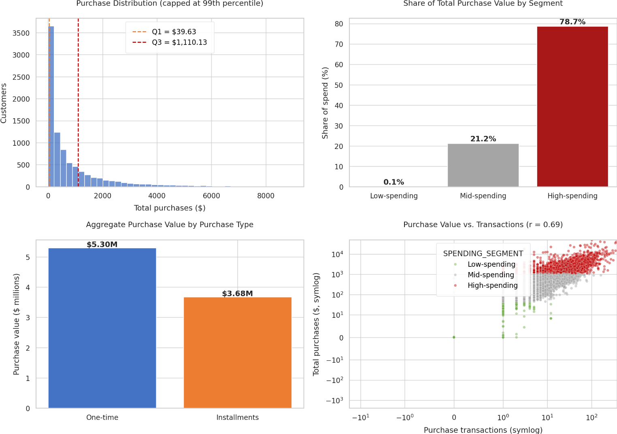

Customer Segmentation
Customers were segmented using purchase quartiles:
- Low-spending: PURCHASES ≤ 39.64
- Mid-spending: 39.64 < PURCHASES < 1,110.13
- High-spending: PURCHASES ≥ 1,110.13
Segment | Customers | Avg Purchases | Median Purchases | Avg Transactions | Share of Total Spend
Low-spending | 2,238 | 2.03 | 0.00 | 0.15 | 0.05%
Mid-spending | 4,474 | 426.36 | 361.28 | 9.64 | 21.25%
High-spending | 2,238 | 3,157.55 | 2,160.45 | 39.41 | 78.70%

Key Insights: High vs Low Spending Customers
High-Spending Customers
- Represent only 25% of customers but contribute 78.7% of total purchase value.
- Average spending is $3,157.55, nearly 7× higher than mid-spending customers.
- Average of 39 purchase transactions, indicating both higher frequency and higher value purchases.
- Strong candidates for:
  - Loyalty programs
  - Premium offers
  - Retention campaigns
  - Cross-selling initiatives
Low-Spending Customers
- Also represent 25% of the customer base.
- Contribute only 0.05% of total spending.
- Median purchase amount = 0, suggesting many inactive customers.
- Average transactions = 0.15, indicating almost no purchasing activity.
Inactive Customers
- 2,044 customers (22.8%) made zero purchases.
- These customers should be targeted separately through reactivation campaigns.

One-Time Purchases vs Installment Purchases
Aggregate Purchase Value
Purchase Type | Total Value
One-time Purchases | $5.30M
Installment Purchases | $3.68M
Distribution
- One-time purchases: 59%
- Installment purchases: 41%
Customer Preference
Dominant Type | Customers
One-time dominant | 3,498
Installment dominant | 3,410
Equal / No Purchases | 2,042
Insights
- One-time purchases generate approximately 44% more value than installment purchases.
- Customer preference is fairly balanced between one-time and installment spending.
- Installment shoppers still represent a significant revenue segment and may respond well to financing-related promotions.

Transaction Behavior
The correlation between PURCHASES and PURCHASES_TRX is:
Correlation = 0.69
This indicates a strong positive relationship:
- Customers who make more transactions generally spend more.
- Increasing transaction frequency can be a key driver of revenue growth.

Top 10 Highest-Spending Customers
Customer ID | Purchases
C10574 | 49,039.57
C10523 | 41,050.40
C11300 | 40,040.71
C11657 | 38,902.71
C14048 | 35,131.16
C10284 | 32,539.78
C11695 | 31,299.35
C10611 | 27,957.68
C13802 | 27,790.42
C17237 | 26,784.62

Business Recommendations
1. Retain High-Value Customers
High spenders contribute nearly 80% of revenue. Focus on:
- VIP programs
- Personalized rewards
- Priority service
2. Increase Transaction Frequency
Since spending and transactions are strongly linked (r = 0.69):
- Encourage repeat purchases
- Offer bundles and loyalty points
- Launch targeted promotions
3. Grow Installment Revenue
Installment purchases account for 41% of spending:
- Promote financing options
- Offer installment-specific incentives
4. Reactivate Dormant Customers
With over 2,000 zero-purchase customers, targeted re-engagement campaigns could unlock additional revenue.
Downloadable Output
- Customer-level segmentation file: customer_spending_segments.csv
The dashboard chart contains:
- Purchase distribution with high/low spending thresholds.
- Spending contribution by segment.
- One-time vs installment purchase totals.
- Relationship between transaction count and purchase value.

