Cash Advance vs Purchase Behavior Analysis
Dashboard
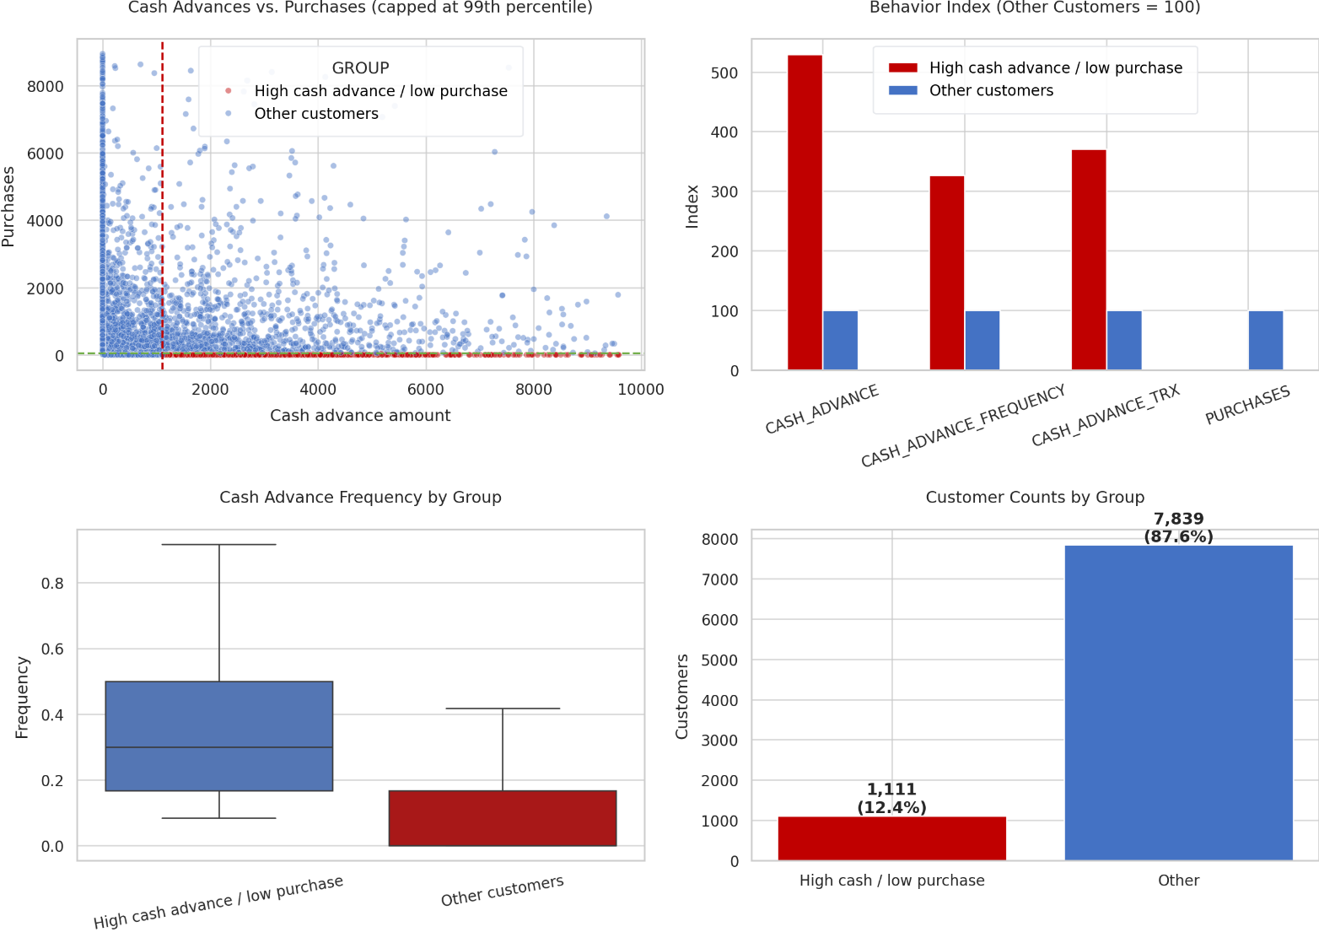

The dashboard includes:
- Cash Advance vs Purchases Scatter Plot
  - Clearly shows customers taking large cash advances while making very few purchases.
  - Red quadrant (high cash advance / low purchases) highlights the target segment.
- Behavior Index Chart
  - Compares target customers against the rest of the portfolio.
  - Easy to present in management reviews.
- Cash Advance Frequency Distribution
  - Shows how frequently the target group uses cash advances compared to others.
- Customer Count Chart
  - Quantifies the size of the segment and its share of the portfolio.

Identifying High Cash Advance / Low Purchase Customers
Thresholds used:
- High CASH_ADVANCE: ≥ 1,113.82 (75th percentile)
- Low PURCHASES: ≤ 39.64 (25th percentile)
Result:
- 1,111 customers
- 12.4% of the customer base

Comparison with Other Customers
Metric | High Cash Advance / Low Purchase | Others
Customers | 1,111 | 7,839
Avg Cash Advance | 3,379.31 | 638.66
Median Cash Advance | 2,548.84 | 0.00
Avg Cash Advance Frequency | 0.34 | 0.11
Avg Cash Advance Transactions | 9.01 | 2.43
Avg Purchases | 0.41 | 1,145.33
Median Purchases | 0.00 | 477.70
Key Insights
Cash Advances are Significantly Higher
The identified group:
- Takes 5.3× more cash advances
- Uses cash advances 3× more frequently
- Performs 3.7× more cash advance transactions
Purchases are Nearly Non-Existent
- Average purchases = 0.41
- Median purchases = 0
This suggests many customers use the card primarily as a source of cash, not for spending.

Relationship Between Variables
Correlation | Value
CASH_ADVANCE ↔ CASH_ADVANCE_TRX | 0.66
CASH_ADVANCE ↔ CASH_ADVANCE_FREQUENCY | 0.63
CASH_ADVANCE ↔ PURCHASES | -0.05
CASH_ADVANCE_FREQUENCY ↔ PURCHASES | -0.12
Interpretation
- Customers taking more cash advances tend to do so more frequently and through more transactions.
- Purchase activity is essentially unrelated to cash advance usage.
- This appears to be a distinct behavioral segment rather than simply heavy card users.

Questions a Bank Analyst Should Investigate
Credit Risk
- Do these customers have higher delinquency rates?
- Are they paying only the minimum due?
- Is revolving balance increasing over time?
- Are they approaching credit limits more often?
Financial Stress Indicators
- Are cash advances clustered before salary dates?
- Has cash advance activity suddenly increased?
- Are these customers experiencing liquidity shortages?
Profitability
- What interest income and fee income do they generate?
- Are charge-offs higher than fee revenue?
- Is this segment profitable after risk costs?
Customer Behavior
- Why are purchases almost zero?
- Are cards being used as emergency funding tools?
- Are they using multiple cards similarly?
- Are there geographic or demographic patterns?
Product Strategy
- Would installment loans be a better product?
- Should proactive counseling or alerts be offered?
- Can risk models use cash advance frequency as an early warning signal?

Most Important Executive Insight
12.4% of customers exhibit a "cash-only" behavior pattern.
These customers:
- Generate very little purchase activity.
- Rely heavily on cash advances.
- Use cash advances more frequently and more often than the rest of the portfolio.
This segment should be monitored because it may indicate:
- Financial stress
- Higher future delinquency risk
- Different product needs than standard credit card customers
Download Files
- Cash Advance Customer List
- Cash Advance Dashboard
For a bank presentation, I would additionally recommend a 4-quadrant customer segmentation matrix (High/Low Purchases vs High/Low Cash Advances) because it is usually the most intuitive chart for executives and risk committees.

