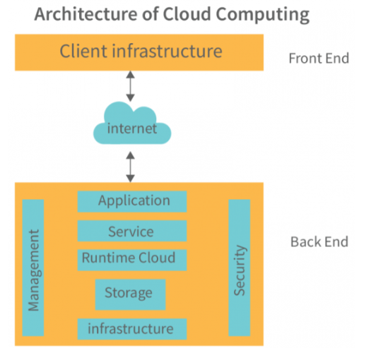

Cloud Computing: Advantages and Disadvantages
Advantages
Cost Efficiency Cloud computing eliminates the need for large upfront investments in hardware and infrastructure. You pay only for what you use, converting capital expenses into operational expenses. This is particularly beneficial for startups and small businesses that can't afford expensive IT infrastructure.
Scalability and Flexibility Resources can be scaled up or down instantly based on demand. During peak times, you can add more computing power, and during slower periods, you can scale back. This elasticity ensures you're never paying for unused capacity.
Accessibility and Remote Work Access your data and applications from anywhere with an internet connection. This enables remote work, collaboration across different locations, and business continuity regardless of physical office availability.
Automatic Updates and Maintenance Cloud providers handle software updates, security patches, and infrastructure maintenance. This reduces the burden on your IT team and ensures you're always running the latest versions.
Disaster Recovery and Backup Cloud providers typically offer robust backup solutions and disaster recovery capabilities. Your data is stored across multiple locations, making it much easier to recover from hardware failures or disasters.
Collaboration Teams can work on the same documents and projects simultaneously, with changes syncing in real-time. This improves productivity and reduces version control issues.
Disadvantages
Internet Dependency Cloud services require a reliable internet connection. If your connection is slow or goes down, you lose access to your applications and data, which can halt business operations.
Security and Privacy Concerns While cloud providers invest heavily in security, storing sensitive data on third-party servers introduces risks. You're trusting another organization with your data, and potential breaches or unauthorized access remain concerns.
Limited Control You depend on your cloud provider's infrastructure and policies. You have less control over the underlying hardware, security measures, and system configurations compared to on-premises solutions.
Ongoing Costs While cloud computing reduces upfront costs, the subscription model means ongoing monthly or yearly expenses. Over time, these costs can accumulate and potentially exceed the cost of maintaining your own infrastructure.
Vendor Lock-in Migrating from one cloud provider to another can be complex and expensive. Proprietary technologies and formats may make it difficult to switch providers or move back to on-premises infrastructure.
Compliance Challenges Certain industries have strict regulations about data storage and handling. Ensuring your cloud provider meets all compliance requirements (like GDPR, HIPAA) can be challenging, especially when data is stored across multiple geographic locations.
Performance Variability Performance can be affected by factors outside your control, such as the provider's infrastructure issues, network congestion, or shared resource allocation in multi-tenant environments.

The choice between cloud and on-premises solutions depends on your specific needs, budget, security requirements, and technical capabilities. Many organizations adopt a hybrid approach, keeping sensitive data on-premises while leveraging the cloud for other workloads.

