What is Virtualization?
Virtualization is the process of creating a virtual version of resources (like servers, storage, or networks) instead of using physical hardware directly.
In simple words: It allows one physical machine to run multiple virtual machines (VMs), each acting like an independent computer.
In virtualization, the job of hypervisor is essential, which it communicates with the equipment to make a few virtual machines from it. These virtual machines working is independent and doesn't interfere with one another.

How it Works
- At the core is a hypervisor (software layer).
- The hypervisor sits between the hardware and the operating systems.
- It divides physical resources (CPU, RAM, storage, network) and allocates them to multiple VMs.
- Each VM can run its own OS and applications independently.
Virtualization is hypervisor based. A hypervisor separates the operating system and applications from the underlying computer hardware so that the host computer can run multiple virtual machines as guests and share physical resources such as network processor, memory space, and network bandwidth. A hypervisor allocates memory or storage services and distributes some of these services to each virtual machine according to the needs of the virtualization architecture.
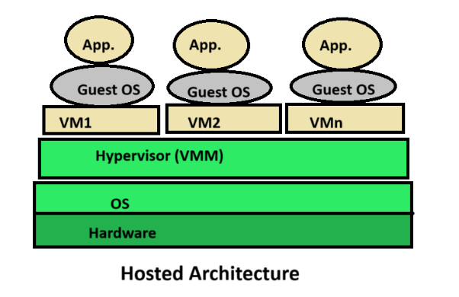

Types of Virtualization in Cloud Computing
- Server Virtualization → Splits one physical server into many virtual servers.
Example: Multiple clients sharing the same AWS server.
- Storage Virtualization → Combines many storage devices into a single virtual storage pool.
- Network Virtualization → Creates virtual networks that run on top of the physical network.
- Desktop Virtualization → Provides virtual desktops to users (e.g., Virtual Desktop Infrastructure).
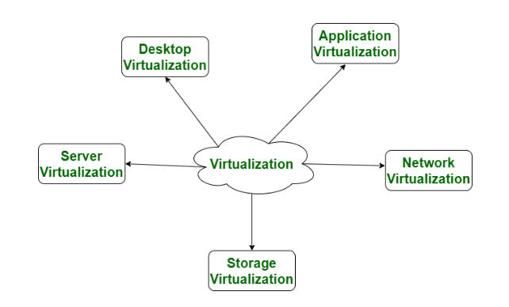

Role in Cloud Computing
- Resource pooling → Multiple customers share the same physical hardware securely.
- Cost efficiency → No need for each customer to buy their own hardware.
- Scalability → Providers can quickly spin up new virtual machines for customers.
- Isolation → Each VM is independent, so one user’s activity doesn’t affect others.

Real-Life Example
- Amazon Web Services (AWS EC2) → When you rent a "virtual server" on AWS, you are actually getting a virtual machine created through virtualization.
- Google Cloud & Azure work the same way.

In short:
Virtualization is the foundation of cloud computing. It makes it possible for cloud providers to maximize hardware usage, offer on-demand resources, and keep everything cost-effective and scalable.

Difference between Virtualization and Cloud Computing

Virtualization vs Cloud Computing
1. Definition
- Virtualization → A technology that creates virtual versions of hardware (servers, storage, networks).
- Cloud Computing → A service model that delivers computing resources (servers, storage, apps, etc.) over the internet, often using virtualization as the backbone.
2. Scope
- Virtualization = About hardware/resource efficiency (splitting one machine into many virtual ones).
- Cloud Computing = About delivering IT services (IaaS, PaaS, SaaS) to end users.

3. Dependency
- Virtualization can exist without cloud computing.
Example: A company sets up VMware on its local servers to run multiple VMs.
- Cloud computing usually depends on virtualization.
Example: AWS uses virtualization to provide virtual servers to customers.

4. User Perspective
- Virtualization is mostly backend technology (used by system admins, IT infra teams).
- Cloud Computing is end-user oriented (anyone can consume cloud services like Gmail, AWS, Dropbox).

5. Examples
- Virtualization: VMware, Oracle VirtualBox, Microsoft Hyper-V.
- Cloud Computing: Amazon Web Services (AWS), Google Cloud Platform, Microsoft Azure.

S.NO | Cloud Computing | Virtualization
1. | Cloud computing is used to provide pools and automated resources that can be accessed on-demand. | While It is used to make various simulated environments through a physical hardware system.
2. | Cloud computing setup is tedious, complicated. | While virtualization setup is simple as compared to cloud computing.
3. | Cloud computing is high scalable. | While virtualization is low scalable compared to cloud computing.
4. | Cloud computing is Very flexible. | While virtualization is less flexible than cloud computing.
5. | In the condition of disaster recovery, cloud computing relies on multiple machines. | While it relies on single peripheral device.
6. | In cloud computing, the workload is stateless. | In virtualization, the workload is stateful.
7. | The total cost of cloud computing is higher than virtualization. | The total cost of virtualization is lower than Cloud Computing.
8. | Cloud computing requires many dedicated hardware. | While single dedicated hardware can do a great job in it.
9. | Cloud computing provides unlimited storage space. | While storage space depends on physical server capacity in virtualization.
10. | Cloud computing is of two types : Public cloud and Private cloud. | Virtualization is of two types : Hardware virtualization and Application virtualization.
11. | In Cloud Computing, Configuration is image based. | In Virtualization, Configuration is template based.
12. | In cloud computing, we utilize the entire server capacity and the entire servers are consolidated. | In Virtualization, the entire servers are on-demand.
13. | In cloud computing, the pricing pay as you go model, and consumption is the metric on which billing is done. | In Virtualization, the pricing is totally dependent on infrastructure costs.

