Google data collection

Source: https://www.bennettinstitute.cam.ac.uk/blog/using-google-data-policy-research/

We tell google “things we might not tell our partners, our friends, our family…even our doctor”. We are sharing life’s most significant and intense moments.

Type in search bar : “Today I want to l” and see what what auto completion suggests.

Search data has been used to predict the spread of the Mayaro virus, identify seasonal patterns in domestic violence, etc.

Use search data to discover mismatches between how consumers articulated demand for its products and how it had listed them on its website. Simple changes like re-naming “outdoor lighting” to “security lighting”, and “nailers” to “nail guns” resulted in a ten-fold increase in online sales from Google search.

Google search data were used to predict who will win.

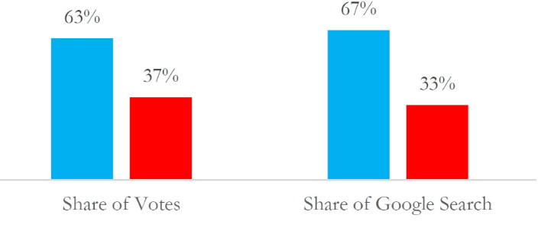

Detailed breakdown of the types of data Google collects:
- Usage data and preferences: This includes information about how you use Google services, such as your search terms, the websites you visit, and the content you interact with.
- Location information: Google collects location data when you use services like Maps, search for local businesses, or use devices that provide location data.
- Browsing history: When you browse the web using a Google-powered browser like Chrome, Google can track your browsing history, including the websites you visit and the content you interact with.
- Device and browser information: This includes information about your device type, operating system, browser version, and other technical details.
- Content: Google-hosted content, such as Gmail messages, photos, videos, and documents, is also analysed by Google.
- Activity on third-party sites and apps: If you're logged into your Google account and use third-party apps or websites that integrate with Google services, Google can track your activity on those platforms.
- Other data: Google also collects IP addresses, crash reports, and other technical information about your use of its services.

Data sites: https://trends.google.co.uk/

#######################################################

