DATA MODELING
for Analytics & Data Warehousing
A 1-Hour Teaching Session
Star & Snowflake Schemas · Fact & Dimension Tables · Slowly Changing Dimensions
Granularity & Surrogate Keys · Normalization vs. Denormalization

Worked example used throughout: "BrightMart" retail sales dataset
Theory + Visual Diagrams + Hands-on Practical Exercises

Contents
1. Why Data Modeling Matters 4
2. Fact and Dimension Tables 4
3. Star Schema vs. Snowflake Schema 6
4. Granularity and Surrogate Keys 8
5. Slowly Changing Dimensions (SCD) 10
6. Normalization vs. Denormalization 13
7. Practical Exercises 15
8. Answer Key (Instructor Reference) 16
9. One-Page Cheat Sheet 18

Session Agenda (60 minutes)

Time | Topic | Format
0:00 – 0:05 | Why data modeling matters | Discussion
0:05 – 0:18 | Fact & dimension tables, Star vs Snowflake schema | Theory + diagrams
0:18 – 0:28 | Granularity & surrogate keys | Theory + diagram
0:28 – 0:48 | Slowly Changing Dimensions — Types 1, 2, 3 | Theory + worked examples
0:48 – 0:56 | Normalization vs denormalization | Theory + diagrams
0:56 – 1:00 | Wrap-up, cheat sheet, hand out exercises | Recap + Q&A

1. Why Data Modeling Matters
A data model is the blueprint for how data is organized, stored, and related.
In analytics, a good model means analysts write simple queries and get consistent numbers; a bad model means every report calculates "revenue" a little differently.

What good data modeling gives you
- Query performance — fewer, simpler JOINs for the queries the business runs most often.
- A shared business vocabulary — "customer", "order", "region" mean the same thing everywhere.
- Predictable structure — BI tools (Power BI, Tableau, Looker) can auto-detect facts and dimensions.
- Controlled history — you decide, deliberately, what changes are tracked over time and what isn't.
The techniques in this session — dimensional modeling, grain, surrogate keys, SCDs, and normalization trade-offs — are the standard toolkit for designing analytical (OLAP) data models, as popularized by Ralph Kimball's dimensional modeling methodology.

2. Fact and Dimension Tables
Dimensional modeling organizes data into two kinds of tables:

Fact tables
Store the measurements/events of the business — things that happened. Rows are typically numeric, additive, and high in volume.
- Contain measures: quantities that can be summed, averaged, counted (e.g. sales_amount, quantity).
- Contain foreign keys to every relevant dimension (date_key, store_key, product_key, customer_key).
- Grow continuously — one row per event, so millions/billions of rows are normal.
- Are narrow (few columns) but very tall (many rows).

Dimension tables
Store the descriptive context that explains the facts — the who/what/where/when. Rows are textual, describe attributes, and are used to filter, group, and label reports.
- Contain descriptive attributes (product_name, category, city, loyalty_tier).
- Are wide (many columns) but comparatively short (few thousand to few million rows).
- Change slowly over time — this is exactly the problem Slowly Changing Dimensions (Section 6) solves.
- Are joined to the fact table via keys — ideally surrogate keys (Section 5).

Aspect | Fact Table | Dimension Table
Contains | Measures / metrics | Descriptive attributes
Shape | Narrow & tall (few cols, many rows) | Wide & short (many cols, fewer rows)
Changes | Append-only (new events) | Attributes updated over time
Example | FACT_SALES | DIM_CUSTOMER, DIM_PRODUCT, DIM_STORE
Used for | "How much / how many" | "By whom / where / when / what kind"

Practical: The BrightMart sample dataset
We'll use one consistent scenario throughout this session: BrightMart, a small electronics retailer with three stores. This is the fact table at line-item grain, and its four dimensions.

FACT_SALES
sales_key | date_key | store_key | product_key | customer_key | qty | unit_price | sales_amount
1 | 20260601 | 1 | 1 | 501 | 2 | 2499 | 4998
2 | 20260601 | 1 | 3 | 501 | 1 | 1299 | 1299
3 | 20260602 | 2 | 4 | 502 | 1 | 13999 | 13999
4 | 20260606 | 3 | 1 | 502 | 3 | 2499 | 7497
5 | 20260615 | 1 | 2 | 501 | 1 | 2799 | 2799
6 | 20260701 | 2 | 3 | 502 | 2 | 1299 | 2598

DIM_DATE, DIM_STORE, DIM_PRODUCT, DIM_CUSTOMER (star-schema / flattened versions)
date_key | full_date | day_name | month | quarter | year
20260601 | 2026-06-01 | Monday | June | Q2 | 2026
20260602 | 2026-06-02 | Tuesday | June | Q2 | 2026
20260606 | 2026-06-06 | Saturday | June | Q2 | 2026

store_key | store_id | store_name | city | region | country
1 | ST-101 | BrightMart Andheri | Mumbai | West | India
2 | ST-102 | BrightMart Koramangala | Bengaluru | South | India
3 | ST-103 | BrightMart Salt Lake | Kolkata | East | India

product_key | sku | product_name | category | subcategory | brand
1 | SKU-5001 | AeroBuds Pro | Electronics | Audio | Aero
3 | SKU-6010 | VoltCharge 65W | Electronics | Power | Volt
4 | SKU-7020 | PixelView 24 Monitor | Electronics | Computing | Pixel

3. Star Schema vs. Snowflake Schema
These are the two classic ways to arrange a fact table and its dimensions.

Star schema
Each dimension is a single, flattened (denormalized) table directly connected to the fact table. Every attribute of a dimension — however hierarchical it conceptually is (city → region → country) — lives in one wide row.
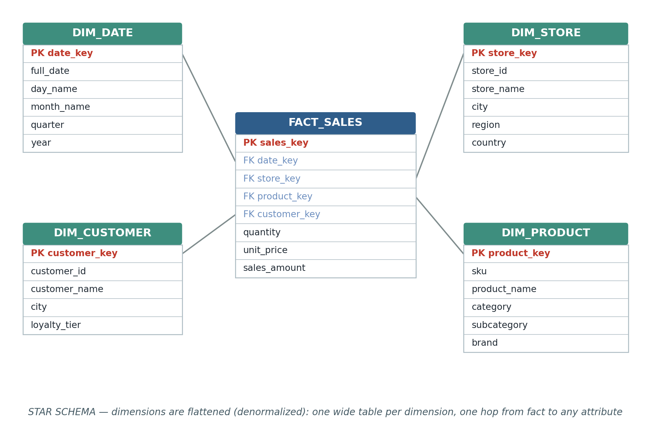
Figure 1 — Star schema: FACT_SALES surrounded by four flattened dimension tables.

Snowflake schema
One or more dimensions are further normalized into sub-dimensions.
Here, DIM_STORE is split into City → Region → Country, and
DIM_PRODUCT into Subcategory → Category — removing repeated text but requiring extra JOINs to reach it.
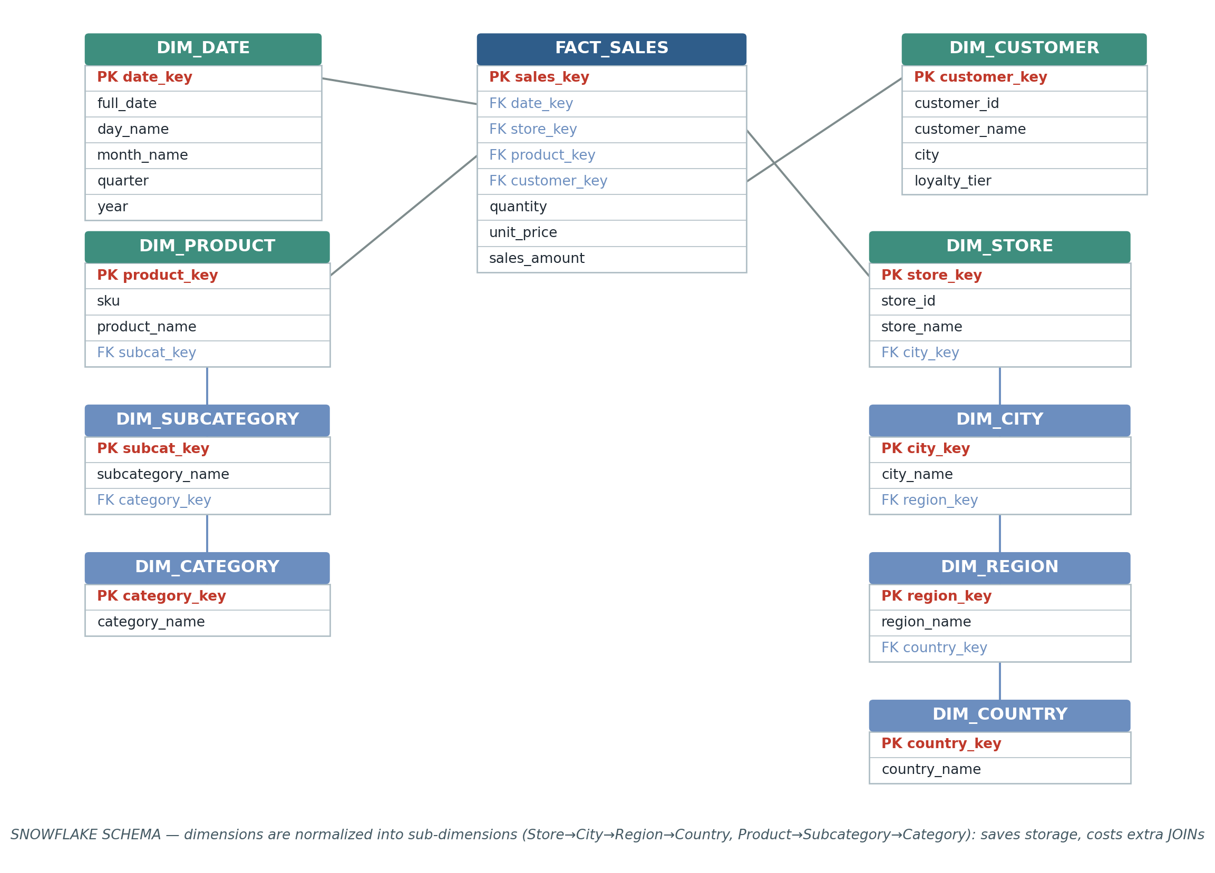
Figure 2 — Snowflake schema: the same fact table, but Store and Product dimensions are normalized into chains of smaller tables.

Choosing between them
Aspect | Star Schema | Snowflake Schema
Dimension structure | Denormalized (flat, wide) | Normalized into sub-dimensions
Joins per query | Fewer (1 hop to any attribute) | More (multi-hop through sub-tables)
Query simplicity | Simpler for BI tools & analysts | More complex SQL
Storage | Some redundant text (e.g. "India" repeated) | Less redundancy, smaller dimension tables
Typical use | Most data warehouses / BI layers | Very large, deeply hierarchical dimensions

Rule of thumb
Default to a star schema.
Snowflake only where a dimension is huge and its hierarchy is reused independently elsewhere — the JOIN cost usually isn't worth it just to save disk space.

4. Granularity and Surrogate Keys

Granularity ("grain")
The grain of a fact table is the precise definition of what a single row represents. It must be decided before choosing measures or dimensions — everything else follows from it.
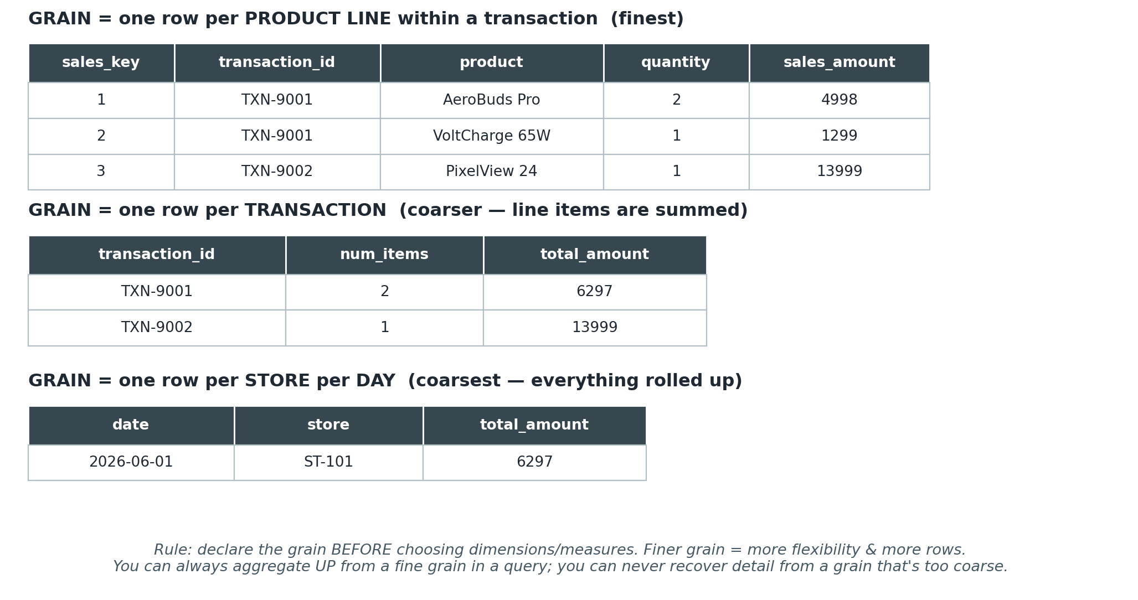
Figure 3 — The same underlying sales data at three different grains.
- Finer grain (e.g. one row per product line) = maximum flexibility, more rows, more storage.
- Coarser grain (e.g. one row per store per day) = smaller table, faster simple reports, but detail is lost forever.
- Golden rule: declare the grain in one sentence before modeling — e.g. “one row per product sold, per transaction line.”

Surrogate keys
A surrogate key is a system-generated identifier (usually a simple auto-incrementing integer) used as the primary key of a dimension table, instead of the business's own "natural" key (SKU, email, national ID, etc.).
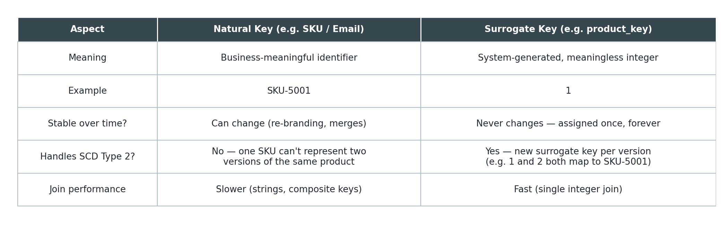
Figure 4 — Natural key vs. surrogate key.
- Surrogate keys are immune to source-system changes (a SKU gets renamed, an email changes).
- They are required to implement SCD Type 2 — the same natural key (SKU-5001) can then have two rows (surrogate keys 1 and 2) representing two versions over time.
- Integer joins are faster than string / composite-key joins.

5. Slowly Changing Dimensions (SCD)
Dimension attributes are not permanent — a customer moves city, a product gets recategorized, a store gets renamed. An SCD strategy is the deliberate policy for how a dimension table reacts when a source attribute changes.
Worked scenario used below: customer Arjun Mehta (CUST-02) relocates from Pune to Mumbai on 2026-07-10.

Type 1 — Overwrite (no history)
The changed attribute is simply updated in place. The old value is gone.
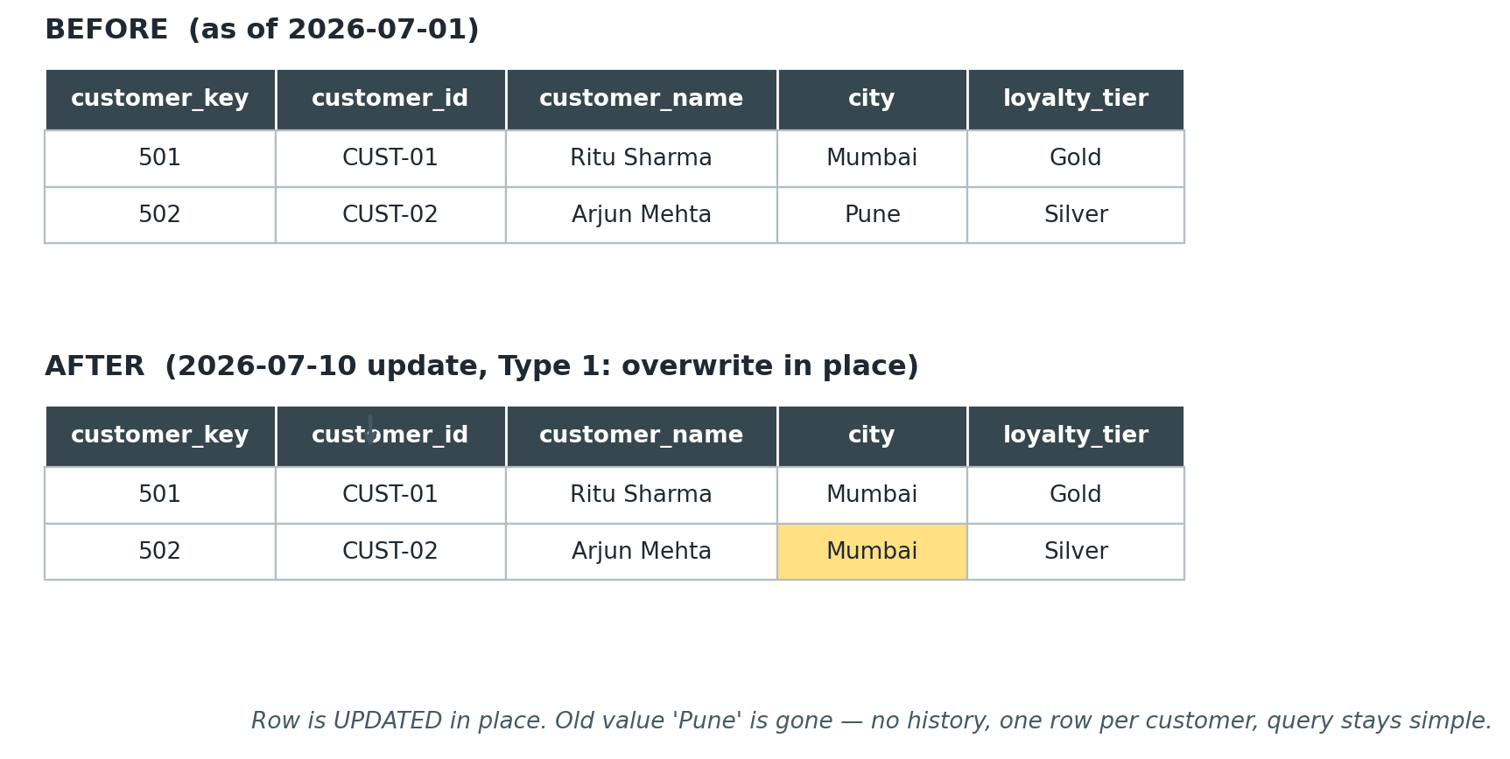
Figure 5 — SCD Type 1: the row is overwritten; 'Pune' is lost.
- Use when: the old value has no analytical value, or correcting bad data (e.g. fixing a typo).
- Downside: any report that used the old value historically will silently change — you cannot answer “what did sales by city look like last quarter” correctly.

Type 2 — New row (full history)
The existing row is “closed” (its end_date is set and is_current flips to 'N'), and a brand new row is inserted with a new surrogate key holding the new value.
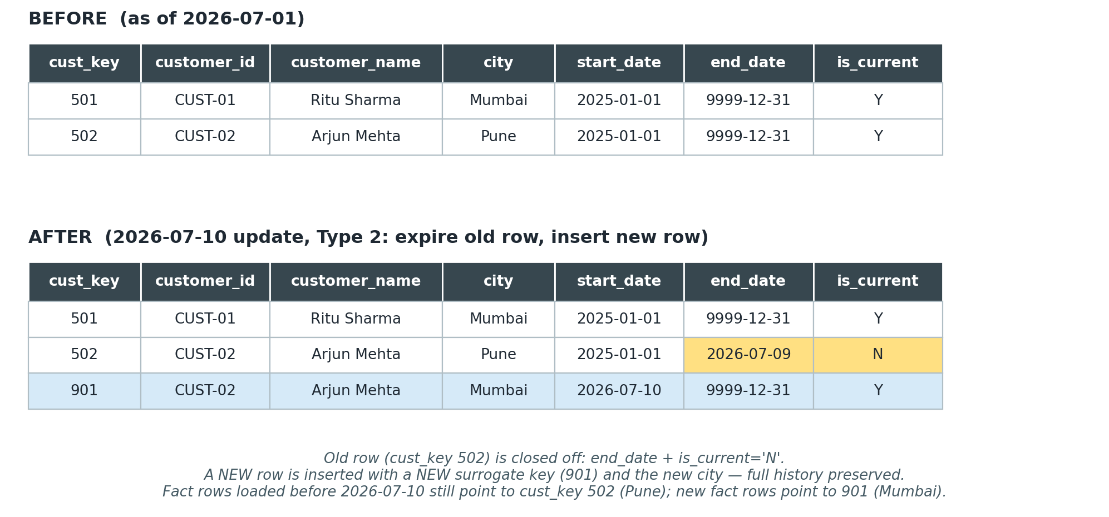
Figure 6 — SCD Type 2: old row is expired, a new row with a new surrogate key is inserted.
- Requires a surrogate key (natural key CUST-02 now maps to two rows: 502 and 901).
- Typical tracking columns: start_date, end_date (or valid_from / valid_to), and is_current (or a version_number).
- Fact rows loaded before the change keep pointing at the old surrogate key, so historical reports stay accurate — this is the main reason Type 2 is the default choice in most warehouses.
- Downside: dimension table grows over time; queries needing “current view only” must filter is_current = 'Y'.

Type 3 — New column (limited history)
The row itself is not duplicated. Instead, a new column stores the immediately-previous value alongside the current one.
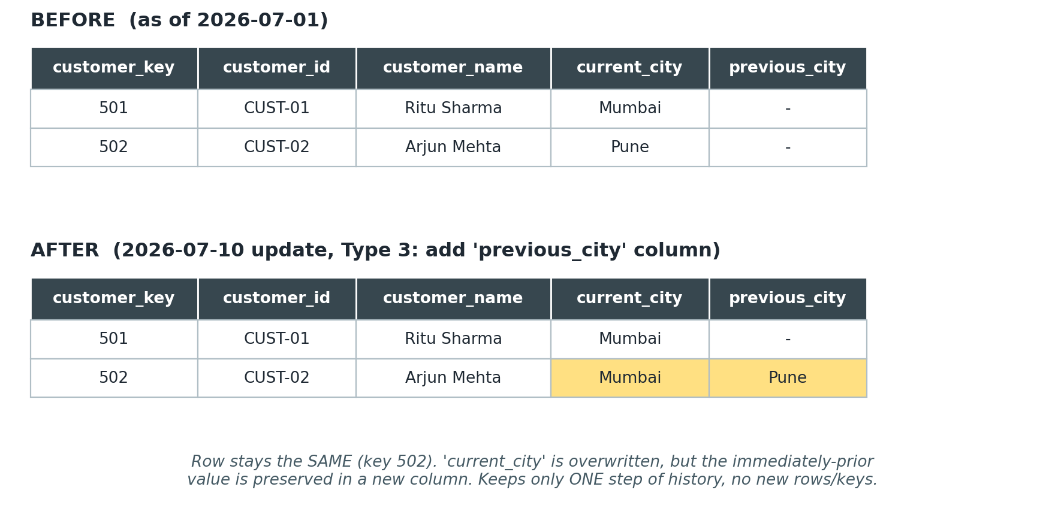
Figure 7 — SCD Type 3: the row stays the same; 'previous_city' captures one step of history.
- Use when you only ever need to compare “current vs. prior” (e.g. “previous sales region” for a one-time reorg).
- Downside: only keeps one (or a fixed number of) prior values — a second change overwrites the “previous” column too.

Choosing a type
 | Type 1: Overwrite | Type 2: New Row | Type 3: New Column
History kept | None | Full | One prior value
New surrogate key? | No | Yes, per change | No
Table grows? | No | Yes (new row per change) | No
Query complexity | Simplest | Needs is_current / date filter | Simple, but limited
Typical use case | Fixing errors, low-value attributes | Customer address, product category, price tier | Sales territory realignment, one-off comparisons

Good to know
Types 0, 4, and 6 also exist: Type 0 = attribute never changes (e.g. date of birth); Type 4 = current values stay in the dimension, history moves to a separate historical table; Type 6 = a hybrid of 1+2+3. Types 1, 2, and 3 cover the vast majority of real-world cases and are the ones worth mastering first.

6. Normalization vs. Denormalization

Normalization
Normalization organizes data to remove redundancy: every fact is stored exactly once, and tables are split so that non-key attributes depend only on the whole primary key (this is, informally, what 3rd Normal Form / 3NF aims for). It is the default design approach for transactional (OLTP) systems — the systems that run the business day-to-day.

Denormalization
Denormalization deliberately re-introduces redundancy — merging tables or repeating attributes — to make reads faster and queries simpler. This is exactly what a star schema's flattened dimension tables do.
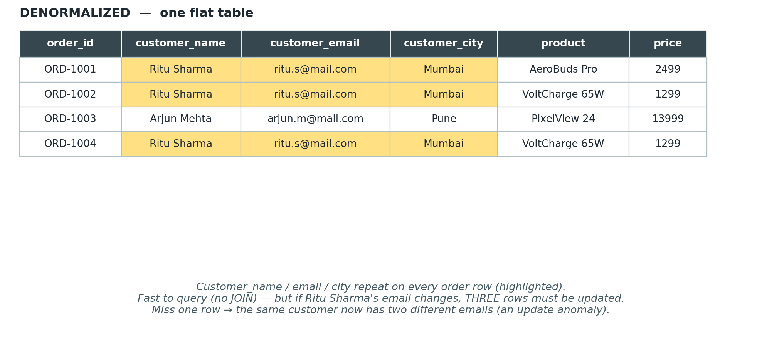
Figure 8 — Denormalized: customer details repeat on every order row.
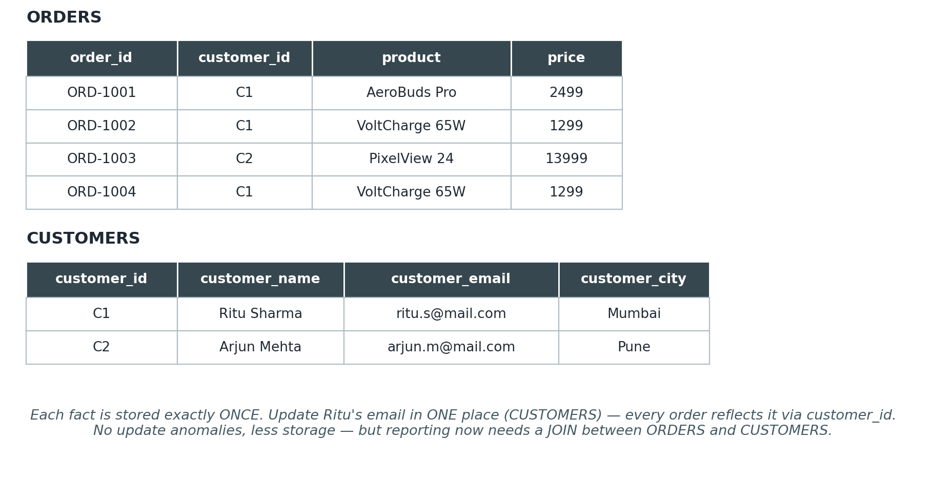
Figure 9 — Normalized (3NF): customer details stored once, referenced by customer_id.
Aspect | Normalized | Denormalized
Redundancy | Minimal — each fact stored once | Deliberate — attributes repeated
Update anomalies | Avoided | Possible if not carefully managed
Read (query) speed | Slower — needs JOINs | Faster — fewer/no JOINs
Write consistency | Easy — one place to update | Harder — must update every copy
Typical system | OLTP (transactional apps) | OLAP / data warehouse dimensions

How this ties back to Section 3
A star schema's dimension tables are intentionally denormalized (fast reads for BI tools). A snowflake schema pushes those same dimensions back toward normalization (less redundancy, more JOINs). Neither is “right” — it's a trade-off between read speed and redundancy, chosen based on query patterns.

7. Practical Exercises
Use the BrightMart dataset from Section 2 (or your own) for all exercises below. Suggested: do Exercise 1 together in class; assign the rest as homework. An answer key follows in Section 8.

Exercise 1 — Identify the grain
BrightMart's warehouse team gives you a raw export with these columns: transaction_id, transaction_line_no, store_id, product_sku, customer_id, sale_date, quantity, line_amount.
- In one sentence, state the grain of a fact table built directly from this export.
- If your finance team only ever asks “total revenue by store by month,” would you model the fact table at this grain, or coarser? Justify your answer.
- Name one question you could answer at the fine grain that you could NOT answer if you pre-aggregated to store-by-month.

Exercise 2 — Design a star schema
Scenario: a hospital wants to analyze appointments. Each appointment has: a patient, a doctor, a clinic location, an appointment date/time, a duration in minutes, and a billed amount.
- List the fact table and its measures.
- List each dimension table and 3–4 attributes it should hold.
- Draw (on paper or in a tool) the star schema, showing foreign keys from the fact table to each dimension.
- Would you snowflake the “clinic location” dimension into City → Region? Under what condition would that be worth it?

Exercise 3 — Apply an SCD
BrightMart's DIM_PRODUCT has: product_key 4, sku SKU-7020, product_name “PixelView 24 Monitor”, category “Electronics”, brand “Pixel”. On 2026-08-01, the product is reclassified from category “Electronics” to a new category “Computing Accessories”.
- Write out the resulting row(s) if you apply SCD Type 1.
- Write out the resulting row(s) if you apply SCD Type 2 (include start_date / end_date / is_current, and a new surrogate key).
- Write out the resulting row if you apply SCD Type 3 (include a previous_category column).
- Which type would you recommend for a “product category” attribute at a retail chain, and why?

Exercise 4 — Normalize a flat table
You are given one wide CSV export with columns: order_id, customer_name, customer_phone, customer_city, store_name, store_city, product_name, product_category, quantity, price.
- Identify which columns are repeated/redundant across rows for the same customer, store, or product.
- Split this into a normalized set of tables (aim for something close to 3NF): list each table and its columns, including primary/foreign keys.
- Name one update anomaly that the original flat table was at risk of, that your normalized design fixes.

8. Answer Key (Instructor Reference)

Exercise 1 — Grain
- Grain: “One row per product line within a transaction” (finest available grain in the export).
- For “total revenue by store by month” only, a coarser grain would technically answer today's question — but modeling at the fine grain is still recommended, since you can always aggregate up in a query. If you model coarse and a new requirement appears (e.g. “top products per store”), you'd need to reload history from source, which may no longer be available.
- Fine grain lets you answer: “what is the average number of items per transaction,” “which products are commonly bought together,” or “revenue per SKU” — all impossible once rows are pre-summed to store-month.

Exercise 2 — Hospital star schema
- FACT_APPOINTMENTS — measures: duration_minutes, billed_amount, count (1 per appointment). FKs: date_key, patient_key, doctor_key, clinic_key.
- DIM_PATIENT: patient_key, patient_id, name, date_of_birth, gender, insurance_plan.
- DIM_DOCTOR: doctor_key, doctor_id, name, specialization, years_experience.
- DIM_CLINIC: clinic_key, clinic_name, city, region.
- DIM_DATE: date_key, full_date, day_name, month, quarter, year.
- Snowflaking clinic into City → Region is worth it only if the hospital network is large (hundreds of clinics) and City/Region are reused as their own reporting dimension elsewhere — otherwise keep it flat (star).

Exercise 3 — SCD on product category
- Type 1: product_key 4 row is updated in place — category becomes “Computing Accessories”; the fact that it was ever “Electronics” is lost.
- Type 2: existing row (key 4) gets end_date = 2026-07-31, is_current = 'N'. A new row is inserted, e.g. key 40, sku SKU-7020, category “Computing Accessories”, start_date = 2026-08-01, end_date = 9999-12-31, is_current = 'Y'.
- Type 3: row (key 4) keeps its key; category becomes “Computing Accessories” and a new column previous_category = “Electronics” is populated.
- Recommended: Type 2. Category changes affect how historical revenue rolls up by category — you want old fact rows to still report under “Electronics” for periods before the reclassification, and new rows under “Computing Accessories.”

Exercise 4 — Normalizing the flat export
- Redundant columns: customer_name/phone/city repeat for every order by the same customer; store_name/city repeat for every order at that store; product_name/category repeat for every order of that product.
- ORDERS(order_id PK, customer_id FK, store_id FK, product_id FK, quantity, price)
- CUSTOMERS(customer_id PK, customer_name, customer_phone, customer_city)
- STORES(store_id PK, store_name, store_city)
- PRODUCTS(product_id PK, product_name, product_category)
- Update anomaly fixed: previously, if a customer's phone number changed, every historical order row for that customer needed updating — miss one, and the customer now has two different phone numbers on file. Now it's stored once in CUSTOMERS.

9. One-Page Cheat Sheet
Concept | In one line
Fact table | Numeric events/measures + FKs to dimensions. Tall & narrow.
Dimension table | Descriptive attributes for filtering/grouping. Wide & shorter.
Star schema | Fact + flattened (denormalized) dimensions. Fewer JOINs.
Snowflake schema | Fact + normalized, multi-level dimensions. More JOINs, less redundancy.
Grain | What one fact row represents — decide this first, before anything else.
Surrogate key | System-generated PK for a dimension; stable, fast, enables SCD Type 2.
SCD Type 1 | Overwrite. No history.
SCD Type 2 | New row + new surrogate key. Full history.
SCD Type 3 | New column for prior value. One step of history.
Normalization | Remove redundancy; each fact stored once. Standard for OLTP.
Denormalization | Add redundancy back for read speed. Standard for OLAP dimensions.

