Google data collection

Source: https://www.bennettinstitute.cam.ac.uk/blog/using-google-data-policy-research/

We tell google “things we might not tell our partners, our friends, our family…even our doctor”. We are sharing life’s most significant and intense moments.

Type in search bar : “Today I want to l” and see what what auto completion suggests.

Search data has been used to predict the spread of the Mayaro virus, identify seasonal patterns in domestic violence, etc.

Use search data to discover mismatches between how consumers articulated demand for its products and how it had listed them on its website. Simple changes like re-naming “outdoor lighting” to “security lighting”, and “nailers” to “nail guns” resulted in a ten-fold increase in online sales from Google search.

Google search data were used to predict who will win.

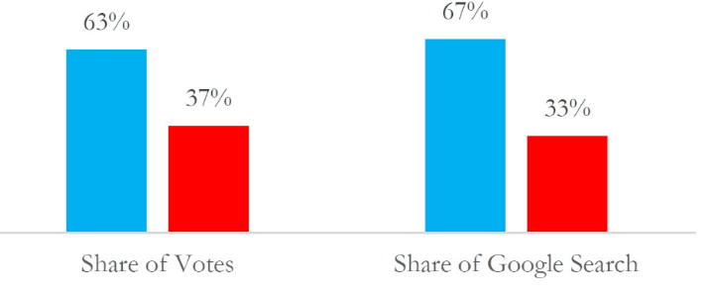

Detailed breakdown of the types of data Google collects:
- Usage data and preferences: This includes information about how you use Google services, such as your search terms, the websites you visit, and the content you interact with.
- Location information: Google collects location data when you use services like Maps, search for local businesses, or use devices that provide location data.
- Browsing history: When you browse the web using a Google-powered browser like Chrome, Google can track your browsing history, including the websites you visit and the content you interact with.
- Device and browser information: This includes information about your device type, operating system, browser version, and other technical details.
- Content: Google-hosted content, such as Gmail messages, photos, videos, and documents, is also analysed by Google.
- Activity on third-party sites and apps: If you're logged into your Google account and use third-party apps or websites that integrate with Google services, Google can track your activity on those platforms.
- Other data: Google also collects IP addresses, crash reports, and other technical information about your use of its services.

Data sites: https://trends.google.co.uk/

#######################################################

Amazon – E-commerce Example

What Amazon Collects:
- Clickstream Data
  - Every product you click on, how long you look at it, and whether you go back.
  - What filters you use (e.g., sort by price, reviews).

- Search Behavior
  - What terms you type in the search bar.
  - Autocomplete suggestions you click on.

- Cart & Wishlist Activity
  - What you add to your cart or wishlist — even if you don’t buy.
  - Items you remove, revisit, or leave in the cart for days.

- Mouse Tracking
  - Amazon may use tools to monitor where your mouse moves and hovers.
  - Tracks your attention even if you don’t click.

- Purchase & Return History
  - What you buy, how often, and what you return — to recommend and price items.

- Reviews & Ratings
  - Content and sentiment of what you write.
  - Whether you click “Helpful” on others' reviews.

- Device & Location
  - IP address, device type, browser info.
  - Delivery address and payment preferences.

- Voice & Visual Search (via Alexa or App)
  - Voice commands or camera-based product scans.

How It’s Used:
- Product recommendations ("Customers also bought...")
- Dynamic pricing (adjusting prices based on user behavior)
- Ad targeting (onsite and offsite)
- Identifying buying intent: browsing vs. ready to purchase
- A/B testing layouts or promotions

#############################################

YouTube – Content & Media Example

What YouTube Collects:

Watch History: Every video you’ve watched, paused, rewatched, or skipped.

Engagement Data:
Likes, comments, shares, and subscriptions.
How long you watch a video (watch time is huge for YouTube’s algorithm).

Search Queries
What you type in YouTube’s search bar.
Which search results you pick.

Video Interaction
Hovering over thumbnails, previewing videos.
Clicking timestamps in the description or comments.

Scroll Behavior
How far you scroll through recommendations.

Device Info & Location
IP address, screen size, app version.

Voice Commands (via YouTube app or smart devices)
If enabled, voice search data is used to refine content recommendations.

How It’s Used:
- To build your recommendation feed ("Up next" and homepage)
- To rank videos in search results
- To personalize ads (on YouTube and other Google platforms)
- To detect trends and improve creator tools
- To test features or layouts (YouTube runs tons of A/B tests)

#######################################

In Above Cases:
- They don't just observe behavior — they predict and influence it.
- AI models run in the background constantly refining recommendations.
- They create detailed user profiles for both personalization and advertising.

