**USN: 4AL18CS008**

**NAME: Anush Shetty (Group 2)**

**Bellman ford algorithm in python:**

print('Enter number of edges in the graph:- ')

n = int(input())

print('Enter number of vertices in the graph:- ')

m = int(input())

graph = []

print('Enter weighted edges of the graph')

for i in range(m):

u, v, w = list(map(int, input().split()))

graph.append([u, v, w])

def BellmanFord(src):

dist = [float("inf") for i in range(n)]

dist[src] = 0

for i in range(n-1):

for u, v, w in graph:

if dist[u] != float("inf") and dist[u]+w < dist[v]:

dist[v] = dist[u]+w

cycle = 0

for u, v, w in graph:

if dist[u] != float("Inf") and dist[u] + w < dist[v]:

print("Graph contains negative weight cycle")

cycle = 1

break

if cycle == 0:

print('Distance from source vertex',src)

print('Vertex \t Distance from source')

for i in range(len(dist)):

print(i,'\t',dist[i])

src=int(input("Enter the source vertex:"))

BellmanFord(src)

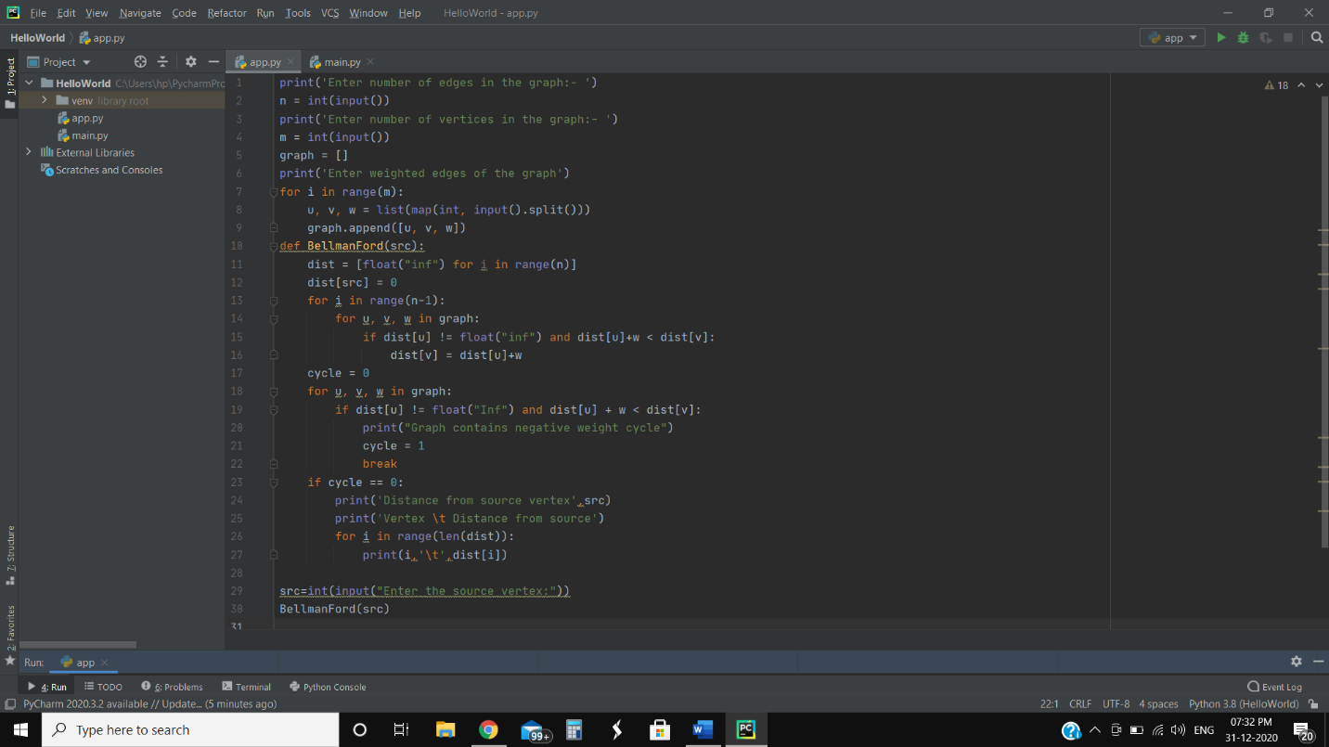

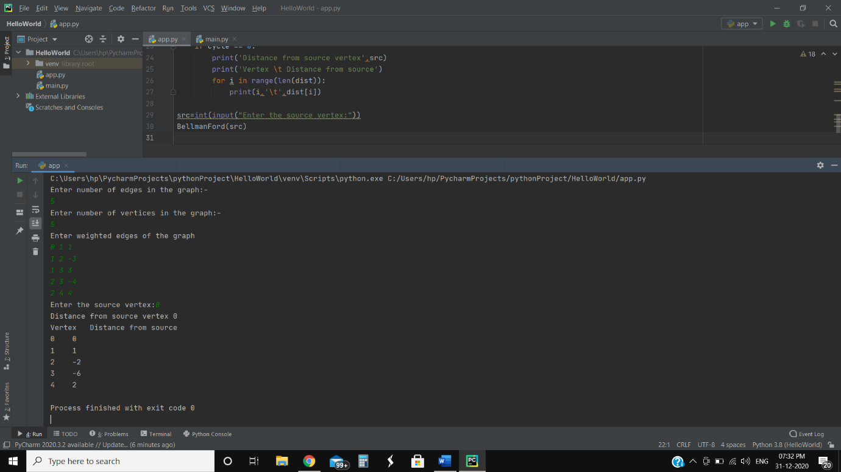

**GitHub Link:**

https://github.com/anushshetty30/BellmanFord/commit/b2ddcee067430f618ad7cca9c9344c626a8cabe4