RFID Based Smart Lock

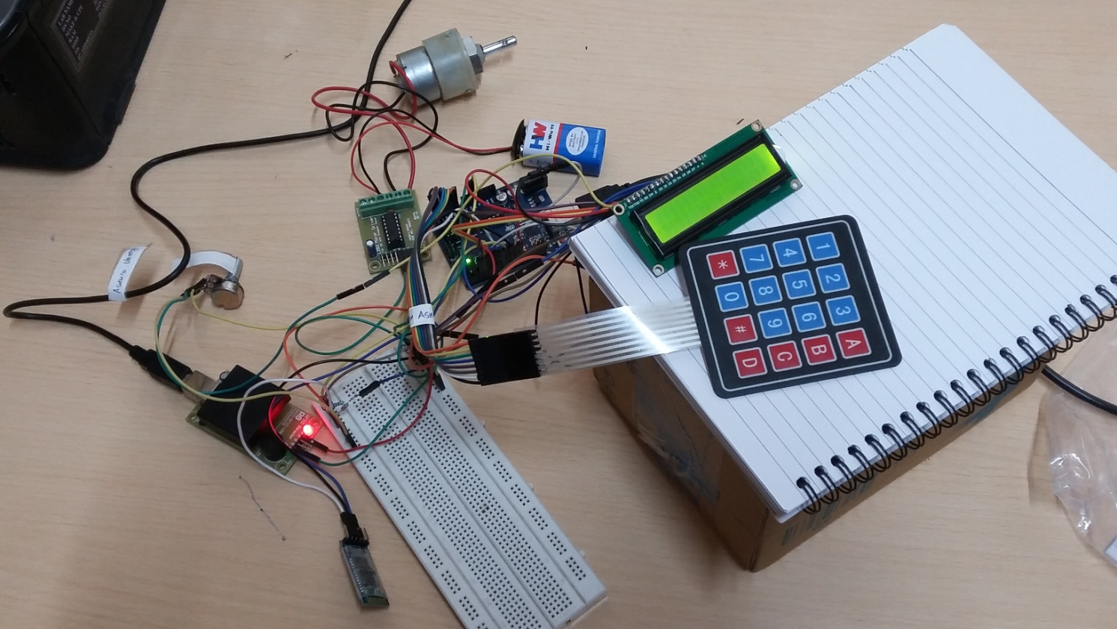

Smart door locking system is not a new concept. However, with advancements in technology, these systems have become more advanced too. The basic idea behind a smart lock is to facilitate easy and secured entry to only permitted people. In this RFID based smart lock, a user can use an authorised RFID tag, a password inputted through the keypad, or a passkey sent via a mobile to lock or unlock the door.

Components Required

1. Arduino Uno
2. RFID Reader
3. RFID tags
4. HC-05 Bluetooth module
5. 16X2 LCD
6. L293D Motor Driver IC module
7. DC Motor
8. 4X4 Keypad
9. Breadboard

Block Diagram

DC Motor

RFID Reader

L293D Motor Driver IC

Arduino Uno

Keypad

Mobile Phone

HC-05 Bluetooth Module

RFID tag

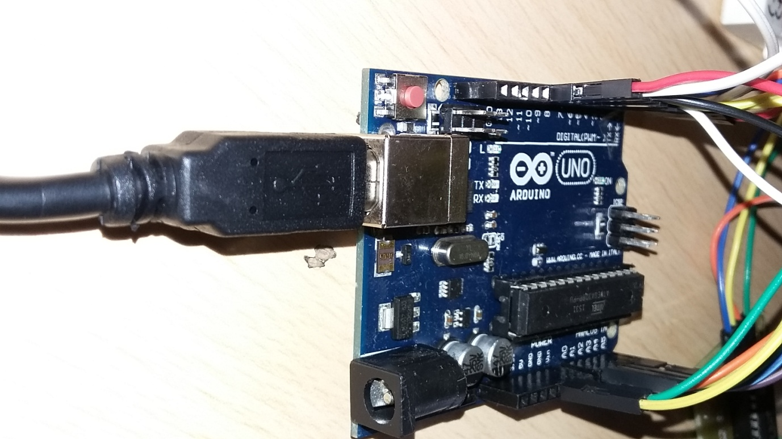Arduino Uno

At the heart of any Internet of Things (IoT) project is a microcontroller. This project uses a Arduino Uno board, which is based on the ATmega 328P microcontroller. It has 6 analog pins and 14 digital GPIO pins of which 6 can be used to give a PWM output. Arduino Uno has 32 KB memory, of which 0.5 KB is occupied by the bootloader, 2KB SRAM and 1KB EEPROM memory. Code can be written to it using the Arduino IDE and flashing it using a USB A-to-B connecting wire.

The Arduino Uno was used to interface the RFID Reader, LCD Display, Bluetooth module, Keypad and the locking mechanism.

There are three available input methods to lock/unlock the door -

1. The Arduino checks whether the tag data sent by the RFID module matches the authorized tags in the database.
2. A pin can be entered from the keypad which is checked by the Uno against the stored passkey.
3. The data received via the Bluetooth module is checked and access granted accordingly.

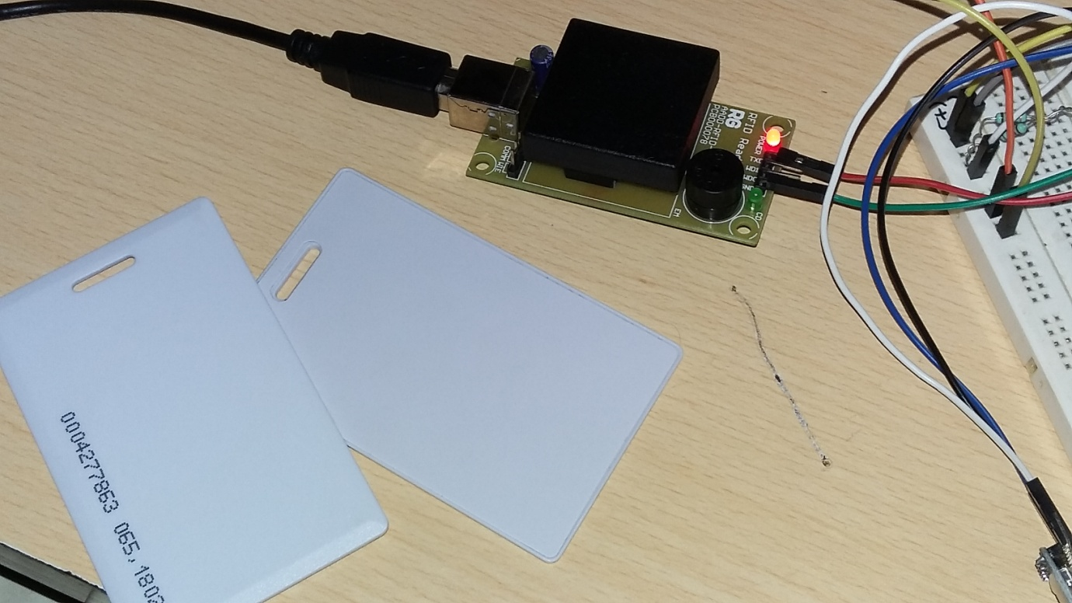RFID Reader and Tags

Radio Frequency Identification (RFID) is a technique facilitating identification of any product or item without the requirement of any line of sight reader or transreceiver.

An RFID structure is composed of 2 main hardware components - the transponder which is located on the product to be identified and the reader or interrogator. The interrogator can be just a reader or a read & write device, depending upon the system design, technology employed and the requirement.

The RFID reader comprises of a radio frequency module, a controlling unit for configurations, a monitor and an antenna to investigate the RFID tags. A few RFID readers are in-built with and extra interface to forward the read data to another system.

An RFID tag is the actual data carrying component of the RFID structure. It consists of an antenna, employed for transferring data using radio waves, and an in-built chip used to transmit the data stored on the tag.

The basic working principle of an RFID module is not complicated -

1. The interrogator emits electromagnetic waves of a particular frequency
2. When the tag is brought into the magnetic field of the reader, it receives the RF signal emitted
3. Current is induced in the tag which powers the in-built chip storing data and this data is then transmitted
4. The reader then receives this signal and reads and decodes the information sent by the tag,

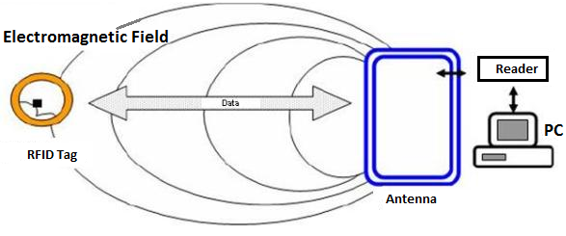

The tag IDs of a few RFID tags are stored on the Arduino Uno. These are the only tags that can are granted access. When an RFID tag is scanned, its ID is sent by the reader to the Uno, where it is checked with the IDs of the tags stored in memory. If it matches any one of the stored IDs, the user is granted access. Otherwise, an error message is generated and the user is declined access.

HC-05 Bluetooth Module

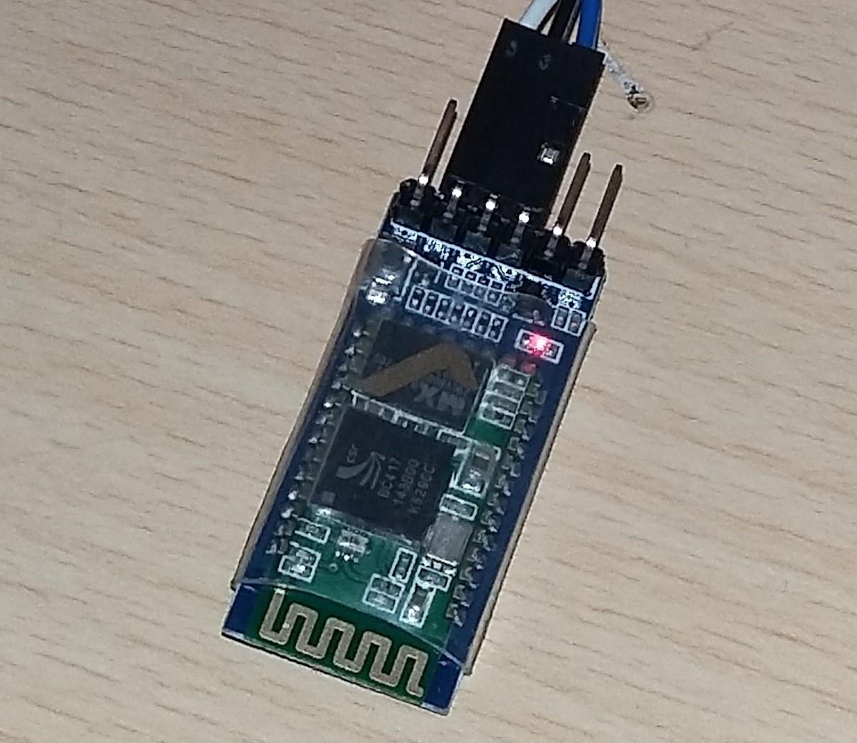

Bluetooth is a wireless technology standard for exchanging data over short distances (upto 100 m) using short-wavelength UHF radio waves in the ISM band from 2.4 GHz to 2.485 GHz from fixed as well as mobile devices and builiding a personal area network (PAN). HC-05 is a commonly available and cheap Bluetooth module. It is a serial port module.

In this project, the mobile phone is used to send a passkey to the Arduino serially via Bluetooth . The serial data from the Bluetooth module is saved into a buffer till the end of transmission occurs, which is indicated by a '#'. The contents of this buffer are then checked against the stored passkey. If the string matches, an appropriate message is printed on the LCD display and the user is granted access.

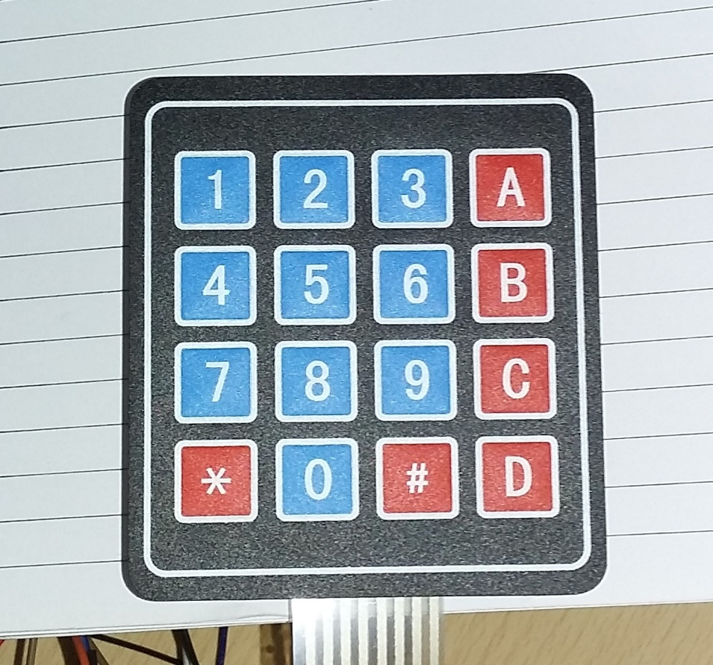Keypad

A 16-button keypad provides a useful human interface component for microcontroller projects.

Matrix keypads use a combination of four rows and four columns to provide button states to the host device. Underneath each key is a push button, with one end connected to one row and the other end connected to one column. In order for the host device to determine which button is pressed, all columns are first pulled high or low, then the states of the 4 rows are polled. Depending on the state of the columns, it can be determined which button is pressed.

An array was created to store the characters of the keypad and a library was used to interface it with the Uno. When a button is pressed on the keypad, '\*' is displayed to represent the character being entered. Using '#' as a terminating character, the input string is checked with a pre-stored password. If they match, entry is authorized.

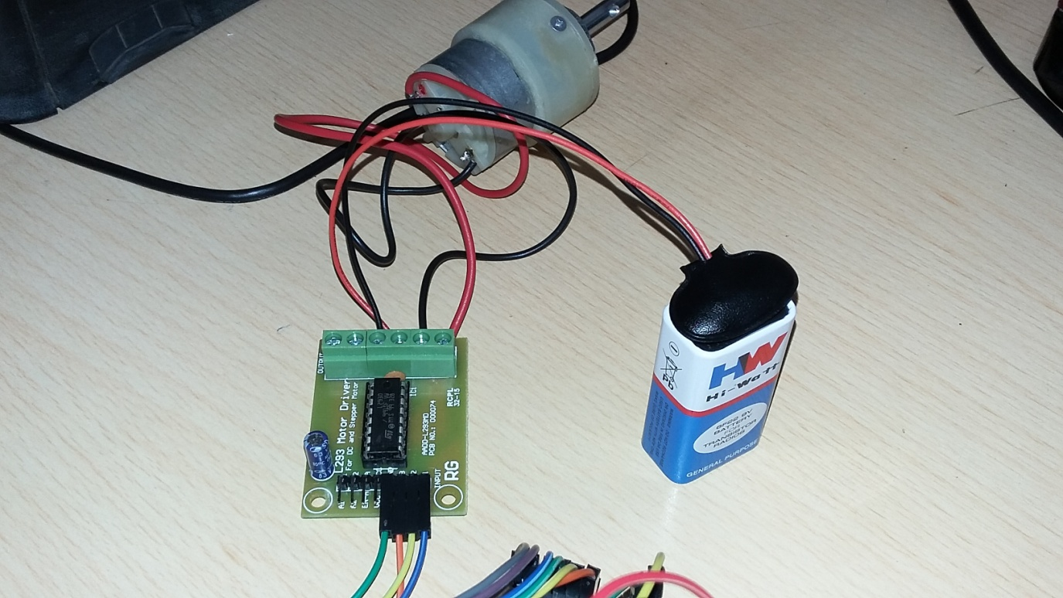L293D Motor Driver IC Module

After authenticating the RFID tag, passkey from a mobile phone via Bluetooth or password from the keypad, a mechanical unit is required for the physical locking and unlocking mechanism. For this, a DC motor with a L293D motor driver IC module is used. L293D acts as an intermediary between the motor and the Arduino.

The L293D is a typical motor driver IC. It can drive two motors simultaneously in either direction. It works on the concept of an H-bridge. An H-bridge is a circuit which allows voltage to flow in either direction. Since a change in direction of flow of voltage is required to change the direction of a motor, thus H-bridges are ideal for driving a DC motor.

A single L293D IC has two H-bridge circuits which can be operated independently. There are 4 input pins, pins 2 and 7 for H-bridge A and pins 15 and 10 for H-bridge B. Their respective enable pins are pins 1 and 9. Motors are connected between pins 3 and 6 or between pins 14 and 11. When the input pins have the same value, ie both LOW or both HIGH, the motor is stopped. When they have value LOW and HIGH, the motor moves in one direction, and when they have value HIGH and LOW, the motor moves in the other direction.

Driving a motor is as simple as giving a high output to the appropriate enable pin and complementary outputs on the input pins.

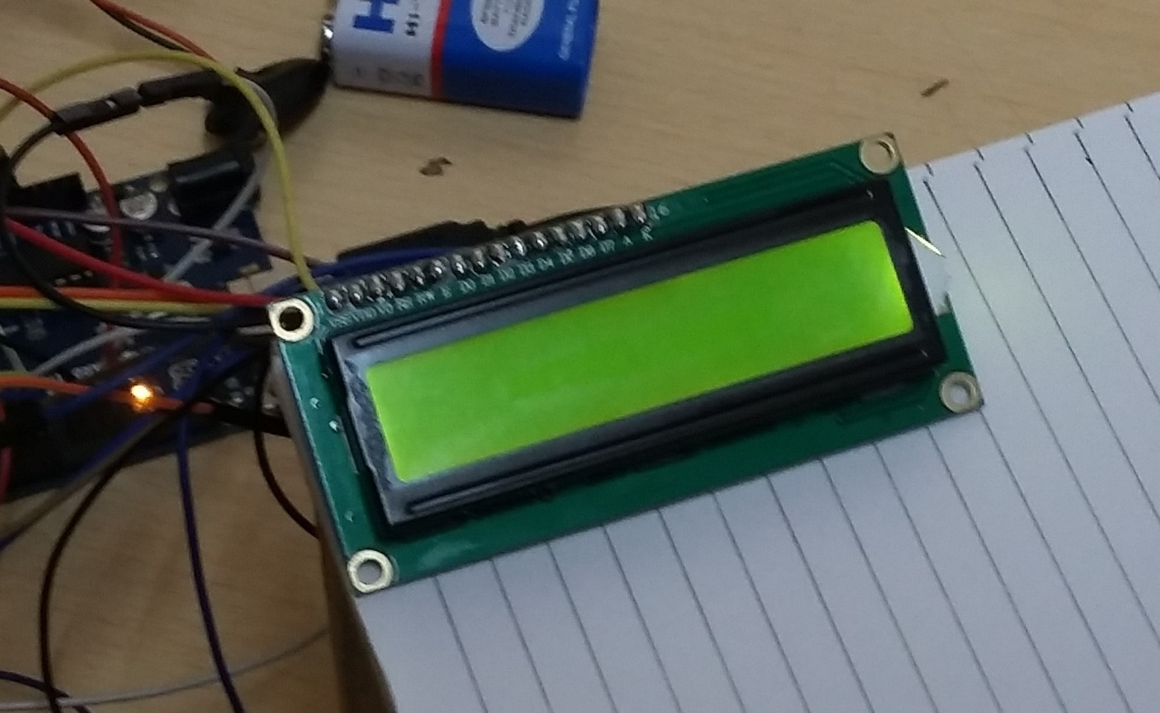16X2 LCD

A Liquid Crystal Display (LCD) is basically a display unit built using Liquid Crystal technology. It provides a medium to display output values and various messages. The 16X2 LCD module is the most commonly used LCD module. It can display 32 ASCII characters in 2 lines (16 characters in 1 line).

The JHD162A LCD module has 16 pins and can be operated in 4-bit or 8-bit modes. The module is interfaced in the 4-bit mode in this project. This means that only four of the digital input lines, DB4 to DB7, of the LCD are utilized. This method is very simple, requires less connections and can almost completely utilize the full potential of the LCD module.

The library LiquidCrystal is used to operate the LCD module with ease with the Arduino board. With the help of the many in-built methods defined inside the library, the LCD module can be used very easily.

The LCD module is used to display whether a user is granted access or not. It also displays if a wrong passkey, wrong password or an unauthorized RFID tag has been used.

PIN Connections

Keypad

Module - Arduino

Pin 7 - A0

Pin 6 - A1

Pin 5 - A2

Pin 4 - A3

Pin 3 - A4

Pin 2 - A5

Pin 1 - Pin 7

Pin 0 - Pin 10

Bluetooth Module

Module - Arduino

TX - Pin 6

GND - GND

Vcc - +5V

RFID Reader

Module - Arduino

TX - Pin 0

GND - GND

Motor Driver

Module - Arduino

GND - GND

EB - +5V

B2 - Pin 9

B1 - Pin 8

LCD Module

Module - Arduino

RS - Pin 12

Enable - Pin 11

D4 - Pin 5

D5 - Pin 4

D6 - Pin 3

D7 - Pin 2

R/W - GND

10k resistor: ends to +5V and GND

Wiper to LCD V0 (pin 3)