React.js Component Creation

name : Shaik Asha Muskan

email : [ashiasha2409@gmail.com](mailto:ashiasha2409@gmail.com)

phone no : 9346526608

Roll NO : 20NN1A1257

College Name : VIGNAN’S NIRULA INSITITUE OF TECHNOLOGY AND SCIENCE FOR WOMEN,GUNTUR

source code :

CARD COMPONENT :

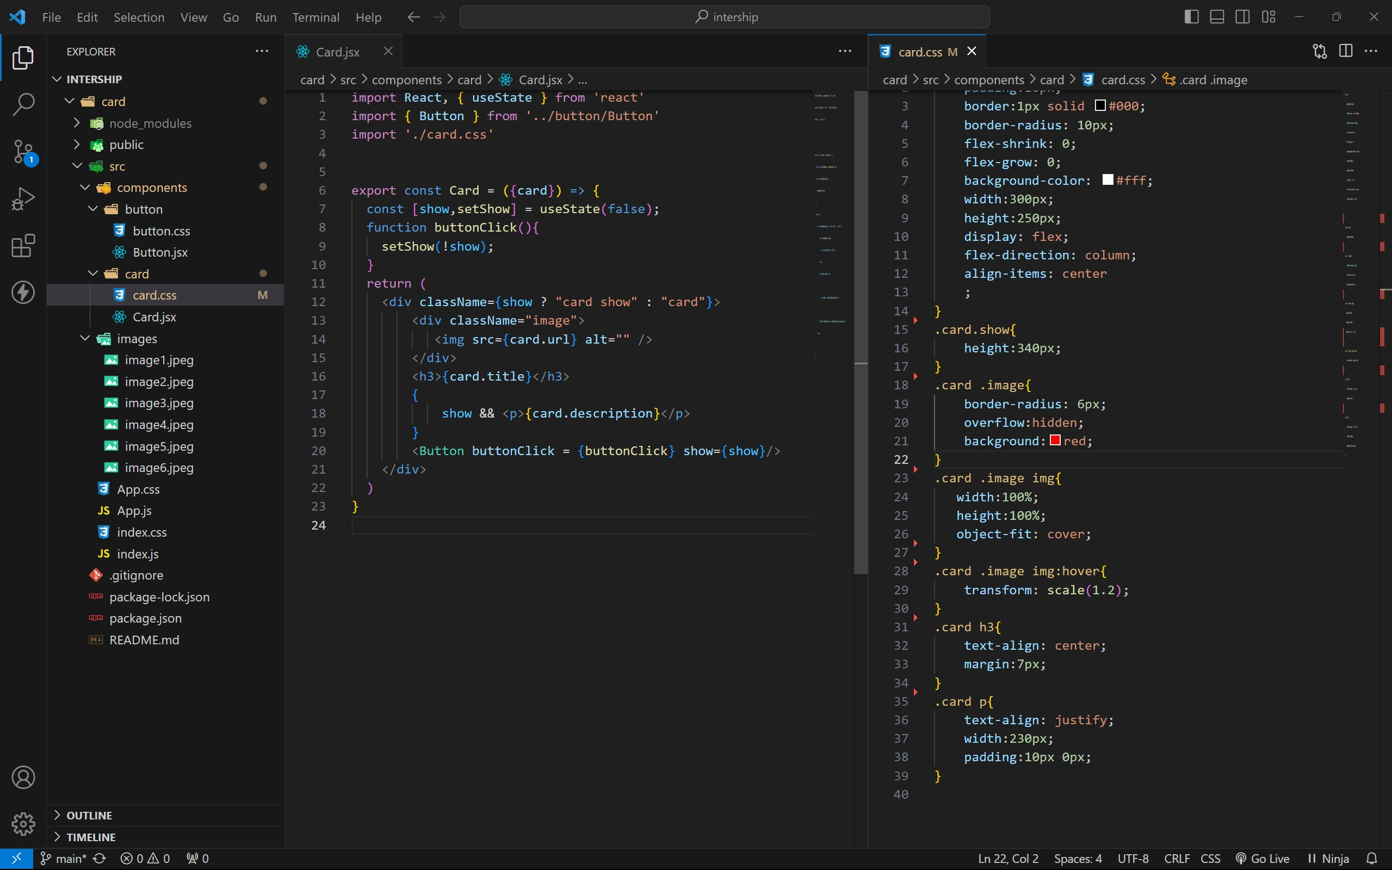

BUTTON COMPONENT :

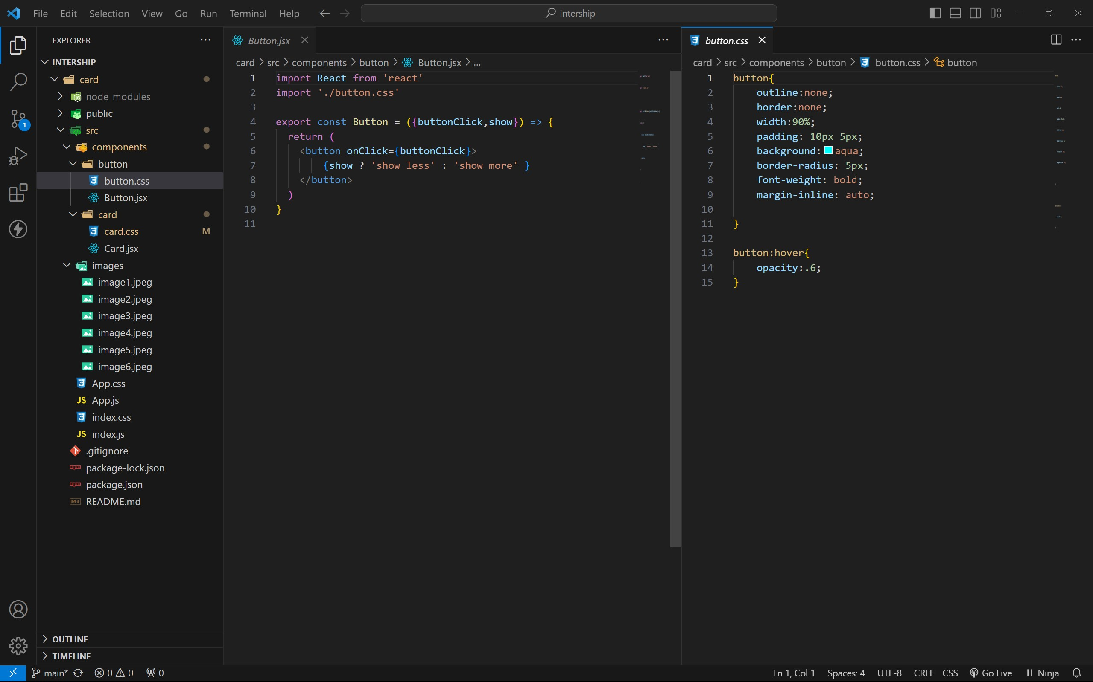

APP COMPONENT :

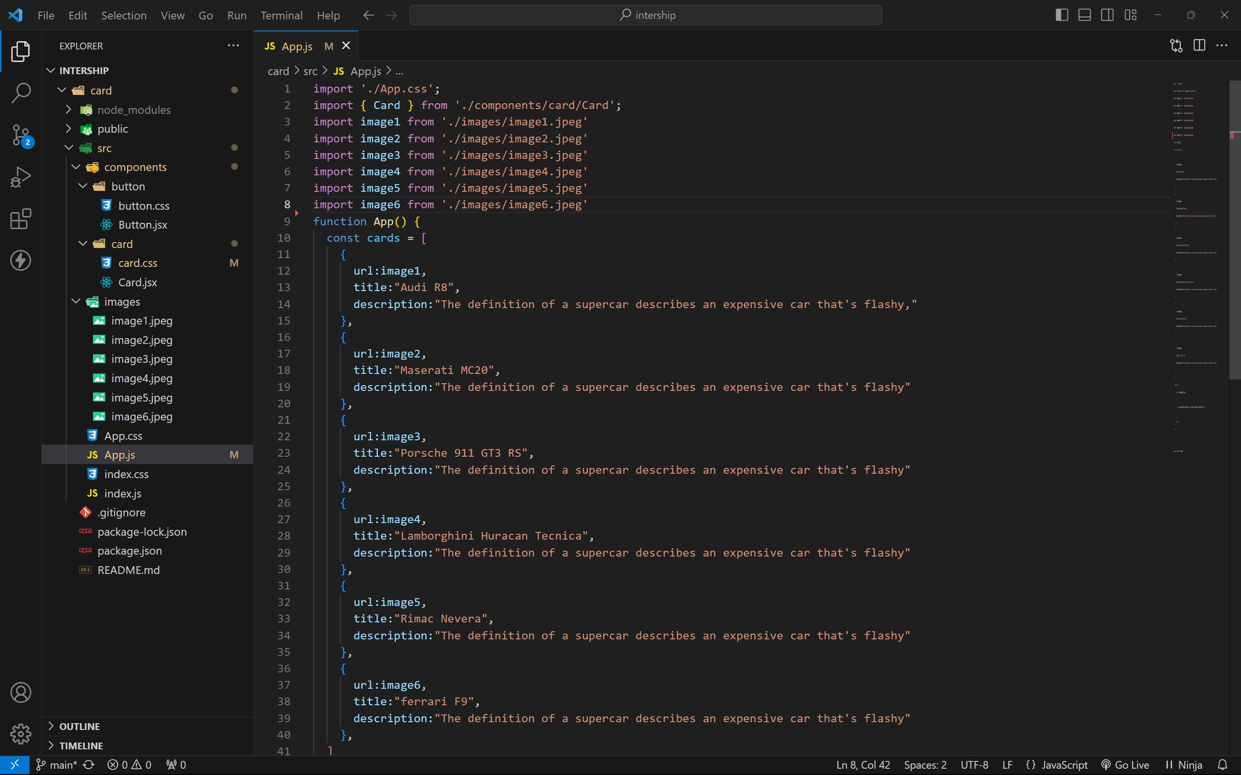

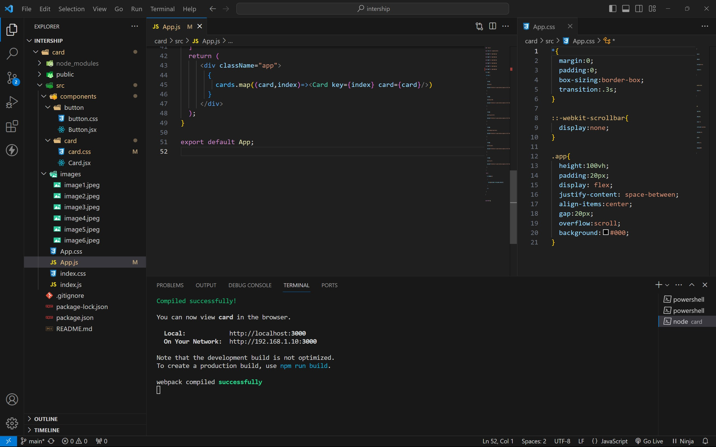

approach :

1. . initially taking an array of objects like below

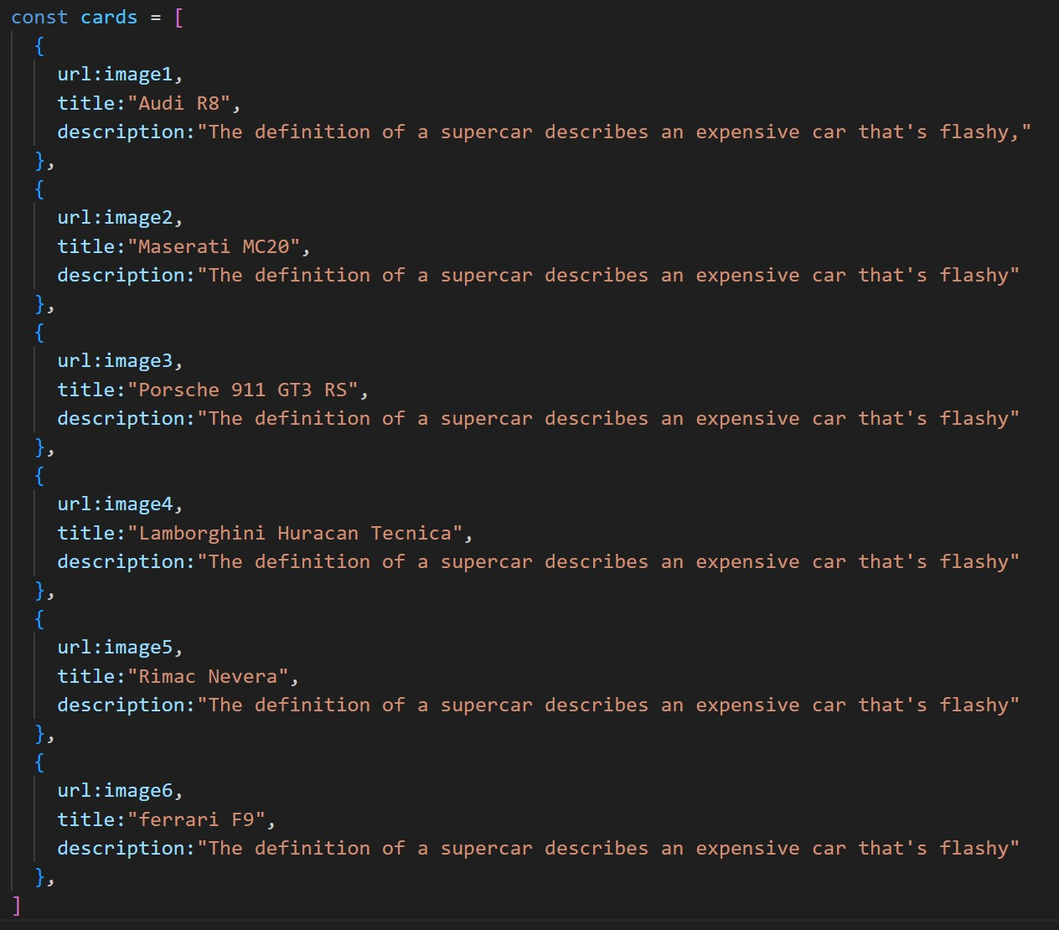

1. . Passing this card array to child (card component) of App component by using props;
2. . getting data as argument like {card} in card component.
3. . in card component i use one state [show, set Show] to get extra info as

description.

1. . When we click the button then show becomes true by assigning setShow (!show).

OUTPUT:

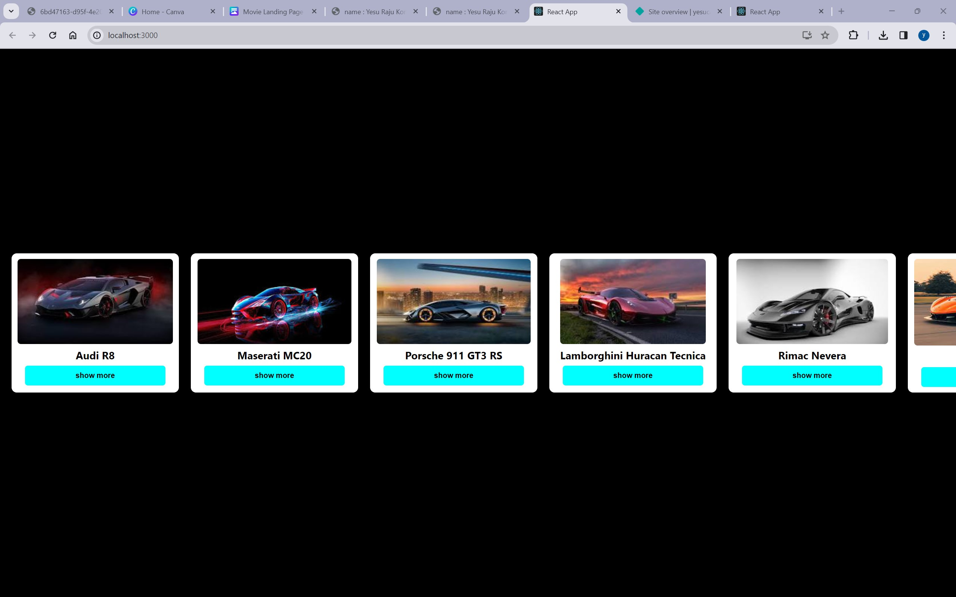

AFTER BUTTON CLICKS :

