Name: SHAIK ASHA MUSKAN

Email id: [ashiasha2409@gmail.com](mailto:ashiasha2409@gmail.com)

**ASSIGNMENT:** create two s3 bucket in different regions, upload a file in one s3 bucket and transfer

the same file from one s3 bucket to other s3 bucket.

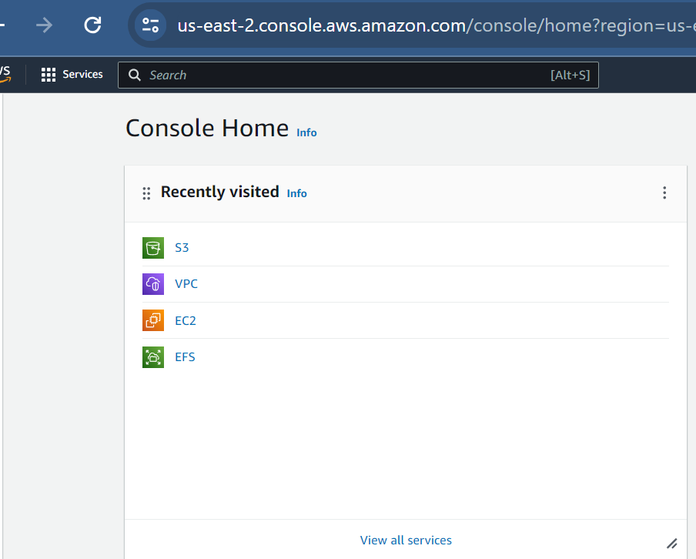

Go to home and search for s3 and click on s3 you will be visible as shown below

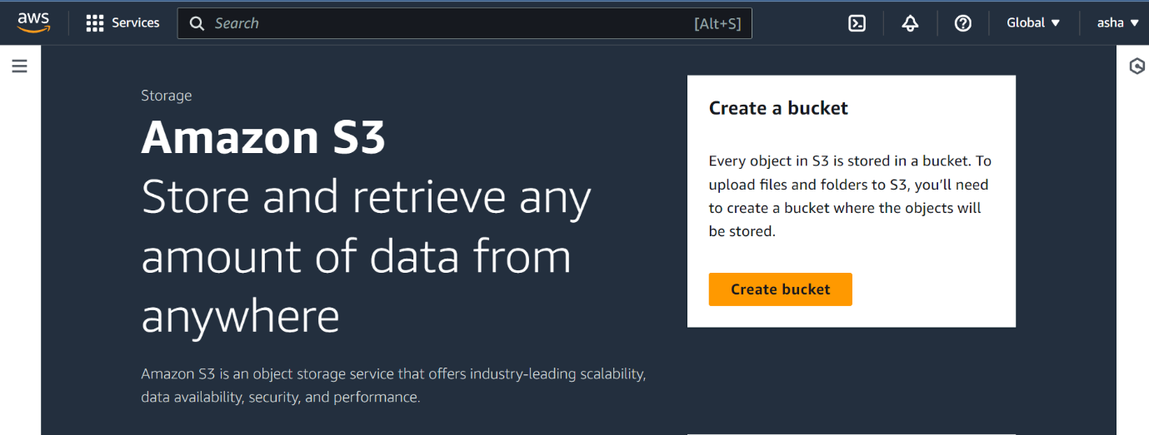

Then click on the create bucket option

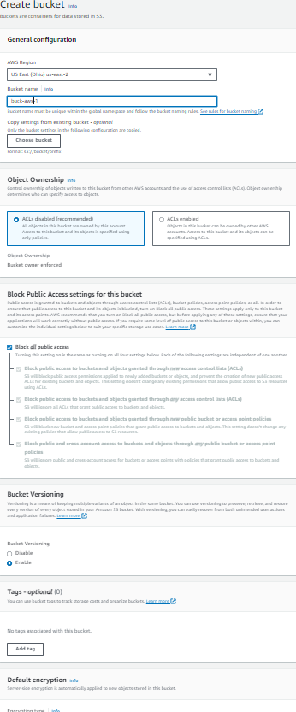

Enable bucket versioning as shown in above

As same as the bucket create another bucket

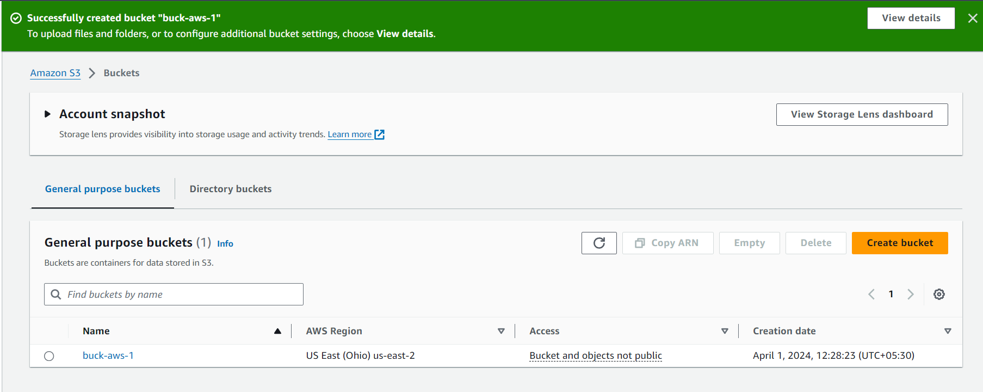

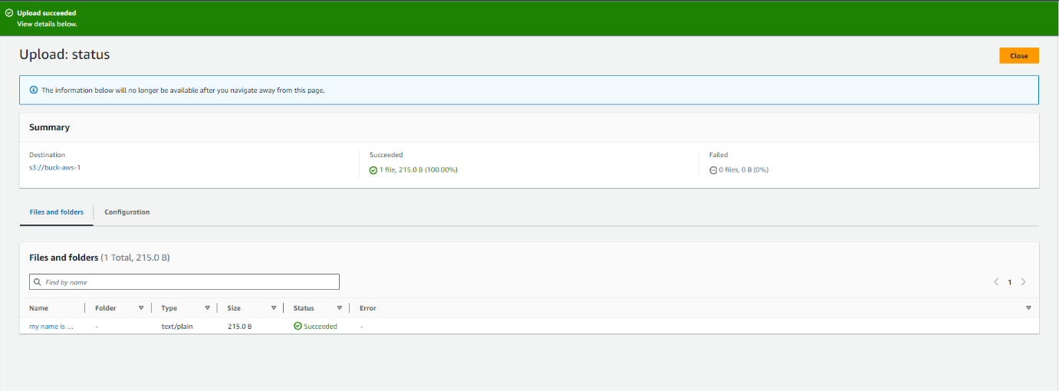

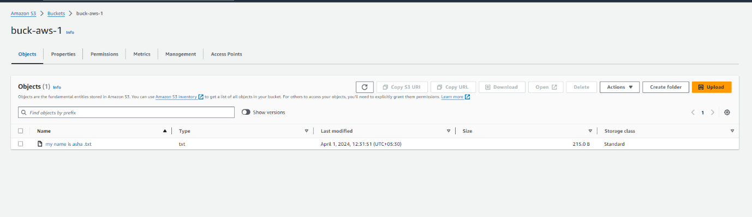

Then create a replication rule

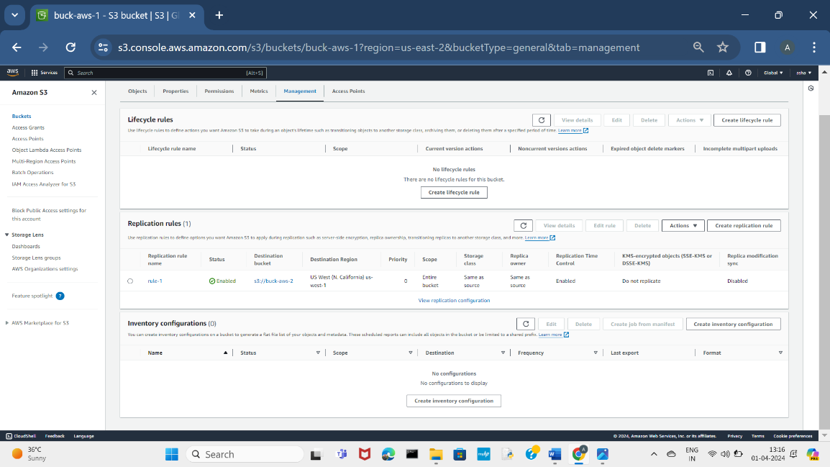

After creating replication rule job application will be created