**Attendance Management System**

**Group 18**

Asha Latha Nagathota

Pavan Sai Varma Budde

Rahul Muralidhara Koushik

Sree Valindha Maddineni

**Sprint Grooming:**

In the sprint grooming meeting, the team members or the scrum team had a discussion on the approach that must be taken to complete the project. The main objective of this project is to plan the execution of the Attendance Management project. The following activities are done as the part of sprint grooming:

* A detailed discussion took place between the team members on the user stories and Product Backlog Items were created.
* The product backlog items arranged on basis of priority.
* Next, we have assigned story points to the Product backlog Items.
* The Story points are not randomly decided but with a majority vote, for this purpose we have used Planning Poker as our story point estimation platform
* We have followed Fibonacci number system in assigning story points to the user stories.
* A new sprint is created with the name ‘CSE563Sprint01’. The sprint started on 24 November and ends on 3 December.
* We have divided the user stories among ourselves and moved the stories to the sprint task board.

**Product Backlog Items:**

We have finalized on 8 product backlog items and added it to our sprint backlog. The product backlog items are:

1. Menu
2. View About Team
3. Load a Roaster
4. Add Attendance
5. Save
6. Plot Data
7. Visualize Data
8. Integration

We have assigned the Story Points to our Product Backlog Items using the story points estimation tool Planning Poker. Below is the instance of our estimation step.

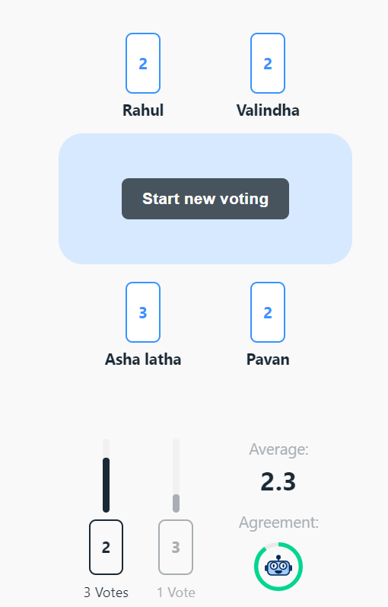

After assigning story points we have assigned these product backlog items among the team members. The final PBI’s with story points and Assigned team member is:

|  |  |  |
| --- | --- | --- |
| **PBI** | **Story Points** | **Assigned Member** |
| **Menu** | 3 | Rahul Muralidhara Koushik |
| **View About Team** | 2 | Rahul Muralidhara Koushik |
| **Load a Roaster** | 5 | Asha Latha Nagathota |
| **Add attendance** | 5 | Pavan Sai Varma Budde |
| **Save** | 3 | Asha Latha Nagathota |
| **Plot Data** | 3 | Sree Valindha Maddineni |
| **Visualize Data** | 3 | Sree Valindha Maddineni |
| **Integration** | 3 | Pavan Sai Varma Budde |

Next, we moved all the Product backlog Items into ‘CSE563Sprint01’ sprint.

**Sprint Task Board:**

The user stories are displayed in the Sprint Task Board. The next step is to create tasks under the user stories.

The Team members created tasks under their respective stories in the Sprint Task board. The tasks under each story are

1. Menu
   1. Learn about Jframe and Initial Setup
   2. Adding Main options for view file menu and view about options
   3. Adding sub options for View File Menu
   4. Add Listeners

2) View About Item

a) Sprint planning and design

b) Create a view containing team details

3) Load a Roaster

a) Sprint Planning and design

b) Interface to get the CSV file

c) Read the file

d) Load the file data on the screen in tabular form

4) Add Attendance

a) Sprint Planning and Design

b) Display the updated data

c) Merge attendance and Roaster data

d) Load data from the CSV

e) Add attendance view

5) Save

a) Display Successful Message

b) Save to user selected CSV file

c) Create a GUI to get the file path

6) Plot Data

a) Learn JFreeChart Library

b) Create a scatter plot

c) Add x-axis to the chart

d) Add y-axis to the chart

7) Visualize Data

a) Planning and Preparation

b) Create a table

c) Add Scrollbars for Jtable

8) Integration

a) Component Testing

b) Integrate all the components

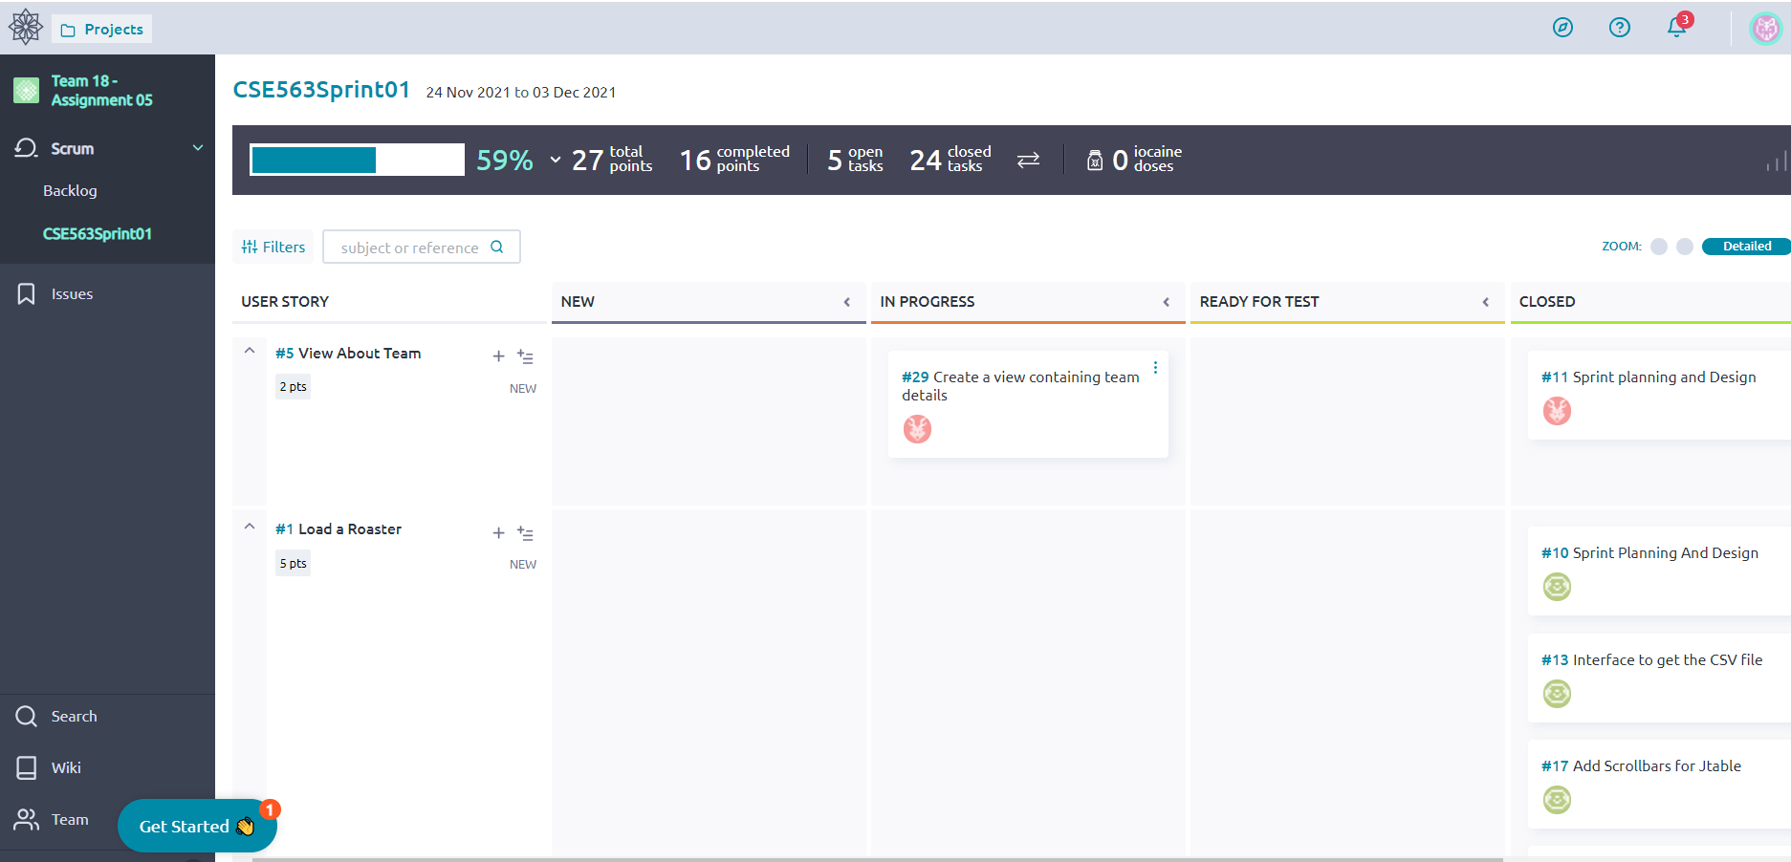

**Sprint Review:**

Our Sprint started on Nov 24. Below are the events that took place in the sprint:

* Nov 24- 2 of the Sprint Planning tasks are closed
* Nov 25-28 - Learning and Execution Preparation
* Nov 29 - Development started for the project
* Nov 30 – 7 tasks are closed as part of execution
* Dec 1 – 6 of the development tasks are closed
* Dec 2 – 7 of the tasks are closed
* Dec 3- Remaining 6 tasks are closed and Sprint Retrospective took place

**Burndown Chart:**

Below is the Burndown chart for the sprint.

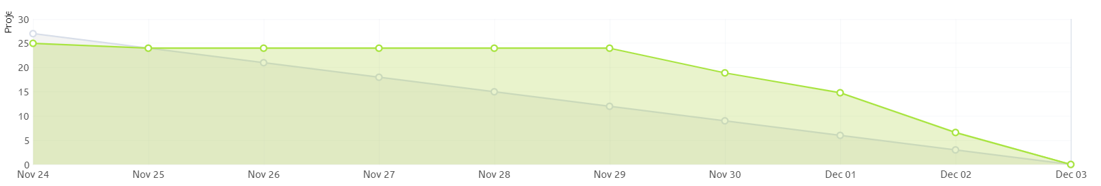

**Sprint Retrospective:**

Sprint retrospective meeting on Dec 03.

**What went well:**

* All the team meetings went as planned.
* Everyone in the team was committed to seeing the project through to completion.
* Team collaboration in fixing the issues.
* Finally, we were able to meet the deadline in delivering the project.
* We had a diverse team, so we were able to help each other in times of need.

**What we learned:**

* We got familiar with Taiga interface and tools in it.
* We learned about the Java Swing framework and java libraries.
* We learned how to plan and accomplish a job within the deadline.
* Being in a group project and learning how to work as a team was a new experience for us.

**What did not go as planned:**

* Initial hiccups in setting up the environment.
* We had no prior experience with these technologies; therefore, we had some difficulties in fully comprehending them.
* During the execution phase, we ran into several issues.
* We are short of one teammate, so it has been tough on us.

**Bibliography:**

* <https://docs.oracle.com/javase/7/docs/api/javax/swing/JFileChooser.html>
* https://www.tutorialspoint.com/how-to-read-the-data-from-a-csv-file-in-java
* <https://www.javatpoint.com/java-jtable>
* https://www.javatpoint.com/jfreechart-scatter-chart
* stackoverflow