**Introduction**

[Blockchain technology](https://www.salesforce.com/eu/blog/2020/01/how-does-blockchain-technology-work.html) is a decentralised, distributed, and public ledger that is used to record transactions across many computers within a network. Because of its design and properties, blockchain is secure, transparent, and nearly impossible to alter.

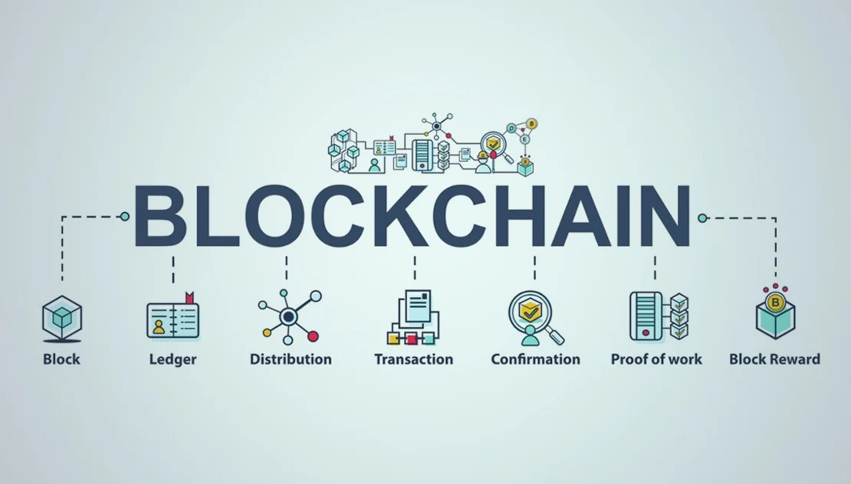

In the [finance industry](https://www.salesforce.com/eu/solutions/industries/financial-services/financial-services-cloud), this underlying technology allows the transfer of currency with confidence that the transaction is secure and reliable.

The benefits of blockchain come from the following properties:

* Distribution: Numerous copies of the ledger exist throughout the network. Each time a new transaction and block are added, everyone within the network receives a copy. No single entity controls the ledger, but the system is designed to provide everyone with the same information.
* Immutability: A blockchain provides an accurate, chronological history of transactions. Because each person within the network has a copy, it’s nearly impossible to alter or erase transactions or to add information that hasn’t been verified. Doing so successfully would require a coordinated attack on hundreds – or even hundreds of thousands – of computers simultaneously, which is unlikely.

**Money transfers**

* Transferring money to other countries presents many problems and challenges for consumers and financial institutions. People send billions of dollars internationally each year, and the process is usually expensive, laborious, and error prone.
* Blockchain can change all that. Many major banks have adopted international payments with blockchain technology, which saves time and money. Consumers can also use blockchain money transfers to complete electronic transfers with mobile devices, avoiding the cumbersome process of visiting a money transfer

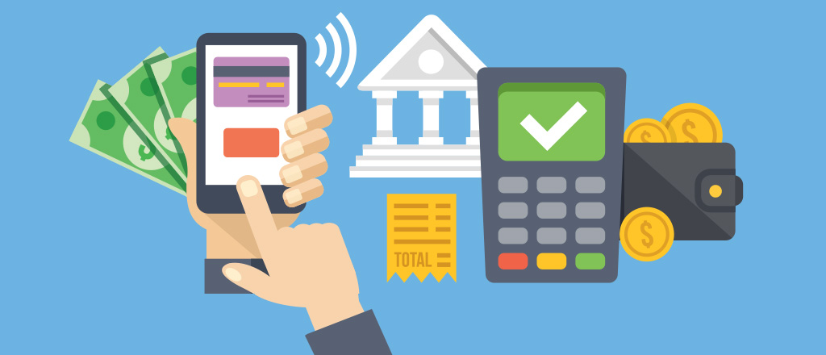

### Inexpensive, direct payments

Most funds move through financial institutions, such as banks or credit card processing centres. Each of these steps adds a layer of complexity, along with fees that can become costly.

The benefits of blockchain-based transfers for merchants include:

* Reduced fees: When customers pay with a credit card, merchants pay processing fees that cut into profit. Blockchain payments reduce or eliminate fees by streamlining the transfer process.
* Eliminated insufficient funds: Consumers sometimes pay for goods or services with a bad cheque, which causes a loss and additional fees for merchants, as well as the possibility of a legal hassle to recover. Blockchain-based payments can give merchants the confidence of knowing that the transaction is good within a few seconds or minutes.

**The benefits of blockchain-based transfers for individuals include:**

* Fewer scams: Online scams are a concern for many individuals, but blockchain-based payments are quick and reversible. They’re also less expensive than using banking services, especially for pricey items.
* Less time and money: The safest payment methods are cash, wire transfers, and cashier’s cheques, but cash is untraceable, wire transfers are time-consuming, and cashier’s cheques can be forged. With blockchain-based payments, all of these issues are removed for greater confidence.

### Transaction details

Money transfers aren’t the only way blockchain can revolutionise banking. Blockchain is an excellent method of tracking transactions and ensuring accurate, secure information, such as:

* Title details: A distributed ledger is nearly impossible to alter, making it easier to track ownership. Transfers of ownership and liens can refer to the ledger to verify the information, so there’s more trust.
* Smart contracts: Transactions can be costly, complex, and time-consuming, but blockchain offers an opportunity for automation. Smart contracts can track when a buyer pays and when the seller delivers, as well as address any problems that come up during the process. Automated systems also reduce human error and work 24/7.

### Financial inclusion

Blockchain’s low costs give startups a chance to compete with major banks, promoting financial inclusion. Many people are looking for an alternative to banks because of restrictions like minimum balance requirements, low access, and banking fees. Blockchain can provide an alternative that uses digital identification and mobile devices, free from the hassle of traditional banking.

### Reduced fraud

Blockchain stores information in a ledger with transaction information within each block, along with a unique hash that refers to the previous block. Every person within the network receives a copy of the transactions as well. Because of these features, blockchain technology is resistant to distributed denial-of-service attacks, hackers, and other types of fraud.

Without the threat of cyber attacks, the expense of conducting business is reduced, helping all parties involved save money and stress.

### Cryptocurrency

Digital currencies are the new wave of assets that rely on blockchain. Though digital currency is already in use, blockchain companies are lowering the barrier of entry and providing a seamless exchange of the most popular cryptocurrencies as a banking alternative.

### Risks that Blockchain and Financial Institutions Face

Weighing against the promise blockchain holds for financial institutions is one major risk affecting the bottom line: Traditional financial institutions make money on transaction fees that could be lowered or eliminated with blockchain technology.

When it comes to transferring money, consumers have to rely on banks or third parties to process transactions.

But adoption of blockchain could bypass third parties such as banks, which would eliminate fees and other costs associated with these services. As a result, banks may face challenges in volume and transaction-based revenue.

Another approach investors can take is investing in [cryptocurrency](https://money.usnews.com/investing/cryptocurrency/slideshows/whats-the-best-cryptocurrency-to-buy)-oriented stocks that serve as a pure play for blockchain investments. MicroStrategy Inc. ([MSTR](https://money.usnews.com/investing/stocks/mstr-microstrategy-inc-ordinary-shares-class-a)) fits the bill here. The software solutions company holds more than 105,000 bitcoins, a portfolio valued at more than $5 billion.

Square Inc. ([SQ](https://money.usnews.com/investing/stocks/sq-square-inc-ordinary-shares-class-a)) is another company that's heavily invested in Bitcoin and strongly believes in the blockchain network. The payment services company recently announced that it will launch a decentralized finance platform with a focus on Bitcoin applications.

Investors are taking notice of these stocks and their potential. MicroStrategy is up about 80% year to date, and Square has seen a year-to-date rise of 23%. That's compared with the S&P 500's year-to-date return of about 20%. Investing in these publicly traded companies allows you to broadly invest in the blockchain without having direct exposure to the volatility and speculation associated with some cryptocurrencies.

For investors looking to further hedge their risk against Bitcoin speculation and volatility, exchange-traded funds may be a better option. Amplify Transformational Data Sharing ETF ([BLOK](https://money.usnews.com/funds/etfs/technology/amplify-transformational-data-shrg-etf/blok)) offers investors exposure to companies that are positioned to profit from the development of blockchain technology. Since the fund's inception in 2018, it has returned 150%, making it a profitable investment option

**The future of blockchain in finance:**

* At this point, we are still in the early stages of both blockchain's development and its use in the financial services industry. Two of the biggest [blockchain](https://www.fool.com/the-ascent/cryptocurrency/blockchaincom-review/) developments to look out for are improvements in transaction processing and interoperability, both of which should make it more useful for financial institutions.
* Earlier blockchains were limited in terms of transaction processing. [Bitcoin](https://www.fool.com/investing/stock-market/market-sectors/financials/cryptocurrency-stocks/bitcoin/) can only process about three to five transactions per second, and [Ethereum](https://www.fool.com/investing/stock-market/market-sectors/financials/cryptocurrency-stocks/ethereum-stock/) can currently only handle about 10 to 15. That is not nearly enough to compete with major payment processors like Visa, which can handle about 1,700 transactions per second.
* More recent blockchains have prioritized scalability with faster transactions. The most notable cryptocurrency project in this regard is Solana ([CRYPTO:SOL](https://www.fool.com/quote/crypto/sol/)), which boasts peak transaction times of 65,000 per second.
* Another change we are seeing is a shift toward interoperability. Most blockchains to this point have been self-contained projects. However, multiple projects have emerged with the goal of facilitating communication between those various blockchains.
* Blockchains will not completely replace existing financial systems anytime soon. Instead, expect financial companies to use blockchain in test runs to see its capabilities and then gradually integrate it as a supplement to their existing systems.
* Implementing blockchain technology comes with its difficulties. Despite the challenges, hundreds of financial companies have started using it, and [blockchain stocks](https://www.fool.com/investing/stock-market/market-sectors/financials/blockchain-stocks/) have become popular investment opportunities. The industry understands the potential advantages and that blockchain will be a growing part of financial services going forward.