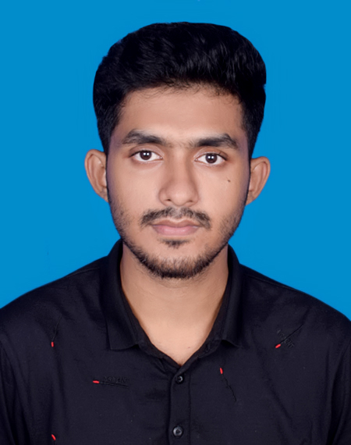
Resume of Ashadul Islam

Mailing Address: Bashail, Rajihar, Agailjhara, Barishal
Mobile : +8801718069307 (WhatsApp)
Email : ashadulmridhaprog@gmail.com
ashadulislam708@gmail.com
Website : https://ashadulmridha.com
LinkedIn : ashadulmridha
GitHub : ashadul-mridha
Behance : ashadulmridha9

CAREER OBJECTIVE:

To be a smart & innovative person who can incorporate the new idea, technology, knowledge, experience & productivity for constructive involvement towards the emergent scenario of Information & Communication Technology. My skills and experiences must enhance the success of your industry and my personal development also.

WORKING EXPERIENCE:

- Laravel Developer at Decode Lab
Duties/Responsibilities: Backend Web Application Development as per client requirement.

- Laravel Developer Internship in Bd Task
Duties/Responsibilities: Backend Web Application Development as per client requirement.

- WordPress Expert at Fiverr

Duties/Responsibilities: Theme Customization, Ecommerce Web Application, Multivendor Web Application, Landing Page Design as per client requirement.

TECHNICAL SKILLS:

Programming Skills:

  - Laravel PHP Framework
  - PHP
  - JavaScript
  - Python(Basic)
  - HTML5
  - CSS3
  - Bootstrap
  - WordPress (CMS), jQuery, Ajax.

Database Skills:
MySQL
Programming and Designing Tools:
Visual Studio Code, PhpStorm
Operating Systems:
Windows
Version Control Tools:
Git, GitHub, Gitlab
Others Computer and Network Literacy’s:
Microsoft Office, Adobe Photoshop, LAN Settings.

ACADEMIC QUALIFICATIONS:

Exam Title | Institute | Board/University | Result | Pass Year
Diploma-in-Computer Engineering (4 years) | Barisal Polytechnic Institute | Bangladesh Technical Education Board. | C.G.P.A. 3.73(On the Scale  4.00) | 2020
S.S.C (Secondary School Certificate) | Bashail Secondary School, Barisal | Barisal Board. | G.P.A.  4.56(On the Scale  5.00) | 2016
J.S.C (Junior School Certificate) | Bashail Secondary School, Barisal | Barisal Board. | G.P.A.  5.00(On the Scale  5.00) | 2013

PERSONAL AND INTERNSHIP PROJECT:

1. Inventory Management System with POS

Used Tools and Technologies: Laravel 8, Html, CSS, Bootstrap, Ajax.

2. Todo App.

Used Tools and Technologies: Laravel and Bootstrap.

3. Student Management System.
Live Preview: http://sms.ashadulmridha.com
Used Tools and Technologies: Raw Php, Html, CSS, Bootstrap.

4. Ecommerce Web Application.
Live Preview: https://ondemand.com.bd

Used Tools and Technologies: WordPress, Elementor.

5. Village International Web Application.
Live Preview: https://villageinternationalbd.com/
Used Tools and Technologies: Laravel 8, PHP, JS, Html, CSS, Bootstrap, Ajax.

PERSONAL DETAILS:

Name : Ashadul Islam
Father’s Name : Habul Mridha
Mother’s Name : Jeba Begum
Date of birth : 05th August, 2000
Nationality : Bangladeshi by birth
National ID Number : 9158338971
Language : Bengali and English (Formal & Fluent)
Religion : Islam
Sex : Male
Marital Status : Unmarried
Permanent Address : C/O: Habul Mridha, Vill+P.O: Bashail, P.S: Agailjhara,
Dist: Barisal, Bangladesh.

REFERENCES:

Sincerely,

………………………
(Ashadul Islam)

