Objective: To make a study of the stock market in the USA, for this you have to pass some data from the Investing and Zacks websites, and pass it to an Excel.

In this Excel, a main page should appear where the summary of each company is. And also, there should be a sheet for each company that is estimated (5900 Excel sheets).

It may be necessary to create a free Investing account.

1. Investing page: https://es.investing.com/stock-screener/?sp=country::5|sector::a|industry::a|equityType::a|exchange::a|eq_market_cap: : 200000000,1360000000000% 3Eeq_market_cap; 1

to. We give the options that appear at the top right of the table, and we put criteria: "Name", "Symbol", "Market", "Sector", "Industry", "Cap. Market ”and“ Vol. ” (if other options appear predetermined we remove them); and we accept.

b. We copy all the data from the table of all the pages that are shown on the page (approximately 5879 companies, the data may vary a little)

2. Enter each link of the company that appears in the search results.

to. Once we enter the link, click on "historical information"

i. Click on the calendar that appears on the right and put the start date 01/01/2012, and then accept

ii. Once this is done, we check that in the left area where it says "term" is "daily"

iii. Later we download the data using the button "download data" and we pass it to excel.

b. To continue with the extraction, click on the "Fundamental" tab and then on "results".

i. We go down until when a table appears where the "publication date" of the results appears, now we click on "show more", and we will continue clicking until this option disappears.

ii. Once this is done, we copy the table and pass it to Excel.

3. Once in Excel, it must be ordered in such a way that: to. The first sheet must be blank b. The second should appear the data of the first download c. Then, the information of each company will go on different sheets, that is, one sheet for each company (5906 companies).

4. Now we need to scrape the zacks page, Link: https://www.zacks.com to. On the zacks website, a search bar appears at the top right, in it we put the symbol of the company (the symbol or ticker, is like "the license plate" of the company, for example the Apple symbol is aapl) , the company symbol must appear in the second column of the 2nd Excel sheet.

b. Once we have searched, the company name will appear, and a small table will appear below, click on “Exp Earning Date

c. Then another table will appear, under this table, we will see a small rectangle where “show 10 entries” appears, since we change it and put “show 50 entries”, once this is done, we copy the table and pass it to Excel, and you should go to the sheet of the company to which that data corresponds.

5. After having scraped the necessary data, we are going to order the information in a specific way, on the page of each company it should look like this: (Final image, after adding filters and some corrections)

a) Some modification must be made to the information extracted:

to. In box A1, we will put the name of the company; in box B1, we will put the ticker.

b. In the column where it says "Vol.", We will remove the M, and in case B comes out, we will multiply it x1000; for example

c. In the investing results data, we have to remove all “Slash /” or “slashes /”

d. Also in the data of the results, we must put the units of the income in the same measure and we must eliminate the letters, in this case, the income will be measured in Millions, so, when a B comes up, we will multiply it x1000, and when M comes out, we just have to delete M.

and. Lastly, you must ensure that the date of the Investing and Zacks results must coincide in the same row; see in the image in yellow.

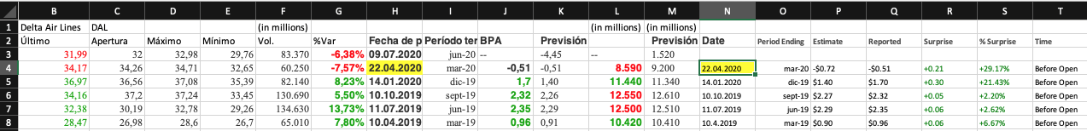

F. On the other hand, the dates provided by Investing and Zacks are in a different order, in Investing it is: Day.Month.Year, and in Zacks it is: Month.Day.Year, this should be corrected, in such a way that both have the same order: Day.Month.Year (In the previous image it is already changed)

6. In the "Results Sheet", we will do the following:

to. In the first row, we will put a search engine to search in the first column for the company, and it will automatically lower us there, but it will not change our pages.

b. Also in the first column, we will put a link in each company to take us to your specific sheet in Excel.

7. Finally, all the data should be able to be updated automatically by means of a button on the "results" page that will be called "update".

Possible mistakes:

1. It is more than likely that some companies are missing from the Zacks page.

2. In Investing, in the table of the results and in the historical information, some companies will lack data.

3. Please, if the slightest doubt arises, please ask me.