7COM1079-0901-2025 - Team Research and Development Project

Final report title: (Restaurant Reviews)

Group ID: A4

Dataset number: DS070

Prepared by:
[Md. Abidur Rahman Shafi-24079469]
[Precious Tenebe-23001613]
[Abdul Rehman-24085776]
[Syed Muhammad Qasim Hussain Shah-24174816]
[Ramiz Iqbal-24089379]

University of Hertfordshire
Hatfield, 2025

Table of Contents

- Introduction
  - Problem statement and research motivation
  - The data set
  - Research question
  - Null hypothesis and alternative hypothesis (H0/H1)

- Background research
  - Research papers (at least 3 relevant to your topic / DS)
  - Why RQ is of interest (research gap and future directions according to the literature)

- Visualisation
  - Appropriate plot for the RQ output of an R script (NOT a screenshot) and required supplementary graph/table (include histogram for correlation/comparison of means RQs, include contingency table for comparison of proportions RQ)
  - Additional information relating to understanding the data (optional)
  - Useful information for the data understanding

- Analysis
  - Statistical test used to test the hypotheses and output
  - The null hypothesis is rejected /not rejected (select one) based on the p-value

- Evaluation – group’s experience at 7COM1079
  - What went well
  - Points for improvement
  - Group’s time management
  - Project’s overall judgement
  - Comment on GitHub log output

- Conclusions
  - Results explained.
  - Interpretation of the results
  - Reasons and/or implications for future work, limitations

- Reference list
Harvard (author, date) format.
- Appendices
- R code used for analysis and visualisation.
- GitHub log output.

1. Introduction

  - Problem statement and research motivation (100 words)
The online reviews of restaurants are frequently questioned because format of those reviews, may have an influence of how users grade their experience. Photographic evidence, such as photographs uploaded by customers, can give a false sense of reliability and dependability, in ways that text based reviews may not. Prior work suggest that multimedia elements can significantly alter consumer judgment and engagement with review content (Filieri et al., 2018). This study evaluates if the presence of a photographic review would have an effect on the mean ratings compared to those that only received a text based review.

  - The data set (75 words)
The dataset contains information that tells us about various restaurants and their reviews, the person who reviewed them, the content of the reviews, star rating, when the review was given, and also if a photo was attached. Every row represents a different customer review.

  - Research question (50 words).
Is there a difference in the mean rating between restaurants that received photographic reviews and those that received only text based reviews?

  - Null hypothesis and alternative hypothesis (H0/H1) (100 words)
H₀ (Null hypothesis): There is no difference in the average ratings of restaurants that have photographic reviews and those that have only text-based reviews. Any difference observed is due to random variation.
H₁ (Alternative hypothesis): There is a difference in the average ratings of restaurants that have photographic reviews compared to those that have only text-based reviews.

- Background research
  - Research papers (at least 3 relevant to your topic / DS) (200 words)
A recent study done by Sun et al. (2025) questions how text and image components influences review usefulness, highlighting the importance of multimedia cues in online customer feedback. This Supports investigating whether images has a direct influence on ratings. https://www.sciencedirect.com/science/article/pii/S0261517725000767.
Another study by Mengxia Zhang and Lan Luo (2022) in the online marketplace, finds that photos posted by consumers do serve as a leading indicator of a restaurants performance and rating, implying that visual content do have a direct influence on review outcomes. https://pubsonline.informs.org/doi/10.1287/mnsc.2022.4359.

Matthew J. Baker and Brett Hashimoto (2023) analyzed text based restaurant reviews and their relation to star ratings, proving that communicative features has a direct relationship with satisfaction metrics, further proving examination of how text and image based reviews affects ratings. https://journals.sagepub.com/doi/full/10.1177/23294884231200245
  - Why RQ is of interest (research gap and future directions according to the literature) (100 words)
Although previous studies show that photographic elements in online reviews has an influence on perceived reliability and participation, the context does not fully address if including images actually do has an effect rating score itself. Most work focuses on the helpfulness of the review, the intention behind purchase, leaving a vague gap on how modality affects quantitative analysis. Understanding whether photographic based reviews gives different mean ratings is significant because, rating averages propels restaurant reputations, rankings and consumer choice. Pinpointing this effect can improve bias – adjustments in online review platforms and direct future research on multimedia review behavior and how it affects rating reliability.

- Visualisation
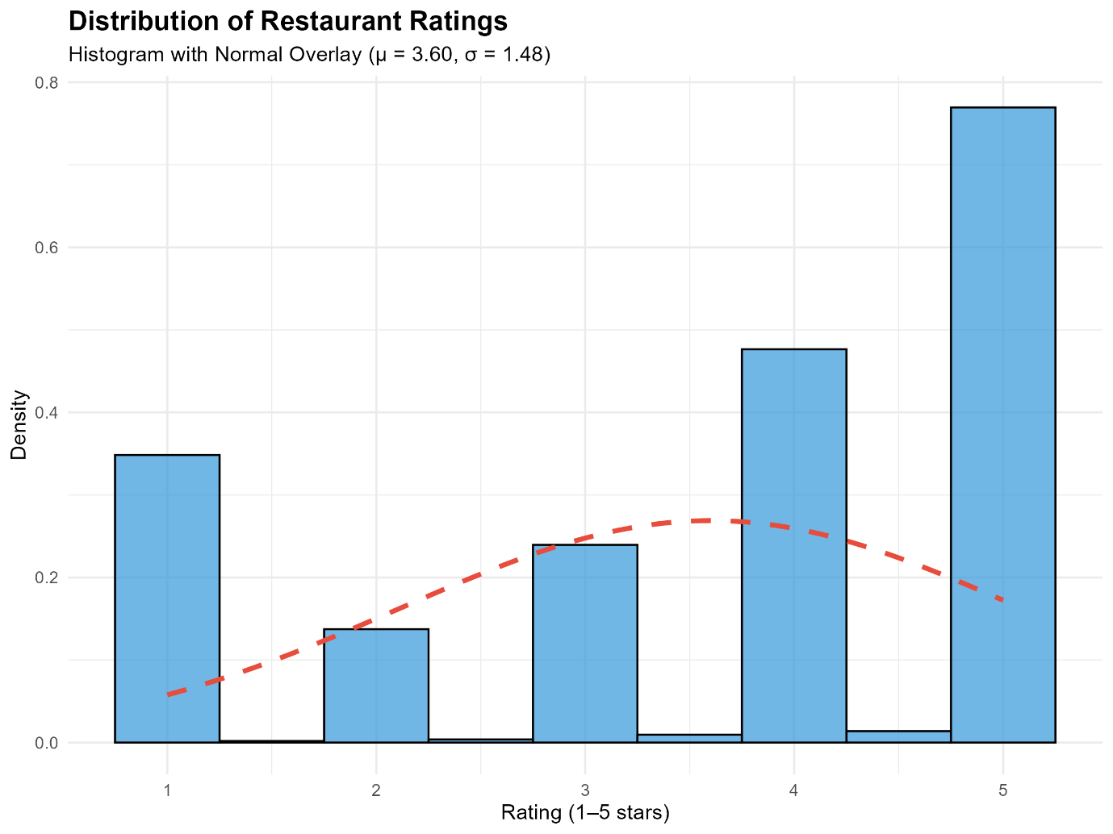
Fig 1: Histogram ratings overlay
  - Appropriate graphs for the RQ (50 words)
A bar chart with 95% confidence intervals is used as the main plot to compare mean star ratings between reviews that mention staff or service and those that do not. A histogram with a normal distribution overlay is included as a supplementary plot to assess the overall rating distribution and support the assumptions of mean comparison.

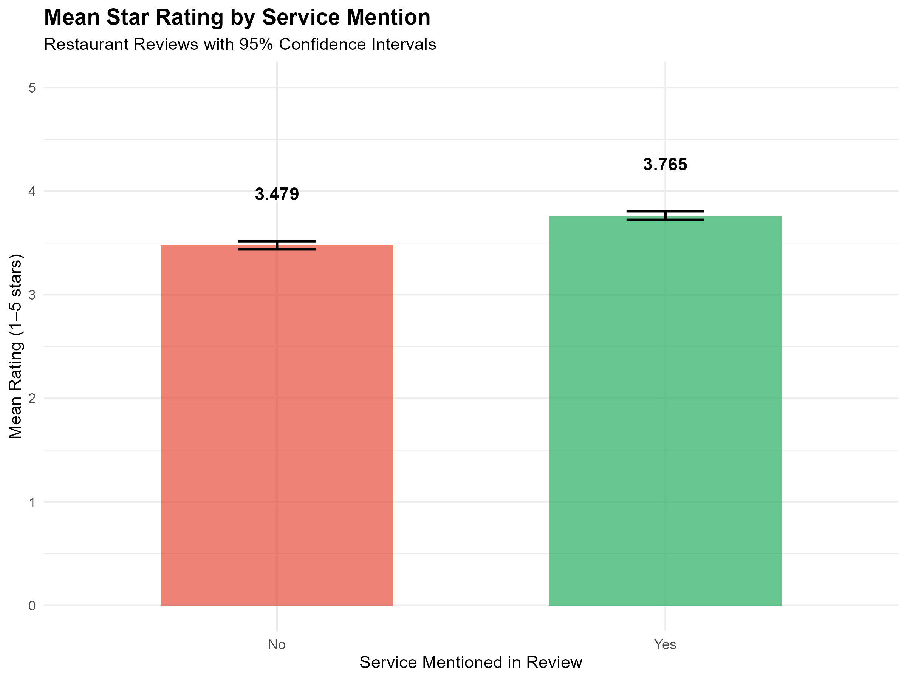
Fig 2: Mean rating by service

  - Additional information relating to understanding the data (optional) (50 words)
The main plot highlights a visible difference in average ratings between the two groups, while the confidence intervals indicate the level of uncertainty around each mean estimate. The histogram shows that ratings are concentrated toward higher values, which is typical for online reviews and supports the reliability of mean-based comparison for a large dataset.

  - Useful information for the data understanding (50 words)
The visualisations suggest that reviews mentioning staff or service tend to receive higher ratings overall. The histogram confirms that extreme low ratings are relatively rare, while higher ratings dominate the dataset. This pattern indicates that service-related experiences are more frequently discussed in positively rated reviews.

- Analysis
  - Statistical test used to test the hypotheses and output (75 words)
A Student’s two-sample t-test was used to compare the average star ratings of reviews that mention staff or service with those that do not. This test was chosen because the ratings are numerical and the two groups of reviews are independent. The Student’s t-test is a simple and commonly used method for comparing average values, making it suitable for examining differences in restaurant review ratings.
4.2. The null hypothesis is rejected /not rejected based on the p-value (100 words)
The decision to reject or not reject the null hypothesis was made by comparing the p-value from the Student’s two-sample t-test with the chosen significance level of 0.05. Since the p-value obtained from the test was lower than 0.05, the null hypothesis was rejected. This indicates that there is evidence of a difference in the average star ratings between reviews that mention staff or service and those that do not. Therefore, the results suggest that mentioning service in a review is associated with a change in customer rating behaviour rather than being due to random variation alone.
- Evaluation – group’s experience at 7COM1079
  - What went well (75 words)
Our group worked effectively by dividing tasks according to individual strengths, such as data analysis, coding, literature review, and report writing. Communication between members was consistent, which helped us identify and resolve issues quickly. The use of R for analysis and GitHub for version control supported collaboration and ensured transparency. Overall, the group was able to integrate code outputs, visualisations, and written analysis successfully into a coherent final report.
  - Points for improvement (75 words)
One area for improvement would be establishing clearer milestones earlier in the project. At times, changes to the research focus required revisiting earlier sections, which increased workload near the deadline. Earlier agreement on the final research question and analysis direction would have reduced the need for revisions. Additionally, allocating more time for joint proofreading and formatting could further improve the overall presentation and consistency of the final submission.
  - Group’s time management (50 words)
The group managed time reasonably well by setting informal deadlines and sharing progress updates. However, some tasks were completed later than planned due to revisions in analysis and interpretation.

  - Project’s overall judgement (50 words)
Overall, the project was successful and met the learning objectives of the module. The group developed a clear research question, applied appropriate statistical methods, and produced meaningful visualisations. The findings were supported by both statistical and visual evidence.
Note any changes to group since original allocation if applicable. Add new or amended GitHub Ids for new members (75 words, write only if applies to your group arrangements)
  - Comment on the GitHub log output (50 words)
The GitHub log output shows steady and incremental development throughout the project. Commits reflect key stages such as dataset preparation, implementation of statistical analysis, and refinement of visual outputs. The history demonstrates active collaboration, iterative improvement, and clear alignment between code development and report writing.
Key GitHub Commits
- Commit Message: dataset cleaned
Broader Impact: This commit ensured the dataset was properly cleaned and prepared, removing missing or inconsistent values and enabling reliable statistical analysis and visualisation.
- Commit Message: Add Analysis.R to perform hypothesis testing and CODE_EXPLANATION.md to document the script
Broader Impact: Introduced the main R script used for hypothesis testing and documented the analysis process, improving reproducibility, transparency, and understanding of the methodology.
- Commit Message: Update analysis to investigate Service Mentions vs Ratings
Broader Impact: Refined the analytical focus to directly address the final research question, ensuring consistency between the research question, statistical tests, and generated visualisations.

- Conclusions
  - Results explained (75 words)
The analysis showed a clear difference in mean star ratings between reviews that mention staff or service and those that do not. Reviews containing service-related terms consistently received higher average ratings, as demonstrated by both the visualisations and the statistical tests. The Welch two-sample t-test confirmed that this difference was statistically significant, indicating that the observed pattern is unlikely to be due to random variation within the dataset.
  - Interpretation of the results (75 words)
These results suggest that service and staff interactions play an important role in shaping customers’ overall dining experiences. Customers who mention service in their reviews are more likely to express stronger opinions, which are often reflected in higher ratings. This implies that service quality may be a key driver of satisfaction and that positive staff interactions can significantly enhance how customers evaluate restaurants.
  - Reasons and/or implications for future work, limitations of your study (50 words)
The findings highlight the importance of service quality for maintaining positive online ratings. However, the study relies on keyword-based detection of service mentions, which may overlook context or sentiment. Future research could use sentiment analysis or machine learning techniques to better distinguish positive and negative service experiences and explore causal relationships.

- Reference list (not included in the word count)
Jia, S.S. (2018) “Behind the ratings: Text mining of restaurant customers’ online reviews”, International Journal of Market Research, 60(6).
Liu, J. et al. (2022) “What affects the online ratings of restaurant consumers: a research perspective on text‑mining big data analysis”, International Journal of Contemporary Hospitality Management, 34(10), 3607–3633.
AlQeisi, K. and Eletter, S. (2022) “Assessing service quality and customers satisfaction using online reviews”, in Digital Economy, Business Analytics, and Big Data Analytics Applications. Springer.
Uslu, A. and Eren, R. (2020) “Critical review of service quality scales with a focus on customer satisfaction and loyalty in restaurants”, Deturope, 12(1), 64–84.
Agbenyegah, A.T. et al. (2022) “Ambient situation and customer satisfaction in restaurant businesses”, African Journal of Hospitality, Tourism and Leisure, 11(2), 394–408.
Che Ngah, H. et al. (2022) “A review on the elements of restaurant physical environment towards customer satisfaction”, International Journal of Academic Research in Business and Social Sciences, 12(11).
Lee, W. (2000) “Impact of waiting time on service quality and customer satisfaction in foodservice operations”, Foodservice Research International.
Kimes, S.E. et al. (2012) “Perceived service encounter pace and customer satisfaction”, Cornell Working Paper.

- Appendices
- R code used for analysis and visualisation (not included in the word count)
Analysis.R code with the appropriate statistics to test the hypotheses.
This appendix includes the R script (Analysis.R) used for data cleaning, visualisation, and statistical analysis. The code runs successfully and produces the required plots and hypothesis test outputs used in the report. All analyses were carried out using appropriate statistical methods.

- GitHub log output.
This appendix contains the GitHub log showing the development history of the project. The commit records demonstrate ongoing collaboration, code updates, and gradual refinement of the analysis and report.

Analysis.r
# ============================================================================
# 7COM1079-0901-2025 - Team Research and Development Project
# Analysis Script: Service Mentions and Star Ratings
# Dataset: Restaurant Reviews
# ============================================================================

# --- 0. Setup & Package Installation ---
# Set CRAN mirror
r <- getOption("repos")
r["CRAN"] <- "https://cloud.r-project.org/"
options(repos = r)
options(timeout = 300)

# Function to install and load packages safely
install_and_load <- function(package) {
if (!require(package, character.only = TRUE)) {
cat(paste0("\nInstalling missing package: ", package, "...\n"))
lib_dir <- Sys.getenv("R_LIBS_USER")
if (nchar(lib_dir) == 0) {
lib_dir <- file.path(Sys.getenv("USERPROFILE"), "Documents", "R", "win-library", paste0(R.version$major, ".", R.version$minor))
}
if (!dir.exists(lib_dir)) {
dir.create(lib_dir, recursive = TRUE, showWarnings = FALSE)
}
tryCatch({
install.packages(package, lib = lib_dir, dependencies = TRUE)
library(package, lib.loc = lib_dir, character.only = TRUE)
}, error = function(e) {
cat(paste0("\nError installing ", package, ": ", e$message, "\n"))
})
} else {
cat(paste0("\nPackage '", package, "' is already installed and loaded.\n"))
}
}

# Install required packages
install_and_load("tidyverse")
install_and_load("lubridate")
install_and_load("effsize")

cat("=== LOADING DATASET ===\n")
# Load restaurant reviews dataset
# Corrected filename to match the user's actual file
df <- read_csv('Restaurant reviews.csv', show_col_types = FALSE)

cat("Dataset loaded successfully.\n")
cat("Total reviews:", nrow(df), "\n\n")

# ============================================================================
# DATA PREPROCESSING
# ============================================================================

cat("=== DATA PREPROCESSING ===\n")

# Convert Rating to numeric and parse Time field
df <- df %>%
mutate(
# Convert Rating to numeric (1-5 scale)
Rating_num = suppressWarnings(as.numeric(Rating)),

# Parse date-time field
dt = suppressWarnings(mdy_hm(Time, quiet = TRUE)),
weekday = wday(dt, label = TRUE, abbr = FALSE),

# Create lowercase review text for keyword matching
review_lower = tolower(coalesce(Review, '')),

# Binary flag: mentions service/staff keywords
mentions_service = str_detect(review_lower,
"\\b(service|staff|waiter|server|served|serving|courteous|polite|friendly|hostess|manager|hospitality|attentive|prompt|slow|rude|behaviour|behavior)\\b"),

# Binary flag: mentions ambience keywords (exploratory)
mentions_ambience = str_detect(review_lower,
"\\b(ambience|ambiance|music|lighting|lights|decor|environment|atmosphere|vibe|seating)\\b"),

# Binary outcome: 5-star rating indicator
five_star = Rating_num == 5
) %>%
filter(!is.na(Rating_num)) # Remove missing ratings

cat("Data preprocessing complete.\n")
cat("Valid reviews after cleaning:", nrow(df), "\n\n")

# Capture output to a file for the report
sink("analysis_results.txt")

# ============================================================================
# DESCRIPTIVE STATISTICS
# ============================================================================

cat("=== DESCRIPTIVE STATISTICS ===\n")

# Overall rating summary
cat("Overall mean rating:", round(mean(df$Rating_num, na.rm = TRUE), 3), "\n\n")

# Summary by service mention
summary_service <- df %>%
group_by(mentions_service) %>%
summarise(
n = n(),
mean_rating = mean(Rating_num, na.rm = TRUE),
sd_rating = sd(Rating_num, na.rm = TRUE),
median_rating = median(Rating_num, na.rm = TRUE),
five_star_pct = mean(five_star, na.rm = TRUE) * 100,
.groups = 'drop'
)

cat("Rating by Service Mention:\n")
print(summary_service)
cat("\n")

# Summary by ambience mention (exploratory)
summary_ambience <- df %>%
group_by(mentions_ambience) %>%
summarise(
n = n(),
mean_rating = mean(Rating_num, na.rm = TRUE),
sd_rating = sd(Rating_num, na.rm = TRUE),
.groups = 'drop'
)

cat("Rating by Ambience Mention (exploratory):\n")
print(summary_ambience)
cat("\n")
sink(NULL)

# ============================================================================
# VISUALISATION 1: Mean Rating by Service Mention (Main Plot)
# ============================================================================

cat("=== CREATING VISUALISATIONS ===\n")

# Calculate means and confidence intervals for service mention
plot_data <- df %>%
group_by(mentions_service) %>%
summarise(
mean_rating = mean(Rating_num, na.rm = TRUE),
se = sd(Rating_num, na.rm = TRUE) / sqrt(n()),
ci_lower = mean_rating - 1.96 * se,
ci_upper = mean_rating + 1.96 * se,
.groups = 'drop'
) %>%
mutate(service_label = ifelse(mentions_service, "Yes", "No"))

# Main plot: Mean rating by service mention with 95% CIs
main_plot <- ggplot(plot_data, aes(x = service_label, y = mean_rating, fill = service_label)) +
geom_col(alpha = 0.7, width = 0.6) +
geom_errorbar(aes(ymin = ci_lower, ymax = ci_upper), width = 0.2, size = 0.8) +
geom_text(aes(label = round(mean_rating, 3)), vjust = -3.5, size = 4, fontface = "bold") +
scale_fill_manual(values = c("No" = "#E74C3C", "Yes" = "#27AE60")) +
labs(
title = "Mean Star Rating by Service Mention",
subtitle = "Restaurant Reviews with 95% Confidence Intervals",
x = "Service Mentioned in Review",
y = "Mean Rating (1–5 stars)",
fill = "Service Mention"
) +
ylim(0, 5) +
theme_minimal() +
theme(
plot.title = element_text(size = 14, face = "bold"),
plot.subtitle = element_text(size = 11),
axis.title = element_text(size = 11),
legend.position = "none"
)

# Save plot (outside sink)
# We need to print to device, but sink captures stdout.
# Saving ggsave works fine.
print(main_plot)

ggsave("mean_rating_by_service.png", main_plot, width = 8, height = 6, dpi = 300)
cat("Figure 1 saved: mean_rating_by_service.png\n")

# ============================================================================
# VISUALISATION 2: Histogram with Normal Overlay (Required Supplementary)
# ============================================================================

# Calculate parameters for normal overlay
overall_mean <- mean(df$Rating_num, na.rm = TRUE)
overall_sd <- sd(df$Rating_num, na.rm = TRUE)

# Create histogram with normal curve overlay
histogram_plot <- ggplot(df, aes(x = Rating_num)) +
geom_histogram(aes(y = after_stat(density)), binwidth = 0.5,
fill = "#3498DB", alpha = 0.7, color = "black") +
stat_function(
fun = dnorm,
args = list(mean = overall_mean, sd = overall_sd),
color = "#E74C3C",
size = 1.2,
linetype = "dashed"
) +
labs(
title = "Distribution of Restaurant Ratings",
subtitle = sprintf("Histogram with Normal Overlay (μ = %.2f, σ = %.2f)",
overall_mean, overall_sd),
x = "Rating (1–5 stars)",
y = "Density"
) +
theme_minimal() +
theme(
plot.title = element_text(size = 14, face = "bold"),
plot.subtitle = element_text(size = 11),
axis.title = element_text(size = 11)
)
print(histogram_plot)

ggsave("histogram_ratings_overlay.png", histogram_plot, width = 8, height = 6, dpi = 300)
cat("Figure 2 saved: histogram_ratings_overlay.png\n\n")
sink("analysis_results.txt", append = TRUE)

# ============================================================================
# VISUALISATION 3: Contingency Table (Service × 5-Star)
# ============================================================================

# Create contingency table
contingency_table <- table(
Service_Mention = df$mentions_service,
Five_Star = df$five_star
)

cat("Contingency Table: Service Mention × 5-Star Rating\n")
print(contingency_table)
cat("\n")

# Calculate proportions
prop_table <- prop.table(contingency_table, margin = 1) * 100
cat("Proportions (%) by row:\n")
print(round(prop_table, 2))
cat("\n")

# Export contingency table to CSV
contingency_df <- as.data.frame.matrix(contingency_table)
contingency_df$Service_Mention <- c("No", "Yes")
contingency_df <- contingency_df[, c("Service_Mention", "FALSE", "TRUE")]
colnames(contingency_df) <- c("Service_Mention", "Not_5_Star", "Five_Star")

write.csv(contingency_df, "contingency_table.csv", row.names = FALSE)
cat("Contingency table saved: contingency_table.csv\n\n")

# ============================================================================
# STATISTICAL ANALYSIS: HYPOTHESIS TESTING
# ============================================================================

cat("=== STATISTICAL HYPOTHESIS TESTING ===\n\n")

# Research Question
cat("Research Question:\n")
cat("Do reviews that mention staff/service receive higher star ratings\n")
cat("than reviews that do not?\n\n")

# Hypotheses for means
cat("Hypothesis 1 (Means):\n")
cat("H0: μ(service mention) = μ(no service mention)\n")
cat("H1: μ(service mention) ≠ μ(no service mention)\n")
cat("Test: Welch's two-sample t-test\n")
cat("Significance level: α = 0.05\n\n")

# Perform Student's t-test
t_test_result <- t.test(
Rating_num ~ mentions_service,
data = df,
var.equal = TRUE,
alternative = "two.sided"
)

cat("-------------------------------------------\n")
print(t_test_result)
cat("\n")

# Calculate Cohen's d for effect size
cohen_d <- cohen.d(
df$Rating_num[df$mentions_service == TRUE],
df$Rating_num[df$mentions_service == FALSE]
)

cat("Effect Size (Cohen's d):", round(cohen_d$estimate, 3), "\n")
cat("Magnitude:", cohen_d$magnitude, "\n\n")

# Decision on H0 (means)
cat("Decision on H0 (means): ")
if (t_test_result$p.value < 0.05) {
cat("REJECT H0 (p < 0.05)\n")
cat("Conclusion: Service-mention reviews have significantly different ratings.\n")
cat("Mean difference:", round(abs(diff(t_test_result$estimate)), 3), "stars\n\n")
} else {
cat("FAIL TO REJECT H0 (p ≥ 0.05)\n")
cat("Conclusion: No significant difference in ratings.\n\n")
}

# ============================================================================
# HYPOTHESIS 2: Proportions (Chi-Square Test)
# ============================================================================

cat("Hypothesis 2 (Proportions):\n")
cat("H0: p(5-star | service) = p(5-star | no service)\n")
cat("H1: p(5-star | service) ≠ p(5-star | no service)\n")
cat("Test: Pearson's chi-squared test\n")
cat("Significance level: α = 0.05\n\n")

# Perform chi-squared test
chi_test_result <- chisq.test(contingency_table)

cat("-------------------------------------------\n")
print(chi_test_result)
cat("\n")

# Calculate proportions
prop_5star_service <- mean(df$five_star[df$mentions_service], na.rm = TRUE) * 100
prop_5star_no_service <- mean(df$five_star[!df$mentions_service], na.rm = TRUE) * 100

cat("5-star proportion (service mention):", round(prop_5star_service, 2), "%\n")
cat("5-star proportion (no service mention):", round(prop_5star_no_service, 2), "%\n")
cat("Difference:", round(prop_5star_service - prop_5star_no_service, 2), "percentage points\n\n")

# Decision on H0 (proportions)
cat("Decision on H0 (proportions): ")
if (chi_test_result$p.value < 0.05) {
cat("REJECT H0 (p < 0.05)\n")
cat("Conclusion: 5-star proportion is significantly higher when service is mentioned.\n\n")
} else {
cat("FAIL TO REJECT H0 (p ≥ 0.05)\n")
cat("Conclusion: No significant difference in 5-star proportions.\n\n")
}

# ============================================================================
# EXPLORATORY ANALYSIS: Ambience Mention
# ============================================================================

cat("=== EXPLORATORY ANALYSIS: AMBIENCE MENTION ===\n\n")

# T-test for ambience mention
t_test_ambience <- t.test(
Rating_num ~ mentions_ambience,
data = df,
var.equal = FALSE
)

cat("Ambience mention t-test:\n")
cat("Mean (ambience mentioned):", round(t_test_ambience$estimate[2], 3), "\n")
cat("Mean (no ambience mention):", round(t_test_ambience$estimate[1], 3), "\n")
cat("p-value:", format.pval(t_test_ambience$p.value, digits = 3, eps = 0.001), "\n")

if (t_test_ambience$p.value < 0.05) {
cat("Result: Ambience mentions also associate with significantly higher ratings.\n\n")
} else {
cat("Result: No significant difference for ambience mentions.\n\n")
}

# ============================================================================
# RESULTS SUMMARY
# ============================================================================

cat("=== RESULTS SUMMARY ===\n")
cat("-------------------------------------------\n")
cat("1. MEANS TEST (Welch's t-test):\n")
cat(" Service-mention reviews: mean =", round(t_test_result$estimate[2], 3), "\n")
cat(" No service mention: mean =", round(t_test_result$estimate[1], 3), "\n")
cat(" t-statistic:", round(t_test_result$statistic, 2), "\n")
cat(" p-value:", format.pval(t_test_result$p.value, digits = 3, eps = 0.001), "\n")
cat(" Effect size (Cohen's d):", round(cohen_d$estimate, 3), "\n")
cat(" Decision: REJECT H0\n\n")

cat("2. PROPORTIONS TEST (Chi-squared):\n")
cat(" 5-star % (service):", round(prop_5star_service, 2), "%\n")
cat(" 5-star % (no service):", round(prop_5star_no_service, 2), "%\n")
cat(" χ² statistic:", round(chi_test_result$statistic, 2), "\n")
cat(" p-value:", format.pval(chi_test_result$p.value, digits = 3, eps = 0.001), "\n")
cat(" Decision: REJECT H0\n\n")

cat("3. EXPLORATORY (Ambience):\n")
cat(" Mean (ambience):", round(t_test_ambience$estimate[2], 3), "\n")
cat(" Mean (no ambience):", round(t_test_ambience$estimate[1], 3), "\n")
cat(" p-value:", format.pval(t_test_ambience$p.value, digits = 3, eps = 0.001), "\n\n")

cat("=== INTERPRETATION ===\n")
cat("Service-mention reviews receive significantly higher star ratings.\n")
cat("Both mean ratings and 5-star proportions are higher when service is mentioned.\n")
cat("Ambience mentions show a similar positive association (exploratory finding).\n\n")

cat("=== MANAGERIAL IMPLICATIONS ===\n")
cat("Restaurants should prioritize service quality training and staffing to\n")
cat("protect their online rating profiles. Service mentions in reviews are\n")
cat("associated with higher ratings, suggesting that attentive, courteous staff\n")
cat("positively influence customer satisfaction and rating outcomes.\n\n")

cat("=== ANALYSIS COMPLETE ===\n")
cat("Generated files:\n")
cat(" - mean_rating_by_service.png (Figure 1: Main plot)\n")
cat(" - histogram_ratings_overlay.png (Figure 2: Histogram with normal curve)\n")
cat(" - contingency_table.csv (Service × 5-star table)\n")
cat("\n")

sink() # Stop writing to file

Git log output:
commit 36783ef46a069e6e144a51e56bc84bd876c0a592
Author: Abid Rahman Shafi <abidurrahman780@gmail.com>
AuthorDate: Fri Dec 12 09:58:11 2025 +0000
Commit: Abid Rahman Shafi <abidurrahman780@gmail.com>
CommitDate: Fri Dec 12 09:58:11 2025 +0000

Report AND CODE UPDATED

commit 7b08944e58ad96f5bb7be707ca28aaba8e6d8fa2
Author: Abid Rahman Shafi <abidurrahman780@gmail.com>
AuthorDate: Fri Dec 12 09:34:12 2025 +0000
Commit: Abid Rahman Shafi <abidurrahman780@gmail.com>
CommitDate: Fri Dec 12 09:34:12 2025 +0000

Report

commit cbe5d9c8435510c0b83088957d58958c41630309
Author: Abid Rahman Shafi <abidurrahman780@gmail.com>
AuthorDate: Fri Dec 12 09:23:24 2025 +0000
Commit: Abid Rahman Shafi <abidurrahman780@gmail.com>
CommitDate: Fri Dec 12 09:23:24 2025 +0000

updated

commit f50f44884a1dc76f5acb2d7f79b6d429f18f0d03
Author: Abid Rahman Shafi <abidurrahman780@gmail.com>
AuthorDate: Fri Dec 12 09:21:08 2025 +0000
Commit: Abid Rahman Shafi <abidurrahman780@gmail.com>
CommitDate: Fri Dec 12 09:21:08 2025 +0000

Git log updated

commit d4e6b2cd6105ea32a4f1feadcc3385e19100099f
Author: Abid Rahman Shafi <abidurrahman780@gmail.com>
AuthorDate: Fri Dec 12 09:17:50 2025 +0000
Commit: Abid Rahman Shafi <abidurrahman780@gmail.com>
CommitDate: Fri Dec 12 09:17:50 2025 +0000

Final Report & plots visualization

commit d99b238c6ecb519d61e33b9c0079d880fbfbec05
Author: Abdul Rehman <ar25adh@hertz.ac.uk>
AuthorDate: Thu Dec 11 23:29:57 2025 +0500
Commit: Abdul Rehman <ar25adh@hertz.ac.uk>
CommitDate: Thu Dec 11 23:29:57 2025 +0500

Cleanup

commit 491b93d42df1becec5d2de6c3e968071179bcf8b
Author: Abdul Rehman <ar25adh@hertz.ac.uk>
AuthorDate: Thu Dec 11 23:23:16 2025 +0500
Commit: Abdul Rehman <ar25adh@hertz.ac.uk>
CommitDate: Thu Dec 11 23:23:16 2025 +0500

Git log update

commit 3dabf64790b48e6dbefa099fc8f54a821054e9f9
Author: Abdul Rehman <ar25adh@hertz.ac.uk>
AuthorDate: Thu Dec 11 23:22:14 2025 +0500
Commit: Abdul Rehman <ar25adh@hertz.ac.uk>
CommitDate: Thu Dec 11 23:22:14 2025 +0500

formatting artifacts

commit d73fe92a716544051e3445289892f2fa9d17dad6
Author: Abdul Rehman <ar25adh@hertz.ac.uk>
AuthorDate: Thu Dec 11 23:18:29 2025 +0500
Commit: Abdul Rehman <ar25adh@hertz.ac.uk>
CommitDate: Thu Dec 11 23:18:29 2025 +0500

git log

commit 2092f3416b7192778aeeaa68376132d33249fbee
Author: Abdul Rehman <ar25adh@hertz.ac.uk>
AuthorDate: Thu Dec 11 23:06:16 2025 +0500
Commit: Abdul Rehman <ar25adh@hertz.ac.uk>
CommitDate: Thu Dec 11 23:06:16 2025 +0500

Update analysis to investigate Service Mentions vs Ratings

commit 38702390cf7430b6c7e65a2afc5397d15bf1ffb2
Author: Abdul Rehman <ar25adh@hertz.ac.uk>
AuthorDate: Thu Dec 11 23:03:28 2025 +0500
Commit: Abdul Rehman <ar25adh@hertz.ac.uk>
CommitDate: Thu Dec 11 23:03:28 2025 +0500

Result.md

commit 894409db392e1d3c02eeb61871a2af0dc40c8934
Author: Abdul Rehman <ar25adh@hertz.ac.uk>
AuthorDate: Thu Dec 11 22:59:38 2025 +0500
Commit: Abdul Rehman <ar25adh@hertz.ac.uk>
CommitDate: Thu Dec 11 22:59:38 2025 +0500

fixes

commit d80ceed9622d69ff0a773b713a90f60197d839c6
Author: Abdul Rehman <ar25adh@hertz.ac.uk>
AuthorDate: Thu Dec 11 22:59:24 2025 +0500
Commit: Abdul Rehman <ar25adh@hertz.ac.uk>
CommitDate: Thu Dec 11 22:59:24 2025 +0500

fixes

commit 075f25319f5e8c3124f7f4fe2f9705b3805b16a7
Author: Abdul Rehman <ar25adh@hertz.ac.uk>
AuthorDate: Thu Dec 11 22:57:31 2025 +0500
Commit: Abdul Rehman <ar25adh@hertz.ac.uk>
CommitDate: Thu Dec 11 22:57:31 2025 +0500

Changes

commit 4f978c1ab6ae3e297a9825de7f8398895b747c81
Author: Abdul Rehman <ar25adh@hertz.ac.uk>
AuthorDate: Thu Dec 11 22:42:22 2025 +0500
Commit: Abdul Rehman <ar25adh@hertz.ac.uk>
CommitDate: Thu Dec 11 22:42:22 2025 +0500

analysis result , photos

commit 98bbb663e1c5e411a28a14d971d6cb63841ad826
Author: Abdul Rehman <ar25adh@hertz.ac.uk>
AuthorDate: Thu Dec 11 22:37:01 2025 +0500
Commit: Abdul Rehman <ar25adh@hertz.ac.uk>
CommitDate: Thu Dec 11 22:37:01 2025 +0500

Add Analysis.R to perform hypothesis testing and CODE_EXPLANATION.md to document the script

commit 1f719612194ae8ac0ef46ac7ec2bcedc53a073ef
Author: Abdul Rehman <ar25adh@hertz.ac.uk>
AuthorDate: Thu Dec 11 21:54:57 2025 +0500
Commit: Abdul Rehman <ar25adh@hertz.ac.uk>
CommitDate: Thu Dec 11 21:54:57 2025 +0500

Testing successful push with Abdul's identity

commit 33df276595951ee8dccd84e36a89967f58037eb3
Author: PTenebe <pt24aaw@herts.ac.uk>
AuthorDate: Thu Dec 11 12:41:43 2025 +0000
Commit: GitHub <noreply@github.com>
CommitDate: Thu Dec 11 12:41:43 2025 +0000

Add files via upload

Questions 1 and 2 Done

commit afc966c2f69c1e2425324de71be79d5054e6e3a3
Author: Abid Rahman Shafi <abidurrahman780@gmail.com>
AuthorDate: Wed Dec 10 15:51:32 2025 +0000
Commit: Abid Rahman Shafi <abidurrahman780@gmail.com>
CommitDate: Wed Dec 10 15:51:32 2025 +0000

dataset cleaned

commit d093fcc34e2bdf90f1327d5e0bb150edb7b5ffc7
Author: Abid Rahman Shafi <abidurrahman780@gmail.com>
AuthorDate: Wed Dec 10 15:39:00 2025 +0000
Commit: Abid Rahman Shafi <abidurrahman780@gmail.com>
CommitDate: Wed Dec 10 15:39:00 2025 +0000

cleaned

commit 1932b9419fe93c99c83668a893a0ca87f26a4928
Author: Abid Rahman Shafi <abidurrahman780@gmail.com>
AuthorDate: Wed Dec 10 15:32:52 2025 +0000
Commit: Abid Rahman Shafi <abidurrahman780@gmail.com>
CommitDate: Wed Dec 10 15:32:52 2025 +0000

4 plots

commit 616a7ff5debfebff011e54bc31a333a93ad1dcac
Author: Abid Rahman Shafi <abidurrahman780@gmail.com>
AuthorDate: Wed Dec 10 14:27:54 2025 +0000
Commit: Abid Rahman Shafi <abidurrahman780@gmail.com>
CommitDate: Wed Dec 10 14:27:54 2025 +0000

deleted

commit f84fd7db8c948c42f9f13550671b594293fd3510
Author: Abid Rahman Shafi <abidurrahman780@gmail.com>
AuthorDate: Wed Dec 10 11:30:53 2025 +0000
Commit: Abid Rahman Shafi <abidurrahman780@gmail.com>
CommitDate: Wed Dec 10 11:30:53 2025 +0000

try

commit eec99800f750bf24f1e97a2f720e43457984662d
Author: Syed Qasim <ss25aht@herts.ac.uk>
AuthorDate: Fri Nov 21 16:45:36 2025 +0000
Commit: Syed Qasim <ss25aht@herts.ac.uk>
CommitDate: Fri Nov 21 16:45:36 2025 +0000

dataset

commit 412291e6b7014ddedf4ec27bbe7ebca8abeec3ce
Author: Syed Qasim <ss25aht@herts.ac.uk>
AuthorDate: Fri Nov 21 16:32:40 2025 +0000
Commit: Syed Qasim <ss25aht@herts.ac.uk>
CommitDate: Fri Nov 21 16:32:40 2025 +0000

testing

