C++ Program Output Screenshots

Question 2:

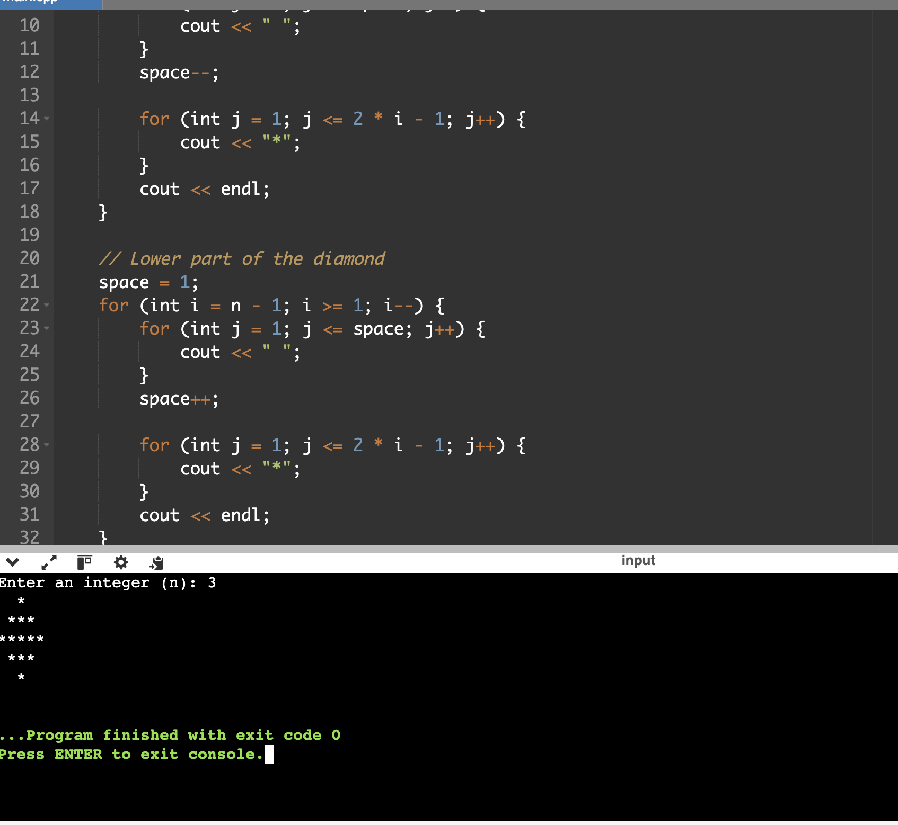

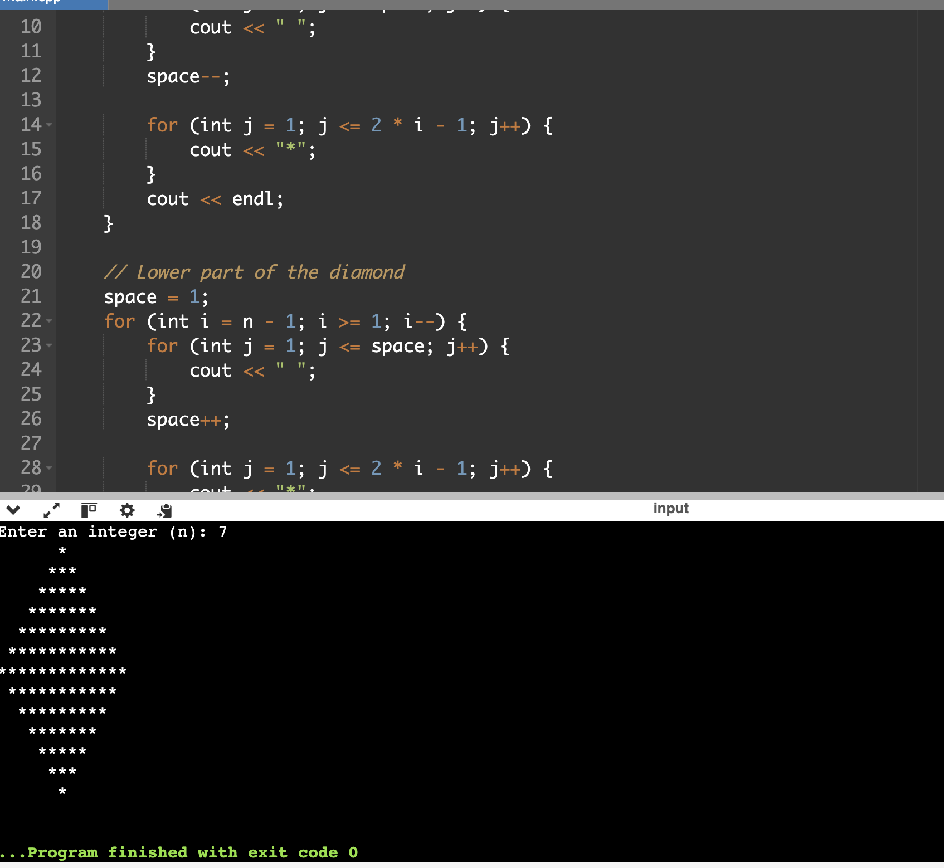

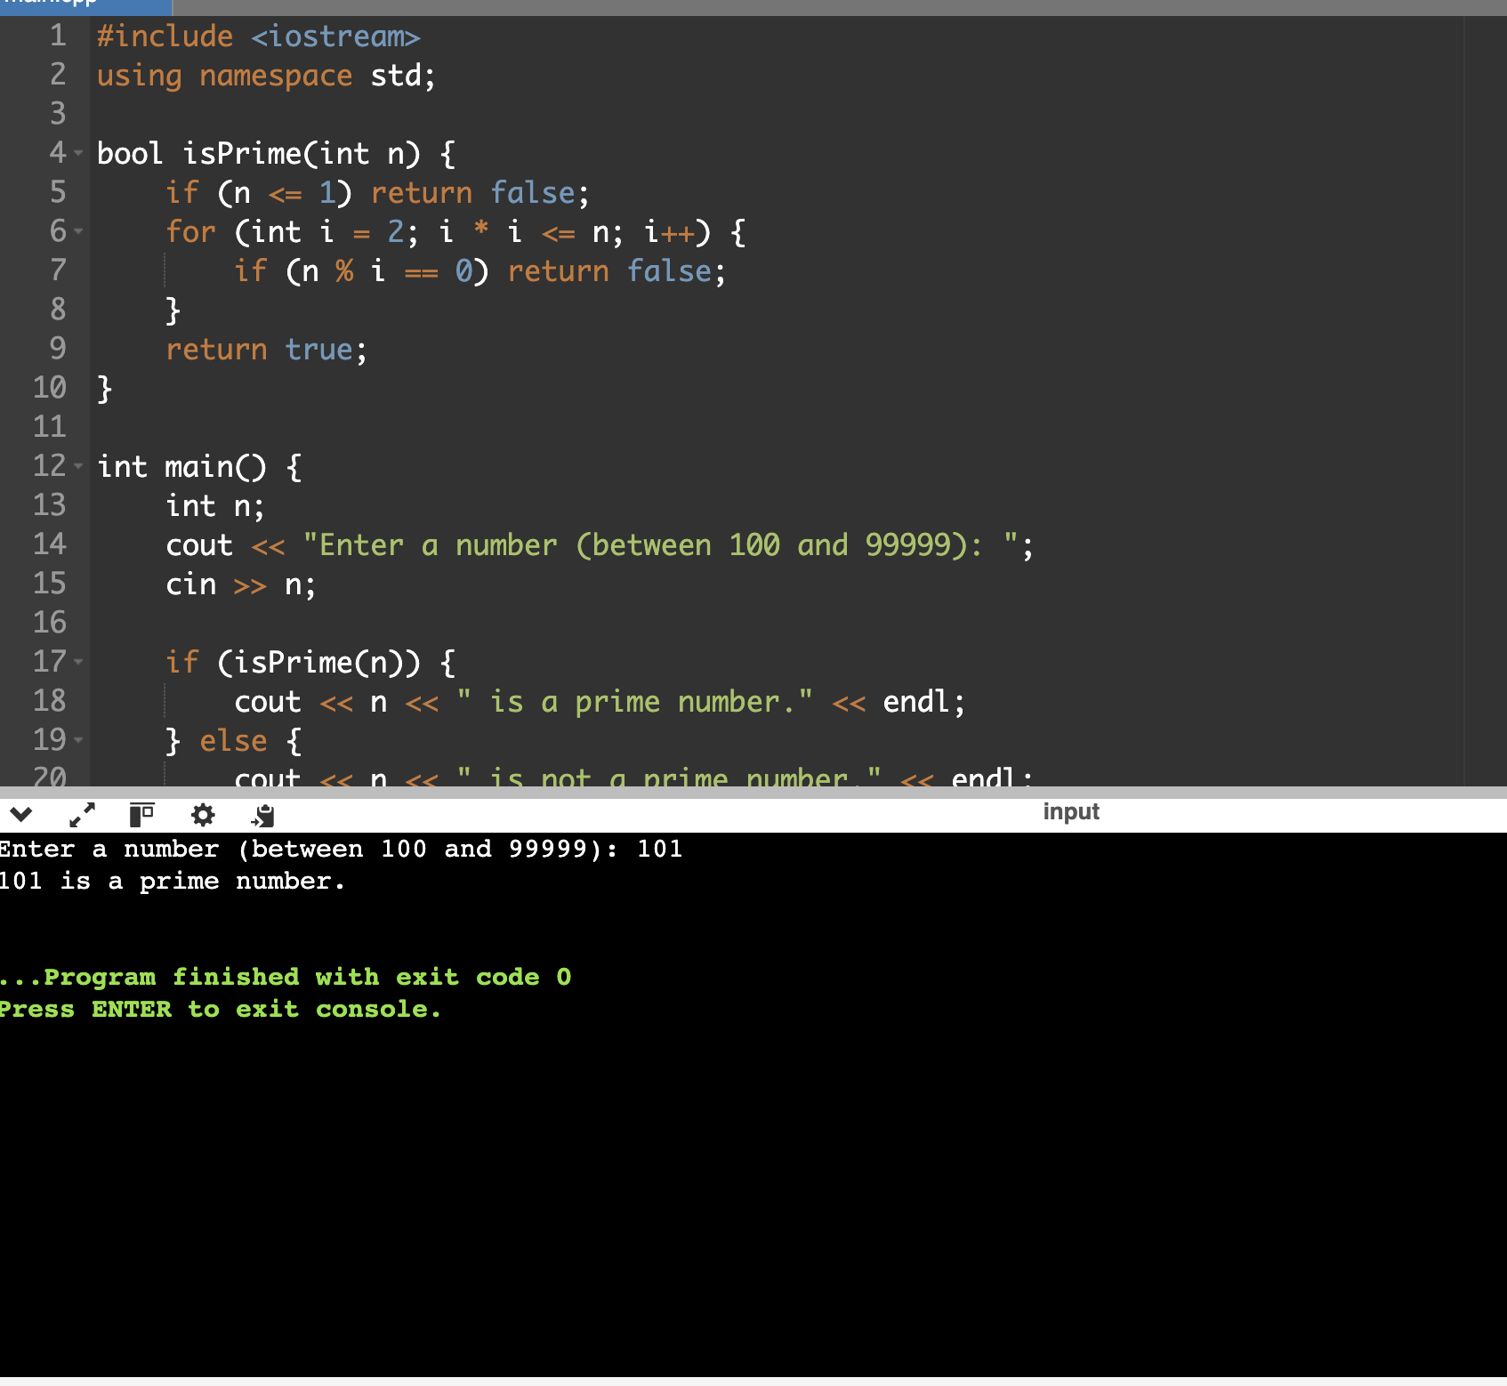

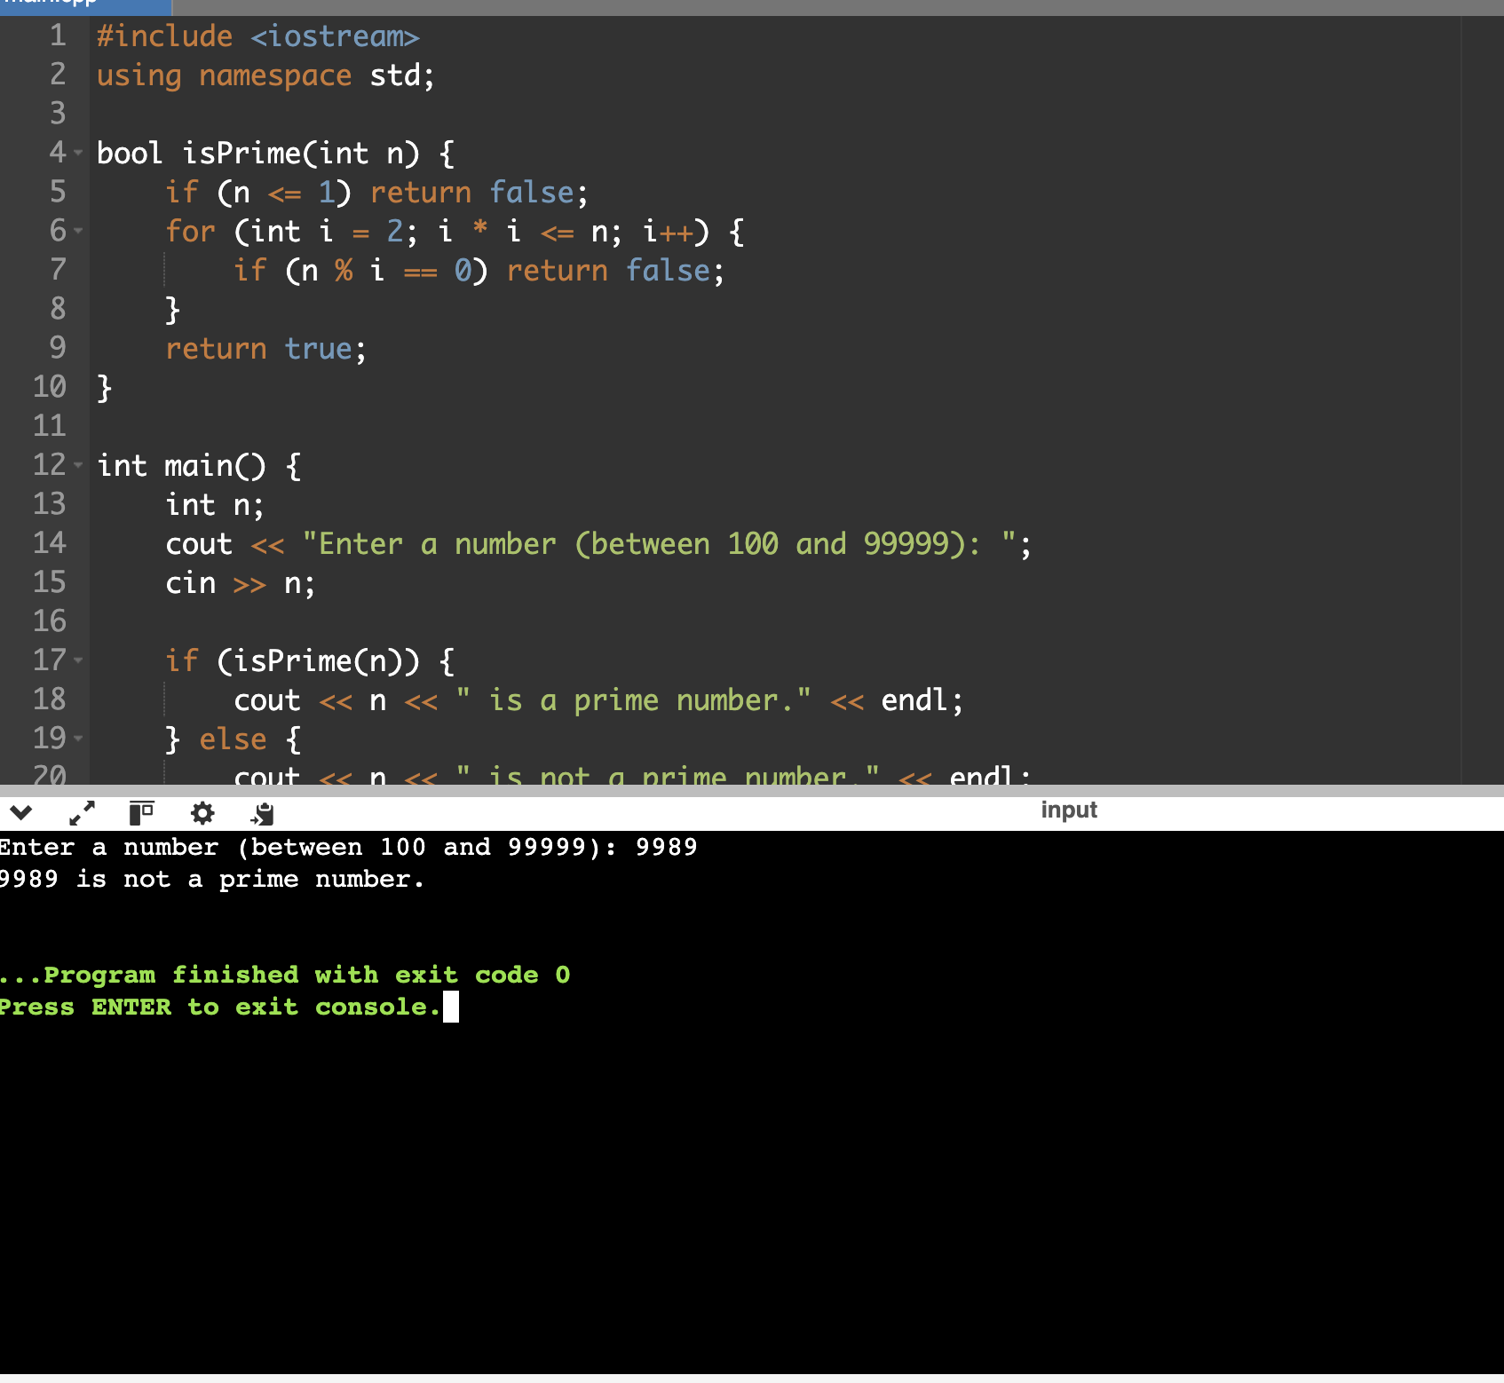

Question 1:

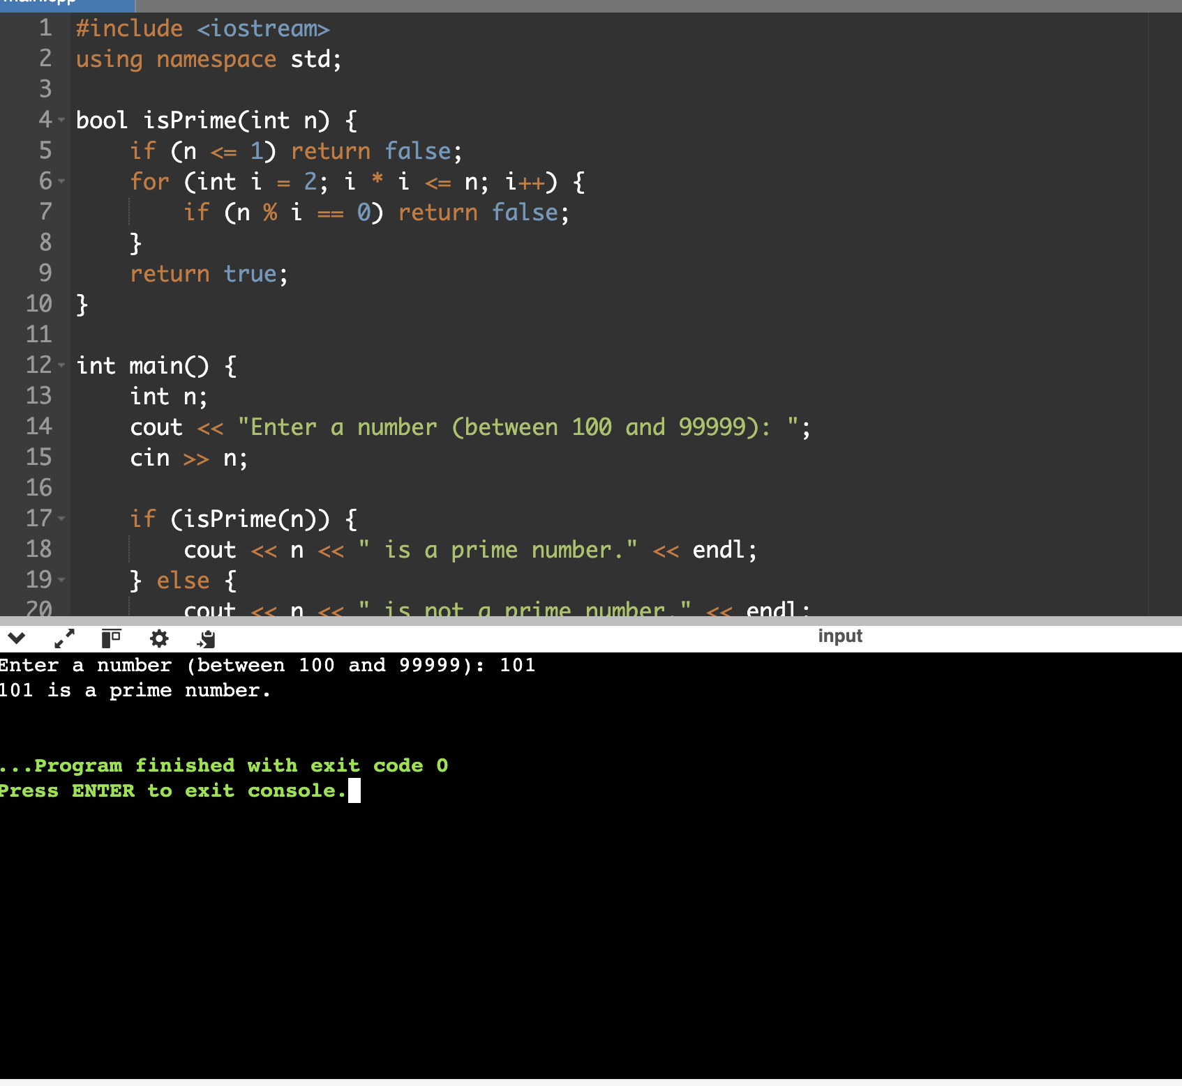

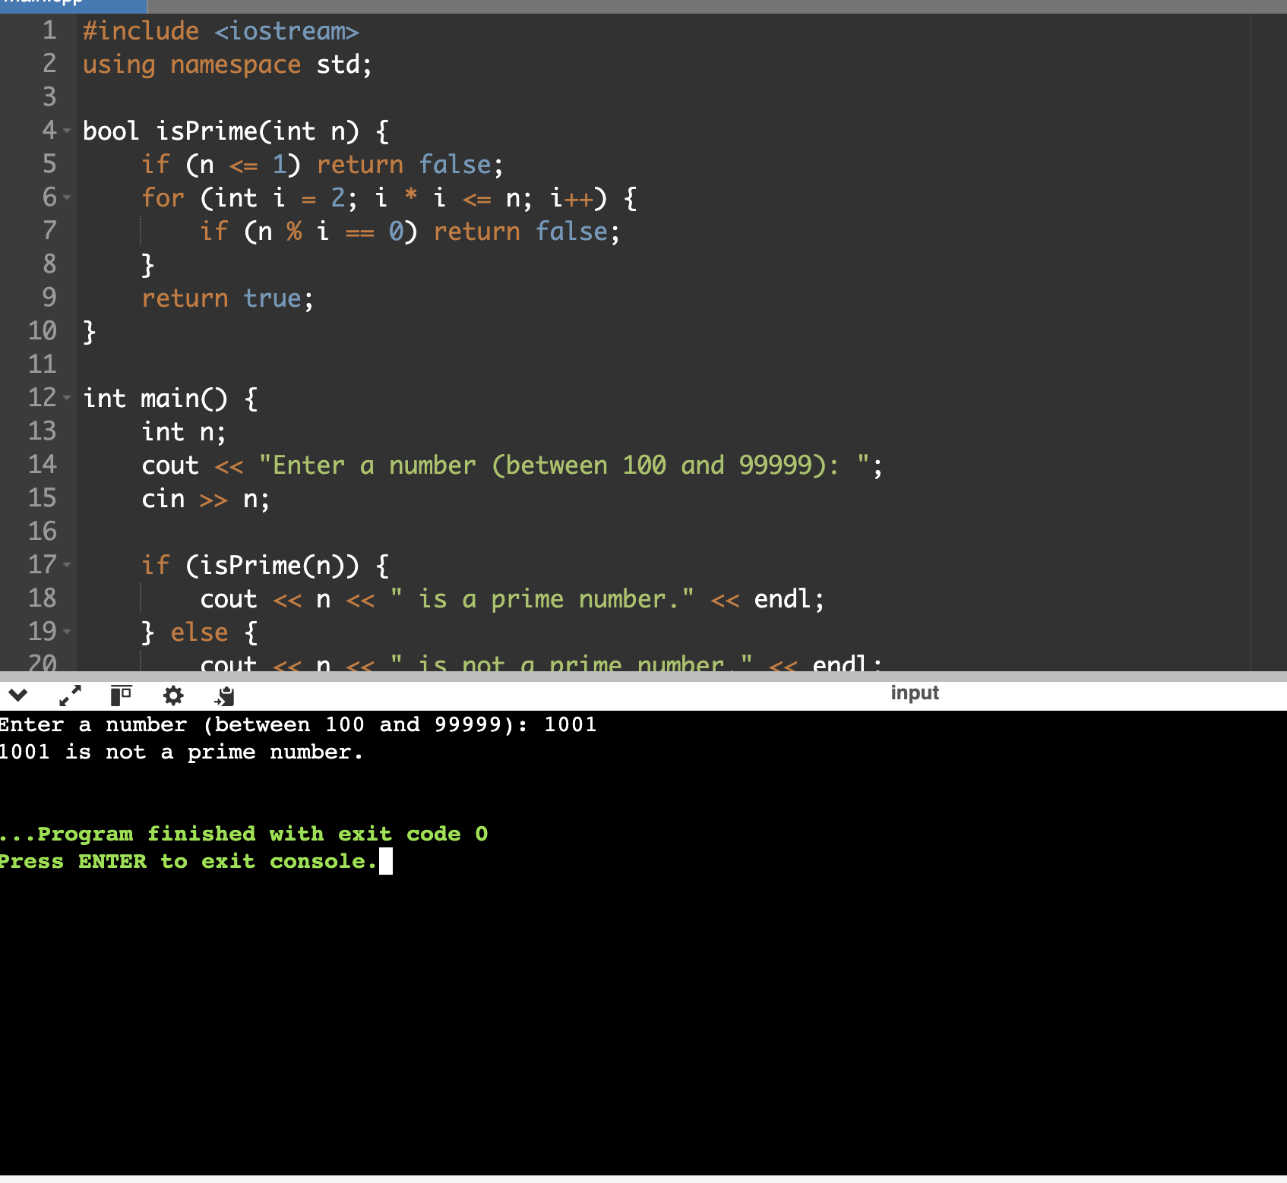

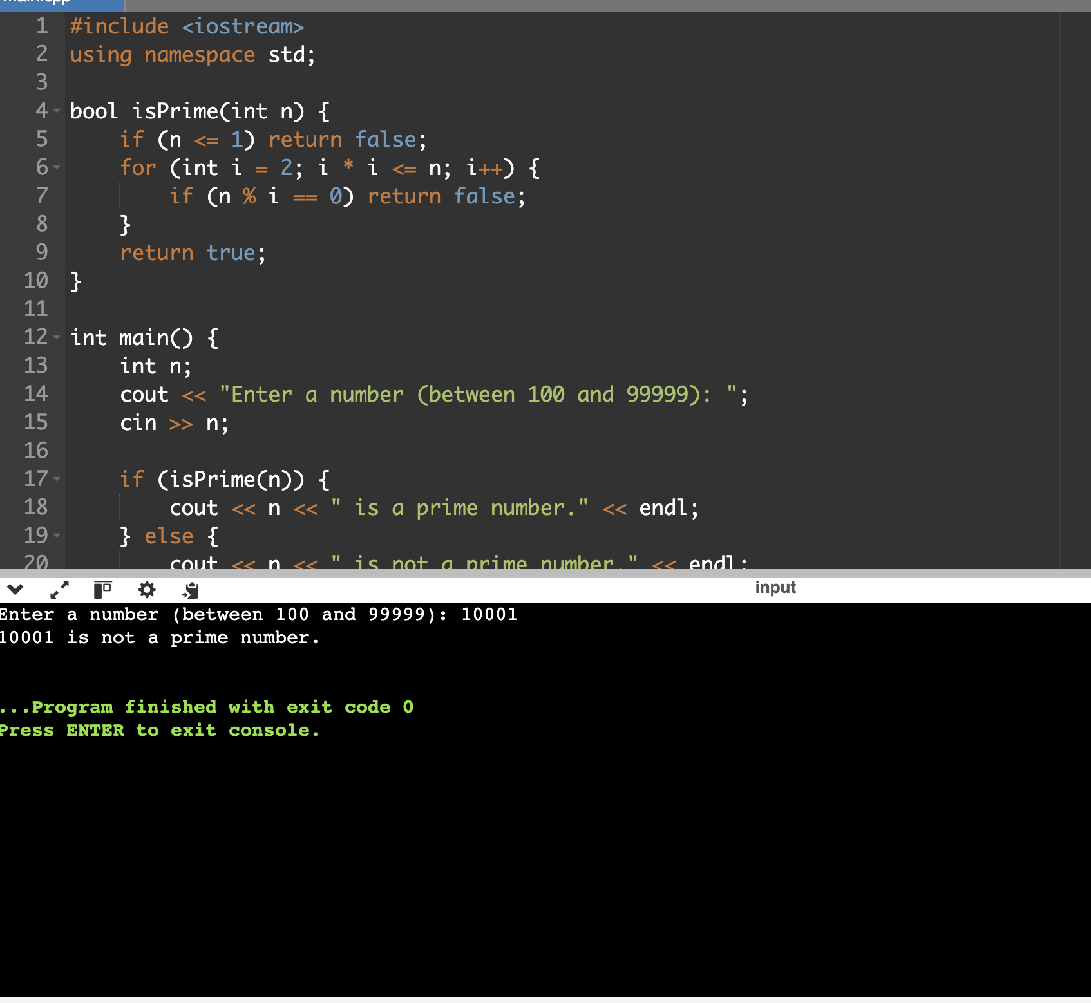

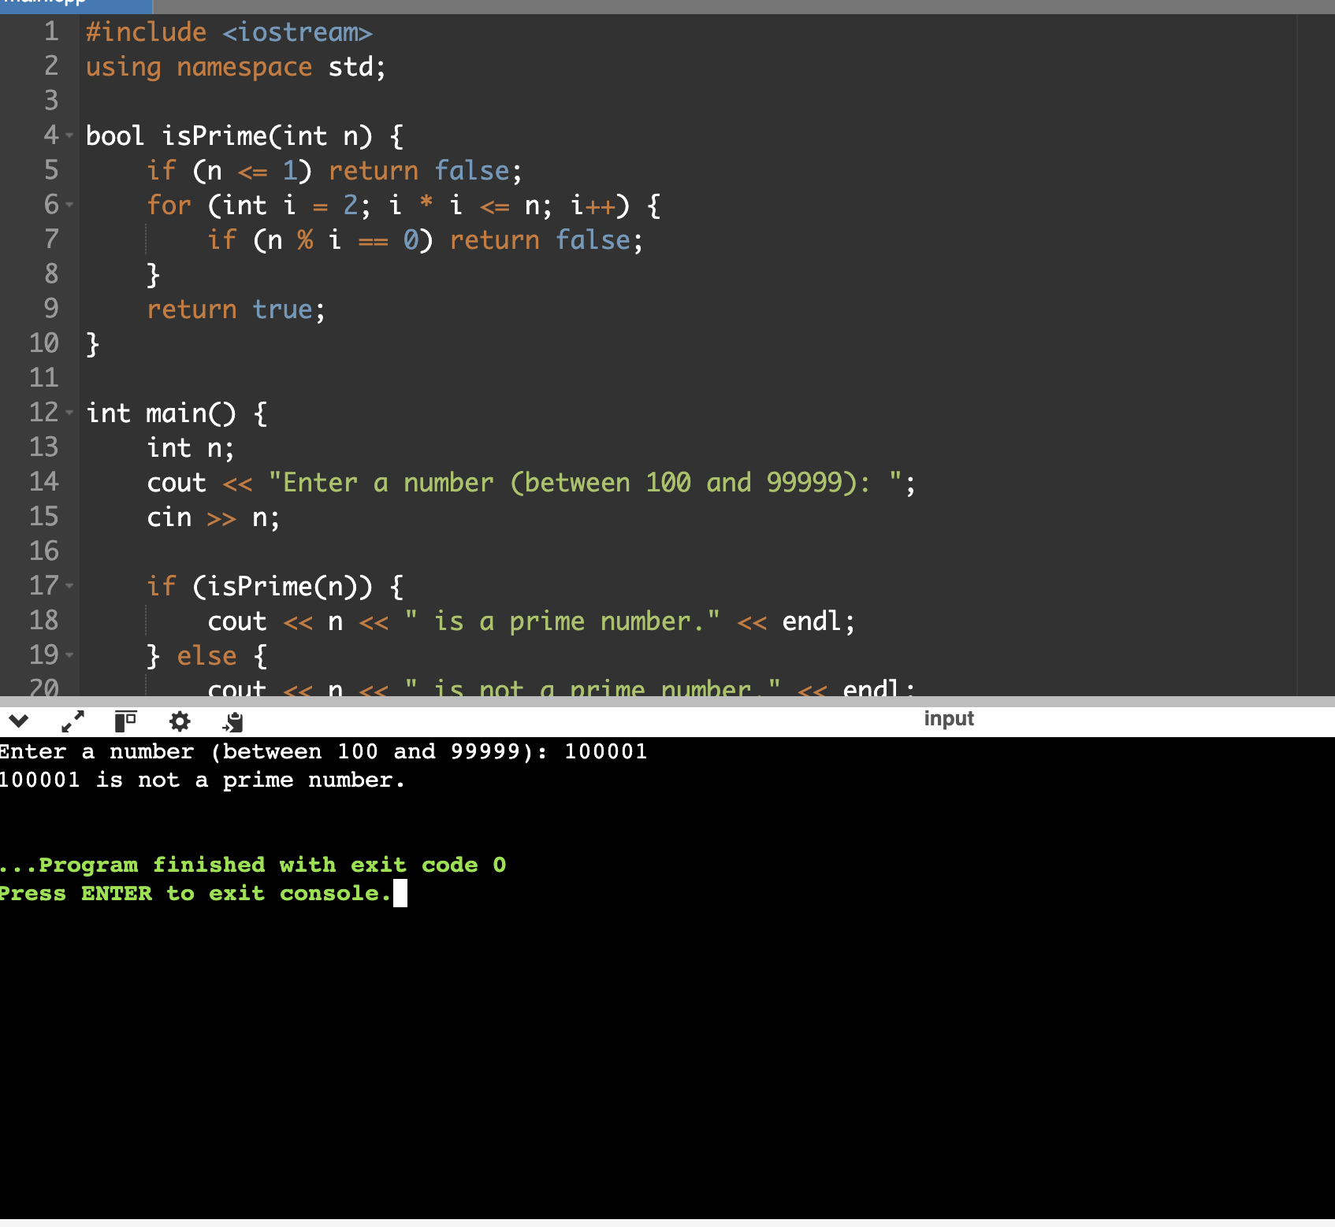

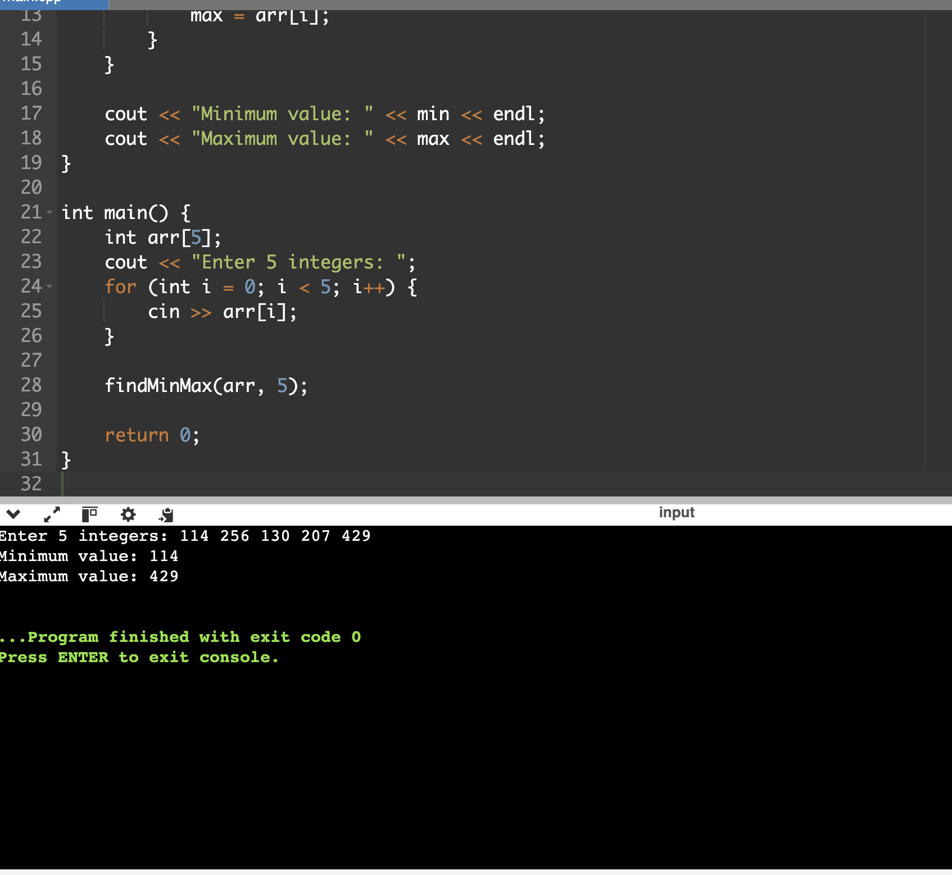

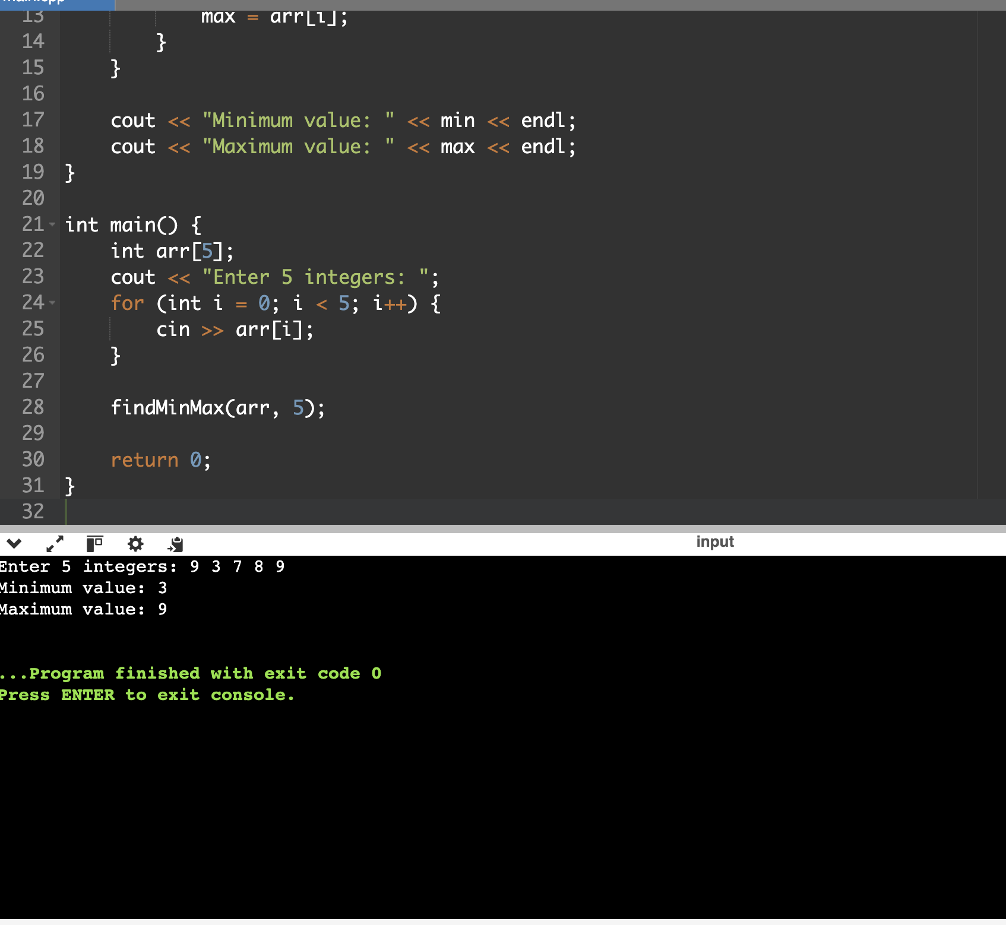

Question 3:

