Red Mountain, AZ
Asha Punia

Eroded Cinder Cones
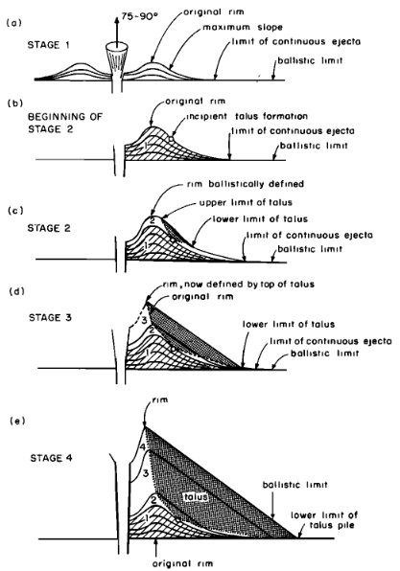
Cinder cones, also commonly referred to as scoria cones, are volcanic landforms defined by their symmetrical geometry and eruptive style. They are one of the most common large-scale features found in volcanic regions (Settle, 1979; Priest et al.,2002).. The formation and erosion of cinder cones can be used to infer past environmental conditions for Earth, the Moon, and Mars.

Formation and Erosion
Characterized by moderate explosiveness, cinder cone volcanoes consist of accumulated fragments that form a circular hill with a bowl-shaped crater at the top and flanks that form from ejected material at angles as steep as the loose material could naturally pile (Mcgetchin et al., 1974, Fig. 1) Cinder cones are unique compared to other types of volcanoes because they typically form during a single, brief eruptive episode (“Cinder Cones (U.S. National Park Service),” 2024). Cinder cones weather and wear down through a predictable process after they form (Wood, 1980). Over many years, rain and weather turn the loose, porous rocks into clay that washes down the sides to form small channels or gullies (Wood, 1980). This process causes the volcano to get shorter and its slopes to become less steep over time (Settle, 1979).
Figure 1: Stages of cinder cone formation (from Mcgetchin et al., 1974)

Red Mountain
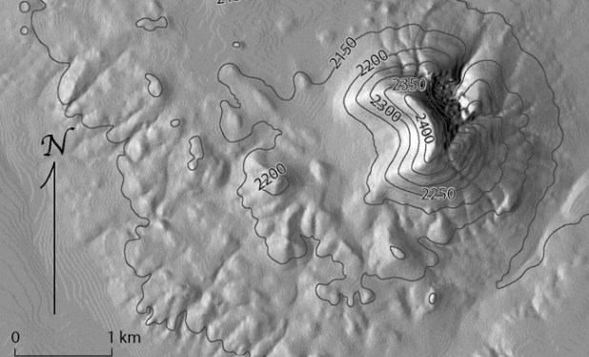
Red Mountain is a prominent landmark located approximately 40 kilometers northwest of Flagstaff in the Coconino National Forest (Priest et al., 2002). It is approximately 740,000 years old and is part of the San Francisco Volcanic Field (Conway et al., 1997). The mountain possesses a distinct U-shaped opening that faces the west (Figure 2). While most cinder cones in the region are known for their symmetrical shapes, Red Mountain has been so heavily modified that its internal core is exposed (Atwood, 1906). Early geological studies show that the mountain is constructed from many thin, successive layers of volcanic ash and rock fragments known as tuff (Atwood, 1906).
Figure 2: Aerial image of Red Mountain, AZ (from Riggs & Duffield, 2008)

Sector Collapse
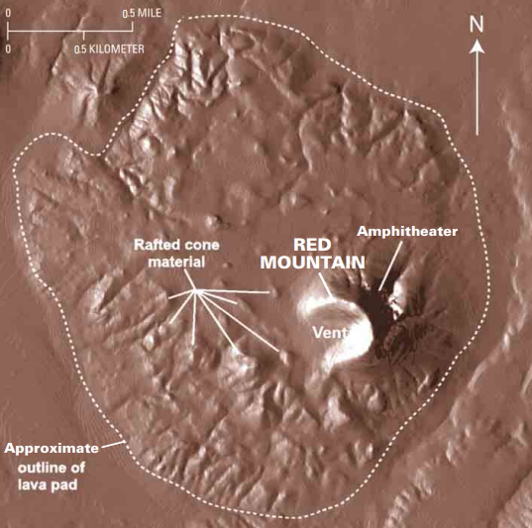
The broken shape of Red Mountain is primarily the result of a massive event called a sector collapse that occurred while the volcano was still active (Riggs and Duffield, 2008). During the eruption, a large amount of lava flowed out from the western base of the mountain, which destabilized the western side of the cone and caused approximately 15% of the mountain to break off and travel away on top of the moving lava (Riggs and Duffield, 2008). This event created the massive, 1-kilometer-wide breach that is visible today. Large sections of the cone were rafted away and now sit as distinctive hills (Figure 3). This structural failure cut the volcano open, and its internal structure of concentric tuff layers and ancient volcanic flows became exposed.
Figure 3: Digital Elevation Model of Red Mountain showing surrounding features (from Riggs and Duffield, 2008)

Hoodoos
The area is also famous for its hoodoos, which are 10- to 20-foot-tall pillars of rock protected by dense lava boulders (Priest et al., 2002). These boulders shield the soft, layered tuff beneath them from wind and water erosion (Priest et al., 2002).

The Amphitheatre
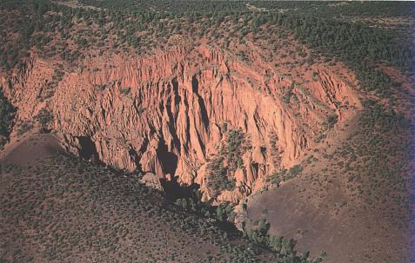
The formation of the Amphitheater (Figure 4) at Red Mountain resulted from a large phreatic explosion that occurred shortly after the primary eruption period ended (Riggs and Duffield, 2008). This event is thought to have been triggered by a groundwater that had been heated from a dike that travelled along a regional fault. The resulting steam became trapped and pressurized beneath layers of ash. Eventually, this system exploded, carving out a steep basin in the shape of a semicircle on the mountain's northeast flank. Erosion further sculpted this area creating the site's vertical cliffs (Riggs and Duffield, 2008.)

Topographic Asymmetry
In the years since it formed, Red Mountain and the surrounding features in the San Francisco Volcanic Field have been slowly reshaped by the local climate and environmental conditions (McGuire et al., 2014). The slopes facing different directions have eroded at different rates (McGuire et al., 2014). Because of factors such as sunlight and moisture, the north-facing slopes of these cones have remained steeper than the south-facing ones (McGuire et al., 2014).
Figure 4: Image showing the central Amphitheatre (from “Red Mountain Volcano—A Spectacular and Unusual Cinder Cone in Northern Arizona Fact Sheet,” n.d.)

Planetary Analogues
Gravity and Volcano Shape
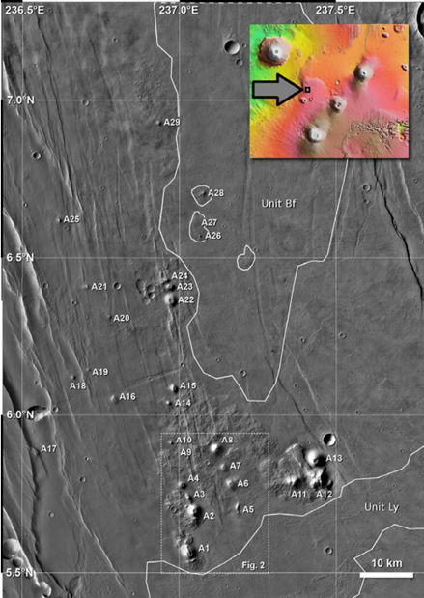
Cinder cones on the Moon and Mars look very similar to those on Earth, providing proof of past explosive volcanic activity across the solar system. However, their size is quite different because of gravity. On the Moon and Mars, gravity is much weaker, so volcanic fragments are shot much farther away from the vent during an eruption (Settle, 1979). This causes planetary cones to have much wider bases and shorter heights than the ones we see on Earth (Settle, 1979). A cone on the Moon is predicted to be about nine times wider than an Earth cone, while a cone on Mars is about three and a half times wider (Mcgetchin et al., 1974).

The Tharsis Region
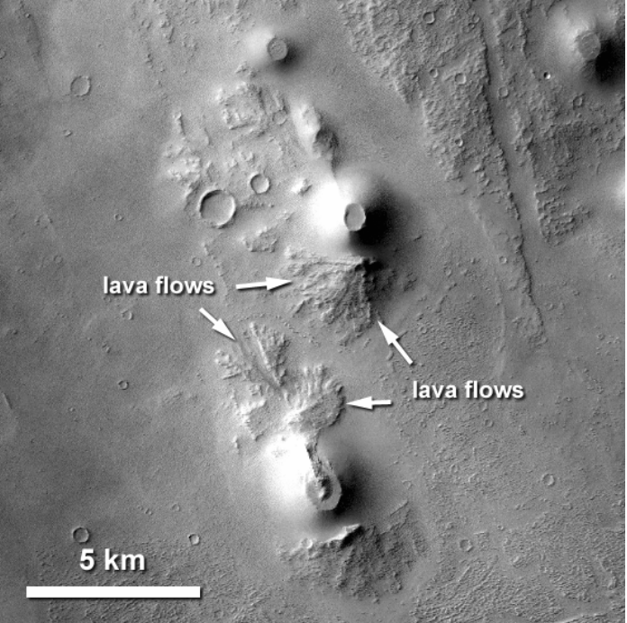
A volcanic field containing 29 individual cones has been identified in the Tharsis region of Mars, and exists as a significant planetary analogue for terrestrial study (Brož and Hauber, 2012, Fig. 5). These Martian features are interpreted as the equivalents of Earth’s cinder cones. They display many of the same physical characteristics, including smooth flanks and clear summit craters (Brož and Hauber, 2012). Researchers have used landmarks from the San Francisco Volcanic Field, to illustrate how these Martian landforms match the visual profile of terrestrial cinder cones (Brož and Hauber, 2012). Although the Martian cones are much larger than those on Earth, averaging about 2.6 times the basal diameter, the geometric ratio between their craters and their bases is nearly the same (Brož and Hauber, 2012). This suggests that the basic physics of how debris piles up around a volcanic vent is consistent throughout the solar system (Brož and Hauber, 2012). Like the volcanoes seen at Red Mountain, these features are thought to be monogenetic, meaning each one was likely built during one brief period of activity (Brož and Hauber, 2012). Furthermore, the way these cones are aligned along underground fractures suggests their location was controlled by regional tectonic trends, much like volcanic fields on Earth (Brož and Hauber, 2012).
Figure 5: CTX and HRSC image of craters in the Tharsis region (from Brož and Hauber, 2012)

Red Mountain as a Model
Red Mountain is a unique analogue because it shows us what happens when a volcano physically falls apart. Its massive sector collapse, where a huge chunk of the mountain broke off and floated away on lava, is used as a model for structural failures on much larger volcanoes like Mount St. Helens (Riggs and Duffield, 2008). The collapse can also provide insight to features on Mars that exhibit a similar appearance. In the Tharsis region, craters with large lava flows are present (Brož and Hauber, 2012, Fig. 6). In craters where this flow appears to spill out of the side, we may be observing processes similar to those that occurred at Red Mountain. Red Mountain Arizona showcases that even relatively small volcanoes can experience complex eruptive failures that dramatically change their shape and how they erupt (Riggs and Duffield, 2008).
Figure 6: CTX of cinder cones on Mars (from Broz et al., 2009).

References
Atwood, W.W., 1906. Red Mountain, Arizona: A Dissected Volcanic Cone. The Journal of Geology 14, 138–146. https://doi.org/10.1086/621288
Brož, P., Hauber, E., 2012. A unique volcanic field in Tharsis, Mars: Pyroclastic cones as evidence for explosive eruptions. Icarus 218, 88–99.
Brož, P., Jagert, F., Hauber, E., 2009. Plains volcanism in Tharsis, Mars (II): Volumes, rates, and rheology of eruption products. European Planetary Science Congress.
Cinder Cones (U.S. National Park Service) [WWW Document], 2024. URL https://www.nps.gov/articles/000/cinder-cones.htm (accessed 4.9.26).
Conway, F.M., Ferrill, D.A., Hall, C.M., Morris, A.P., Stamatakos, J.A., Connor, C.B., Halliday, A.N., Condit, C., 1997. Timing of basaltic volcanism along the Mesa Butte Fault in the San Francisco Volcanic Field, Arizona, from 40Ar/39Ar dates: implications for longevity of cinder cone alignments. Journal of Geophysical Research 102, 815–824
Mcgetchin, T.R., Settle, M., Chouet, B.A., 1974. Cinder cone growth modeled after Northeast crater, Mount Etna, Sicily. Journal of Geophysical Research 79.
McGuire, L.A., Pelletier, J.D., Roering, J.J., 2014. Development of topographic asymmetry: Insights from dated cinder cones in the western United States. JGR Earth Surface 119, 1725–1750. https://doi.org/10.1002/2014JF003081
Priest, S.S., W.A. Duffield, N.R. Riggs, B. Poturalski, K. Malis-Clark, 2002. Red Mountain Volcano: a spectacular and unusual cinder cone in northern Arizona. U.S. Geological Survey Fact Sheet 024-02.
Red Mountain Volcano—A Spectacular and Unusual Cinder Cone in Northern Arizona Fact Sheet [WWW Document], n.d. URL https://pubs.usgs.gov/fs/2002/fs024-02/ (accessed 4.10.26).
Riggs, N.R., Duffield, W.A., 2008. Record of complex scoria cone eruptive activity at Red Mountain, Arizona, USA, and implications for monogenetic mafic volcanoes. Journal of Volcanology and Geothermal Research 178, 763–776. https://doi.org/10.1016/j.jvolgeores.2008.09.004
Settle, M., 1979. The structure and emplacement of cinder cone fields. American Journal of Science 279, 1089–1107. https://doi.org/10.2475/ajs.279.10.1089

