Determining Shear-Wave Velocity Profiles in Langley using Constrained Microtremor Horizontal-to-Vertical Spectral Ratio Inversions

Author: Asha Punia – Western University – apunia4@uwo.ca
Supervisor: Dr. Sheri Molnar – Western University – smolnar8@uwo.ca
Submitted August 31st 2026 as part of the MSc Geophysics (Project Based) requirements

Key Points
- Metro Vancouver is situated in a high-risk seismic zone and has a subsurface that contains a variety of geologic material requiring detailed hazard assessment
- Constrained MHVSR inversions performed on sites in the township of Langley, BC can produce ground profiles giving the depth and shear wave velocity layers in the subsurface
- Shear wave velocity profiles can be used to build accurate hazard maps to enhance emergency preparedness in the region
Abstract
Metro Vancouver is located in a high-risk seismic zone and is threatened by earthquake related hazards resulting from activity in the Cascadia Subduction Zone. The Cascadia plate boundary is over 1000 kilometers and accumulates significant amounts of strain. This accumulated strain will eventually be released and has the potential to create a magnitude 9.0 earthquake. In order to predict ground shaking intensity of an earthquake, the region’s complex geology must be understood. The subsurface includes a deep basin filled with high-velocity Tertiary bedrock, thick Ice Age sediments, and soft Holocene Salish deposits. Large seismic impedance contrasts between these layers can trap seismic waves, significantly increasing the amplitude and duration of surface shaking based on the principle of conservation of energy. To improve emergency preparedness, the Metro Vancouver Seismic Microzonation Mapping Project creates region specific hazard maps. As part of this project, 209 Microtremor Horizontal-to-Vertical Spectral Ratio (MHVSR) measurements have been collected in the region of Langley. This data is typically used only to estimate layer depths and is not inverted to model shear wave velocity (v_{s}). This research project suggests that we can invert existing MHVSR data using priori subsurface information to constrain inverted shear-wave velocity models using Geopsy’s DINVER software. To do this, we use established depth and velocity values as parameters to guide the inversions. This will generate one-dimensional v_{s} profiles that are consistent with the subsurface geology. The data produced will be visualized in cross section view to understand the widespread layering in the area. V_{s30} values will also be calculated for each of the sites inverted to better evaluate potential ground motion amplification across the study area.

Table of Contents
Abstract……………………...……………………………………………………………………1
Introduction……………………..……………………………………………….……………….4
Background…………..……………………………………………………………….…….……5
Seismic Activity on the West Coast………………………............….......….……..……...............5
Geologic History and Lithology…………………………............…………………………….….6
Site Effects………………………….………………………............…………………………..…9
Hazard Maps...………………...…………...………………………............……………………12
Objectives……………………………………………………..…………………………………13
Methodology…………...…………………………………….………………………………….14
The MHVSR Method…………..………………………...………………...............……………14
Data Collection…………………...…………………………………………............………...…15
Inversions………………...…............……………...……………………………………………16
Results…………………...…………………...……………………………………………….....18
Successful Reinversions……............……………...…………………………………………….19
Unsuccessful Reinversions………............………………...……………………………………21
Depth Profiles and Vs₃₀ Data………………............………………..……...……………..……22
Discussion……………………………………………………………………………………….22
Subsurface Transects…………...........…………………………………………...………….….22
Vs₃₀ Values.…………………………...............…………………………………………………23
Maple Ridge and Pitt Meadows……..................……………...……………………………..….23
Conclusion……...………...…………………………………………….……………………….24
Data and resources…………..…………………………………………………….……………25
Acknowledgements…..…………………………………………………………………………26
References…………...….……………………………………………………………………….27
Tables………...………………………………………………….......…………………………..28
Figures…………………..……...………………………………………………………………..31
Appendix……………......……………………………………………………………………….56

Introduction
Predicting the shaking effects during an earthquake in the seismically active area of Vancouver and its surrounding greater area is uniquely difficult due to the region's complex geology. To address this, the Metro Vancouver Seismic Microzonation Mapping Project was created to produce region specific seismic hazard maps. This project is in collaboration with the British Columbia Ministry of Emergency Management and Climate Readiness and the Institute of Catastrophic Loss Reduction (Molnar et al., 2023). For nearly ten years, members of this team have focused on determining local site effects such as shaking amplification, liquefaction, and landslides (Molnar et al., 2023). The hazard maps produced from these investigations are important tools as they provide the information needed to improve developments and enhance emergency preparedness in the densely populated region.
The primary survey method utilized in this research project is the single-station microtremor horizontal-to-vertical spectral ratio (MHVSR). MHVSR is a highly efficient, non-invasive technique that records ambient background noise such as wind, traffic or ocean waves using a single three component seismometer to identify a site's resonance frequency. This method requires minimal personnel and equipment compared to traditional seismic array methods and allows for rapid data collection over large urban areas. Figure 1 shows the 209 MHVSR sites collected in the region of Langley as part of two summer field campaigns in 2024 and 2025.
The Metro Vancouver Seismic Microzonation Project (MVSMMP) has compiled a database of over 500 MHVSR measurements in Metro Vancouver. This data is traditionally used to determine depths of subsurface layers. The objective of this research is to utilize the MHVSR data collected and derive subsurface shear wave velocity profiles for each of the sites through the process of inversions that are constrained based on predetermined parameters. This approach involves restricting the possible mathematical solutions to those that match the known local geology. The working hypothesis of this study is that by using these specific regional parameters, we can successfully invert our MHVSR data to develop a new set of v_{s} profiles. This will increase the subsurface information available for Eastern Metro Vancouver, providing a foundation for more reliable seismic hazard models.
Background
Seismic Activity on the West Coast
The Cascadia Subduction Zone is a massive active tectonic plate boundary that stretches over 1000 km from Northern California up to central Vancouver Island (Clague, 1997). The boundary, seen on the map in Figure 2, involves the Explorer, the Juan de Fuca and the Gorda plates which are all are currently subducting beneath the North American continent at a rate of approximately four centimeters per year (Clague, 1997). The subducting plates are considered to be ‘locked’. This means that the plates are not smoothly moving past each other. As the plates move, the crust undergoes significant elastic bending and bucking (Clague, 1997). This process creates a significant amount of strain.
This strain exists as stored energy and can be eventually released as catastrophic megathrust earthquakes. Geologic evidence and oral histories indicate that the last megathrust event was a Magnitude 9.0 earthquake on January 26, 1700, which ruptured the entire length of the subduction zone (NRCAN, 2011). This event was extraordinarily devastating. Oral histories from Vancouver Island First Nations describe a massive tsunami that destroyed a village at Pachena Bay, leaving no survivors. The tsunami was so powerful it traveled across the Pacific, with written records from Japan documenting the precise time of the waves' arrival. Other effects of this event involved coastal forests and marshes suddenly subsiding by 0.5 to 2 meters, causing them to be buried by tidal mud and tsunami sand (NRCAN, 2011).
While these magnitude 9.0 megathrust events are the most catastrophic, the Metro Vancouver area is also subject to much frequent, smaller seismic events. Approximately 400 earthquakes occur each year in the region stretching from northern Vancouver Island to Seattle (NRCAN, 2011). Majority of these earthquakes are too small to be felt and have a magnitude of less than 3.0. Earthquakes in the region originate both within the overriding North American crust and deep within the subducting Juan de Fuca plate. Even moderate earthquakes, with magnitudes between 5.0 and 6.0, present significant hazards. Research suggests they occur frequently enough to trigger local effects like submarine landslides in Saanich Inlet roughly once every century (Clague, 1997). According to National Resources Canada, an earthquake capable of causing structural damage strikes the region on average once every decade. These events serve as a constant reminder of the active tectonic environment and the associated threats.
Geologic History and Lithology
The Metro Vancouver region and the surrounding Lower Fraser Valley is geographically bordered by the Coast Mountains to the North and the Cascade Mountains and Chuckanut Hills in the south (Turner et al., 1997). The area consists of mountain peaks, gently rolling uplands, and lowlands. Beneath the surface, the region is characterized by a deep geological basin sitting above granitic rock. This basin is filled with a variety of layered materials. This subsurface structure includes a layer of sandstone bedrock that reaches thicknesses over 4 kilometers. Overlying this bedrock is a significant accumulation of Ice Age sediments, which can be up to 1 kilometer thick. A relatively thin layer of modern sediments overlies the bedrock (Turner et al., 1997). The variety of geological material present exhibit a variety of physical properties that influence the region's response to seismic hazards.
Subsurface Layers
Bedrock
The oldest geologic units in the area are sedimentary and volcanic rocks exposed in the Cascade Mountains and as small hills in the eastern Fraser Valley (Turner et al., 1997). These rocks, dating back up to approximately 185 million years, underwent significant metamorphism. This metamorphism resulted in foliation of the rocks. Following this, granitic rocks were formed between 165 and 95 million years ago. These medium to coarse-grained igneous rocks such as granite and granodiorite, are the rocks seen in The Coast Mountains and are highly resistant to erosion and make up the mountain slopes. During the Tertiary period, between 85 and 37 million years ago, a massive sequence of sandstones, siltstones, and conglomerates were deposited. While these rocks are mostly hidden at depth throughout the Fraser Valley, they appear as scattered outcrops in Vancouver and Burnaby, such as at Burnaby Mountain and Stanley Park, where southward-tilted sandstone layers form prominent ridges. The youngest bedrock units are volcanic rocks, specifically basalt and andesite, formed between 35 and 17 million years ago. These rocks form many of the valley's hills, such as Queen Elizabeth Park and Sentinel Hill. The bedrock present also occusr as thick tabular sills and subvertical dykes that cut through older rock layers (Turner et al., 1997).
Ice Age Sediments
Glacial activity during The Pleistocene Epoch, which occurred from 2 million to 11,000 years ago, had significant geologic influence in the region, particularly during the last glaciation and the subsequent retreat of the ice (Turner et al., 1997). These Ice Age sediments are part of the gently rolling uplands of the Fraser Valley, which range from 15 to 250 meters in elevation. The most widespread surface sediments in these uplands are thick marine silts and clays. These fine-grained materials were deposited when the sea covered the area during the period of glacial retreat. The bearing capacity of these sediments varies significantly based on their history. East of Aldergrove, these deposits were compressed by massive glaciers, which significantly increased their bearing strength. However, their fine-grained nature results in poor water infiltration and drainage, and they are notoriously prone to landsliding when situated on slopes steeper than 20 degrees. Another foundational unit present in this region is till. In the Vancouver upland, till is often the dominant near-surface material, while in the Langley and Surrey areas, it is frequently buried beneath thick sequences of marine silt and clay. Till is generally compact and concrete-like, offering high bearing capacity and serving as an excellent foundation material. For the Langley and Abbotsford regions, Ice Age gravel and sand deposits are of important economic and hydrogeologic significance. These units can reach thicknesses of 40 meters and are useful sources of aggregate for construction. Furthermore, they host major aquifers, such as the Brookswood and Abbotsford aquifers, which provide drinking water. Older Ice Age sediments are exposed in steep escarpments along the edges of the uplands, where they are susceptible to undercutting by waves or streams, frequently leading to localized landslides (Turner et al., 1997).
Modern Sediments
The youngest geological units in the region are modern sediments, which are less than 10,000 years old and primarily occupy the lowlands along the Fraser River (Turner et al., 1997). These loose materials underlie about half of the Fraser Valley, including the flat, flood-prone lands of the Fraser delta. The lithology of these lowlands varies by throughout the region. Gravel and sand dominate the Fraser River floodplain between Hope and Mission, while sand and silt become the primary deposits farther downstream and throughout the Nicomekl-Serpentine valley. These deposits often exist as shallow aquifers and offer moderate to high bearing capacity, yet they pose a significant seismic risk as they are highly susceptible to liquefaction during a strong earthquake. In poorly drained depressions and parts of the Fraser delta, peat has accumulated in thicknesses of up to 5 meters. Peat is an exceptionally poor foundation material due to its high compressibility. Additionally, modern marine silts and clays are common in the Nicomekl-Serpentine flats, where they were formed by fine river sediment settling in the sea. These sediments generally make poor foundations due to low bearing capacity. Finally, human activity has introduced landfill along shorelines like False Creek and Burrard Inlet. These deposits are highly heterogeneous and can be problematic for structural foundations and are prone to settling or liquefaction during seismic events. Together, these modern sediments constitute the most geologically volatile areas of the Lower Mainland (Turner et al., 1997).
Site Effects
In Metro Vancouver, the intensity of ground shaking is determined by the stiffness of the soil, which is measured by shear-wave velocity. Figure 3 displays the large variety of geological material that can respond differently to seismic waves in Metro Vancouver. Soft Holocene sediments have velocities in the range of 200-300 m/s, which leads to significant amplification of the travelling seismic wave (Assaf et al., 2019). The Pleistocene sediments beneath however reach velocities around 500 m/s, and the bedrock beneath can transport shear waves at velocities of 1500m/s (Assaf et al., 2019). These large contrasts can trap the seismic waves, and the waves are forced to reflect within the soft upper layers (Şafak, 2001). This reflection prevents the energy from dissipating, which significantly increases the amplitude and duration of shaking at the surface. To standardize these geologic variations for engineering practice, the National Building Code of Canada (NBCC) utilizes National Earthquake Hazards Reduction Program (NEHRP) Site Classes based on the time-averaged shear-wave velocity in the upper 30 meters (Vs₃₀) (Table 1). Under this system, the region’s high-velocity bedrock is categorized as Site Class A or B, while the dense Older Pleistocene uplands typically fall into Site Class C. In contrast, the thick, soft silts and clays of the Fraser River delta and the Nicomekl-Serpentine valley are designated as Site Class E, representing the highest potential for ground motion amplification (Taylor et al., 2006).
The physical basis for this amplification is described by the concept of seismic impedance. Seismic impedance is defined as the product of a material's mass density (ρ) and its wave propagation velocity (V). Based on the conservation of energy principles and the seismic energy flux (E) along a ray of seismic waves can be expressed as Equation 1.
$$E\left(t\right) = \left(\frac{1}{2}\right)\left(ρV\right)x$$²(t) (1)
In equation 1, x(t) represents the velocity of seismic shaking. The energy flux must remain constant as the wave travels. Therefore, changes in the impedance must be compensated for by an increase in the shaking velocity (Şafak, 2001). The magnitude of this amplification (A), Equation 2, depends on how abruptly the impedance changes. The amplification is determined by the square root of the impedance ratio.
$A= \frac{x_{2}{(t)}_{max}}{x_{1}{(t)}_{max}}= \sqrt{\frac{{(pV)}_{1}}{{(pV)}_{2}}}$ (2)
Beyond impedance contrasts, several other factors influence site amplification in the region. As described in Şafak (2001) in Figure 4, these other factors include the focusing of waves caused by subsurface topography (such as the shape of the sedimentary basin), and the conversion of body waves into surface waves. Additionally, high water content and the inherent randomness in the geological medium can further complicate how seismic energy is distributed, often leading to the extreme increased amplification.
The importance of understanding geology’s role in site amplification is illustrated by the aftermath of an Earthquake on December 13th, 1990 in Sicily, Italy. Although considered to be a moderate event with a magnitude of 5.6, it caused significant structural failure, 20 casualties, and left 15,000 people homeless (Panzera et al., 2018). In the cities of Lentini and Carlentini, Panzera et al (2018) observed that the distribution of damage was not uniform. The destruction observed was heavily influenced by the underlying lithology. Buildings on soft silty-clay alluvial deposits and Early Pleistocene marly clays suffered significantly higher damages, and structures built on rigid calcarenite or volcanic rock experienced much less structural distress. To quantify these variations, the seismic response of the area was categorized into four distinct patterns based on subsurface impedance contrasts, shown in Figure 5. Category (a), represented by the red lines in Figure 5b, identifies sharp, low-frequency peaks (< 3.0 Hz). These curves indicate thick sequences of soft marly clays and marine sands (> 40 m) overlying bedrock, a type of layering that is capable of trapping large amounts of seismic energy. Category (b), shown by the orange lines, displays high-frequency peaks (3.0 Hz) and represent thinner alluvial deposits. Category (c), the green lines in Figure 5c, identifies less pronounced peaks (3.0–4.0 Hz) that indicate a moderate velocity contrast, such as calcarenites overlying basaltic lavas. Finally, Category (d), the blue lines, captures "broadband" behavior where no single strong contrast exists to trap energy, typically occurring in areas with many alternating layers of varied velocities.
These variations in subsurface responses controlled the level of destruction in the area. One dimensional numerical modeling revealed that peak ground acceleration was nearly three times higher on the shallow alluvial deposits compared to the firmer Carlentini plateau. These observations emphasize that local site effects, determined by both the stiffness and thickness of the geological layers are a primary factor in structural survival and earthquake devastation.
Hazard Maps
Seismic hazard maps visualize the hazards associated with earthquakes across different areas by integrating historical earthquake and fault information, the behavior of seismic waves as they travel through the crust, and local subsurface geology. According to the U.S. Geological Survey, these maps show the relative hazards in different regions to assist in disaster mitigation and the development of building codes. While technical experts use these products to follow regulated engineering rules, they also serve as critical tools for non-technical users to make informed decisions regarding earthquake insurance or the structural rehabilitation of their homes.
While many hazard maps exist for a variety of natural disasters at a multitude of scales, the Metro Vancouver Seismic Microzonation Project aims to produce seismic microzonation maps that subdivide the region into zones of similar risk. A suite of 29 maps has been published for Western Metro Vancouver. These maps were constructed using extensive seismological simulations. The maps produced are called seismic hazard susceptibility maps. Susceptibility maps, display characteristics such as V_{s30}, site period (T₀), and sediment thickness (H_{pg}), landslide susceptibility and are designed to characterize the ground conditions in a given area (Molnar, 2024). Probabilistic maps depict specific hazards like shaking amplification, liquefaction potential, or landslide displacement at 2% or 10% probability of exceedance in 50 years. Research is currently expanding to the Eastern region to fill existing data gaps and provide a more comprehensive assessment of seismic risk for the entire Metro Vancouver area.
Shaking amplification maps, which display the factor by which seismic waves are altered as they interact with subsurface sediments, are important maps for the goals of this project. These maps show amplification factors relative to a reference site condition, which for Metro Vancouver is defined as a time-averaged shear-wave velocity in the top 30 meters (V_{s30}) of 760 m/s. Factors greater than 1 indicate increased shaking, while values less than 1 represent deamplification. The project distinguishes between 1D site effects, where waves become trapped and resonant within a local sediment column, and 3D basin effects, where amplitude and duration change as waves interact with the geometry of the deep sedimentary basin.
As illustrated by figure 6, amplification hazards are often mapped for specific spectral periods to reflect the risks posed to different structure types. Figure 6 shows long-period (2.0 seconds) amplification hazard for a 2475-year return period. Shaking at these longer periods is particularly relevant for taller buildings and is significantly increased by the presence of the Georgia sedimentary basin. Regional observations documented in these maps show that the soft Holocene sediments of the Fraser River delta amplify shaking by factors of 3 to 6 relative to stiffer glaciated sediments, with the highest amplification occurring near the delta’s northern edge. By providing this region-specific data, these maps are an improvement of general models and accurately reflect the unique geological nature of the Lower Mainland.
Objectives
The primary goal of this research project is to determine and interpret the subsurface seismic properties of Langley to contribute to microzonation hazard mapping efforts. To achieve this, the following objectives were defined:
- To perform seismic inversions on MHVSR field data collected from summer field campaigns to Langley to generate one-dimensional shear-wave velocity profiles. These inversions are performed on MHVSR data (amplification curves) and are constrained by existing regionally appropriate models.
- To calculate V_{s30} values (the average shear-wave velocity in the top 30 meters) for each site, providing a standardized measurement for site specific subsurface behaviour.
- To integrate newly acquired data subsurface data into the existing Metro Vancouver Seismic Microzonation Project database to be included in the site amplification hazard maps
Methodology
The MHVSR Method
The seismic data that will be inverted for this study was collected using the single-station microtremor horizontal-to-vertical spectral ratio (MHVSR) method. This is non-invasive technique that estimates the characteristics of subsurface layers by measuring ambient seismic noise, or microtremors, with a single three-component seismometer. These background vibrations consist of a mixture of various seismic waves, typically dominated by surface waves (Rayleigh and Love waves) at large distances from sources. This method identifies subsurface characteristics by calculating the ratio between the horizontal and vertical Fourier amplitude spectra (FAS) recorded at the surface (Molnar, 2022).
Yutaka Nakamura (1989) was one of the first researchers to pioneer this method for site characterization. In his 1989 paper, Nakamura proposed that the MHVSR could reliably estimate the fundamental resonance frequency (f₀) and the amplification factor of a site without requiring an actual earthquake. This technique defines the spectral ratio (R_{s}) as equation 3.
(3)
S_{HS} and S_{VS} represent the horizontal and vertical Fourier amplitude spectra of the vibrations recorded at the surface, respectively. His theory assumes that while horizontal microtremors are significantly amplified by soft surface layers, the vertical component undergoes negligible amplification. By further assuming that the spectral ratio in the underlying bedrock substrate is approximately unity, the ratio at the surface can be treated as a "quasi-transfer function" for the soil column. Nakamura validated this method by demonstrating that the microtremor-derived closely resembles the actual transfer function (S_{TT}) obtained from earthquake recordings (Figure 7). As shown in Figure 7, these two functions share nearly identical peak positions and magnitudes, confirming the method's reliability for identifying site resonance. While the full composition of the wavefield remains a subject of academic debate, Nakamura’s assertion that the lowest frequency peak approximates a site's natural resonance remains a standard foundation for seismic microzonation.
Data Collection
The data used for this project was collected over two field campaigns in the summers of 2024 and 2025 and was accomplished by members of the Metro Vancouver Seismic Microzonation Mapping Project team. During these campaigns, single-station measurements were recorded at 433 locations across Eastern Metro Vancouver, with 227 sites specifically located within the City and Township of Langley. This data was collected using instruments called TROMINO units, which are portable, high-sensitivity three-component seismometers manufactured by MoHo s.r.l (Figure 8). At each measurement site, a seismometer was placed on the ground surface to record ambient vibrations for approximately 30 minutes. To ensure a comprehensive assessment of the region’s subsurface variability, the data was collected with a variable grid resolution of 600–1000 meters. Standard data was documented for each site, including the latitude and longitude, and the specific geological material on which the sensor was placed. To protect the sensitive equipment from wind disturbances or light rain during the recording window, a bucket was typically placed over the TROMINO unit (Motuzas, 2025).
Data Processing
The determined resonance frequency identified from these recordings is used to interpret the thickness of layers in the subsurface. Data processing involves dividing the recorded time-series into overlapping windows of 60 seconds in length and applying a Fourier transform to calculate the spectra for the vertical and horizontal (Molnar et al., 2022). The spectra are then smoothed using the Konno and Ohmachi function to reduce variance. The Konno and Ohmachi function is a logarithmic frequency that works to avoid bias in the peak amplification regardless of the frequency. The horizontal components of the readings are typically combined using the geometric mean method to define a representative horizontal spectrum. The amplitude of the resulting spectral peak is proportional to the impedance contrast between the soft overburden and the underlying stiffer glaciated sediments or bedrock (Molnar et al., 2022). The MHVSR data collected and used for this project are in Appendix A.
Inversions
To invert the H/V peaks of each MHVSR curve, this study will use the DINVER software, which is part of the open-source geophysical data analysis package called Geopsy. DINVER utilizes a neighborhood algorithm to search for 1D layered earth models, specifically shear-wave (v_{s}) and compressional-wave (v_{p}) velocity profiles, whose theoretical elliptical curves best match the observed H/V peak (Arimuko et al., 2020). The algorithm runs thousands of times, iteratively refining subsurface parameters with the intention of finding the best-fit model that minimizes the misfit function between experimental and calculated data. MHVSR inversion is a nonlinear problem with no unique solution for different combinations of layer thicknesses and velocities and can often produce nearly identical spectral ratios (Arimuko et al., 2020).
Our inversion attempts rely on the parameters we set to constrain this non-uniqueness. Traditionally, MHVSR data is used only to estimate subsurface layer depths, as the frequency curves cannot be inverted in isolation to produce reliable velocity profiles without a priori information. However, because there exists an established baseline for local geologic layering and velocity profiles in Langley from previous geophysical surveys, we can use these velocity models as parameters to guide the software. As detailed in Table 2, the inversions are constrained by specific depth and velocity ranges for each layer, reflecting the regional lithology where speed values generally increase in proportion to depth. Different ‘options’ were used on different sites in different areas based on what is already known about the subsurface conditions. After the first round of inversions, parameters for sites were adjusted and options 4 through 10 were added (Table 3). More on this to be discussed in the results section.
For this project, the study area is divided into sub-regions F2, H, I, J, K, (Figure 9). In sub-regions F2 and H, two options for parameters were initially used. Sites with narrow, high-amplitude (> 8) peaks around 0.4 Hz are inverted using Option 1 boundaries. These parameter boundaries assume softer surface materials and deeper layer interfaces (reaching depths up to 500 m). Sites in these same regions with broader, moderate-amplitude peaks at 0.7 Hz or higher indicate stiffer and shallower conditions, utilizing Option 2. For the I, J, K, and N sub-regions, which primarily exhibit moderate amplification and broader peaks, a consistent four-layer boundary parameterization model (Option 3) was initially applied. This option uses established ranges, such as 350–800 m/s for intermediate glaciated layers and 1500–2500 m/s for the bedrock half-space, to ensure the resulting 1D profiles are geologically consistent. For each MHVSR site, three DINVER inversions are performed, and the final model is selected by identifying the profile that achieves both the lowest numerical misfit and the best visual agreement between the observed spectral data and the theoretical Rayleigh wave ellipticity curve. As shown in the provided ellipticity plots in Appendix B, this visual inspection ensures that the theoretical model (indicated by the red curve) accurately captures the position of the experimental peak (black data points), providing a qualitative check on the numerical results produced by the software.
Results
For this project, inversions on 86 sites across the six regions (F2, H, I, J and K) were performed. Of these 86 inversions, 70 sites produced accurate models where the theoretical Rayleigh wave ellipticity curve effectively matched the observed H/V data. Figure 10 displays the ground profiles for each of the subregions. In region F2, 14 sites were inverted, H had 13 inversions, I and J saw 15 inversions, K had 14 inversions, and N had 15 inverted sites. Figure 11 shows the locations of the inverted sites in their respective subregions. The ground profiles in Figure 10 allows for an understanding of the differences in geologic material across Langley. In subregions F2 and H (Figures 10A and 10B), the depth profiles display relatively high lateral variability. The estimated bedrock interface which is characterized by the sharp velocity step where shear-wave velocities exceed 1500 m/s is split into two distinct depth ranges. Several sites resolve bedrock at relatively shallow depths between 150 and 300 meters, while others place it much deeper at 450 to 550 meters. These differences reflect the lateral geological transition between the stiff upland till sequences and the deeper, softer sedimentary channels in the western part of the study area. The profiles in subregions I, J, K, and N (Figures 10C, 10D, 10E, and 10F) show a more consistent ground profile structure. Across these four subregions, the subsurface layers are more uniform, with the bedrock interface mapped between 450 and 550 meters depth. This lack of variation among dozens of independent site models confirms that the thick, glaciated sedimentary basin is widespread, flat-lying, and continuous across these central and eastern portions of Langley
A total of 16 sites were identified to produce unreasonable inversion results. This is likely because proper parameterization bounds could not be established to achieve an accurate fit with the H/V curve. It is also possible that these sites represent areas where there was an issue with data collection and/or processing. A detailed breakdown of which sites produced or did not produce results can be seen in Appendix D. Appendix D also provides the coordinates, subsurface layering for each MHVSR site.
The neighbourhood algorithm within the DINVER software was executed thousands of times for every station to search for the best-fit 1D shear-wave velocity model. Following these runs, the misfits and ellipticity curves of three separate runs were compared for each site. After performing each inversion, the misfits and ellipticity curves of runs 1, 2 and 3. The final model was chosen by identifying the run that achieved the best visual agreement between the theoretical red ellipticity curve and the experimental black H/V data points. Figure 12, an example of an inversion for site LAN079, shows the ellipticity and ground profile plots for the three respective runs. For this inversion, run 1 was selected as it was the best fit. The best fit runs selected for each initial inversion can be seen in Appendix B. LAN079 is an example of a site where the initial parameters used for the inversion produced reasonable results. After first attempts at inversion, approximately 42 sites produced inaccurate results.
Successful Reinversions
For these 42 inaccurate inversions, reinverting the MHVSR curve with the hope of producing more accurate results was performed. A variety of problems were addressed through this reinversion process. The first step in hoping to successfully reinvert these sites was to analyze the inaccurate curve. This involved observing the behavior of the model relative to the initial constraints. Most of the sites required adjusting the parameterization boundaries. The additional parameterization boundaries used to reinvert these 42 sites are listed in Table 3. Since both three and four layer models are assumed in this region, a common reversion method practiced was to switch the number of layers used in the model parameterization bounds. The inversion and reinversion of LAN081 is an example where switching from a three layer to a four layer model produced a more accurate inversion (Figure 13).
Another example of an inaccurate result and two reinversion attempts can be seen in LAN076 (Figure 14). In the case of this site, adjustments were necessary to correct the issue of overfitting. This problem was caused by the mathematical algorithm creating "phantom" peaks (Figure 14A) not supported by the actual microtremor recordings. The first approach to try and correct this was to switch to a three layer model (Figure 14B). For site LAN076, this approach was not successful as the model missed the first peak and incorrectly fit the second peak. The inversion of the site was eventually resolved by returning to a 4-layer model with deeper and faster parameter boundaries (Option 5). These parameters provided a significantly more accurate fit to the observed H/V curve.
Knowing the location and understanding the geologic conditions of the sites was an important piece of the reinversion process. In the region of Langley, there are both uplands and lowlands. When the initial inversion for LAN050B did not produce accurate results (Figure 15A), the analysis shifted to how the specific location of the site might require different parameters. LAN050B is situated in the uplands. The initial inversion failed because the model assumed the existence of a soft surface layer that in reality, did not exist. For the reinversion, the upper low velocity layer was removed, and the upper layer was forced to be thicker and faster with the new model parameters. The initial and modified inversion for LAN050B is displayed in Figure 15.
LAN102 is a site in the lowlands that falls in a clay channel in the region. This site required specific adjustments to resolve the inaccurate model initially produced (Figure 16A). This site could be fit by either a "soft clay" or "moderate glacial" model, but the soft clay model was selected as it matched the known surficial geology.
Cutting the MHVSR curve was another approach taken when it came to reinverting the inaccurate curves. Often times the MHVSR curves have another peak in the higher frequency. For sites like LAN199 (Figure 17), cutting the MHVSR curve at 20 Hz prevented the algorithm from wasting low-velocity solutions on high-frequency ambient noise, resulting in a more accurate model of the actual resonance peak.
Unsuccessful Reinversions
Despite the reinversion attempts discussed, some sites were unable to produce results that gave rise to reasonable models. LAN208 (Figure 18) is an example of a site where the parameters were adjusted multiple times, and the ellipticity curve always produced an extra peak. This site is situated in the deep lowlands. Given this geological context, the parameters were adjusted to allow for very deep low velocities. Even with these new model parameterization boundaries, the theoretical ellipticity curve consistently produced an extra peak that did not match the recorded data.
Other unsuccessful efforts, such as site LAN092B (Figure 19), were due to the software’s inability to properly identify the front or lead-in of the resonance peak despite parameter adjustments and curve cutting. These failures are often attributed to high levels of transient noise or a lack of a clear impedance contrast at the site.
Depth Profiles and Vs30 Data
The targeted primary output of the successful inversions is a compilation of 1D shear-wave velocity (V_{s}) depth profiles. These profiles characterize the subsurface layering and provide data needed to evaluate ground shaking response. The initial depth profiles are provided in Appendix B, while the revised final depth profiles are detailed in Appendix C. From these velocity profiles, V_{s30} values were calculated for every site. V_{s30} values represent the time-averaged shear-wave velocity in the top 30 meters. These values provide a standardized metric for subsurface stiffness used in modern building codes. The calculated values for each site are listed in the master spreadsheet in Appendix D, and their spatial distribution is visualized in the gradient map (Figure 20). The MATLAB code used to generate this visualization is provided in Appendix E.
Discussion
Subsurface Transects
To evaluate the consistency of the 1D velocity models, subsurface transects were constructed across the region of Langley. These transects allow for a comparison of generated depth profiles with known regional geologic trends and help understand the nature and trends of the geologic area. Figures 21 and 22 display transects spanning West to East across the study area. These figures demonstrate that the subsurface layering is relatively consistent across large portions of Langley. These subsurface visuals highlight a sequence of stiff Older Pleistocene glaciated sediments, typically compact till and dense marine silts and clays, overlying high-velocity Tertiary bedrock. In the eastern portions of these transects, the Pleistocene layers represented by the higher velocities maintain a consistent thickness, providing a stable geotechnical foundation compared to the softer lowland units.
Figures 23 and 24 illustrate the transition going from North to South in the region. This area spans from the flat lowlands of the Fraser River in the north to the rolling central uplands and the southern low-lying flats. These transects highlight the variations in the thickness of soft Holocene Salish sediments. These modern sediments, including peat, organic silts, and deltaic sands, exhibit low shear-wave velocities (200–300 m/s) and are prone to trapping seismic waves, which can significantly increase the duration and amplitude of shaking. As the transects move from the lowlands into the central uplands, these soft Salish layers thin out or disappear, and the stiffer Pleistocene glaciomarine and till units become the dominant near-surface materials.
V_{s30} Values
The V_{s30} map (Figure 20) aided in identifying regional trends across Langley. While majority of the region exhibits moderate velocities consistent with the stiff glaciated deposits of the rolling uplands, a low-velocity region is present between 49.110°N to 49.132°N and -122.604°W to -122.548°W. This area corresponds to a buried clay channel where soft Holocene deposits are significantly thicker than the surrounding areas. These low V_{s30} values, often falling into Site Class E, indicate a higher potential for ground motion amplification during a seismic event. This effect occurs because seismic energy flux must remain constant. As waves move from high-impedance bedrock into low-impedance soft clays, the shaking velocity must increase to compensate.
Expanding to Maple Ridge and Pitt Meadows
While these sites in Langley were being inverted, BSc student Ari Chote was performing the same process of inversion to sites in the Northern part of Eastern Metro Vancouver in areas called Maple Ridge and Pitt Meadows. His Maple Ridge and Pitt Meadows V_{s30} values have been integrated into the Langley dataset and have been put into a combined Vs30 map (Figure 25). The values across most of the Langley region primarily fall within a moderate range of 150-300 m/s, which is consistent with the stiff Pleistocene glaciomarine and till sequences that dominate the central uplands. In contrast, the data for the Maple Ridge and Pitt Meadows areas to the north exhibit a broader range of velocities, including several sites with significantly higher values exceeding 450–600 m/s. These higher values visually indicate the transition toward the granitic rocks of the Coast Mountains, where the thick basin sediments begin to pinch out.
Despite these regional differences, both datasets show consistent patterns where low-velocity anomalies, often dropping below 150 m/s, align with specific geographic features. In both Langley and the regions to the north, these lower values correlate with the presence of soft Holocene Salish sediments, such as peat, organic silts, and channel-fill deposits found in low-lying areas and abandoned river valleys. By mapping these values together, the project provides a visual representation of near-surface stiffness across the entire eastern study area, highlighting that while Langley's geology is relatively widespread and consistent, the northern regions experience more dramatic lateral changes in soil properties as they approach the mountain front. A detailed list containing the coordinates and V_{s30} values for the Maple Ridge and Pitt Meadows is provided in Appendix F.
Conclusion
This project focused on determining the subsurface seismic properties of the City and Township of Langley to contribute to ongoing regional hazard mapping efforts. Ambient seismic noise recordings from 86 sites were processed using the MHVSR method to identify fundamental resonance peaks. These spectral curves were then inverted using Geopsy’s DINVER software to produce 1D shear-wave velocity depth profiles. To address the non-uniqueness of the inversion problem, the models were constrained by regional geologic parameters, and final selection was based on a combination of numerical misfit and visual agreement with theoretical Rayleigh wave ellipticity curves. This process resulted in accurate velocity profiles used to calculate V_{s30} values, providing a standardized value for near-surface ground conditions across the study area.
The data generated through these inversions will be integrated into the Metro Vancouver Seismic Microzonation Mapping Project (MVSMMP) database. This database supports the creation of Level 3 hazard maps, which is the most advanced category of microzonation. Level 3 maps utilize a large collection of data points and complex 1D and 3D simulations to provide the hazard assessment. The maps produced by the Metro Vancouver Microzonation Mapping Project identify specific amplification factors. Long-period (2.0 s) shaking is predicted to be much more intense in areas with deep basin sediments, which is important information for the design of tall buildings. By replacing general models with this region-specific, data-driven information, the project provides a more accurate assessment of seismic risk for the Lower Mainland. These maps are intended for use in regional land-use planning and disaster mitigation.
Data and Resources
The microtremor data used in this project was collected during the 2024 and 2025 field campaigns as part of the Metro Vancouver Microzonation Mapping Project. This data was recorded using TROMINO three-component seismometers manufactured by MoHo s.r.l. This data, along with the rest of the data for the Eastern phase of the mapping project has not been released to the public and currently belongs to the Metro Vancouver Microzonation Mapping Project. Upon completion of the project, the data and resulting hazard maps will be made available through the project’s public website at metrovanmicromap.ca. Information regarding the Western Metro Vancouver phase of the project, including the initial suite of 29 hazard maps, are currently accessible on that site. All inversion processing was completed using the Geopsy software package, which is available as an open-source resource. The coding software MATLAB was used for data analysis and figure construction.
Acknowledgments
Thank you to Dr. Sheri Molnar for taking me on as a student and for all of your guidance with this project. Her and the rest of the Good Vibrations and Excitations lab group are an incredibly supportive and hardworking group of scientists, and I am very happy to have had the pleasure of working with them.
Thank you to Dr. Robert Shcherbakov for taking the time to review this project and for your support as a professor.

References
Assaf, J., H. Ghofrani, M. Salsabili, S. R. Adhikari, A. Sirohey, A. Bilson Darko, M. H. El Naggar, and S. Molnar, 2024, Map 26: Shaking Amplification Hazard (Multiplicative Factor) for Spectral Acceleration at 2.0 s Period, SA(2.0 s), 2475-year Return Period.

Assaf, J., S. Molnar, H. El Naggar, and A. Sirohey, 2019, Seismic Site Characterization at Strong Motion Stations in Metro Vancouver.

Clague, J. J., 1997, Evidence for large earthquakes at the Cascadia Subduction Zone, Reviews of Geophysics, 35, no. 4, 439–460, doi: 10.1029/97RG00222.

Earthquakes in southwestern British Columbia, 2011, Natural Resources Canada, PDF-Eng: M4-59/4-2010E-PDF 978-1-100-12101-7.

Molnar, S., A. Bilson Darko, H. Ghofrani, S. Adhikari, and S. Mohammad, 2023, The Metro Vancouver Seismic Microzonation Mapping Project: Overview and Multi-Method Approach to Regional Geodatabase Development.

Molnar, S., A. Sirohey, J. Assaf, P.-Y. Bard, S. Castellaro, C. Cornou, B. Cox, B. Guillier, B. Hassani, H. Kawase, et al., 2022, A review of the microtremor horizontal-to-vertical spectral ratio (MHVSR) method, J Seismol, 26, no. 4, 653–685, doi: 10.1007/s10950-021-10062-9.

Motuzas, C., 2025, Evaluation of Amplification Frequency Spectra in Eastern Metro Vancouver , BSc Geophysics Thesis, University of Western Ontario.

Nakamura, Y., 1989, A Method for Dynamic Characteristics Estimation of Subsurface using Microtremor on the Ground Surface, Railway Technical Research Institute, 30, no. 1, 25–33.

Panzera, F., G. Lombardo, S. Imposa, S. Grassi, S. Gresta, S. Catalano, G. Romagnoli, G. Tortorici, F. Patti, and E. Di Maio, 2018, Correlation between earthquake damage and seismic site effects: The study case of Lentini and Carlentini, Italy, Engineering Geology, 240, 149–162, doi: 10.1016/j.enggeo.2018.04.014.

Şafak, E., 2001, Local site effects and dynamic soil behavior, Soil Dynamics and Earthquake Engineering, 21, no. 5, 453–458, doi: 10.1016/S0267-7261(01)00021-5.

Taylor, G., P. Monahan, T. White, and C. Ventura, 2006, British Columbia school seismic mitigation program: Dominant influence of soil type on life safety of Greater Vancouver and Lower Mainland schools of British Columbia. .

Turner, R. J. W., J. J. Clague, B. J. Groulx, and J. M. Journeay, 1997, GeoMap Vancouver: <https://www.cgenarchive.org/vancouver-geomap.html> (accessed August 10, 2026).

Tables
Table 1: Geologic Site Classes for National Earthquake Hazards Reduction Program. Retrieved from (Taylor et al., 2006)
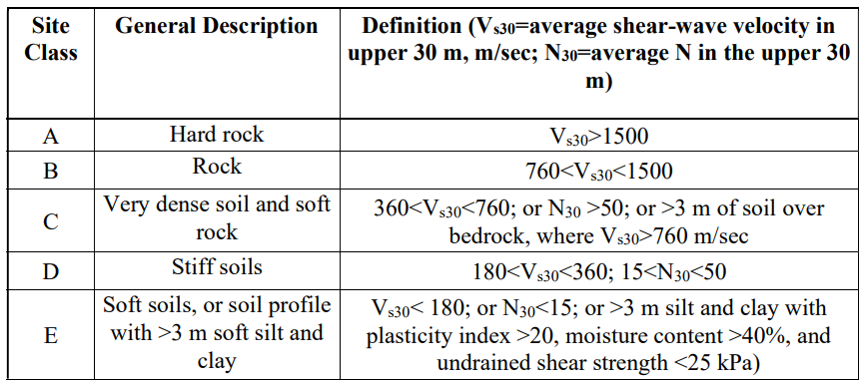

Table 2: Initial Depth and v_{s} boundaries of each subsurface layer for the MHVSR inversions

Table 3: Additional Depth and Vs boundaries of each subsurface layer for the MHVSR inversions

Figures

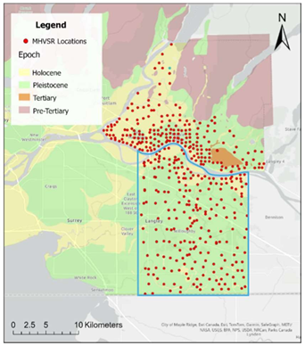

Figure 1: Map of MHVSR Sites and Geology of Eastern Vancouver. The Blue box contains the city of Langley. Retrieved from Motuzas (2025).

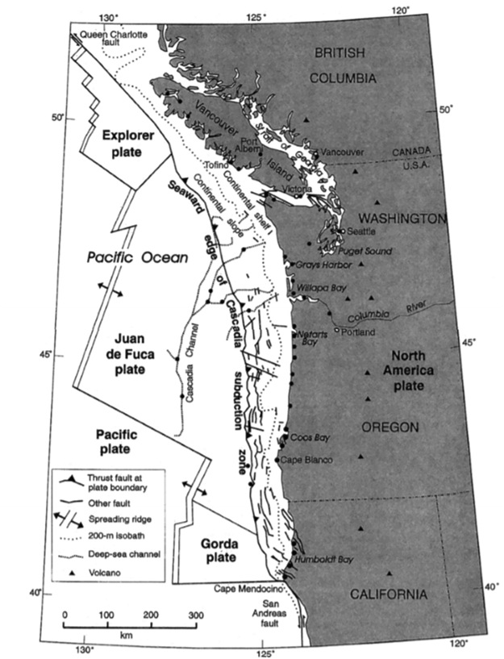
Figure 2: Map of the plates, faults, ridges, volcanos, islands and continent involved in the Cascadia Subduction Zone. Retrieved from Clague (1997).

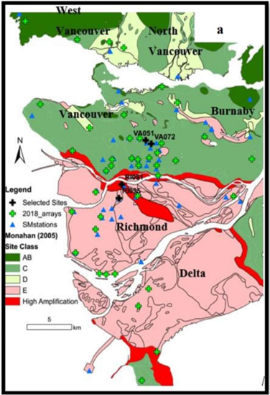
Figure 3: Greater Vancouver and its seismic site classes. Retrieved from Assaf et al (2019)
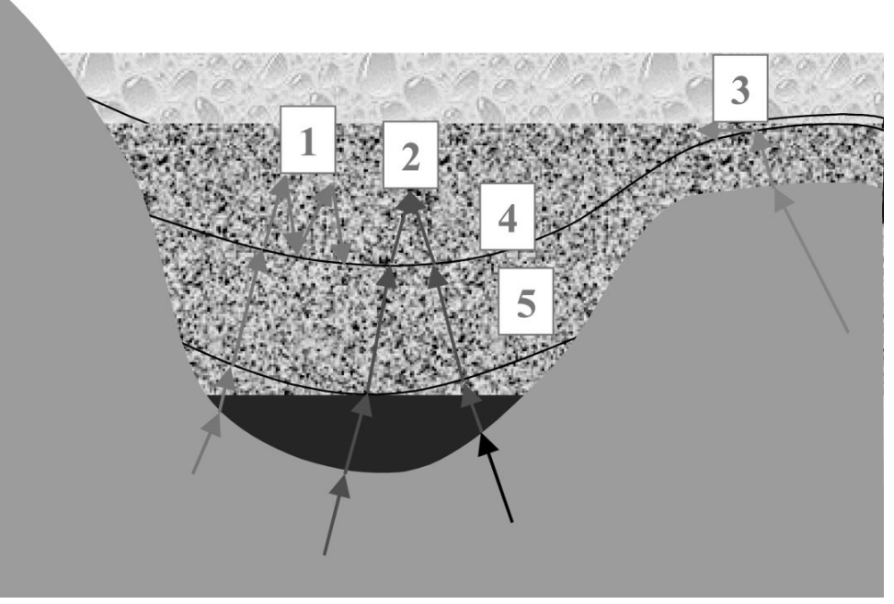Figure 4: Visual of factors such as (1) impedance contrasts, (2) topography focusing, (3) converted surface waves, (4) water content, and (5) randomness that influence seismic amplification. Retrieved from Şafak (2001).

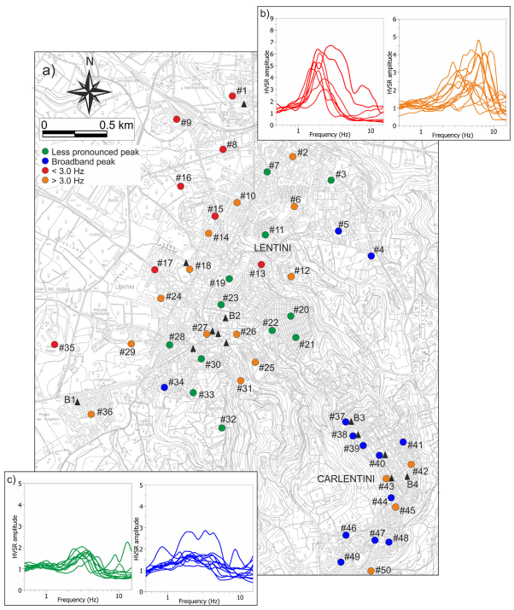
Figure 5: Distribution of resonance frequencies and HVSR patterns in the Lentini and Carlentini area. Retrieved from Panzera et al. (2018).

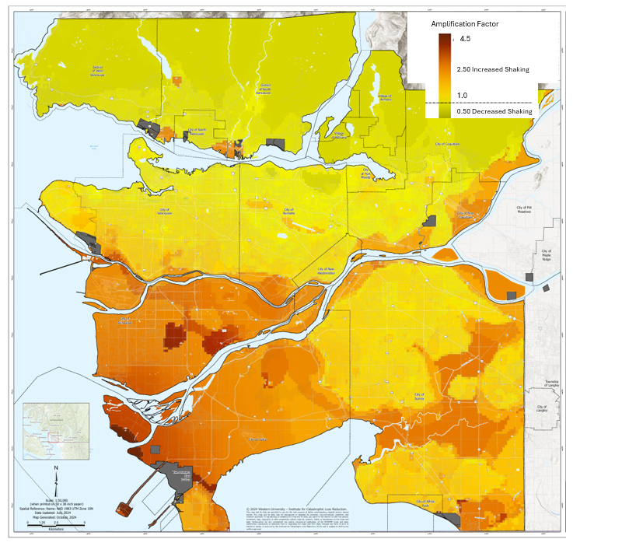Figure 6: Western Metro Vancouver Amplification hazard Map. Modified from Assaf et al. (2024)
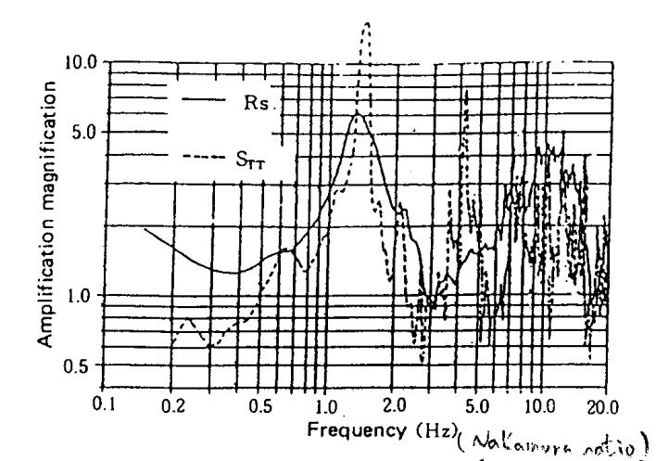
Figure 7: Comparison of the microtremor spectral ratio (R_{-s}) and earthquake transfer function (S_{TT}). Retrieved from Nakamura (1989).

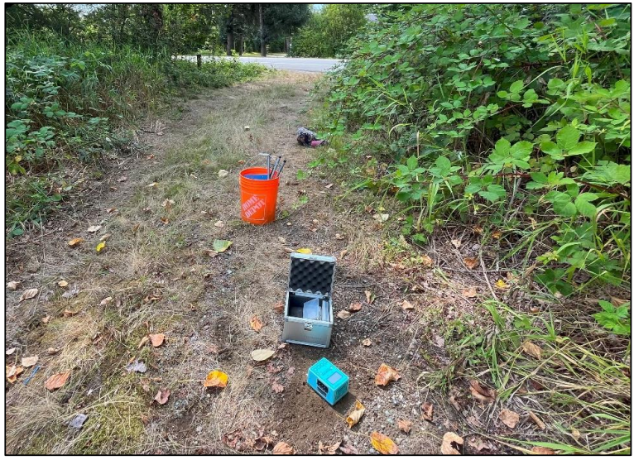
Figure 8: Image of TROMINO for MHVSR measurement in Langley. Retrieved from Motuzas (2025)

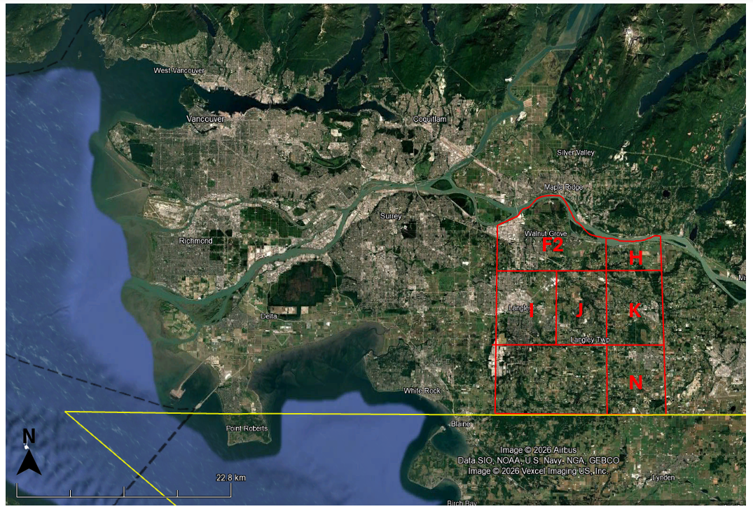Figure 9: project area and regional subsections for MHVSR sites

Figure 10: Ground profiles for final inversions from A) Region F2 B) Region H C) Region I D) Region J E) Region K F) Region N

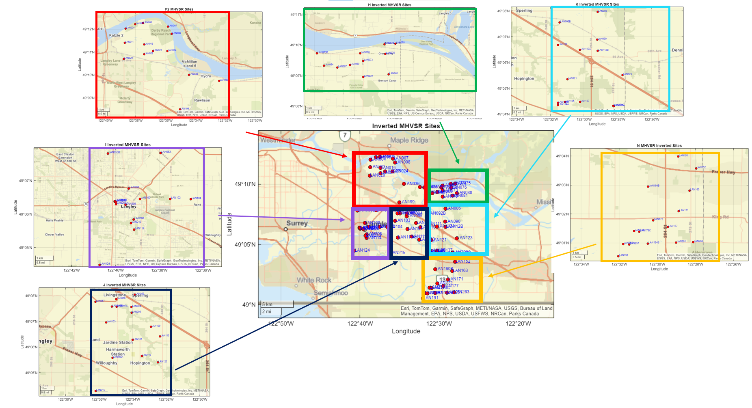Figure 11: Maps of the Sites used for MHVSR Inversions

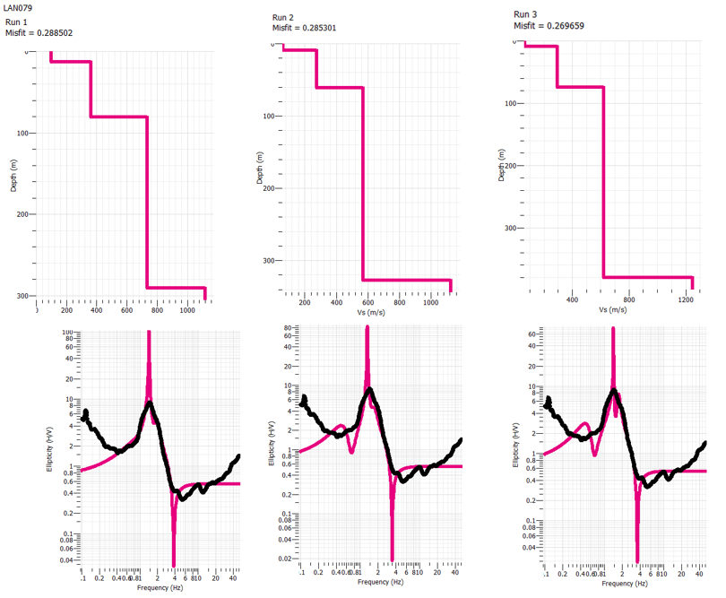
Figure 12: Example of results produced for the MHVSR Inversions.

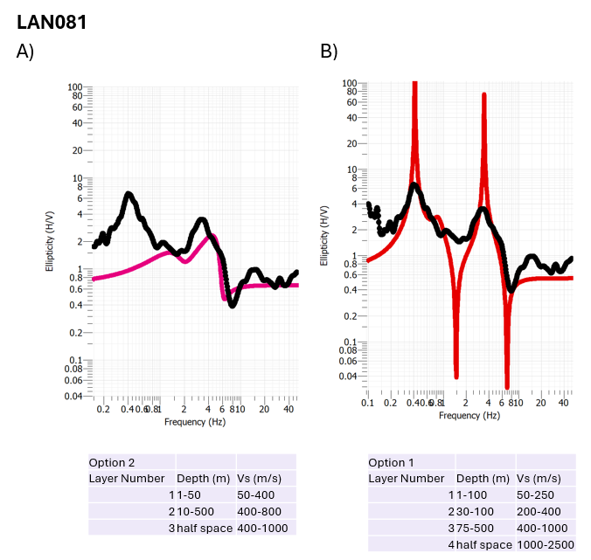
Figure 13: A) Frequency/Ellipticity curve produced through the inversion of site LAN081 using option 2 parameters B) Frequency/Ellipticity curve produced through the inversion of site LAN076 using option 1 parameters
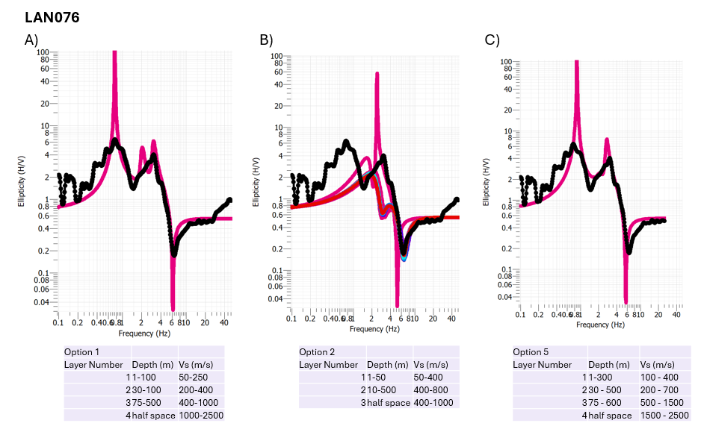
Figure 14: A) Frequency/Ellipticity curve produced through the inversion of site LAN076 using option 1 parameters B) Frequency/Ellipticity curve produced through the inversion of site LAN076 using option 2 parameters C) Frequency/Ellipticity curve produced through the inversion of site LAN076 using option 5 parameters

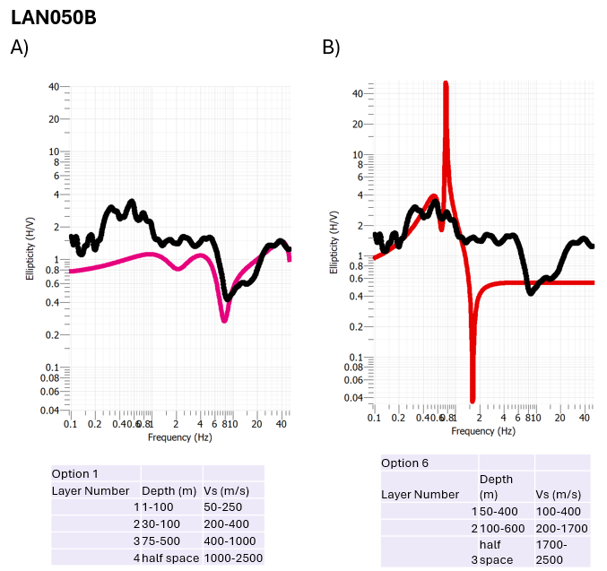
Figure 15: A) Frequency/Ellipticity curve produced through the inversion of site LAN050B using option 1 parameters B) Frequency/Ellipticity curve produced through the inversion of site LAN050B using option 6 parameters
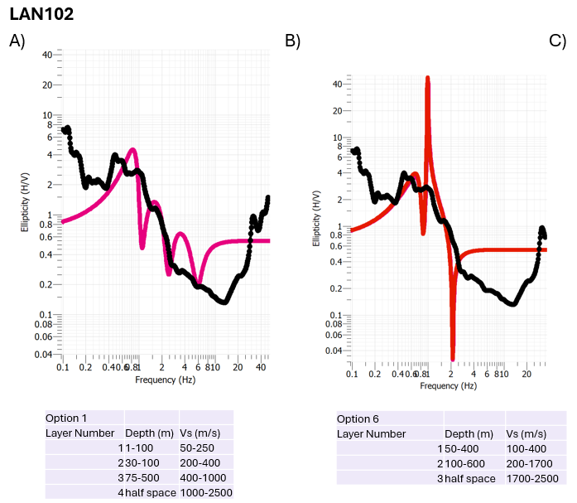

Figure 16: A) Frequency/Ellipticity curve produced through the inversion of site LAN102 using option 1 parameters B) Frequency/Ellipticity curve produced through the inversion of site LAN102 using option 6 parameters

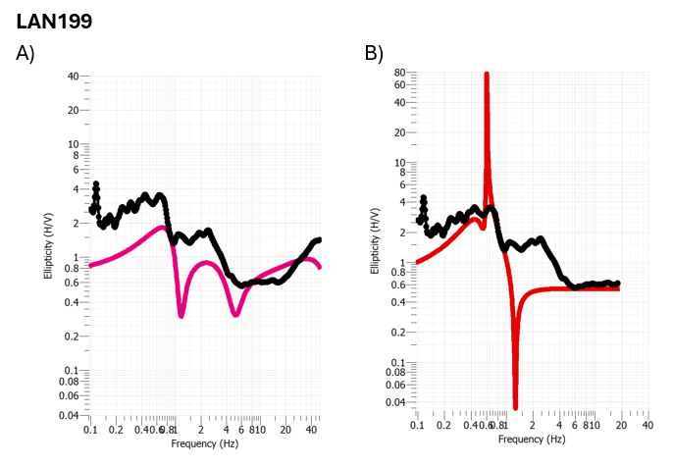
Figure 17: A) Frequency/Ellipticity curve produced through the inversion of site LAN199 with no cutting of the MHVSR curve B) Frequency/Ellipticity curve produced through the inversion of site LAN199 after cutting off the MHVSR curve at 20 Hz
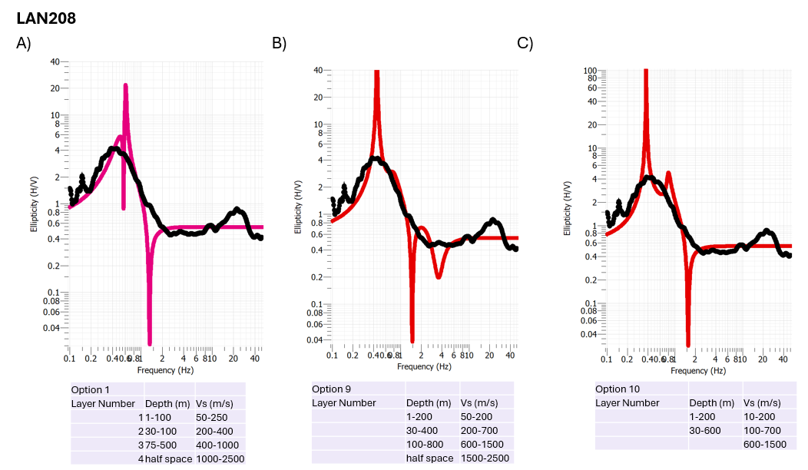
Figure 18: A) Frequency/Ellipticity curve produced through the inversion of site LAN208 using option 1 parameters B) Frequency/Ellipticity curve produced through the inversion of site LAN208 using option 9 parameters C) Frequency/Ellipticity curve produced through the inversion of site LAN208 using option 10 parameters

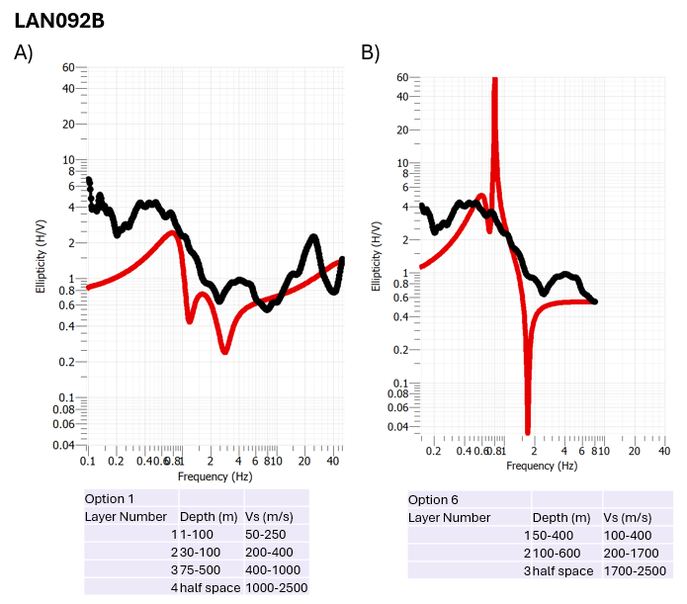
Figure 19: A) Frequency/Ellipticity curve produced through the inversion of site LAN092B with option 1 parameters and no cutting of the MHVSR curve B) Frequency/Ellipticity curve produced through the inversion of site LAN199 using option 6 parameters after cutting off the MHVSR curve at 10 Hz

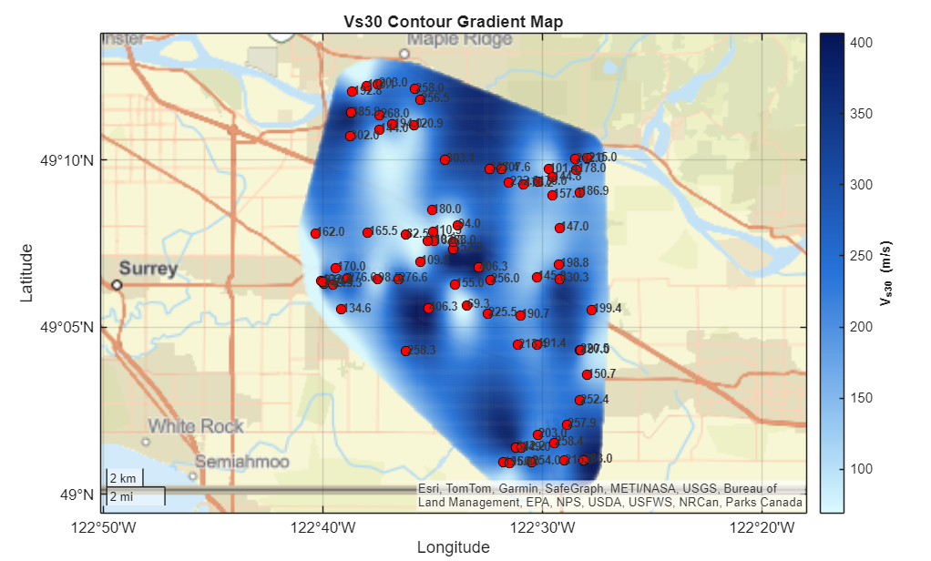
Figure 20: Vs₃₀ Gradient Map

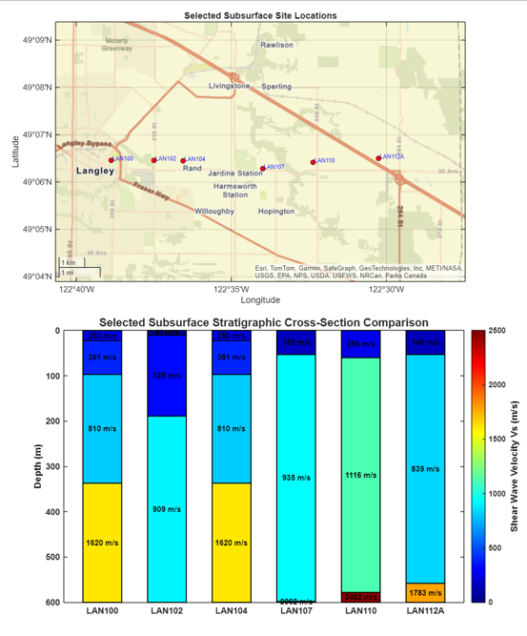
Figure 21: East-West transect showing subsurface layering for specified sites

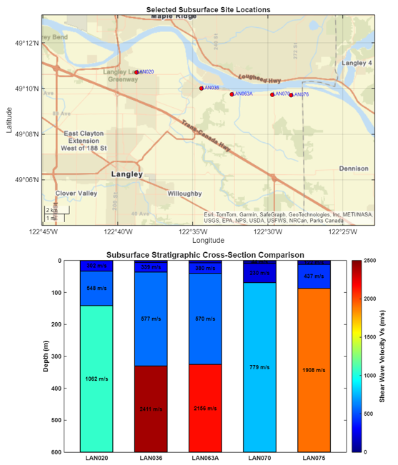
Figure 22: East-West transect showing subsurface layering for specified sites
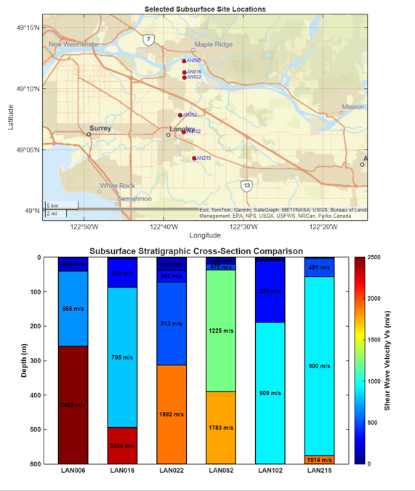

Figure 23: North-South transect showing subsurface layering for specified sites
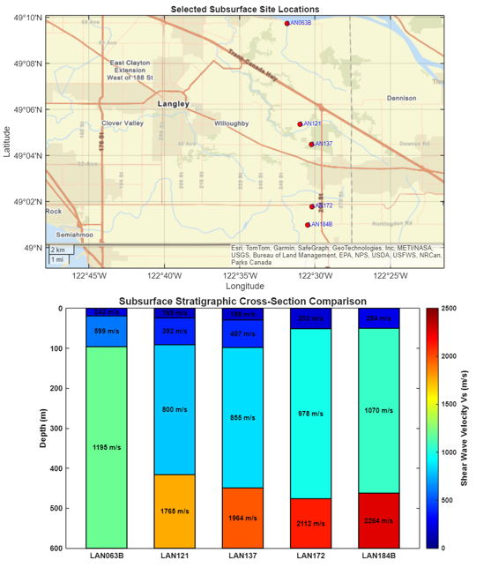
Figure 24: North-South transect showing subsurface layering for specified sites

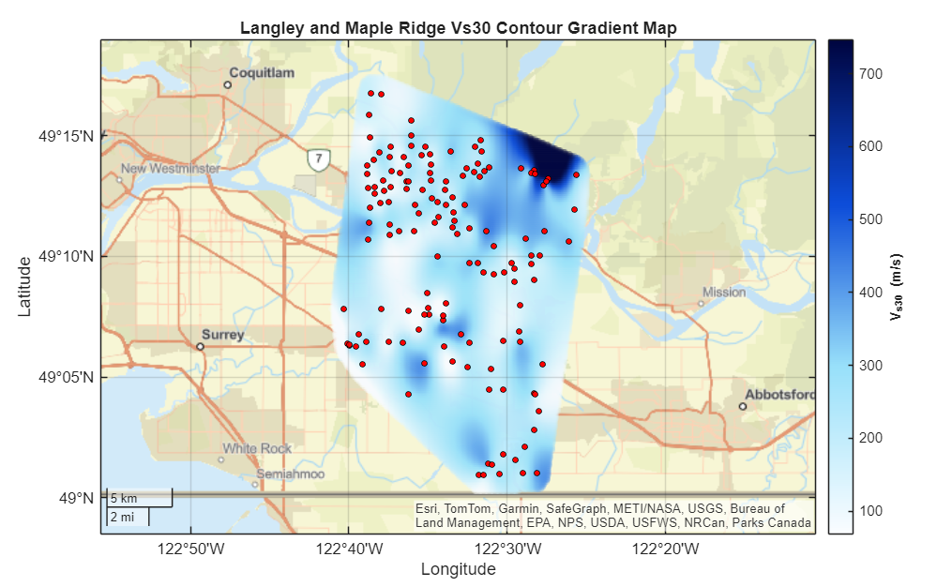
Figure 25: Vs30 map with additional Maple Ridge Data

Appendices

Appendix A: Field Collected MHVSR Curves

A1: MHVSR Curves for subregion F2
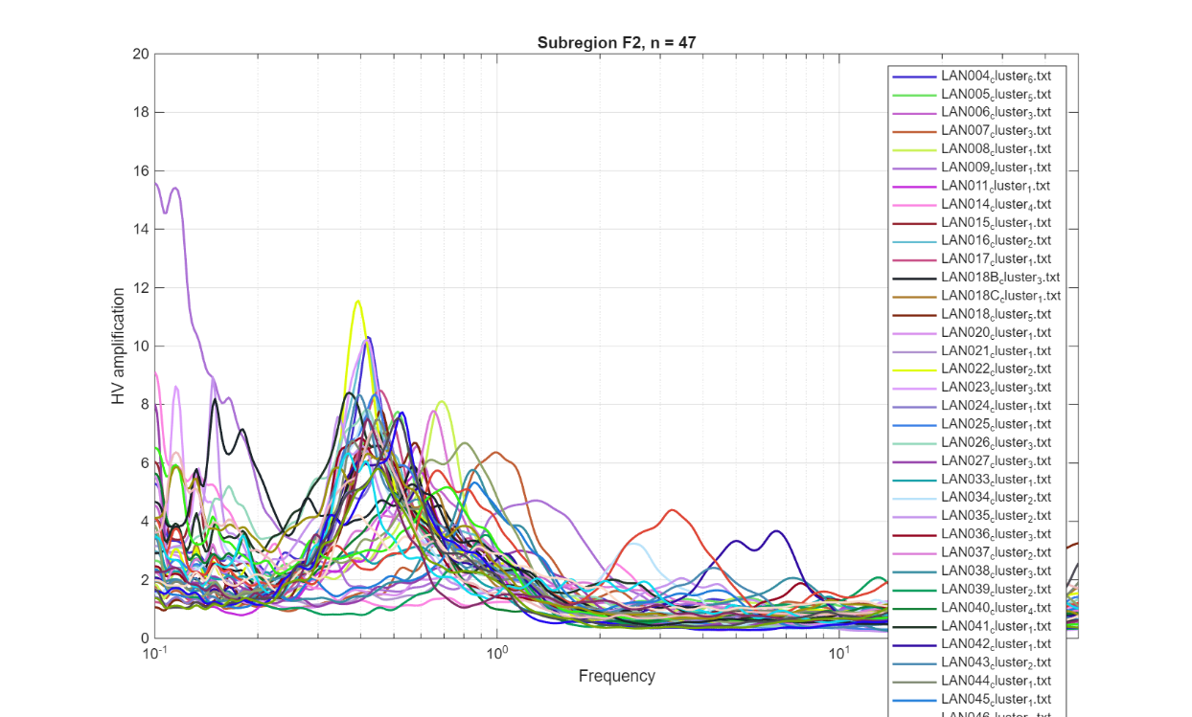
A2: MHVSR Curves for subregion H
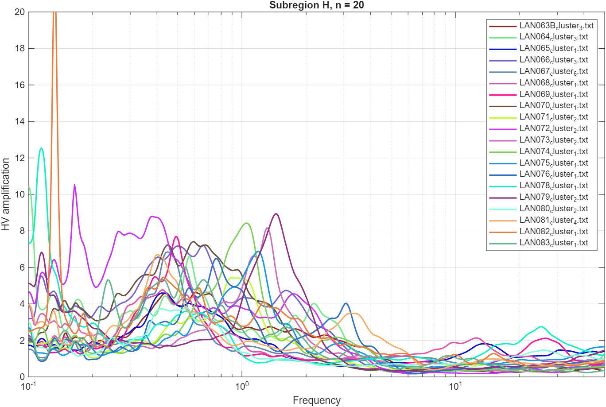
A3: MHVSR Curves for subregion I
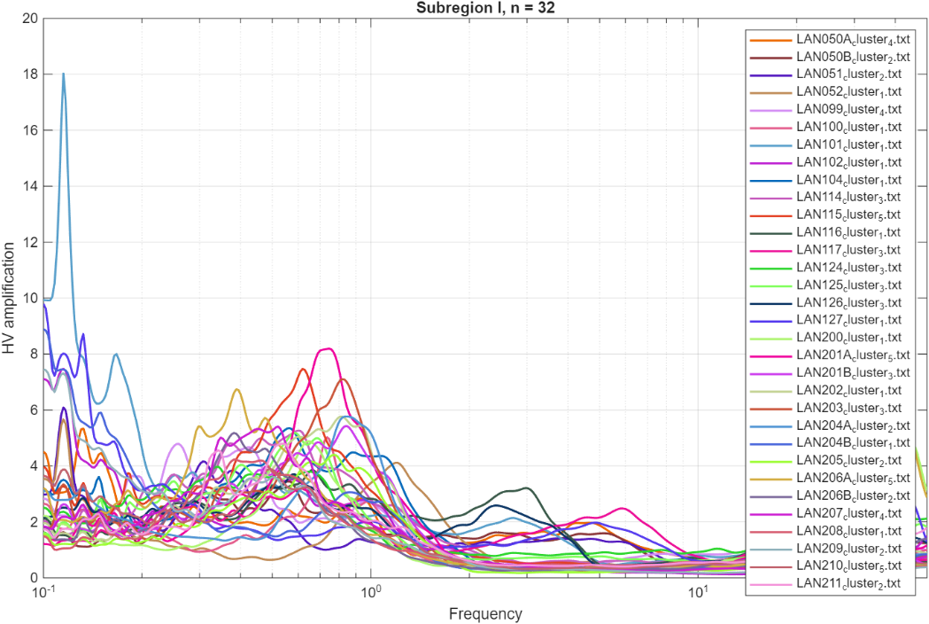
A4: MHVSR Curves for subregion J
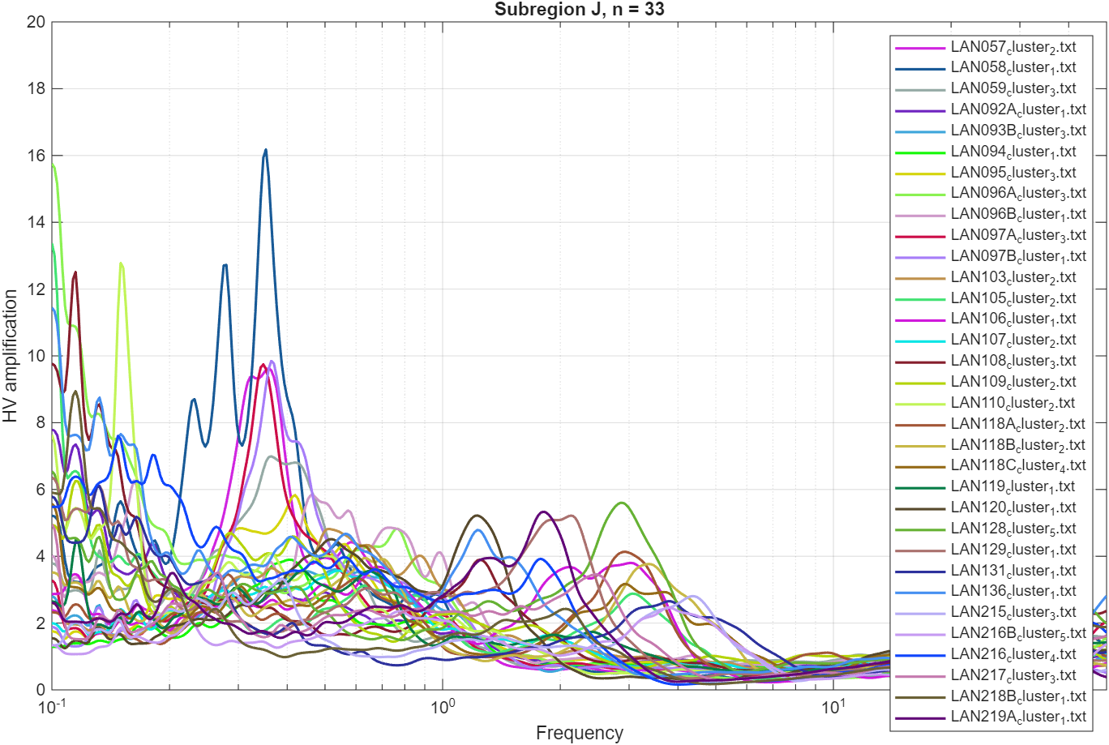

A5: MHVSR Curves for subregion K
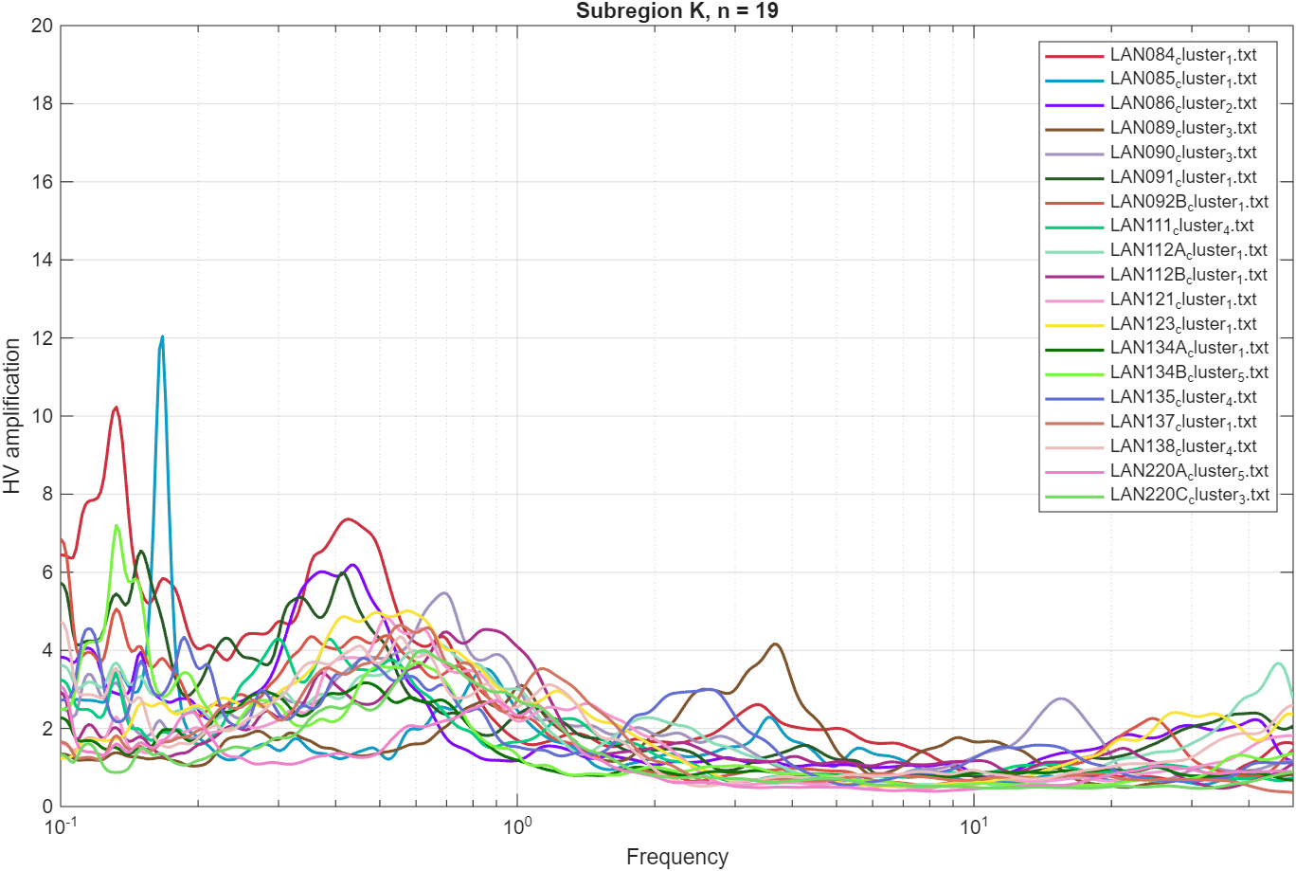

A6: MHVSR Curves for subregion N
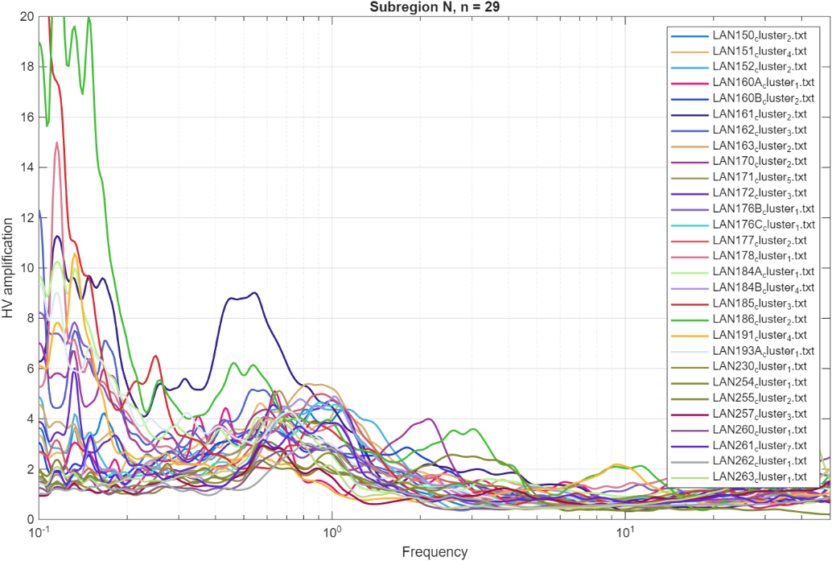

Appendix B: Initial Ground Profiles and Ellipticity Curves for each site
B1: F2 Region
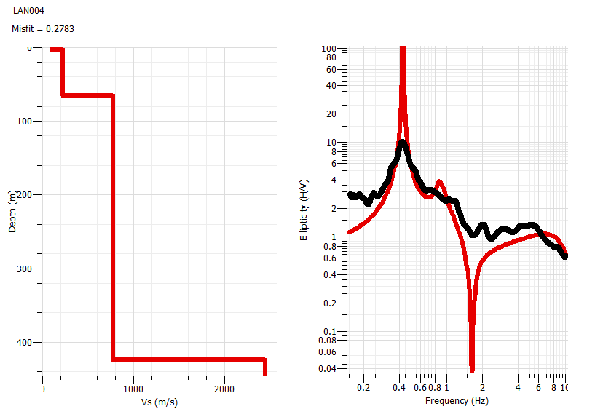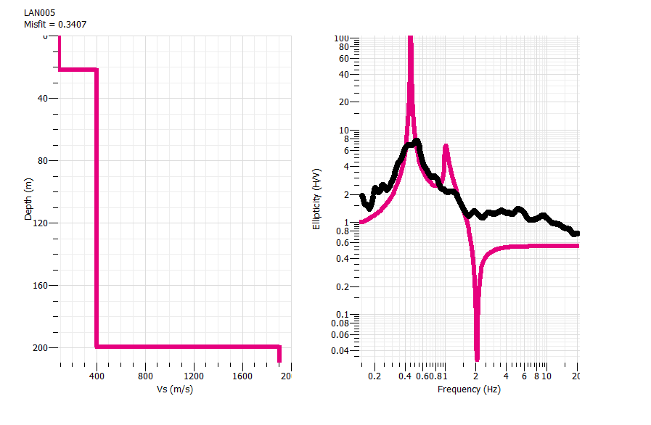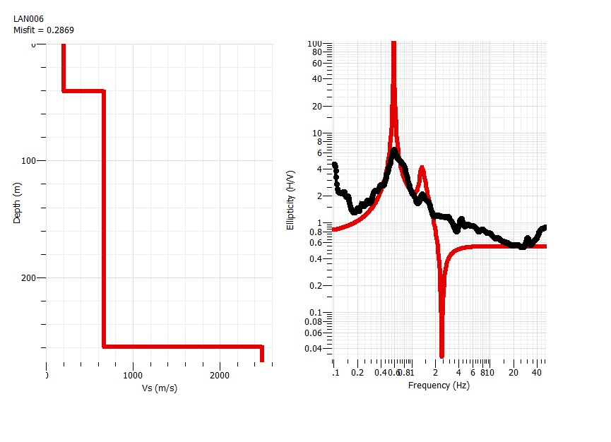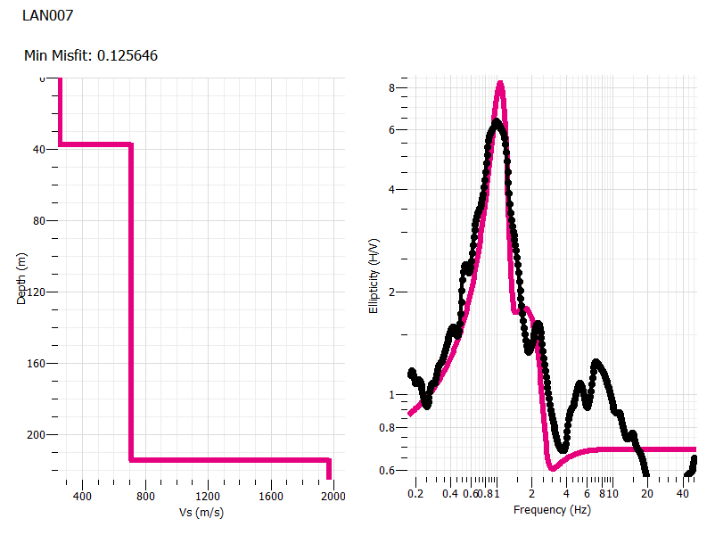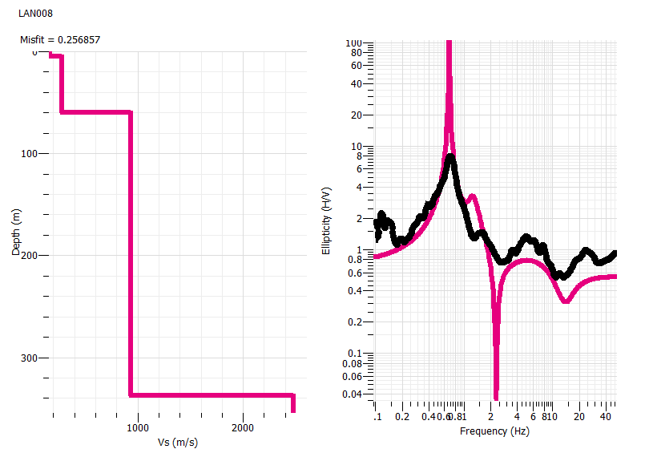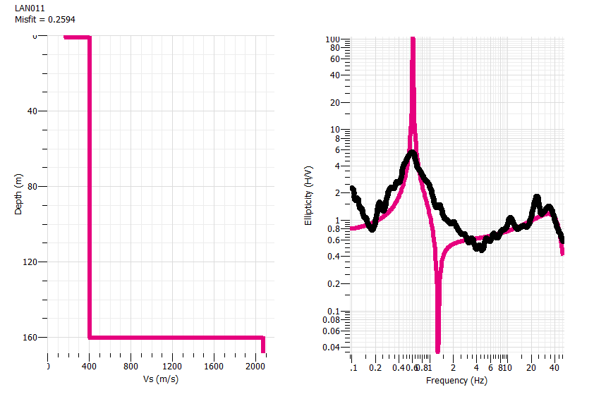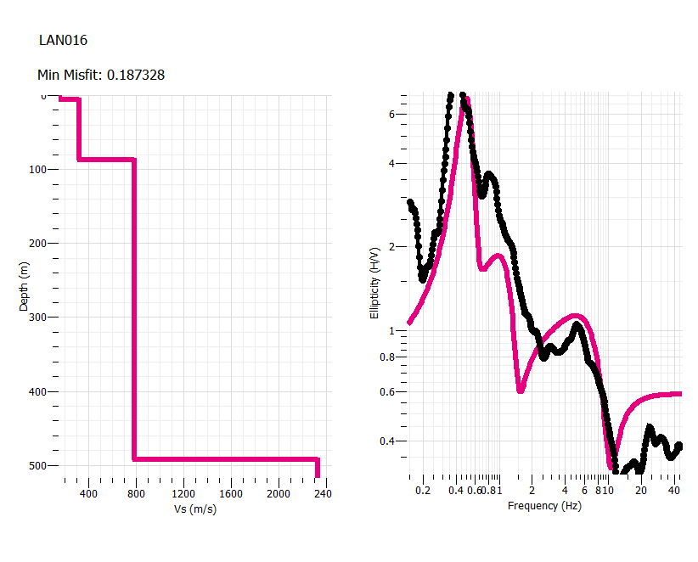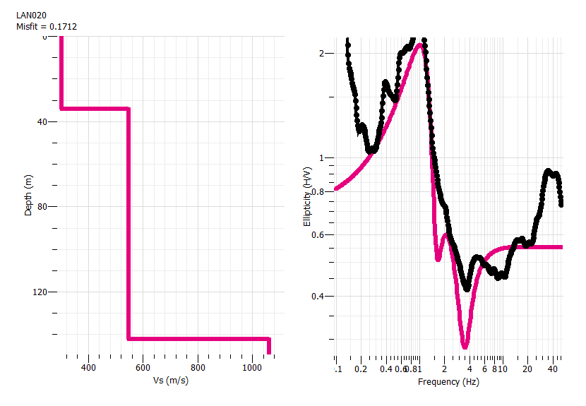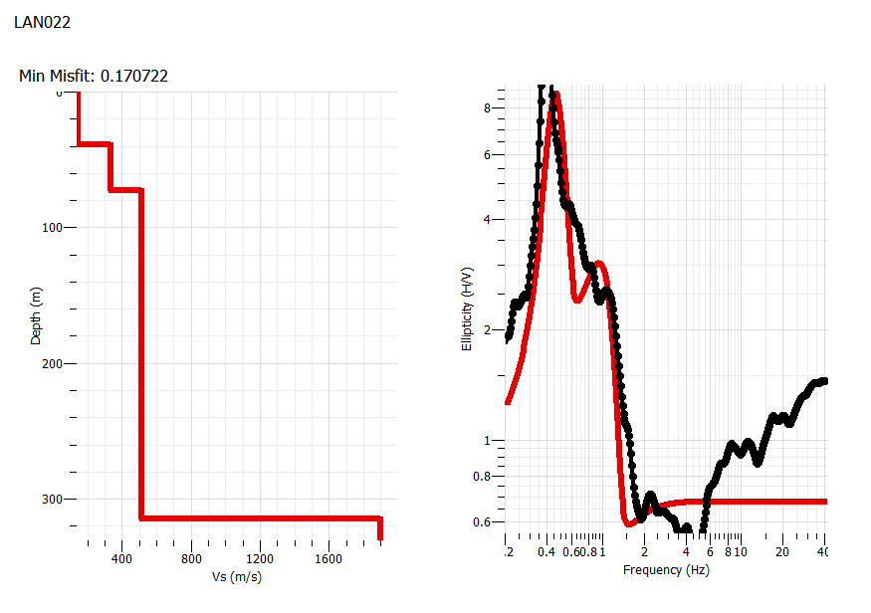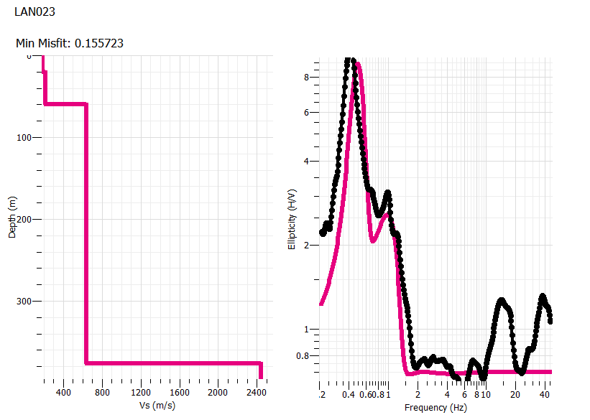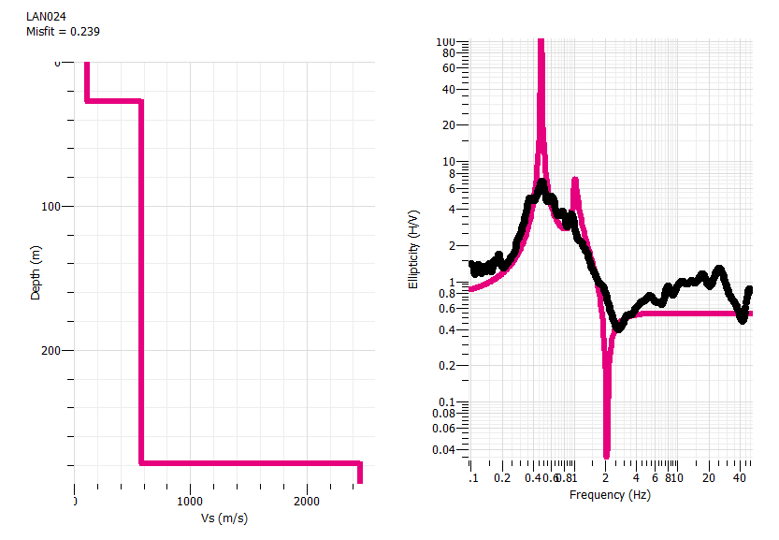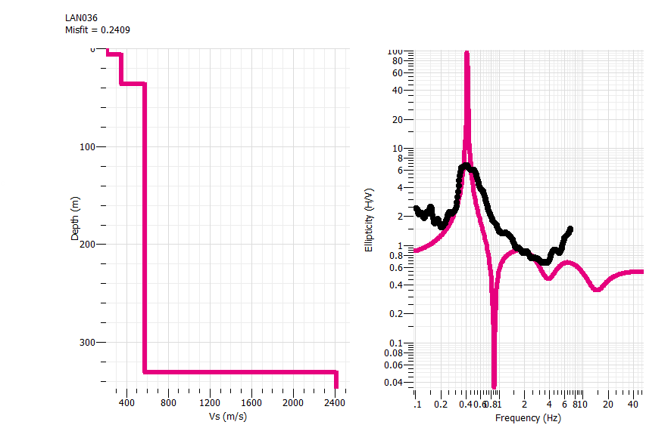
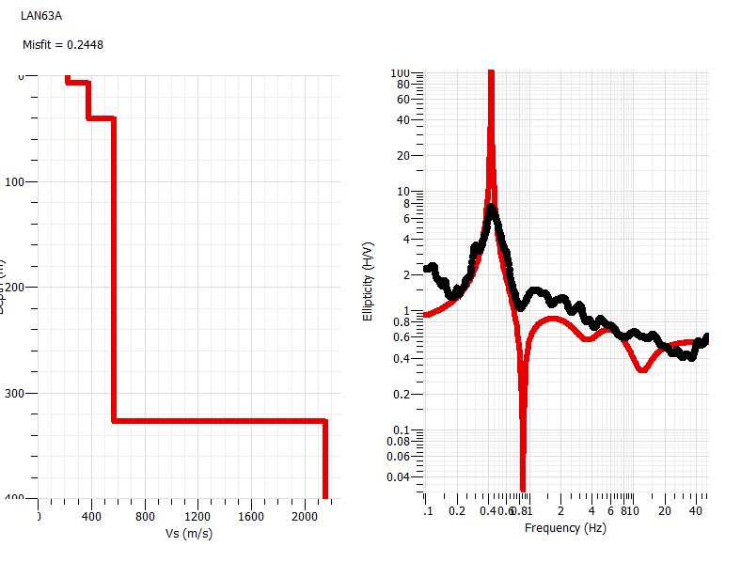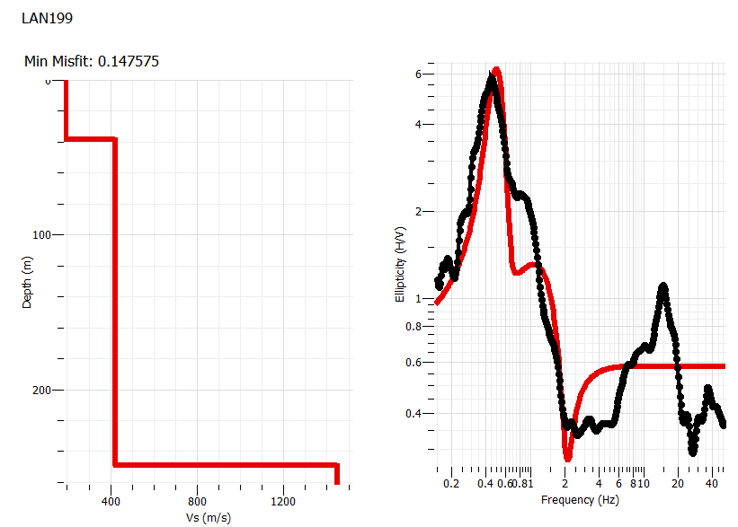
B2: H Region
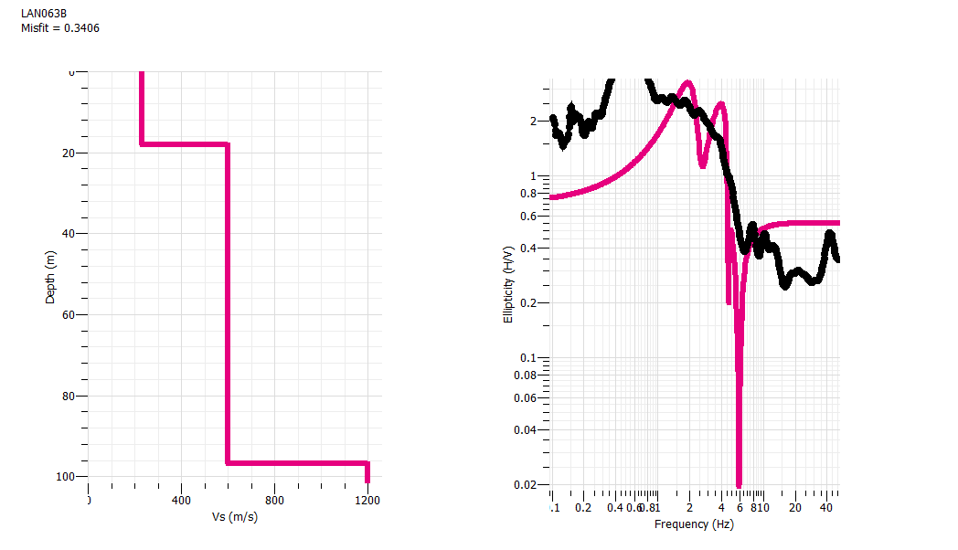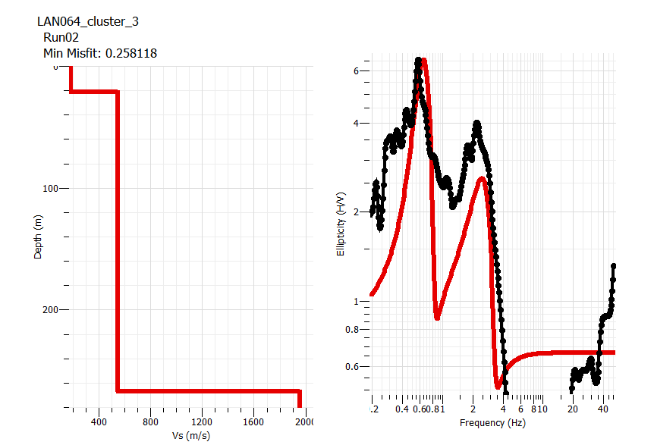
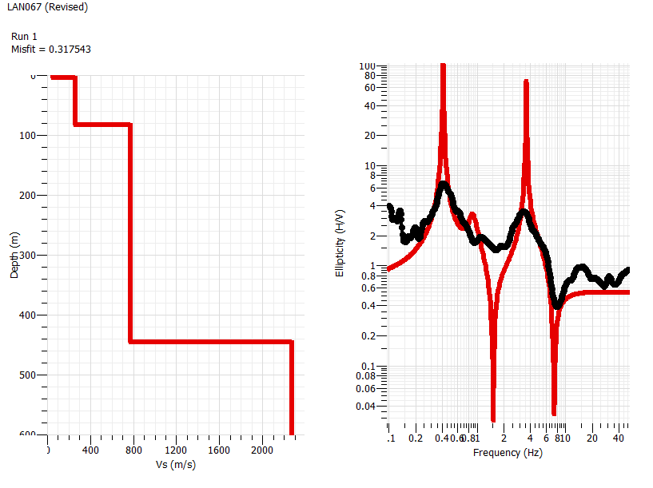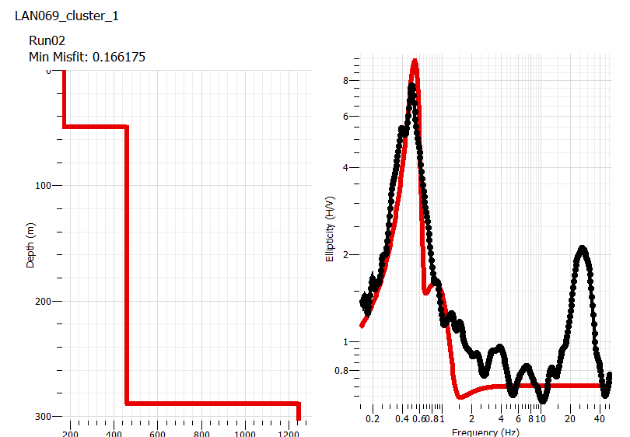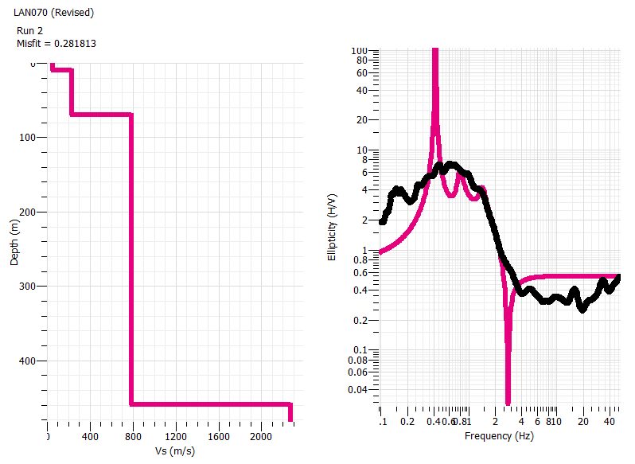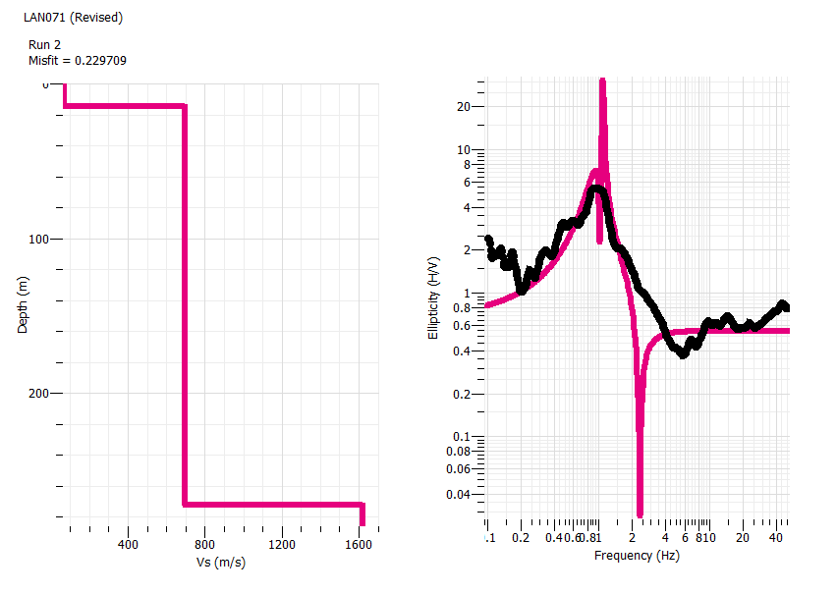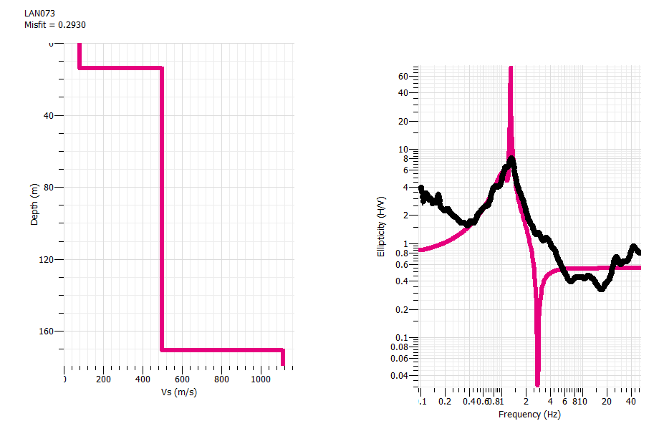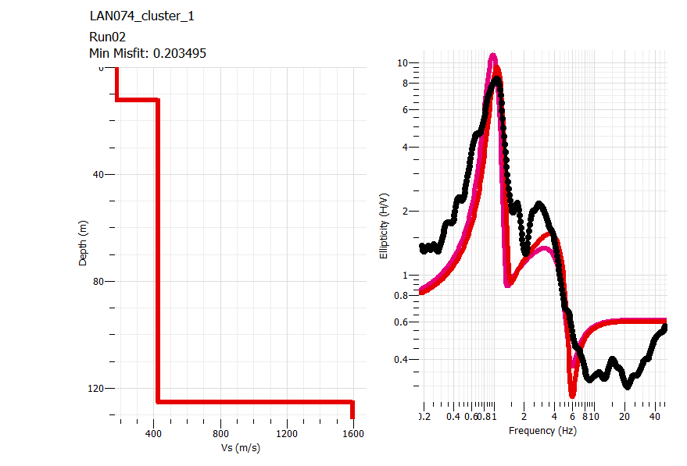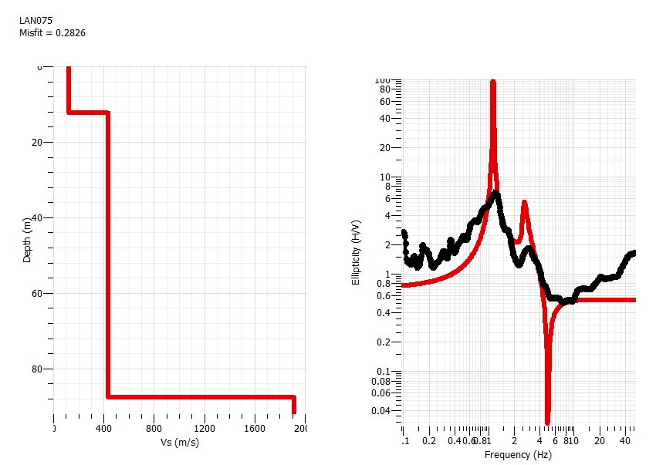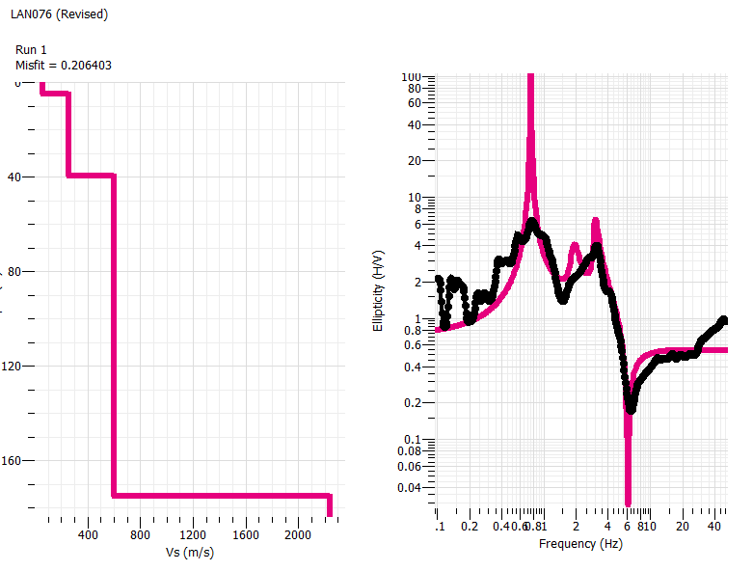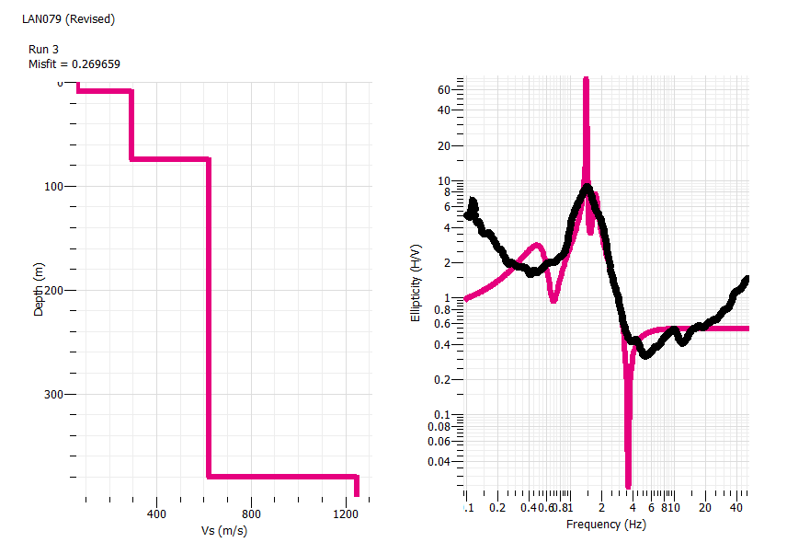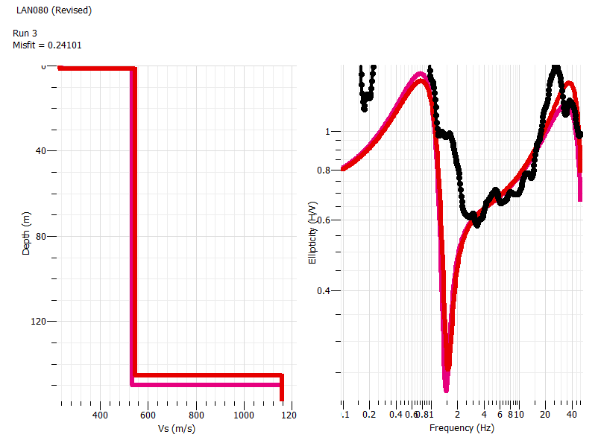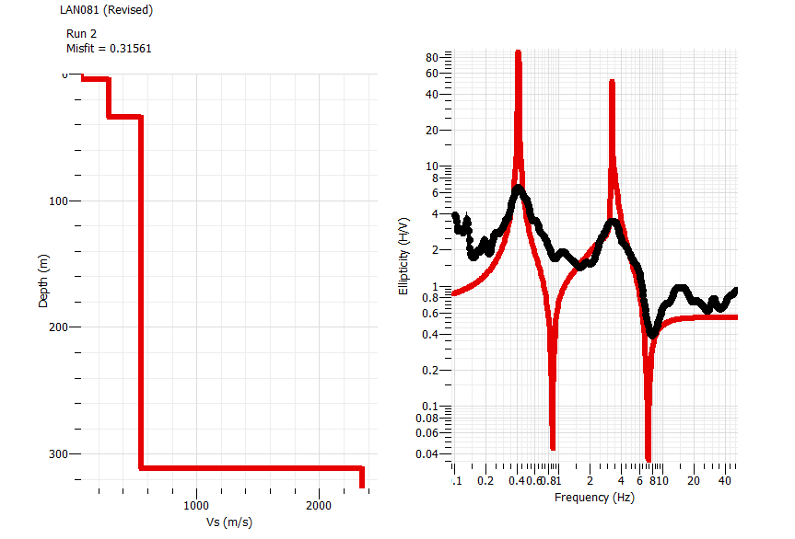
B3: I Region
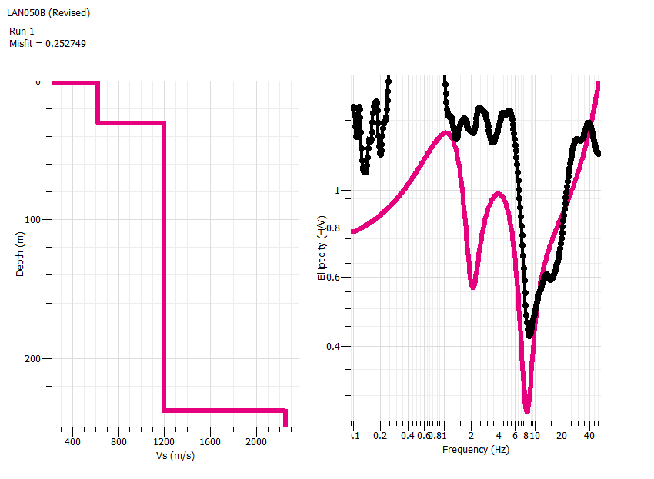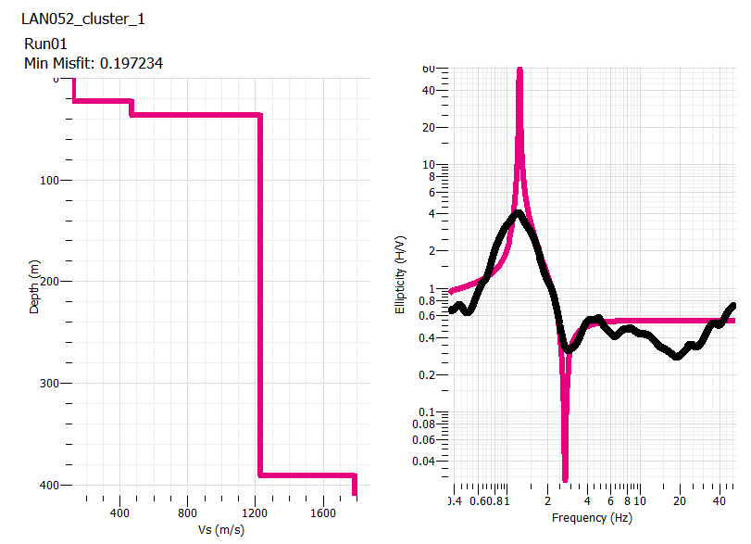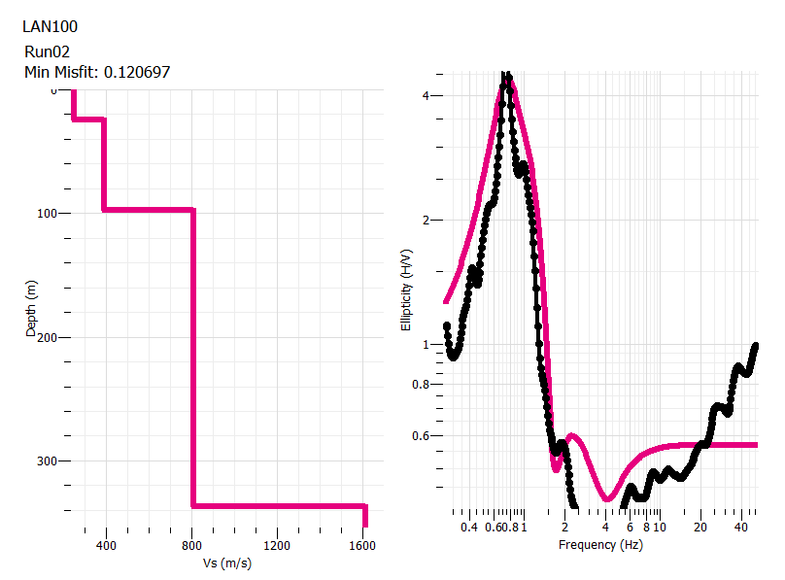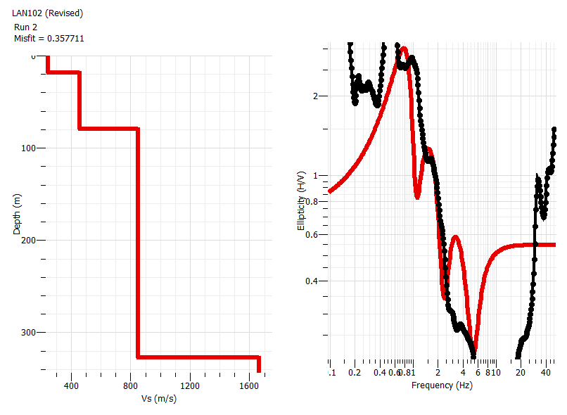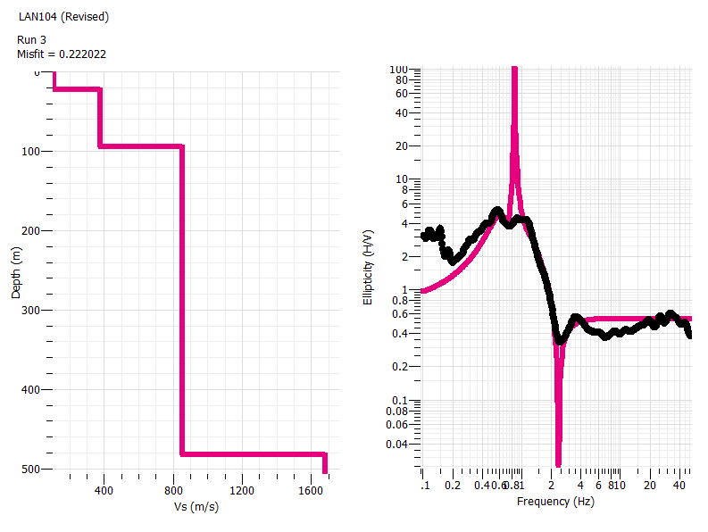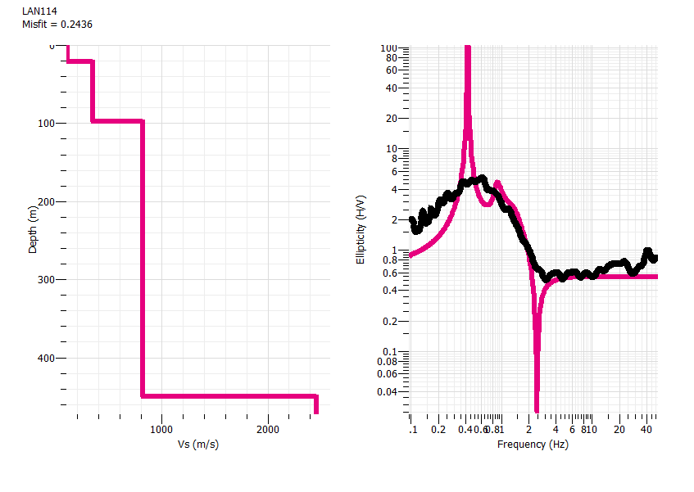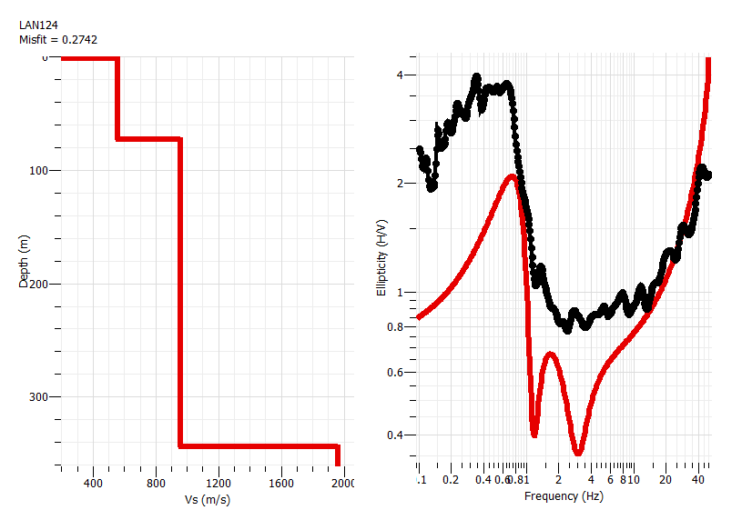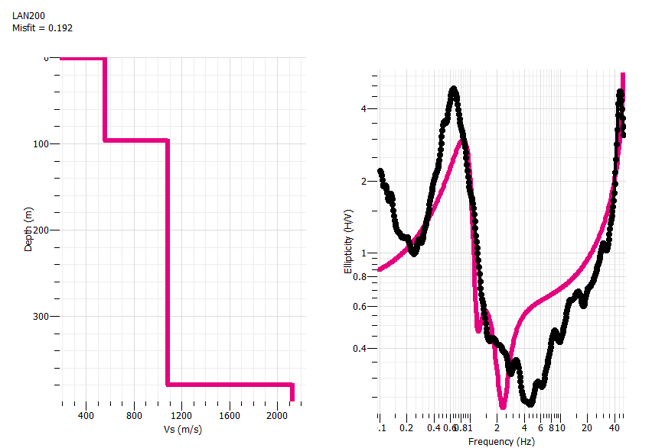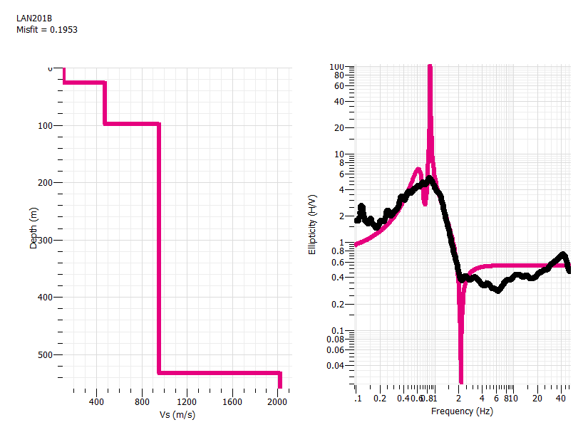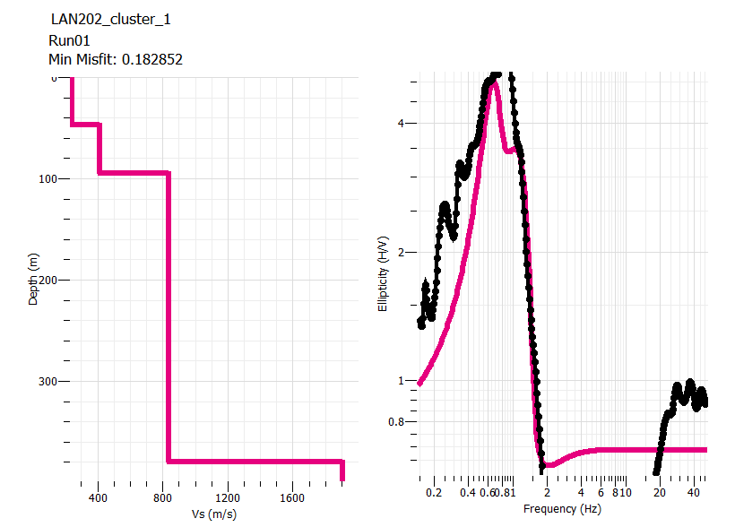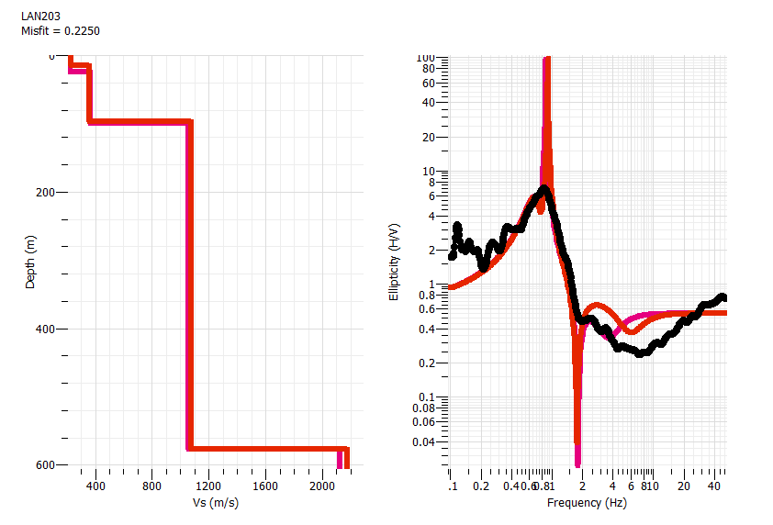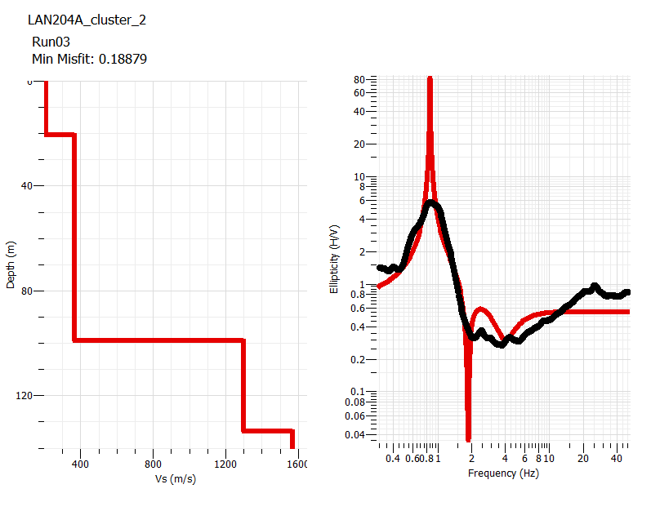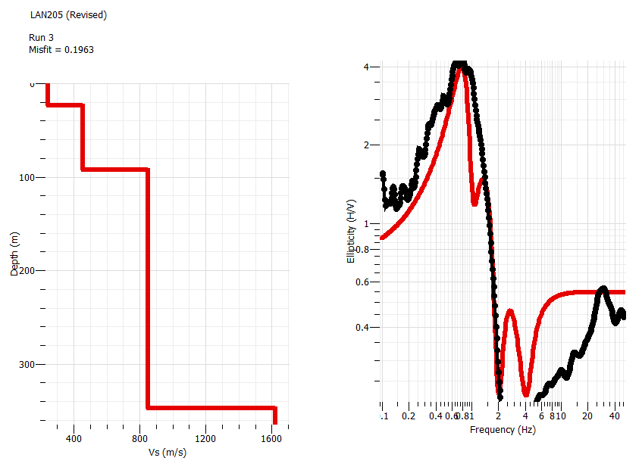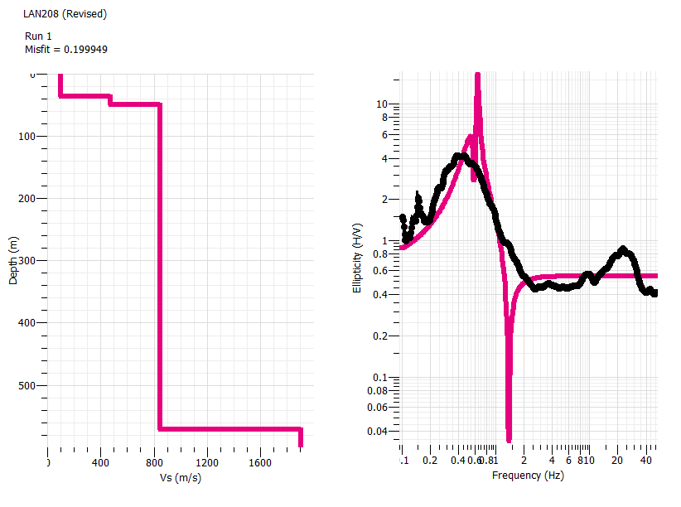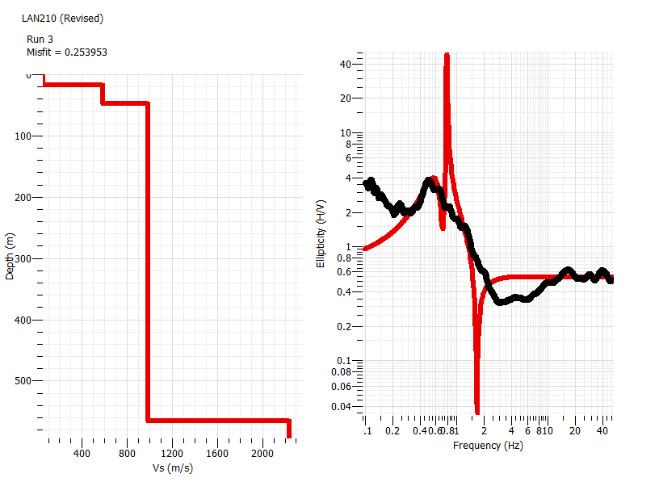
B4: J Region
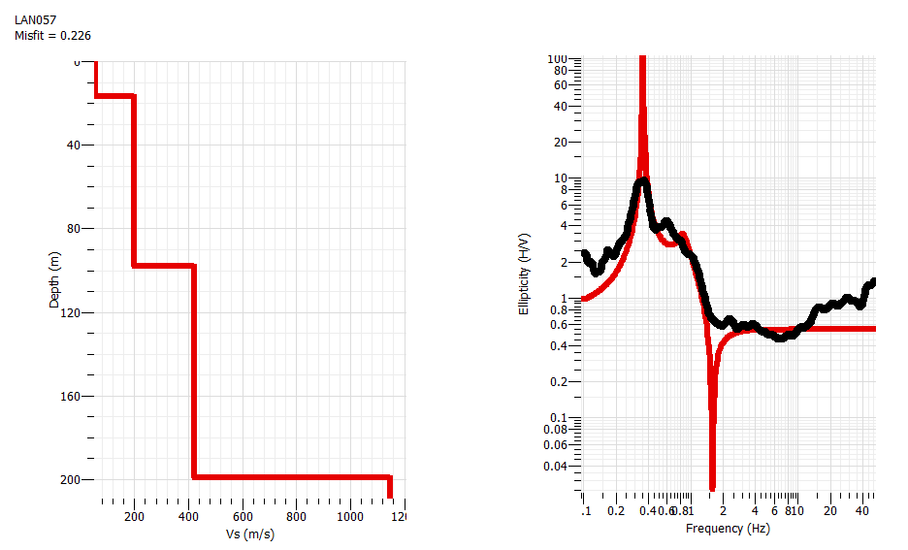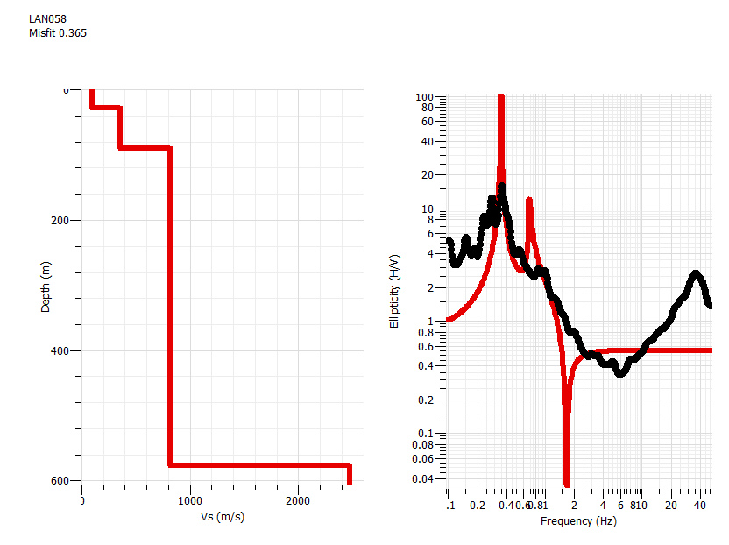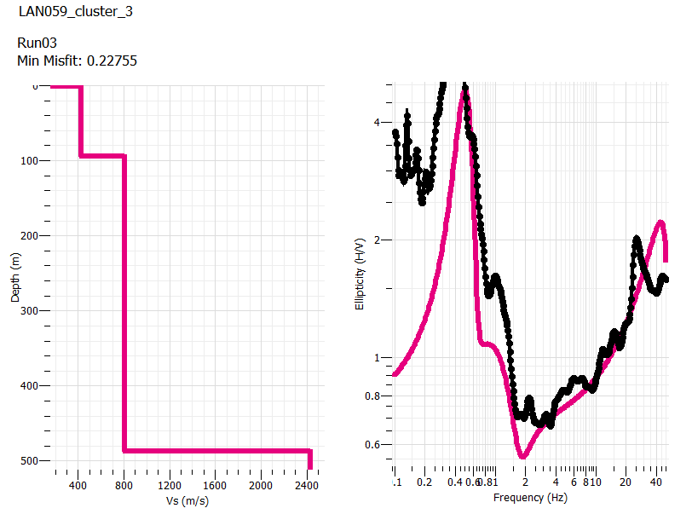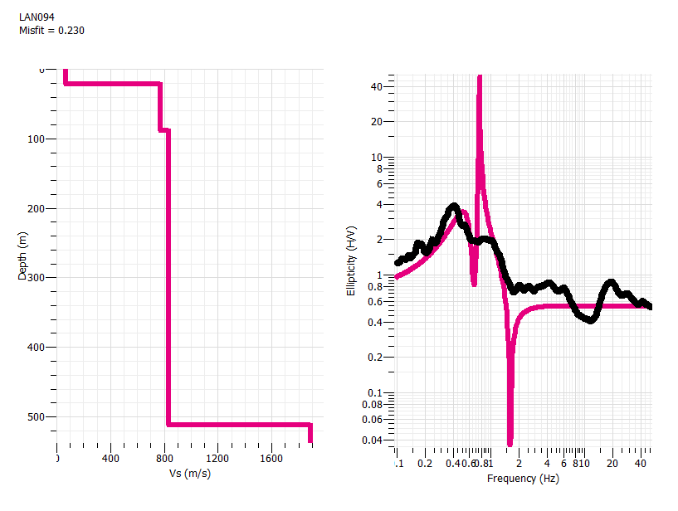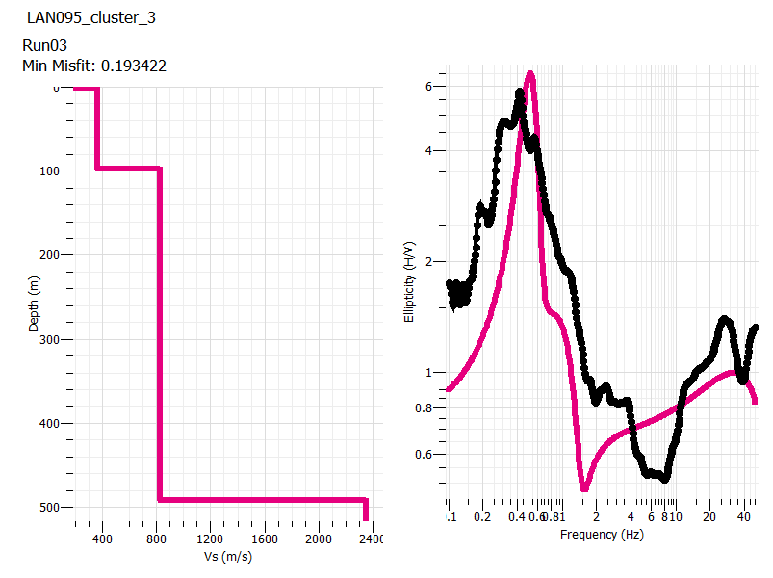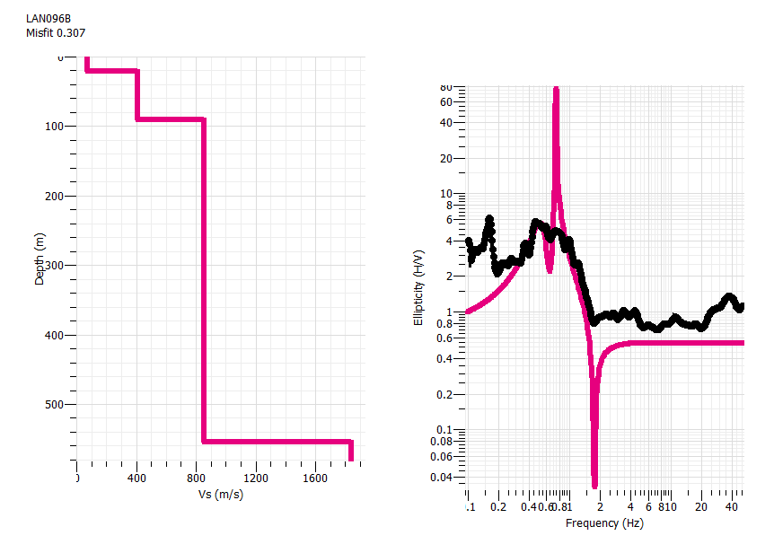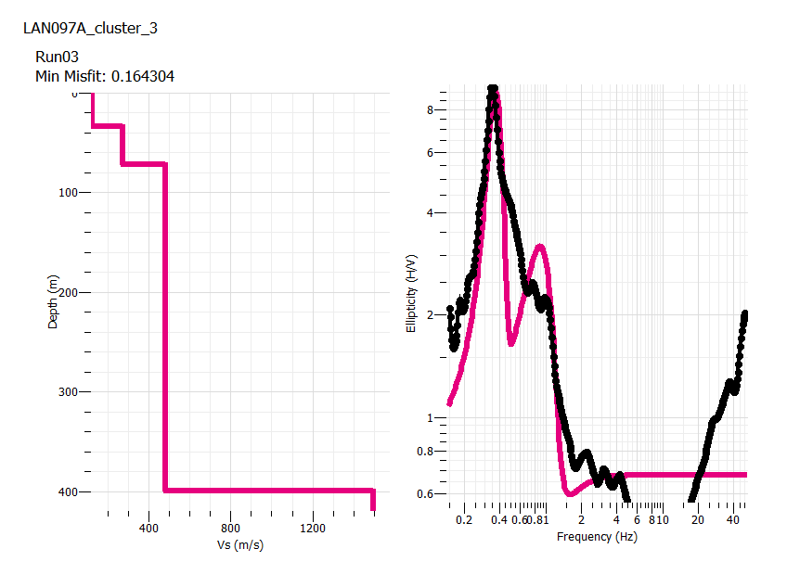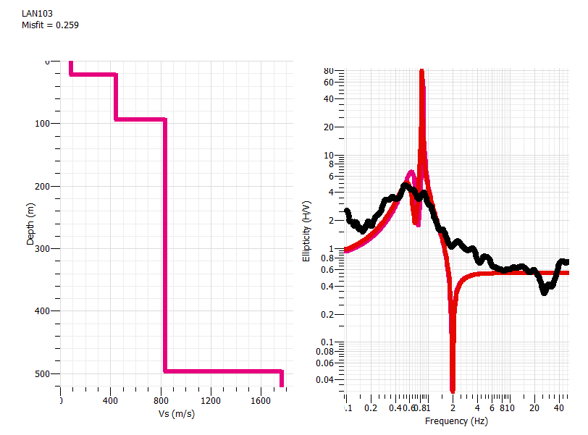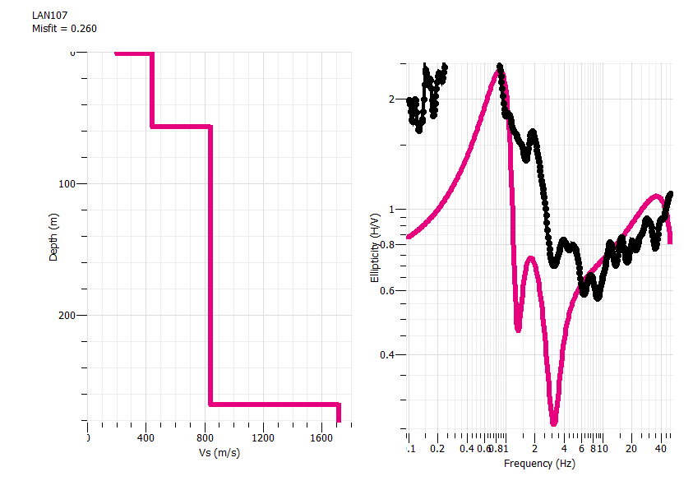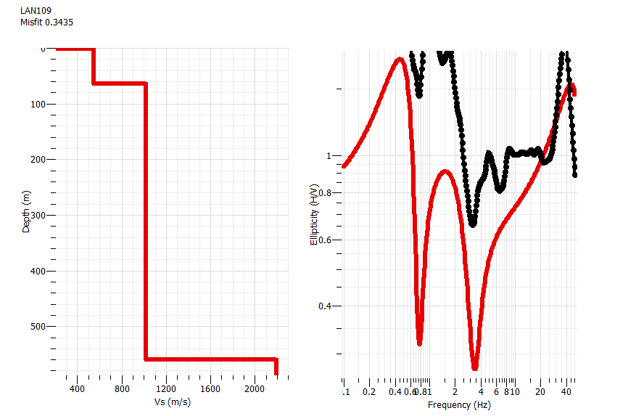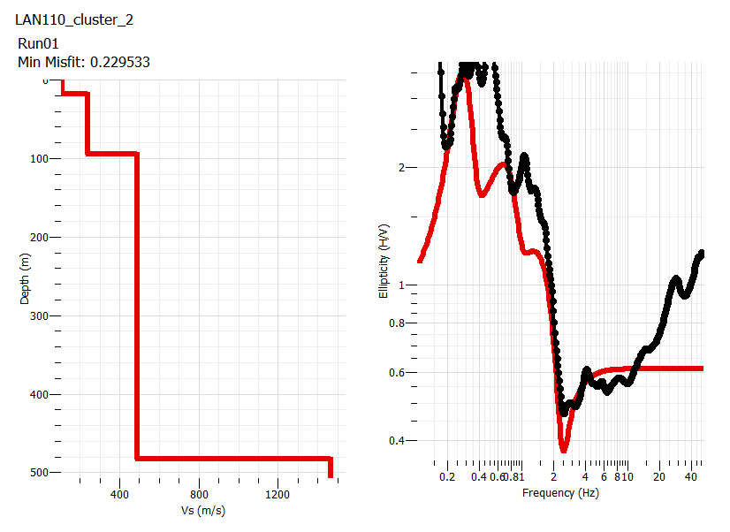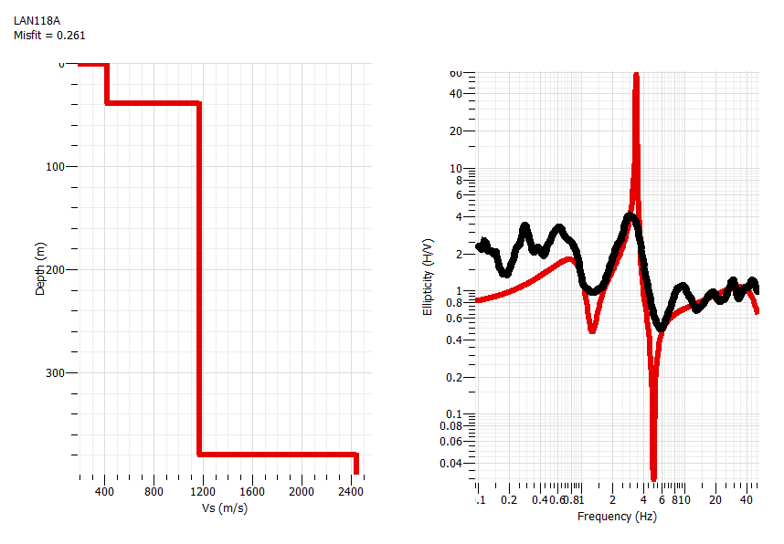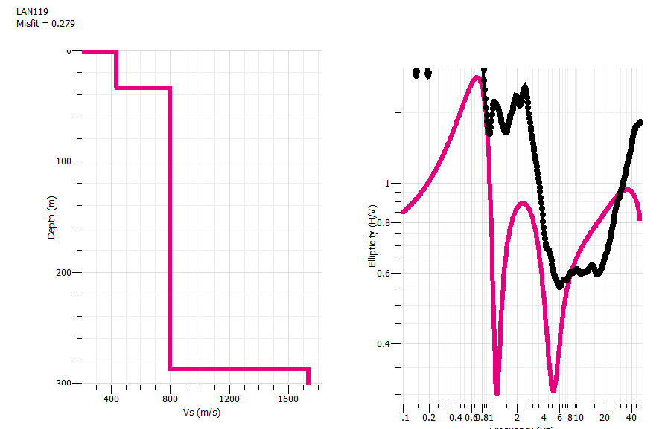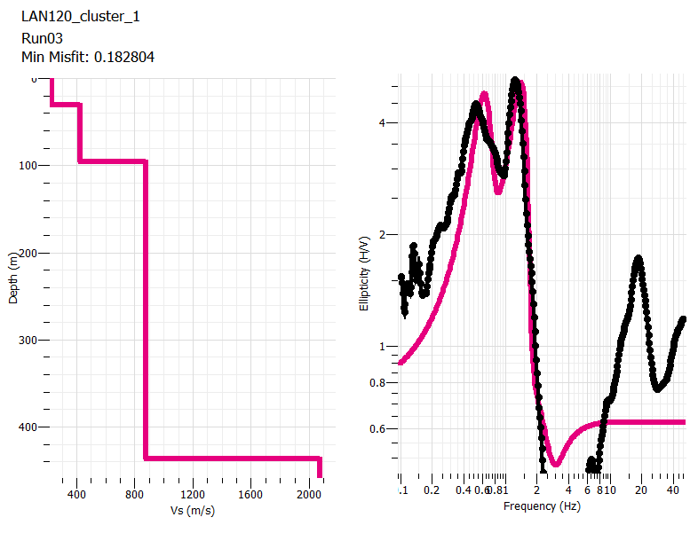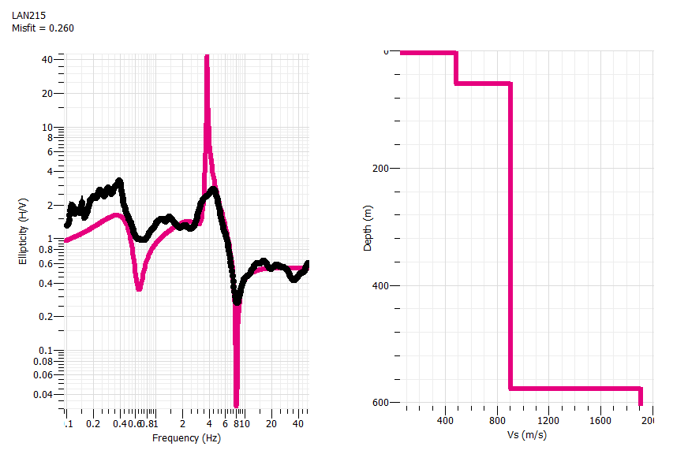
B5: K Region
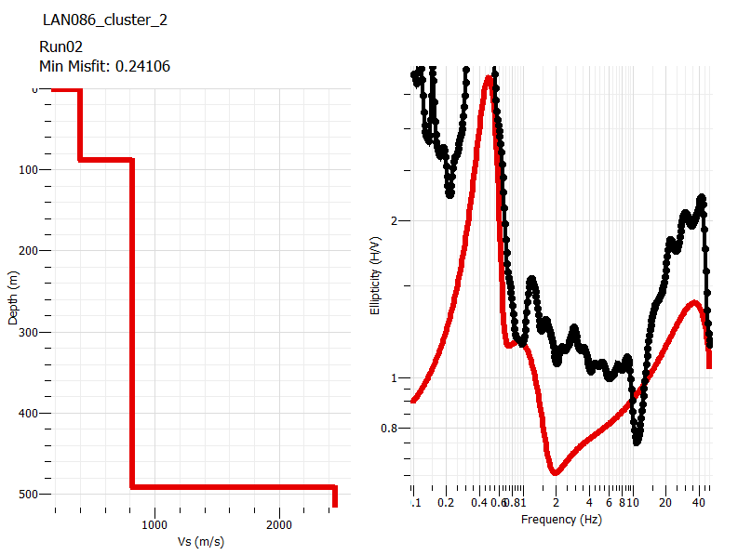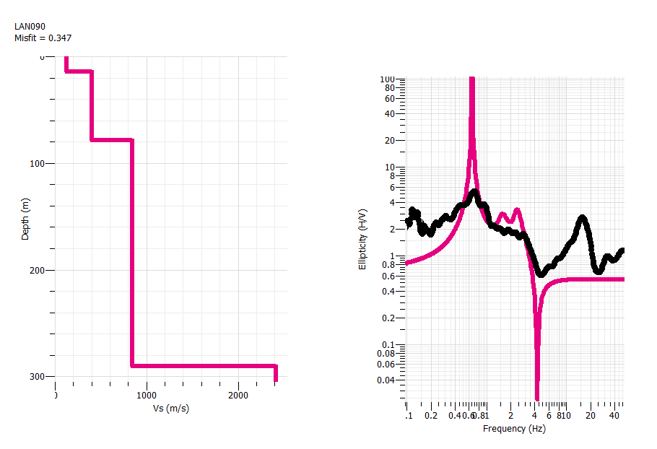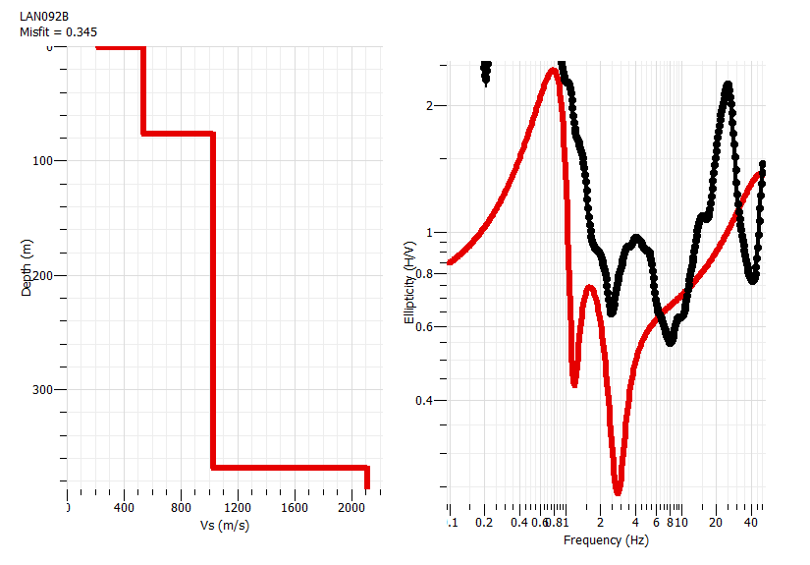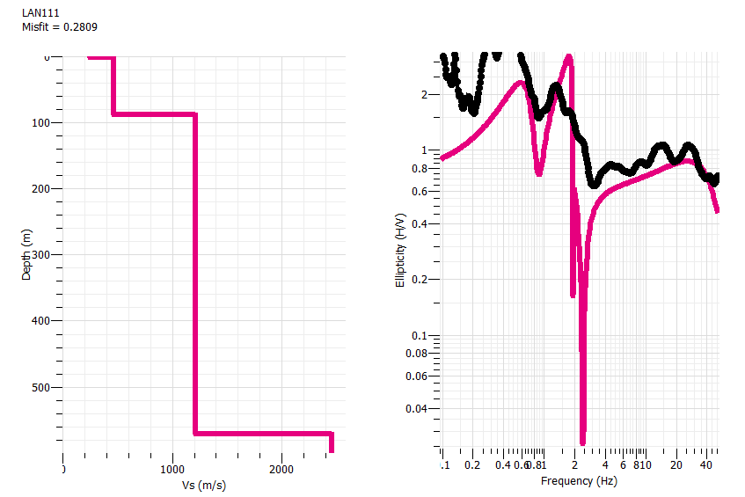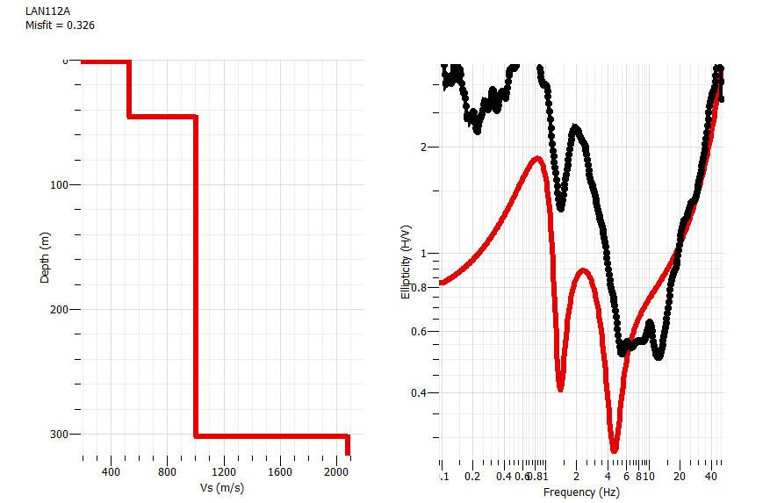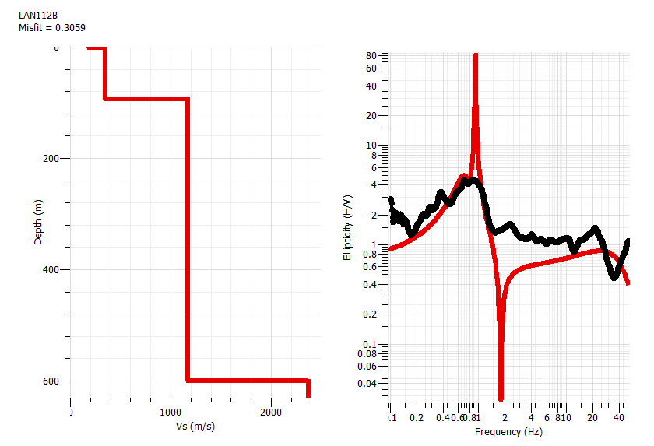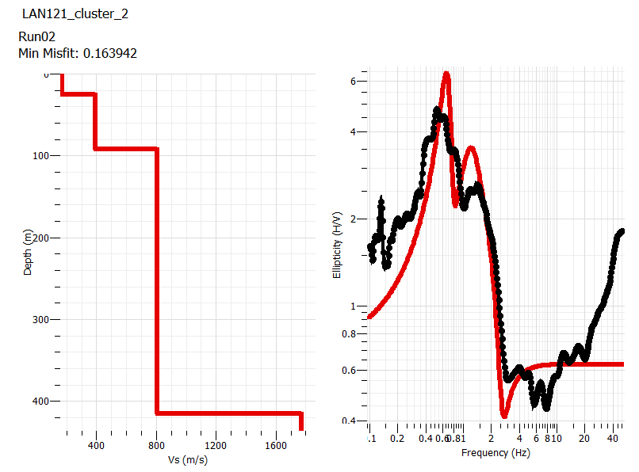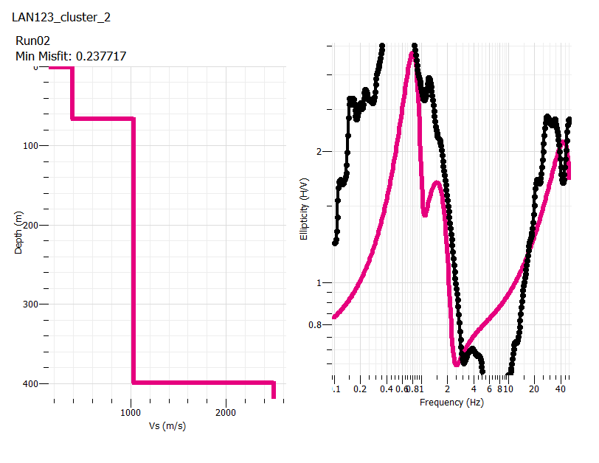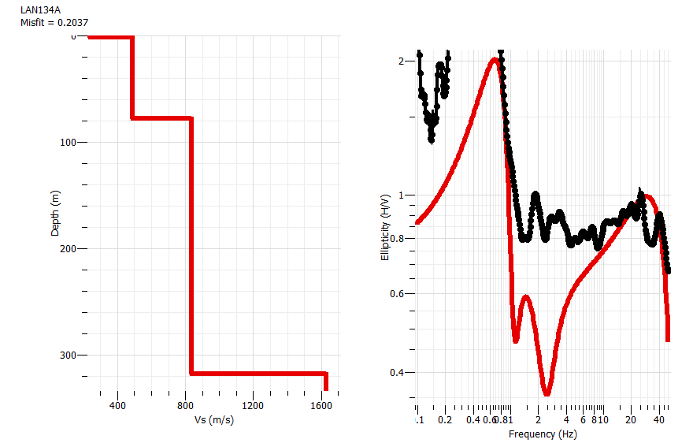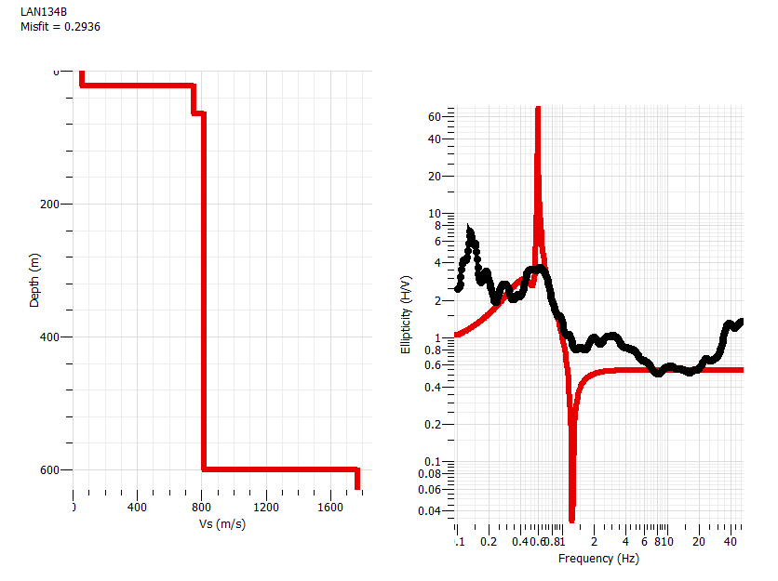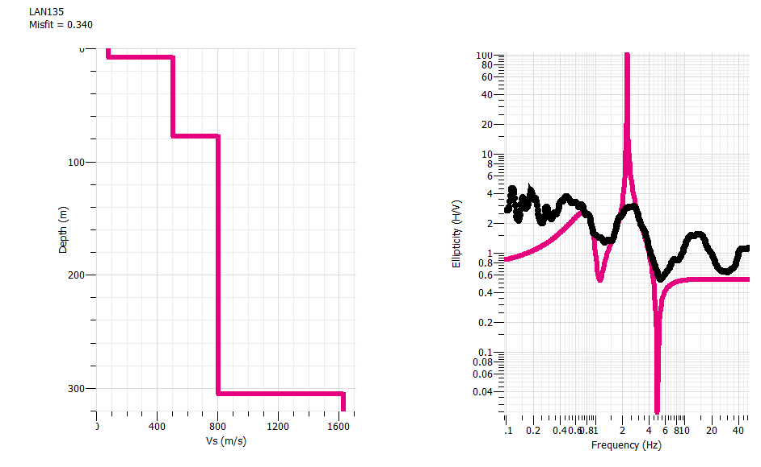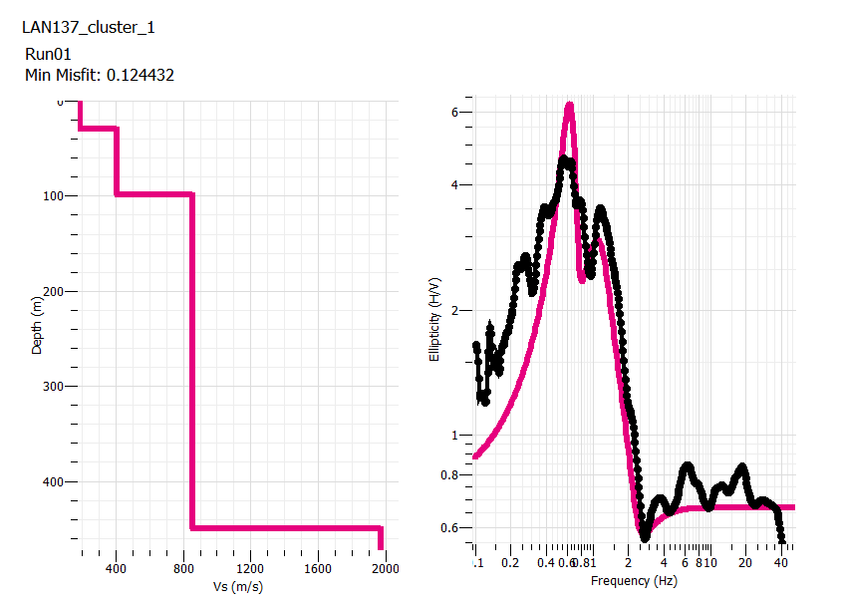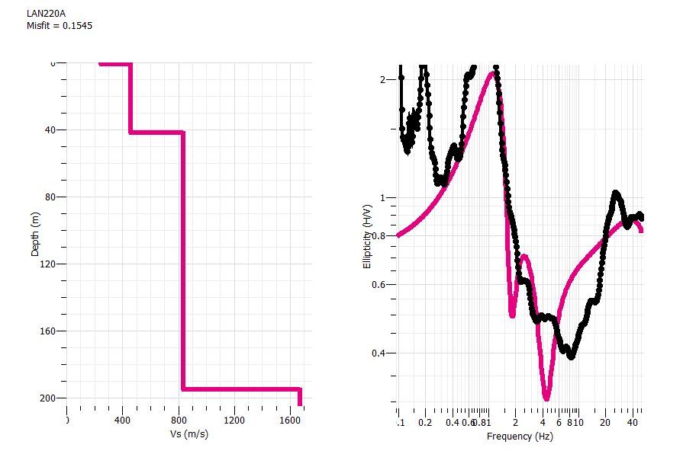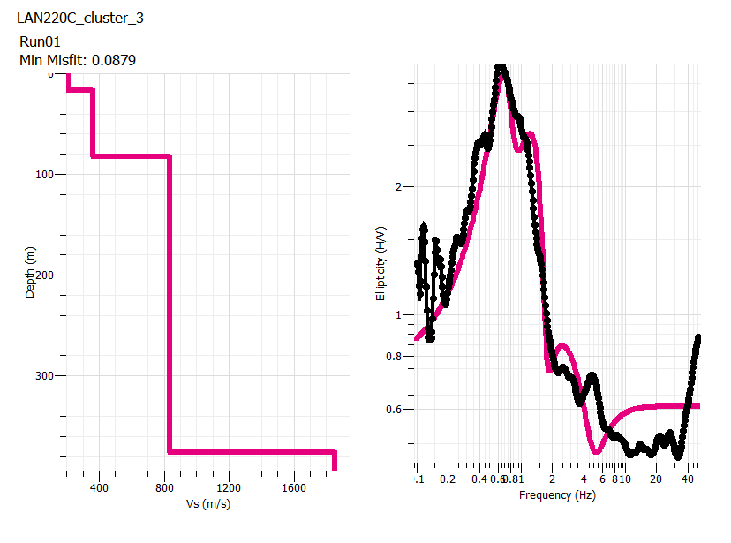
B6: N Region
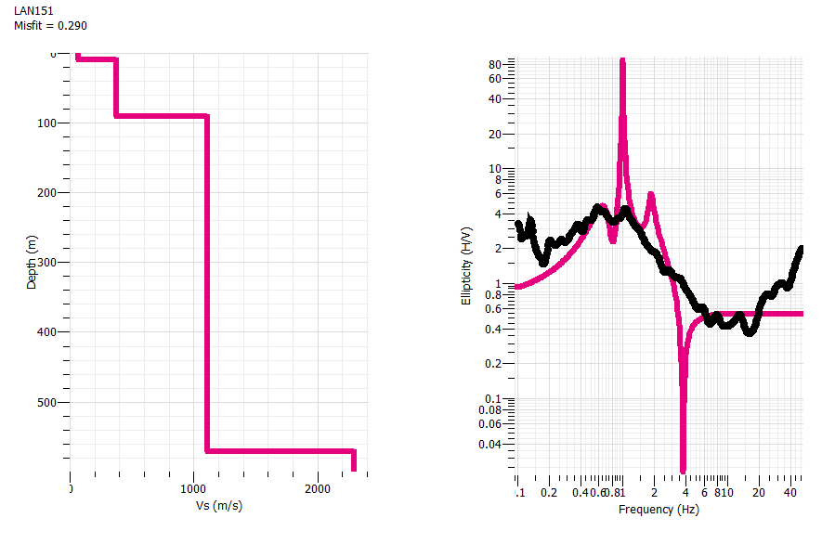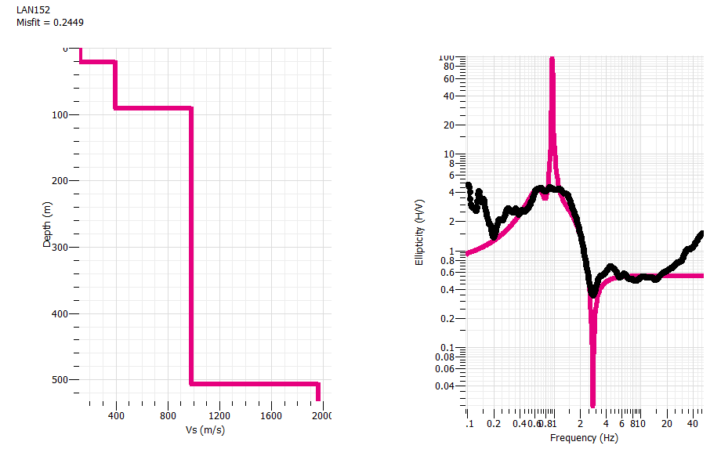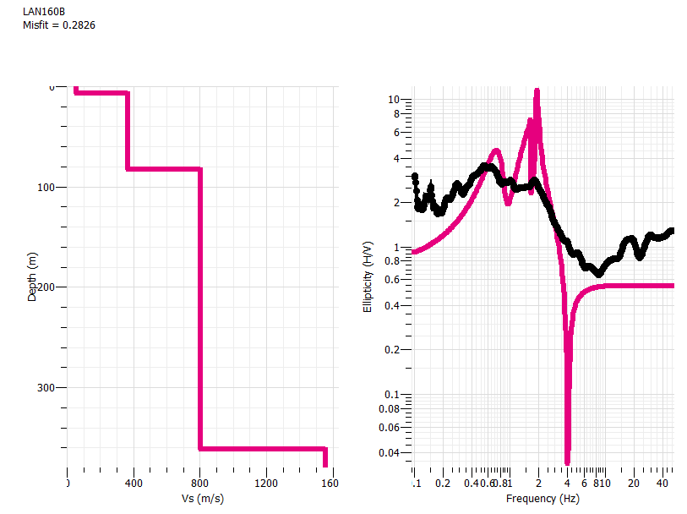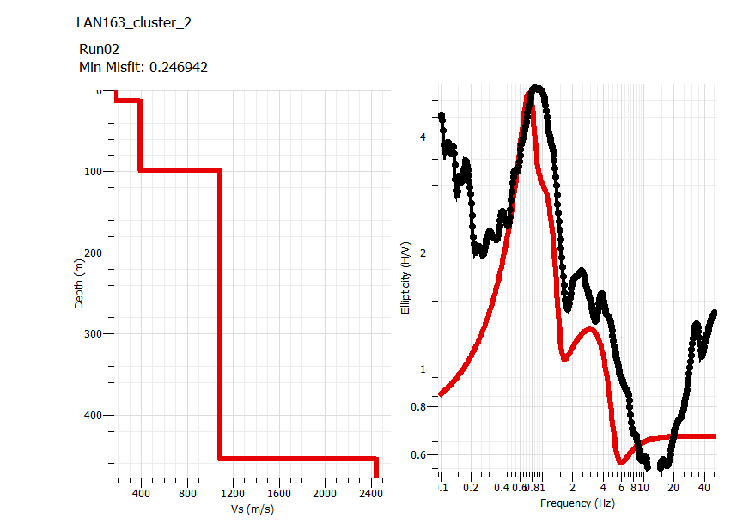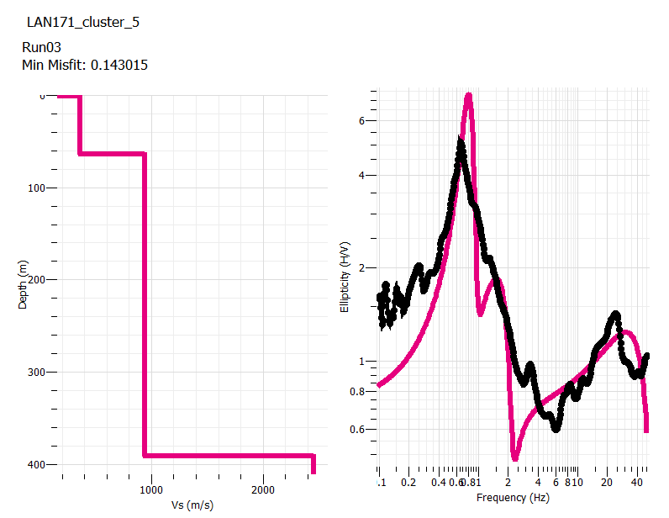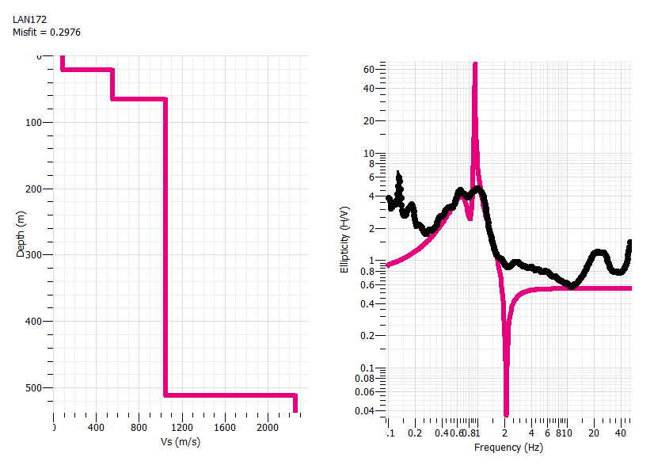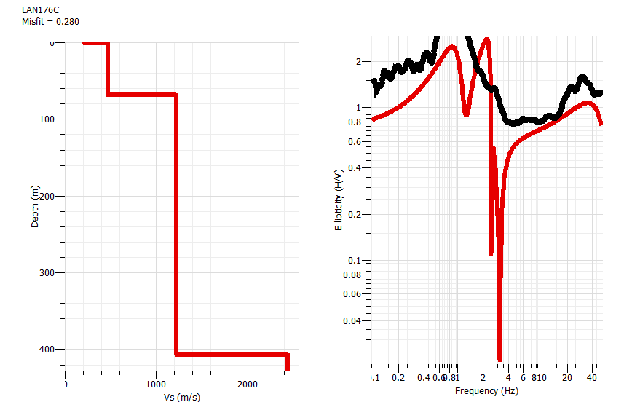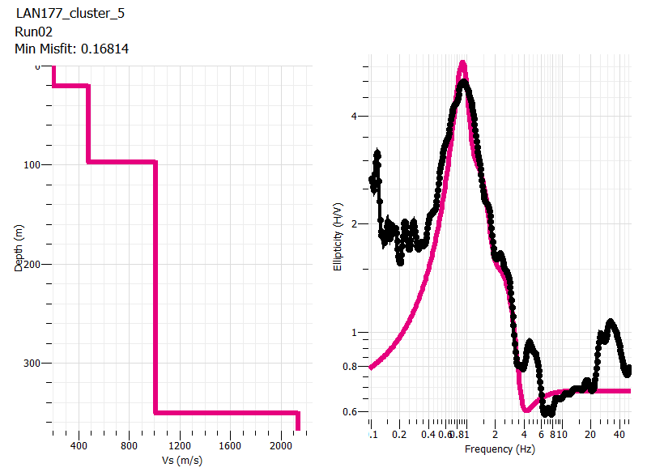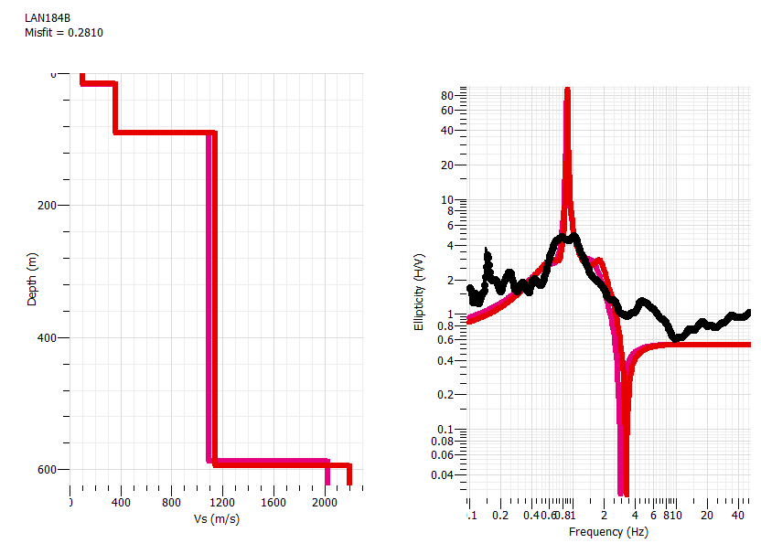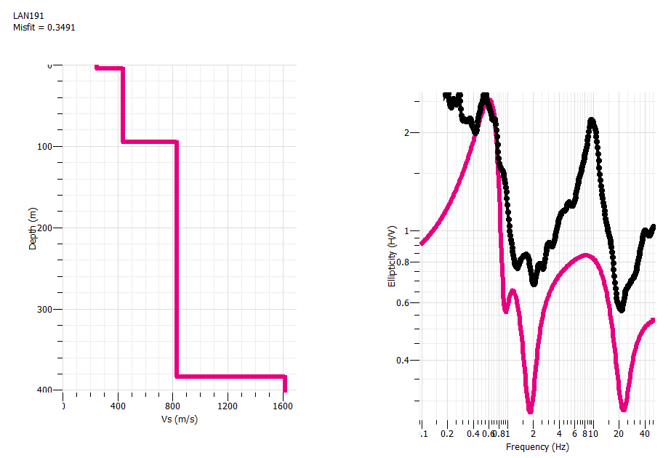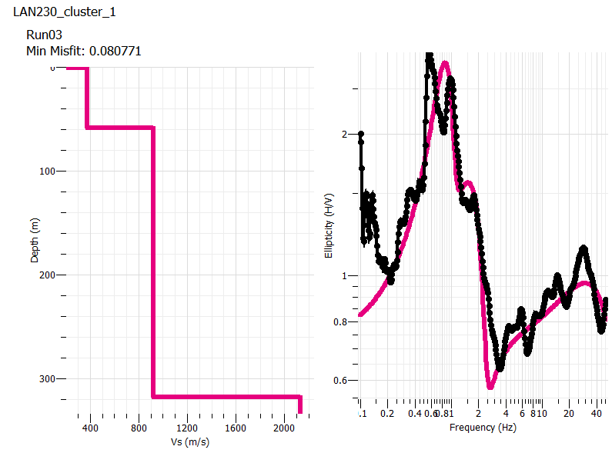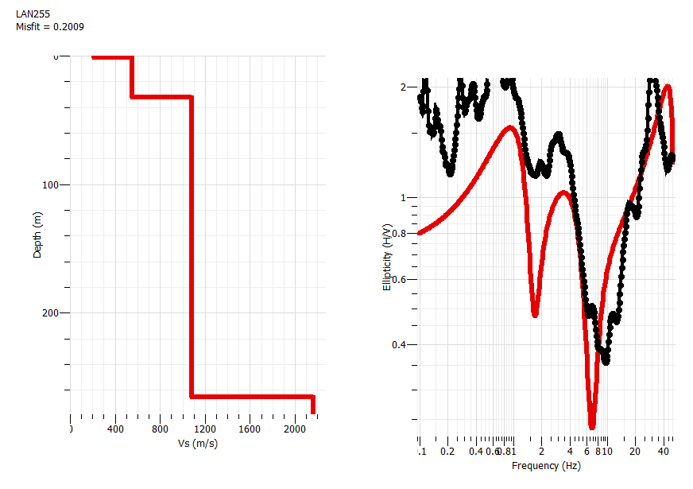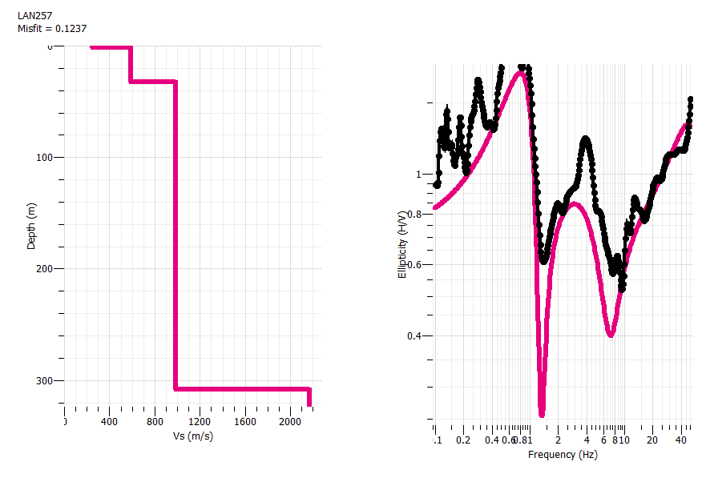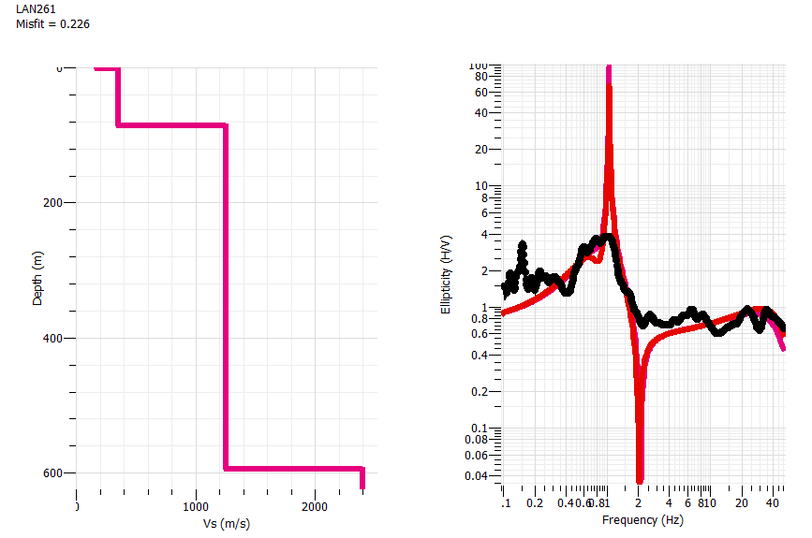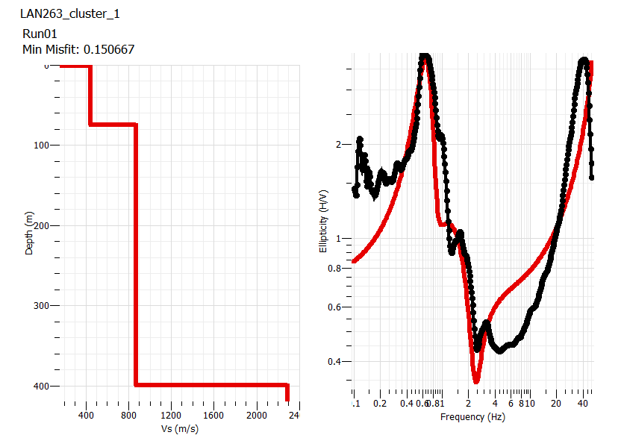
Appendix C: Final inversion results Including Revised Results
FINAL Inversion Results
Geopsy Figue files included in this folder

Appendix D: Master spreadsheet
Also available at this link: Master_Spreadsheet.xlsx
Site Name | Successfully Inverted? (Y/N) | Final Parameters Used | Long | Lat | Layering (m): |  |  |  | Vs30
F2 Region
LAN199 | Y | Option 2 | -122.583699 | 49.141635 | h | ztop | zbot | vs | vs30
 |  |  |  |  | 33 | 0 | 33 | 121 | 121
 |  |  |  |  | 191 | 33 | 224 | 429
 |  |  |  |  |  | 224 |  | 1956
LAN023 | Y | Option 1 | -122.613753 | 49.184164 | h | ztop | zbot | vs | vs30
 |  |  |  |  | 30 | 0 | 30 | 140 | 140
 |  |  |  |  | 33 | 20 | 53 | 200
 |  |  |  |  | 293 | 53 | 346 | 421
 |  |  |  |  |  | 346 |  | 1271
LAN022 | Y | Option 1 | -122.623492 | 49.181818 | h | ztop | zbot | vs | vs30
 |  |  |  |  | 41 | 0 | 41 | 176 | 176
 |  |  |  |  | 17 | 41 | 58 | 252
 |  |  |  |  | 361 | 58 | 419 | 570
 |  |  |  |  |  | 419 |  | 2140
LAN016 | Y | Option 1 | -122.623398 | 49.188872 | h | ztop | zbot | vs | vs30
 |  |  |  |  | 20 | 0 | 20 | 120 | 145.1612903
 |  |  |  |  | 68 | 20 | 88 | 250
 |  |  |  |  | 262 | 88 | 350 | 519
 |  |  |  |  |  | 350 |  | 1625
LAN007 | Y | Option 2 | -122.596925 | 49.201902 | h | ztop | zbot | vs | vs30
 |  |  |  |  | 37 | 0 | 37 | 258 | 258
 |  |  |  |  | 178 | 37 | 215 | 716
 |  |  |  |  |  | 215 |  | 1962
LAN004 | Y | Option 1 | -122.644205 | 49.200461 | h | ztop | zbot | vs | vs30
 |  |  |  |  | 3 | 0 | 3 | 100 | 192.8251121
 |  |  |  |  | 61 | 3 | 64 | 215
 |  |  |  |  | 359 | 64 | 423 | 775
 |  |  |  |  |  | 423 |  | 2438
LAN006 | Y | Option 2 | -122.624745 | 49.204452 | h (m) | ztop (m) | zbot (m) | Vs (m/s) | vs30
 |  |  |  |  | 40 | 0 | 40 | 203 | 203
 |  |  |  |  | 218 | 40 | 258 | 666
 |  |  |  |  |  | 258 |  | 2485
LAN005 | Y | Option 2 | -122.633371 | 49.203617 | h (m) | ztop (m) | zbot (m) | Vs (m/s) | vs30
 |  |  |  |  | 21 | 0 | 21 | 84 | 110.0917431
 |  |  |  |  | 177 | 21 | 198 | 400
 |  |  |  |  |  | 198 |  | 1907
LAN008 | Y | Option 1 | -122.592784 | 49.196599 | h (m) | ztop (m) | zbot (m) | Vs (m/s) | vs30
 |  |  |  |  | 15 | 0 | 15 | 71 | 110.5919003
 |  |  |  |  | 66 | 15 | 81 | 250
 |  |  |  |  | 389 | 81 | 470 | 690
 |  |  |  |  |  | 470 |  | 1225
LAN011 | Y | Option 2 | -122.6451 | 49.19008 | h | ztop | zbot | vs | vs30
 |  |  |  |  | 1.16 | 0 | 1.16 | 173 | 385.903287
 |  |  |  |  | 157.84 | 1.16 | 159 | 406
 |  |  |  |  |  | 159 |  | 2074
LAN020 | Y | Option 2 | -122.646098 | 49.178437 | h | ztop | zbot | vs | vs30
 |  |  |  |  | 33 | 0 | 33 | 302 | 302
 |  |  |  |  | 108 | 33 | 141 | 548
 |  |  |  |  |  | 141 |  | 1062
LAN024 | Y | Option 2 | -122.59763 | 49.18408 | h | ztop | zbot | vs | vs30
 |  |  |  |  | 27 | 0 | 27 | 112 | 121.8260379
 |  |  |  |  | 251 | 27 | 278 | 579
 |  |  |  |  |  | 278 |  | 2460
LAN036 | Y | Option 1 | -122.573609 | 49.16677 | h | ztop | zbot | vs | vs30
 |  |  |  |  | 6 | 0 | 6 | 213 | 303.1360202
 |  |  |  |  | 30 | 6 | 36 | 339
 |  |  |  |  | 294 | 36 | 330 | 577
 |  |  |  |  |  | 330 |  | 2411
LAN063A | Y | Option 1 | -122.539895 | 49.162388 | h | ztop | zbot | vs | vs30
 |  |  |  |  | 7 | 0 | 7 | 225 | 327.3771538
 |  |  |  |  | 33 | 7 | 40 | 380
 |  |  |  |  | 285 | 40 | 325 | 570
 |  |  |  |  |  | 325 |  | 2156
H Region
LAN064 | Y | Option 2 | -122.525204 | 49.155428 | h | ztop | zbot | vs | vs30
 |  |  |  |  | 21 | 0 | 21 | 187 | 232.5634518
 |  |  |  |  | 245 | 21 | 266 | 539
 |  |  |  |  |  | 266 |  | 1955
LAN067 | Y | Option 1 | -122.514147 | 49.154443 | h | ztop | zbot | vs | vs30
 |  |  |  |  | 3.4 | 0 | 3.4 | 50 | 176.1517615
 |  |  |  |  | 77.6 | 3.4 | 81 | 260
 |  |  |  |  | 363 | 81 | 444 | 772
 |  |  |  |  |  | 444 |  | 2266
LAN069 | Y | Option 2 | -122.503516 | 49.155761 | h | ztop | zbot | vs | vs30
 |  |  |  |  | 48 | 0 | 48 | 178 | 178
 |  |  |  |  | 239 | 48 | 287 | 463
 |  |  |  |  |  | 287 |  | 1246
LAN074 | Y | Option 2 | -122.474771 | 49.167089 | h | ztop | zbot | vs | vs30
 |  |  |  |  | 11 | 0 | 11 | 178 | 281.958354
 |  |  |  |  | 114 | 11 | 125 | 426
 |  |  |  |  |  | 125 |  | 1594
LAN081 | Y | Option 1 | -122.471345 | 49.15063 | h | ztop | zbot | vs | vs30
 |  |  |  |  | 4 | 0 | 4 | 63 | 193.4967556
 |  |  |  |  | 29 | 4 | 33 | 284
 |  |  |  |  | 278 | 33 | 311 | 554
 |  |  |  |  |  | 311 |  | 2406
LAN063B | N | Option 2 | -122.531077 | 49.162167
LAN070 | N | Option 2 | -122.494949 | 49.162123
LAN071 | Y | Option 4 | -122.492604 | 49.164599 | h | ztop | zbot | vs | vs30
 |  |  |  |  | 46 | 0 | 46 | 207 | 207
 |  |  |  |  |  | 46 |  | 977
LAN076 | Y | Option 5 | -122.473984 | 49.161778 | h | ztop | zbot | vs | vs30
 |  |  |  |  | 9 | 0 | 9 | 114 | 237.8340366
 |  |  |  |  | 63 | 9 | 72 | 445
 |  |  |  |  | 178 | 72 | 250 | 931
 |  |  |  |  |  | 250 |  | 2337
LAN079 | Y | Option 2 | -122.492484 | 49.149202 | h | ztop | zbot | vs | vs30
 |  |  |  |  | 13 | 0 | 13 | 86 | 157.3170732
 |  |  |  |  | 107 | 13 | 120 | 430
 |  |  |  |  |  | 120 |  | 876
LAN080 | N |  | -122.462444 | 49.154345
LAN073 | Y | Option 2 | -122.492489 | 49.158017 | h | ztop | zbot | vs | vs30
 |  |  |  |  | 14 | 0 | 14 | 80 | 144.7924253
 |  |  |  |  | 156 | 14 | 170 | 497
 |  |  |  |  |  | 170 |  | 1108
LAN075 | Y | Option 2 | -122.465739 | 49.167403 | h | ztop | zbot | vs | vs30
 |  |  |  |  | 12 | 0 | 12 | 122 | 214.9758065
 |  |  |  |  | 75 | 12 | 87 | 437
 |  |  |  |  |  | 87 |  | 1908
I Region
LAN052 | Y | Option 3 | -122.632326 | 49.130439 | h | ztop | zbot | vs | vs30
 |  |  |  |  | 30 | 0 | 30 | 98 | 98
 |  |  |  |  | 21 | 30 | 51 | 477
 |  |  |  |  | 491 | 51 | 542 | 998
 |  |  |  |  |  | 542 |  | 1577
LAN100 | Y | Option 3 | -122.647977 | 49.107589 | h | ztop | zbot | vs | vs30
 |  |  |  |  | 22 | 0 | 22 | 250 | 276.598755
 |  |  |  |  | 75 | 22 | 97 | 391
 |  |  |  |  | 240 | 97 | 337 | 810
 |  |  |  |  |  | 337 |  | 1620
LAN104 | Y | Option 3 | -122.609273 | 49.107416 | h | ztop | zbot | vs | vs30
 |  |  |  |  | 17 | 0 | 17 | 92 | 136.5901552
 |  |  |  |  | 79 | 17 | 96 | 373
 |  |  |  |  | 394 | 96 | 490 | 844
 |  |  |  |  |  | 490 |  | 1703
LAN202 | N |  | -122.667241 | 49.106257
LAN204A | Y | Option 3 | -122.666176 | 49.104999 | h | ztop | zbot | vs | vs30
 |  |  |  |  | 20 | 0 | 20 | 209 | 243.2733119
 |  |  |  |  | 78 | 20 | 98 | 362
 |  |  |  |  | 35 | 98 | 133 | 1294
 |  |  |  |  |  | 133 |  | 1569
LAN050B | Y | Option 6 | -122.672368 | 49.130218 | h | ztop | zbot | vs | vs30
 |  |  |  |  | 50 | 0 | 50 | 162 | 162
 |  |  |  |  | 548 | 50 | 598 | 973
 |  |  |  |  |  | 598 |  | 2151
LAN102 | Y | Option 6 | -122.624893 | 49.107549 | h | ztop | zbot | vs | vs30
 |  |  |  |  | 10 | 0 | 10 | 41 | 98.45985401
 |  |  |  |  | 179 | 10 | 189 | 329
 |  |  |  |  |  | 189 |  | 909
LAN114 | Y | Option 3 | -122.652462 | 49.092235 | h | ztop | zbot | vs | vs30
 |  |  |  |  | 19 | 0 | 19 | 96 | 130.8071632
 |  |  |  |  | 78 | 19 | 97 | 350
 |  |  |  |  | 352 | 97 | 449 | 820
 |  |  |  |  |  | 449 |  | 2454
LAN124 | N |  | -122.678608 | 49.074683
LAN200 | Y | Option 6 | -122.65658 | 49.11276 | h | ztop | zbot | vs | vs30
 |  |  |  |  | 57 | 0 | 57 | 170 | 170
 |  |  |  |  | 524 | 57 | 581 | 1000
 |  |  |  |  |  | 581 |  | 1931
LAN201B | Y | Option 3 | -122.6677248 | 49.10648274 | h | ztop | zbot | vs | vs30
 |  |  |  |  | 24 | 0 | 24 | 112 | 132.2222222
 |  |  |  |  | 72 | 24 | 96 | 476
 |  |  |  |  | 436 | 96 | 532 | 952
 |  |  |  |  |  | 532 |  | 2024
LAN203 | Y | Option | -122.6662483 | 49.10606883 | h | ztop | zbot | vs | vs30
 |  |  |  |  | 14 | 0 | 14 | 213 | 270.7627119
 |  |  |  |  | 82 | 14 | 96 | 355
 |  |  |  |  | 480 | 96 | 576 | 1074
 |  |  |  |  |  | 576 |  | 2177
LAN205 | Y | Option 3 | -122.6590133 | 49.10460059 | h | ztop | zbot | vs | vs30
 |  |  |  |  | 22 | 0 | 22 | 193 | 219.3276495
 |  |  |  |  | 69 | 22 | 91 | 351
 |  |  |  |  | 485 | 91 | 576 | 1103
 |  |  |  |  |  | 576 |  | 2178
LAN208 | N |  | -122.6527207 | 49.09736934
LAN210 | N |  | -122.6548701 | 49.09553278
J Region
LAN059 | Y | Option 10 | -122.564452 | 49.134055 | h | ztop | zbot | vs | vs30
 |  |  |  |  | 35 | 0 | 35 | 94 | 94
 |  |  |  |  | 285 | 35 | 320 | 474
 |  |  |  |  |  | 320 |  | 1442
LAN095 | N | Option 3 | -122.567576 | 49.122383
LAN097A | Y | Option 3 | -122.582433 | 49.126264 | h | ztop | zbot | vs | vs30
 |  |  |  |  | 33 | 0 | 33 | 124 | 124
 |  |  |  |  | 39 | 33 | 72 | 264
 |  |  |  |  | 328 | 72 | 400 | 490
 |  |  |  |  |  | 400 |  | 1495
LAN110 | Y | Option 6 | -122.53933 | 49.10698 | h | ztop | zbot | vs | vs30
 |  |  |  |  | 60 | 0 | 60 | 256 | 256
 |  |  |  |  | 518 | 60 | 578 | 1116
 |  |  |  |  |  | 578 |  | 2462
LAN120 | Y | Option 3 | -122.541467 | 49.090075 | h | ztop | zbot | vs | vs30
 |  |  |  |  | 29 | 0 | 29 | 222 | 225.5249514
 |  |  |  |  | 66 | 29 | 95 | 418
 |  |  |  |  | 340 | 95 | 435 | 876
 |  |  |  |  |  | 435 |  | 2073
LAN057 | Y | Option 3 | -122.603611 | 49.129412 | h | ztop | zbot | vs | vs30
 |  |  |  |  | 15 | 0 | 15 | 52 | 82.45418327
 |  |  |  |  | 83 | 15 | 98 | 199
 |  |  |  |  | 100 | 98 | 198 | 427
 |  |  |  |  |  | 198 |  | 1145
LAN094 | Y | Option 3 | -122.56771 | 49.126043 | h | ztop | zbot | vs | vs30
 |  |  |  |  | 20 | 0 | 20 | 61 | 87.99182904
 |  |  |  |  | 69 | 20 | 89 | 765
 |  |  |  |  | 422 | 89 | 511 | 833
 |  |  |  |  |  | 511 |  | 1883
LAN103 | Y | Option 3 | -122.592878 | 49.116112 | h | ztop | zbot | vs | vs30
 |  |  |  |  | 22 | 0 | 22 | 86 | 109.4575746
 |  |  |  |  | 70 | 22 | 92 | 438
 |  |  |  |  | 404 | 92 | 496 | 836
 |  |  |  |  |  | 496 |  | 1765
LAN107 | Y | Option 6 | -122.566488 | 49.10461 | h | ztop | zbot | vs | vs30
 |  |  |  |  | 53 | 0 | 53 | 155 | 155
 |  |  |  |  | 545 | 53 | 598 | 935
 |  |  |  |  |  | 598 |  | 2062
LAN215 | Y | Option 3 | -122.6033818 | 49.07142612 | h | ztop | zbot | vs | vs30
 |  |  |  |  | 3 | 0 | 3 | 50 | 258.3243824
 |  |  |  |  | 53 | 3 | 56 | 481
 |  |  |  |  | 520 | 56 | 576 | 900
 |  |  |  |  |  | 576 |  | 1914
LAN119 | Y | Option 3 | -122.557376 | 49.09422 | h | ztop | zbot | vs | vs30
 |  |  |  |  | 17 | 0 | 17 | 43 | 69.34842884
 |  |  |  |  | 245 | 17 | 262 | 349
 |  |  |  |  |  | 262 |  | 784
LAN118A | Y | Option 3 | -122.586641 | 49.093043 | h | ztop | zbot | vs | vs30
 |  |  |  |  | 0.89 | 0 | 0.89 | 183 | 406.2594801
 |  |  |  |  | 37.11 | 0.89 | 38 | 422
 |  |  |  |  | 349 | 38 | 387 | 1172
 |  |  |  |  |  | 387 |  | 2432
LAN109 | N | Option 3 | -122.548322 | 49.113179
LAN096B | Y | Option 3 | -122.587241 | 49.126362 | h | ztop | zbot | vs | vs30
 |  |  |  |  | 19 | 0 | 19 | 78 | 110.8850174
 |  |  |  |  | 70 | 19 | 89 | 408
 |  |  |  |  | 463 | 89 | 552 | 853
 |  |  |  |  |  | 552 |  | 1827
LAN058 | Y | Option 3 | -122.582975 | 49.131123 | h | ztop | zbot | vs | vs30
 |  |  |  |  | 25 | 0 | 25 | 97 | 110.2869518
 |  |  |  |  | 65 | 25 | 90 | 350
 |  |  |  |  | 485 | 90 | 575 | 816
 |  |  |  |  |  | 575 |  | 2466
K Region
LAN086 | Y | Option 6 | -122.486615 | 49.132748 | h | ztop | zbot | vs | vs30
 |  |  |  |  | 76 | 0 | 76 | 147 | 147
 |  |  |  |  | 524 | 76 | 600 | 843
 |  |  |  |  |  | 600 |  | 1878
LAN121 | Y | Option 3 | -122.516467 | 49.089282 | h | ztop | zbot | vs | vs30
 |  |  |  |  | 24 | 0 | 24 | 169 | 190.6966033
 |  |  |  |  | 67 | 24 | 91 | 392
 |  |  |  |  | 325 | 91 | 416 | 800
 |  |  |  |  |  | 416 |  | 1765
LAN123 | Y | Option 3 | -122.462204 | 49.091969 | h | ztop | zbot | vs | vs30
 |  |  |  |  | 25 | 0 | 25 | 182 | 199.3540968
 |  |  |  |  | 70 | 25 | 95 | 381
 |  |  |  |  | 353 | 95 | 448 | 823
 |  |  |  |  |  | 448 |  | 2325
LAN137 | Y | Option 3 | -122.504006 | 49.074696 | h | ztop | zbot | vs | vs30
 |  |  |  |  | 29 | 0 | 29 | 188 | 191.4335752
 |  |  |  |  | 69 | 29 | 98 | 407
 |  |  |  |  |  | 98 | 449 | 855
 |  |  |  |  |  | 449 |  | 1964
LAN220C | Y | Option 3 | -122.4714 | 49.0721 | h | ztop | zbot | vs | vs30
 |  |  |  |  | 28 | 0 | 28 | 231 | 237.2521957
 |  |  |  |  | 67 | 28 | 95 | 382
 |  |  |  |  | 311 | 95 | 406 | 870
 |  |  |  |  |  | 406 |  | 2040
LAN090 | Y | Option 3 | -122.487061 | 49.114746 | h | ztop | zbot | vs | vs30
 |  |  |  |  | 14 | 0 | 14 | 126 | 198.7912088
 |  |  |  |  | 64 | 14 | 78 | 402
 |  |  |  |  | 220 | 78 | 298 | 836
 |  |  |  |  |  | 298 |  | 2405
LAN111 | N |  | -122.525781 | 49.111295
LAN112B | Y | Option 3 | -122.486542 | 49.107555 | h | ztop | zbot | vs | vs30
 |  |  |  |  | 1.4 | 0 | 1.4 | 162 | 330.3023201
 |  |  |  |  | 90.6 | 1.4 | 92 | 348
 |  |  |  |  | 506 | 92 | 598 | 1171
 |  |  |  |  |  | 598 |  | 2373
LAN134A | N |  | -122.525858 | 49.072488
LAN135 | Y | Option 3 | -122.518842 | 49.074633 | h | ztop | zbot | vs | vs30
 |  |  |  |  | 7 | 0 | 7 | 74 | 213.3794694
 |  |  |  |  | 69 | 7 | 76 | 500
 |  |  |  |  | 229 | 76 | 305 | 804
 |  |  |  |  |  | 305 |  | 1629
LAN220A | Y | Option 6 | -122.470718 | 49.07179532 | h | ztop | zbot | vs | vs30
 |  |  |  |  | 48 | 0 | 48 | 197 | 197
 |  |  |  |  | 516 | 48 | 564 | 1206
 |  |  |  |  |  | 564 |  | 2230
LAN134B | N |  | -122.52589 | 49.074013
LAN112A | Y | Option 6 | -122.504109 | 49.108287 | h | ztop | zbot | vs | vs30
 |  |  |  |  | 53 | 0 | 53 | 145 | 145
 |  |  |  |  | 505 | 53 | 558 | 839
 |  |  |  |  |  | 558 |  | 1783
LAN092B | N |  | -122.524149 | 49.125907
N Region
LAN163 | Y | Option 3 | -122.47173 | 49.046787 | h | ztop | zbot | vs | vs30
 |  |  |  |  | 12 | 0 | 12 | 167 | 252.4112076
 |  |  |  |  | 85 | 12 | 97 | 383
 |  |  |  |  | 356 | 97 | 453 | 1095
 |  |  |  |  |  | 453 |  | 2440
LAN171 | Y | Option 3 | -122.481255 | 49.034907 | h | ztop | zbot | vs | vs30
 |  |  |  |  | 23 | 0 | 23 | 227 | 257.8581295
 |  |  |  |  | 72 | 23 | 95 | 466
 |  |  |  |  | 261 | 95 | 356 | 874
 |  |  |  |  |  | 356 |  | 1831
LAN177 | Y | Option 3 | -122.490892 | 49.025828 | h | ztop | zbot | vs | vs30
 |  |  |  |  | 19 | 0 | 19 | 198 | 252.2617253
 |  |  |  |  | 77 | 19 | 96 | 479
 |  |  |  |  | 302 | 96 | 398 | 1010
 |  |  |  |  |  | 398 |  | 2130
LAN230 | Y | Option 3 | -122.5202 | 49.0235 | h | ztop | zbot | vs | vs30
 |  |  |  |  | 1.2 | 0 | 1.2 | 197 | 342.161976
 |  |  |  |  | 46.8 | 1.2 | 48 | 353
 |  |  |  |  | 229 | 48 | 277 | 830
 |  |  |  |  |  | 277 |  | 2344
LAN263 | Y | Option 3 | -122.4686 | 49.0171 | h | ztop | zbot | vs | vs30
 |  |  |  |  | 1 | 0 | 1 | 138 | 383.0204082
 |  |  |  |  | 46 | 1 | 47 | 408
 |  |  |  |  | 281 | 47 | 328 | 802
 |  |  |  |  |  | 328 |  | 2235
LAN151 | N |  | -122.4817 | 49.066387
LAN152 | Y | Option 3 | -122.46605 | 49.059589 | h | ztop | zbot | vs | vs30
 |  |  |  |  | 20 | 0 | 20 | 115 | 150.6765677
 |  |  |  |  | 70 | 20 | 90 | 397
 |  |  |  |  | 416 | 90 | 506 | 981
 |  |  |  |  |  | 506 |  | 1965
LAN160B | N |  | -122.50806 | 49.049048
LAN172 | Y | Option 6 | -122.503592 | 49.0297 | h | ztop | zbot | vs | vs30
 |  |  |  |  | 51 | 0 | 51 | 203 | 203
 |  |  |  |  | 425 | 51 | 476 | 978
 |  |  |  |  |  | 476 |  | 2112
LAN176C | Y | Option 6 | -122.51577 | 49.02317 | h | ztop | zbot | vs | vs30
 |  |  |  |  | 49 | 0 | 49 | 249 | 249
 |  |  |  |  | 434 | 49 | 483 | 1129
 |  |  |  |  |  | 483 |  | 2434
LAN184B | Y | Option 6 | -122.50826 | 49.016294 | h | ztop | zbot | vs | vs30
 |  |  |  |  | 50 | 0 | 50 | 254 | 254
 |  |  |  |  | 412 | 50 | 462 | 1070
 |  |  |  |  |  | 462 |  | 2264
LAN191 | N |  | -122.534029 | 49.008988
LAN255 | Y | Option 6 | -122.5298848 | 49.01603936 | h | ztop | zbot | vs | vs30
 |  |  |  |  | 48 | 0 | 48 | 195 | 195
 |  |  |  |  | 537 | 48 | 585 | 1146
 |  |  |  |  |  | 585 |  | 2410
LAN257 | Y | Option 6 | -122.5245087 | 49.01583436 | h | ztop | zbot | vs | vs30
 |  |  |  |  | 53 | 0 | 53 | 160 | 160
 |  |  |  |  | 545 | 53 | 598 | 1116
 |  |  |  |  |  | 598 |  | 1799
LAN261 | Y | Option 6 | -122.4835587 | 49.01692097 | h | ztop | zbot | vs | vs30
 |  |  |  |  | 49 | 0 | 49 | 215 | 215
 |  |  |  |  | 471 | 49 | 520 | 1121
 |  |  |  |  |  | 520 |  | 2287

Appendix E: Matlab code for producing Vs₃₀ Map
%VS30 Map - Asha Punia

clear all;
clc;

% Database [
data.LAN199 = [49.141635, -122.583699, 180.0];
data.LAN023 = [49.184164, -122.613753, 194.0244];
data.LAN022 = [49.181818, -122.623492, 144.0];
data.LAN016 = [49.188872, -122.623398, 144.0];
data.LAN007 = [49.201902, -122.596925, 258.0];
data.LAN004 = [49.200461, -122.644205, 192.8251];
data.LAN006 = [49.204452, -122.624745, 203.0];
data.LAN005 = [49.203617, -122.633371, 110.0917];
data.LAN008 = [49.196599, -122.592784, 256.5121];
data.LAN011 = [49.190080, -122.645100, 385.9033];
data.LAN020 = [49.178437, -122.646098, 302.0];
data.LAN024 = [49.184080, -122.597630, 120.9363];
data.LAN036 = [49.166770, -122.573609, 303.136];
data.LAN063A = [49.162388, -122.539895, 327.3772];
data.LAN064 = [49.155428, -122.525204, 232.5635];
data.LAN067 = [49.154443, -122.514147, 176.1518];
data.LAN069 = [49.155761, -122.503516, 178.0];
data.LAN074 = [49.167089, -122.474771, 281.9584];
data.LAN081 = [49.150630, -122.471345, 186.9077];
data.LAN063B = [49.162167, -122.531077, 307.5957];
data.LAN070 = [49.162123, -122.494949, 101.4028];
data.LAN076 = [49.161778, -122.473984, 178.0488];
data.LAN079 = [49.149202, -122.492484, 157.3171];
data.LAN073 = [49.158017, -122.492489, 144.7924];
data.LAN075 = [49.167403, -122.465739, 214.9758];
data.LAN052 = [49.130439, -122.632326, 165.493];
data.LAN100 = [49.107589, -122.647977, 276.5988];
data.LAN104 = [49.107416, -122.609273, 276.5988];
data.LAN204A = [49.104999, -122.666176, 243.2733];
data.LAN050B = [49.130218, -122.672368, 162.0];
data.LAN102 = [49.107549, -122.624893, 98.45985];
data.LAN114 = [49.092235, -122.652462, 134.5794];
data.LAN200 = [49.112760, -122.656580, 170.0];
data.LAN201B = [49.106482, -122.667725, 132.2222];
data.LAN203 = [49.106068, -122.666248, 270.7627];
data.LAN205 = [49.104600, -122.659013, 219.3276];
data.LAN059 = [49.134055, -122.564452, 94.0];
data.LAN095 = [49.122383, -122.567576, 352.1506];
data.LAN097A = [49.126264, -122.582433, 182.3044];
data.LAN110 = [49.106980, -122.539330, 110.31];
data.LAN120 = [49.090075, -122.541467, 225.525];
data.LAN057 = [49.129412, -122.603611, 82.45418];
data.LAN094 = [49.126043, -122.567710, 87.99183];
data.LAN103 = [49.116112, -122.592878, 109.4576];
data.LAN107 = [49.104610, -122.566488, 155.0];
data.LAN215 = [49.071426, -122.603382, 258.3244];
data.LAN119 = [49.094220, -122.557376, 69.34843];
data.LAN118A = [49.093043, -122.586641, 406.2595];
data.LAN109 = [49.113179, -122.548322, 406.2595];
data.LAN096B = [49.126362, -122.587241, 110.885];
data.LAN058 = [49.131123, -122.582975, 110.287];
data.LAN086 = [49.132748, -122.486615, 147.0];
data.LAN121 = [49.089282, -122.516467, 190.6966];
data.LAN123 = [49.091969, -122.462204, 199.3541];
data.LAN137 = [49.074696, -122.504006, 191.4336];
data.LAN220C = [49.072100, -122.471400, 220.4639];
data.LAN090 = [49.114746, -122.487061, 198.7912];
data.LAN112B = [49.107555, -122.486542, 330.3023];
data.LAN135 = [49.074633, -122.518842, 213.3795];
data.LAN200A = [49.071795, -122.470718, 197.0];
data.LAN112A = [49.108287, -122.504109, 145.0];
data.LAN163 = [49.046787, -122.471730, 252.4112];
data.LAN171 = [49.034907, -122.481255, 257.8581];
data.LAN177 = [49.025828, -122.490892, 258.394];
data.LAN230 = [49.023500, -122.520200, 342.162];
data.LAN263 = [49.017100, -122.468600, 383.0204];
data.LAN152 = [49.059589, -122.466050, 150.6766];
data.LAN172 = [49.029700, -122.503592, 203.0];
data.LAN176C = [49.023170, -122.515770, 249.0];
data.LAN184B = [49.016294, -122.508260, 254.0];
data.LAN255 = [49.016039, -122.529885, 195.0];
data.LAN257 = [49.015834, -122.524509, 160.0];
data.LAN261 = [49.01692097, -122.483559, 215.0];

% Setting up the geometries of the map
siteNames = fieldnames(data);
numSites = length(siteNames);
lats = zeros(numSites, 1);
lons = zeros(numSites, 1);
vs30 = zeros(numSites, 1);
for i = 1:numSites
lats(i) = data.(siteNames{i})(1);
lons(i) = data.(siteNames{i})(2);
vs30(i) = data.(siteNames{i})(3);
end

% Generating the Map
figure('Color', 'w', 'Name', 'Vs30 Heatmap');

% Setting up the margins
margin = 0.025;
minLat = min(lats) - margin;
maxLat = max(lats) + margin;
minLon = min(lons) - margin;
maxLon = max(lons) + margin;

[latGrid, lonGrid] = meshgrid(linspace(minLat, maxLat, 250), linspace(minLon, maxLon, 250));

% Setting up the Vs30 grid
Vs30_grid = griddata(lats, lons, vs30, latGrid, lonGrid, 'v4');

% Creating polygons for the boundaries of map
k = convhull(lats, lons);
hullPoly = polyshape(lats(k), lons(k));

bufferDistance = 0.012;
bufferedPoly = polybuffer(hullPoly, bufferDistance);

[polyLats, polyLons] = boundary(bufferedPoly);

inBoundary = inpolygon(latGrid, lonGrid, polyLats, polyLons);

Vs30_grid(~inBoundary) = NaN;

% Clipping
Vs30_grid(Vs30_grid < min(vs30)) = min(vs30);
Vs30_grid(Vs30_grid > max(vs30)) = max(vs30);

validIdx = ~isnan(Vs30_grid(:));

% Plot background interpolations
geoscatter(latGrid(validIdx), lonGrid(validIdx), 18, Vs30_grid(validIdx), 'filled', 'MarkerFaceAlpha', 0.22, 'HandleVisibility', 'off');
hold on;

% Plotting sites
geoscatter(lats, lons, 40, 'red', 'filled', 'MarkerEdgeColor', 'k');

% Applying map limits & map style
geolimits([minLat, maxLat], [minLon, maxLon]);
geobasemap streets;

% Selecting the gradient colours
numColors = 256;
darkBlue = [0.02, 0.08, 0.35]; % Deep Blue (High Vs30)
midBlue = [0.15, 0.45, 0.85]; % Vibrant Mid Blue
lightCyan = [0.85, 0.98, 1.00]; % Bright Cyan/White (Low Vs30)
half = numColors / 2;

customMap = [
linspace(darkBlue(1), midBlue(1), half)', linspace(darkBlue(2), midBlue(2), half)', linspace(darkBlue(3), midBlue(3), half)';
linspace(midBlue(1), lightCyan(1), half)', linspace(midBlue(2), lightCyan(2), half)', linspace(midBlue(3), lightCyan(3), half)'
];

colormap(flipud(customMap));
clim([min(vs30), max(vs30)]);

% Setup Colourbar
c = colorbar;
c.Label.String = 'V_{s30} (m/s)';
c.Label.FontWeight = 'bold';

% Labelling of the sites
for i = 1:numSites
labelText = sprintf('%.1f', vs30(i));
text(lats(i) + 0.0005, lons(i) + 0.0005, labelText, 'FontSize', 7.5, 'FontWeight', 'bold', 'Color', [0.2, 0.2, 0.2]);
end

title('Vs30 Contour Gradient Map');

Appendix H: Maple Ridge Coordinates and Vs30
Site lon lat VS30
MR002 -122.600855 49.250333 260
MR004 -122.6225077 49.2424976 171.3074205
MR007 -122.624456 49.235405 209.1493939
MR036 -122.6011452 49.2429416 284.1176471
MR037 -122.586235 49.24202 210.8206221
MR039 -122.5587723 49.2389299 326.787736
MR040 -122.581249 49.237237 122.2671377
MR041 -122.590447 49.2365 179.1966313
MR042 -122.6093906 49.2352244 106.1194446
MR043 -122.5275373 49.24688987 250.6442111
MR044 -122.5338352 49.24219711 232.9868775
MR045 -122.5273315 49.23885632 234.9450469
MR131 -122.63354 49.238217 286.6990616
PMW010 -122.643257 49.278823 179.5998496
PMW018 -122.64488 49.26427 164.792887
PMW019 -122.60095 49.26021111 168.2224146
PMW101 -122.6325 49.27871 128.2
PMW126 -122.644322 49.248501 84.2718301
MR008 -122.6403092 49.23328727 139.1720541
MR011 -122.6469796 49.22927409 155.5887097
MR016 -122.6471777 49.22380057 126.7265696
MR019 -122.621701 49.225176 194.0927703
MR023 -122.6296191 49.21913901 161.6894792
MR026 -122.6457441 49.21389411 146.3669314
MR033 -122.6387185 49.21018966 157.1934088
MR035 -122.6228178 49.2145107 86.7756315
MR048 -122.5802531 49.2298514 175.3114542
MR051 -122.6043712 49.2294862 229.6986836
MR053 -122.613057 49.224108 108.242514
MR054B -122.60585 49.21854 229
MR056 -122.604461 49.218154 223.1415548
MR058 -122.5805556 49.22388889 247.3002412
MR060 -122.605522 49.213018 142.5580757
MR063 -122.580031 49.219125 241.3323945
MR065 -122.543247 49.227721 252.3650867
MR070 -122.5639305 49.21862279 213.9469844
MR072 -122.588633 49.212262 172.604971
MR075 -122.579328 49.206622 307.7060761
MR077 -122.56532 49.212526 158.9223432
MR079 -122.572886 49.203995 220.4365741
MR081 -122.556904 49.20737 190.8540055
MR089 -122.54542 49.202087 342.9578556
MR091 -122.564101 49.202205 291.5247844
MR093 -122.571529 49.193574 190.2352995
MR095 -122.556074 49.196881 150.0014433
MR097 -122.576455 49.189938 143.6921979
MR099 -122.555413 49.191521 327.1079174
MR103 -122.556799 49.186432 208.9951509
MR105 -122.539569 49.185878 187.5042294
MR107 -122.551963 49.181903 231.0665049
MR132 -122.638574 49.214382 92.00805751
MR134 -122.629326 49.212172 116.4
MR147 -122.5460737 49.222268 271.926408
MR109 -122.5223395 49.1839727 426.9052827
MR112 -122.514326 49.17394 319.4945142
MR116 -122.4795865 49.1791692 402.4024648
MR118 -122.4795865 49.1791692 290.8644032
MR120 -122.461308 49.183872 362.961516
MR124 -122.428978 49.198692 230.2279946
MR128 -122.435193 49.176926 337.4201186
MR139 -122.530606 49.230516 221.1278015
MR141 -122.484975 49.227321 388.5148393
MR144 -122.535058 49.224523 294.5738793
MR146 -122.519441 49.227804 320.3034061
MR150 -122.529306 49.221327 286.9989236
MR158 -122.523634 49.225435 316.4693417
MR160 -122.456819 49.220533 745.8089441
MR162 -122.42699 49.223041 349.5260356
MR154B -122.4710124 49.225873 561.2907716
MR152B -122.47411 49.22437 374.6040309
MR157 -122.461663 49.216057 478.3043599
MR159 -122.45935 49.218055 344.5444616
MR155B -122.470354 49.223787 607.716678

