**File Service**

**Database setup:**

1. GIT Repo:[**https://github.com/ashaloka/file-service**](https://github.com/ashaloka/file-service)
2. After cloning go to file-service folder
3. Execute docker-compose up -d



1. DB will be in local with master

1. Create DataBase under master
2. Graphical user interface, text, application, chat or text message

   Description automatically generated
3. Next Copy the file_service_schema.sql content from GIT REPO [**https://github.com/ashaloka/file-service**](https://github.com/ashaloka/file-service)**/file_service_schema.sql**
4. Execute all table creation
5. Tables will be created

**Service Setup:**

J**ava** 🡪 JDK 1.8

**MSSQL DB** 🡪 Configure the Data base details in application-dev.yml

**Maven:** setup required

**Start File Service:**

**Go to Application.java**

**Heartbeat API:** to check service status

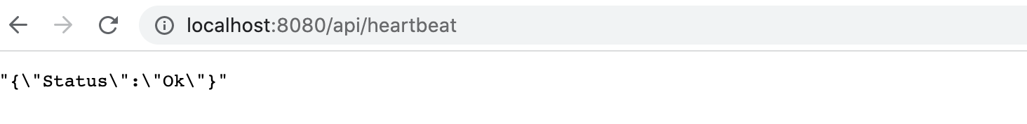

**File Service Validations:**

1. **5000 Employee Data file read stats: 1 min 15 secs**

2022-06-13 20:48:16.805 INFO 15663 --- [eServiceThreads] c.o.rqns.ftm.processor.FileProcessor : File process started for : EmployeeData_1.txt **2022-06-13T15:18:16.805Z**

2022-06-13 20:49:38.302 INFO 15663 --- [#4 - Aggregator] c.o.rqns.ftm.routes.MessageRouteBuilder : EmployeeData_1.txt - Update Completed Successfully : **2022-06-13T15:19:38.302Z**

1. **25000 Employee Data file read stats: 2 mins 5 secs**

2022-06-13 16:22:49.929 INFO 1672 --- [eServiceThreads] c.o.rqns.ftm.processor.FileProcessor : File process started for : EmployeeData_5.txt 2022-06-13T10:52:49.929Z

2022-06-13 16:24:47.584 INFO 1672 --- [11 - Aggregator] c.o.rqns.ftm.routes.MessageRouteBuilder : EmployeeData_5.txt - Update Completed Successfully : 2022-06-13T10:54:47.584Z

1. **50000 Employee Data file read stats: 3 mins 20 secs**

2022-06-13 16:15:28.465 INFO 1672 --- [eServiceThreads] c.o.rqns.ftm.processor.FileProcessor : File process started for : EmployeeData_6.txt 2022-06-13T10:45:28.465Z

2022-06-13 16:18:01.191 INFO 1672 --- [#8 - Aggregator] c.o.rqns.ftm.routes.MessageRouteBuilder : EmployeeData_6.txt - Update Completed Successfully : 2022-06-13T10:48:01.191Z

1. **100000 Employee Data file read stats: 4 mins**

2022-06-13 16:25:24.421 INFO 1672 --- [eServiceThreads] c.o.rqns.ftm.processor.FileProcessor : File process started for : EmployeeData_7.txt **2022-06-13T10:55:24.421Z**

2022-06-13 16:29:18.947 INFO 1672 --- [15 - Aggregator] c.o.rqns.ftm.routes.MessageRouteBuilder : EmployeeData_7.txt - Update Completed Successfully : **2022-06-13T10:59:18.947Z**

**Parallel File Processing Logs FR:**

**DB Validation:**

1. FileStatusAudits:

1. **Employee**

1. **EmployeeDepartmentDetails**

1. **EmployeeLeaves**

1. **EmployeeFamilyDetails**

1. **EmployeeSalaryDetails**

