Software Design
Specification

File Service
Revision 1.0

Table of Contents
Table of Contents ii
Revision History iii
Approved By iii
1. Introduction 1
1.1 Purpose 1
1.2 System Overview 1
1.3 Design Map 1
1.4 Definitions and Acronyms 2
2. Design Considerations 2
2.1 Assumptions 2
2.2 Constraints 2
2.3 System Environment 2
2.4 Design Methodology 2
3. Architecture 2
3.1 Overview 3
3.2 Subsystem, Component, or Module 1 …N 3
4. Database Schema 4
4.1 Tables, Columns and Relationships 4
4.1.1 Databases 4
4.1.2 New Tables 4
4.1.3 New Tables with Column details 5
4.1.4 ER Diagram 7
4.1.5 All Other Changes 7
5. High Level Design 8
5.1 File Service 8
5.2 File Format 8
6. Low Level Design 9
6.1 Flow Chart Diagram 9
6.2 Class Diagram 10
6.3 File Service Process 10
7. Performance 11

Revision History
Version | Name | Reason For Changes | Date
1.0 | Asha | Initial Revision | 14/06/2022

Approved By
Approvals should be obtained for project manager, and all developers working on the project.

Name | Signature | Department | Date

Introduction

Purpose
This design will detail the implementation of the requirements as defined in the Software Requirements Specification – File Service.

System Overview
This project extends the functionality of the File Service process that reads files from the directory and updates into the database. Read all files from the configured directory based on last modification and stores the data into respective tables based on Employee Id and Employee Id should be unique.

Design Map
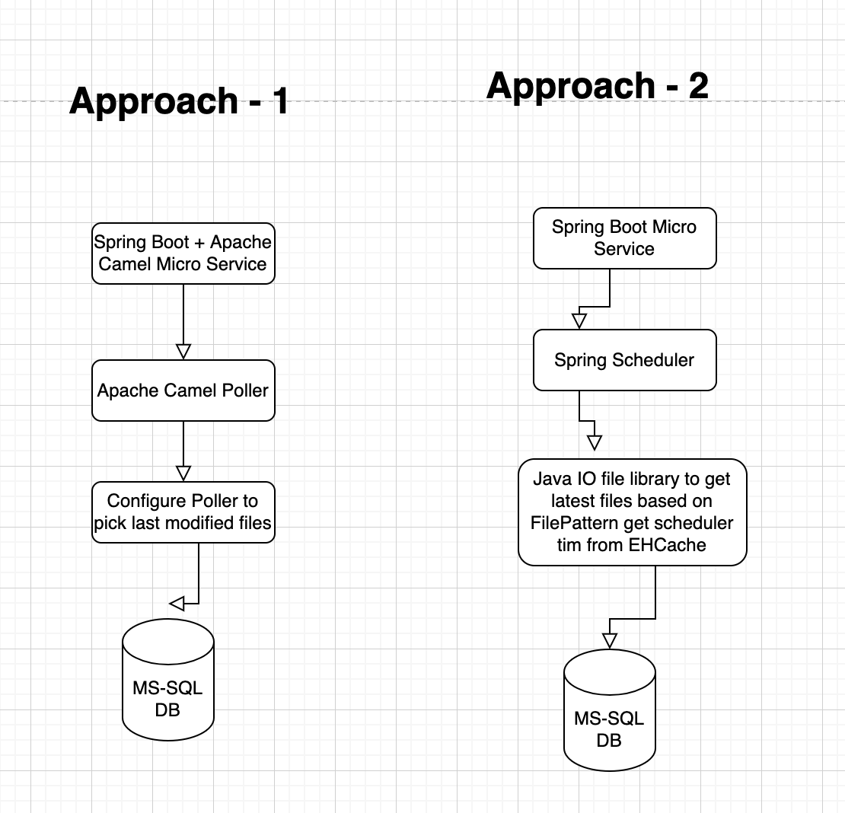

Definitions and Acronyms

Design Considerations
All design considerations were handled in File Service Release.

Assumptions
FileService database should be created and tables should be available.
FileService should be deployed and Poler directory should be created.

Constraints

System Environment
The File Service is a Spring Boot Micro Service.

Setup Required:
- Docker should be installed for MS-SQL or MS-SQL should be installed.
- Java: JDK 1.8
- IDE: IntelliJ
- Build Tool: Maven

Design Methodology
- Spring Boot with Apache Camel FTP
- Spring Boot with Spring Scheduler and IO file system

Architecture
File Service created Micro Service based approach.

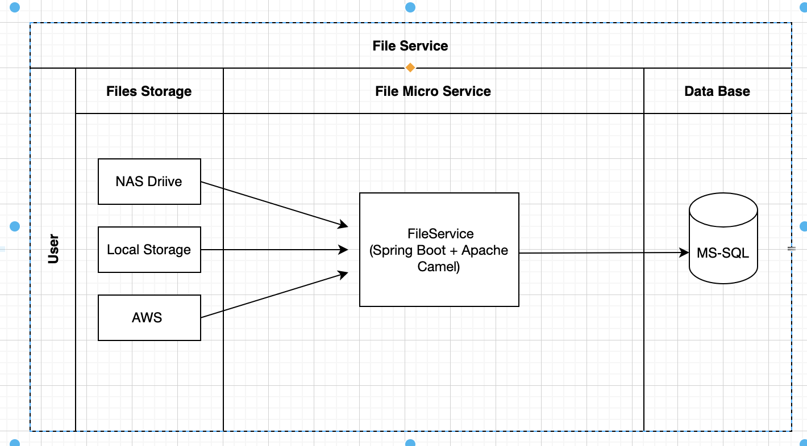

Overview
File Service reads files from directory and updates data into database.

Subsystem, Component, or Module 1 …N
Used Strategy 1 for File Service Micro Service.

Strategy 1:

  - Create FileService database and required tables.
  - Used Data base is MS-SQL.
  - Create Spring Boot Micro Service Apache Camel
  - Use Camel File Poller to pick the latest modified files.
  - Add parallelism based on System memory we can increase the threads – default configured 3 threads
  - Camel-FTP supports steaming for files, based on streams configuration reads list of Employee objects (Using streams system avoids OutOfMemory error)
  - Camel-Bindy library supports – conversion of data from file to List of objects
  - Camel-SQL supports DML, added MERGE queries based on EmployeeId the data will be inserted/updated.

Strategy 2:
  - Create FileService database and required tables.
  - Used Data base is MS-SQL.
  - Create Spring Boot Micro Service
  - Add Spring Scheduler
  - Create EHCache – to store last scheduler time.
  - Create Service to get last modified files based on scheduler time (ehcache).
  - Use FilePattern to get only last modified files based on time.
  - Add Java-8 streams to parallel the threads (Based on System configuration only) or Use ExecuterService to create multiple threads.
  - Use Java Stream provided by BufferedReader to process big files to avoid OutOfMemory error or Use FileChannel
  - Convert file data to list of objects using any converter
  - Create Repository to handle data base DML commands.

Database Schema
- Created SQL script file for tables creation and static data load.
- We can go for Liquibase micro service for database tables creation and static data load. Required project setup with Liquibase dependencies.

Tables, Columns and Relationships

Databases
Create database FileService.

New Tables
Table Name | Description
Employee | To employee basic information
Departments | To store department details, created static data
EmployeeDepartmentDetails | To store employee and department details based on EmployeeId
EmployeeLeaves | To store employee and leaves details based on EmployeeId
EmployeeSalaryDetails | To store employee and salary details based on EmployeeId
EmployeeFamilyDetails | To store employee and family details based on EmployeeId
FileStatusAudits | To store received files information for audit purpose

New Tables with Column details

Table Name | Field Name | Data Type | Field Description
Employee | Id | INT | Auto Increment Column
 | EmployeeId | BIGINT | Inserts EmployeeId from file
 | Name | NVARCHAR | Inserts Name from file
 | Email | NVARCHAR | Inserts Email from file
 | PhoneNo | BIGINT | Inserts PhoneNo from file
 | DateOfBirth | DATETIME | Inserts DateOfBirth from file
 | CreatedBy | NVARCHAR | Audit Fields
 | CreatedDate | DATETIME | Audit Fields
 | UpdatedBy | NVARCHAR | Audit Fields
 | UpdatedDate | DATETIME | Audit Fields

Table Name | Field Name | Data Type | Field Description
Departments | DepartmentId | INT | Auto Increment Column for DepartmentId
 | DepartmentName | NVARCHAR | Inserts Department Name
 | CreatedBy | NVARCHAR | Audit Fields
 | CreatedDate | DATETIME | Audit Fields
 | UpdatedBy | NVARCHAR | Audit Fields
 | UpdatedDate | DATETIME | Audit Fields

Table Name | Field Name | Data Type | Field Description
EmployeeDepartmentDetails | Id | INT | Auto Increment Column
 | EmployeeId | BIGINT | Inserts EmployeeId from file
 | DepartmentId | INT | Inserts DepartmentId based on department name provided in file
 | CreatedBy | NVARCHAR | Audit Fields
 | CreatedDate | DATETIME | Audit Fields
 | UpdatedBy | NVARCHAR | Audit Fields
 | UpdatedDate | DATETIME | Audit Fields

Table Name | Field Name | Data Type | Field Description
EmployeeLeaves | Id | INT | Auto Increment Column
 | EmployeeId | BIGINT | Inserts EmployeeId from file
 | TotalSickLeaves | INT | Inserts TotalSickLeaves from file
 | UsedSickLeaves | INT | Inserts UsedSickLeaves from file
 | TotalCasualLeaves | INT | Inserts TotalCasualLeaves from file
 | UsedCasualLeaves | INT | Inserts UsedCasualLeaves from file
 | CreatedBy | NVARCHAR | Audit Fields
 | CreatedDate | DATETIME | Audit Fields
 | UpdatedBy | NVARCHAR | Audit Fields
 | UpdatedDate | DATETIME | Audit Fields

Table Name | Field Name | Data Type | Field Description
EmployeeFamilyDetails | Id | INT | Auto Increment Column
 | EmployeeId | BIGINT | Inserts EmployeeId from file
 | MaritalStatus | NVARCHAR | Inserts MaritalStatus from file
 | FatherName | NVARCHAR | Inserts FatherName from file
 | MotherName | BIGINT | Inserts MotherName from file
 | SpouseName | DATETIME | Inserts SpouseName from file
 | KidsDetails | BIGINT | Inserts KidsDetails from file
 | DaughterName | DATETIME | Inserts DaughterName from file
 | SonName | DATETIME | Inserts SonName from file
 | CreatedBy | NVARCHAR | Audit Fields
 | CreatedDate | DATETIME | Audit Fields
 | UpdatedBy | NVARCHAR | Audit Fields
 | UpdatedDate | DATETIME | Audit Fields

Table Name | Field Name | Data Type | Field Description
EmployeeSalaryDetails | Id | INT | Auto Increment Column
 | EmployeeId | BIGINT | Inserts EmployeeId from file
 | Salary | FLOAT | Inserts Salary from file
 | CreatedBy | NVARCHAR | Audit Fields
 | CreatedDate | DATETIME | Audit Fields
 | UpdatedBy | NVARCHAR | Audit Fields
 | UpdatedDate | DATETIME | Audit Fields

Table Name | Field Name | Data Type | Field Description
FileStatusAudits | Id | INT | Auto Increment Column
 | FileName | NVARCHAR | Refers EmployeeId
 | FileLength | NVARCHAR | Refers Name
 | Status | NVARCHAR | Refers Email
 | CreatedBy | NVARCHAR | Audit Fields
 | CreatedDate | DATETIME | Audit Fields
 | UpdatedBy | NVARCHAR | Audit Fields
 | UpdatedDate | DATETIME | Audit Fields

ER Diagram
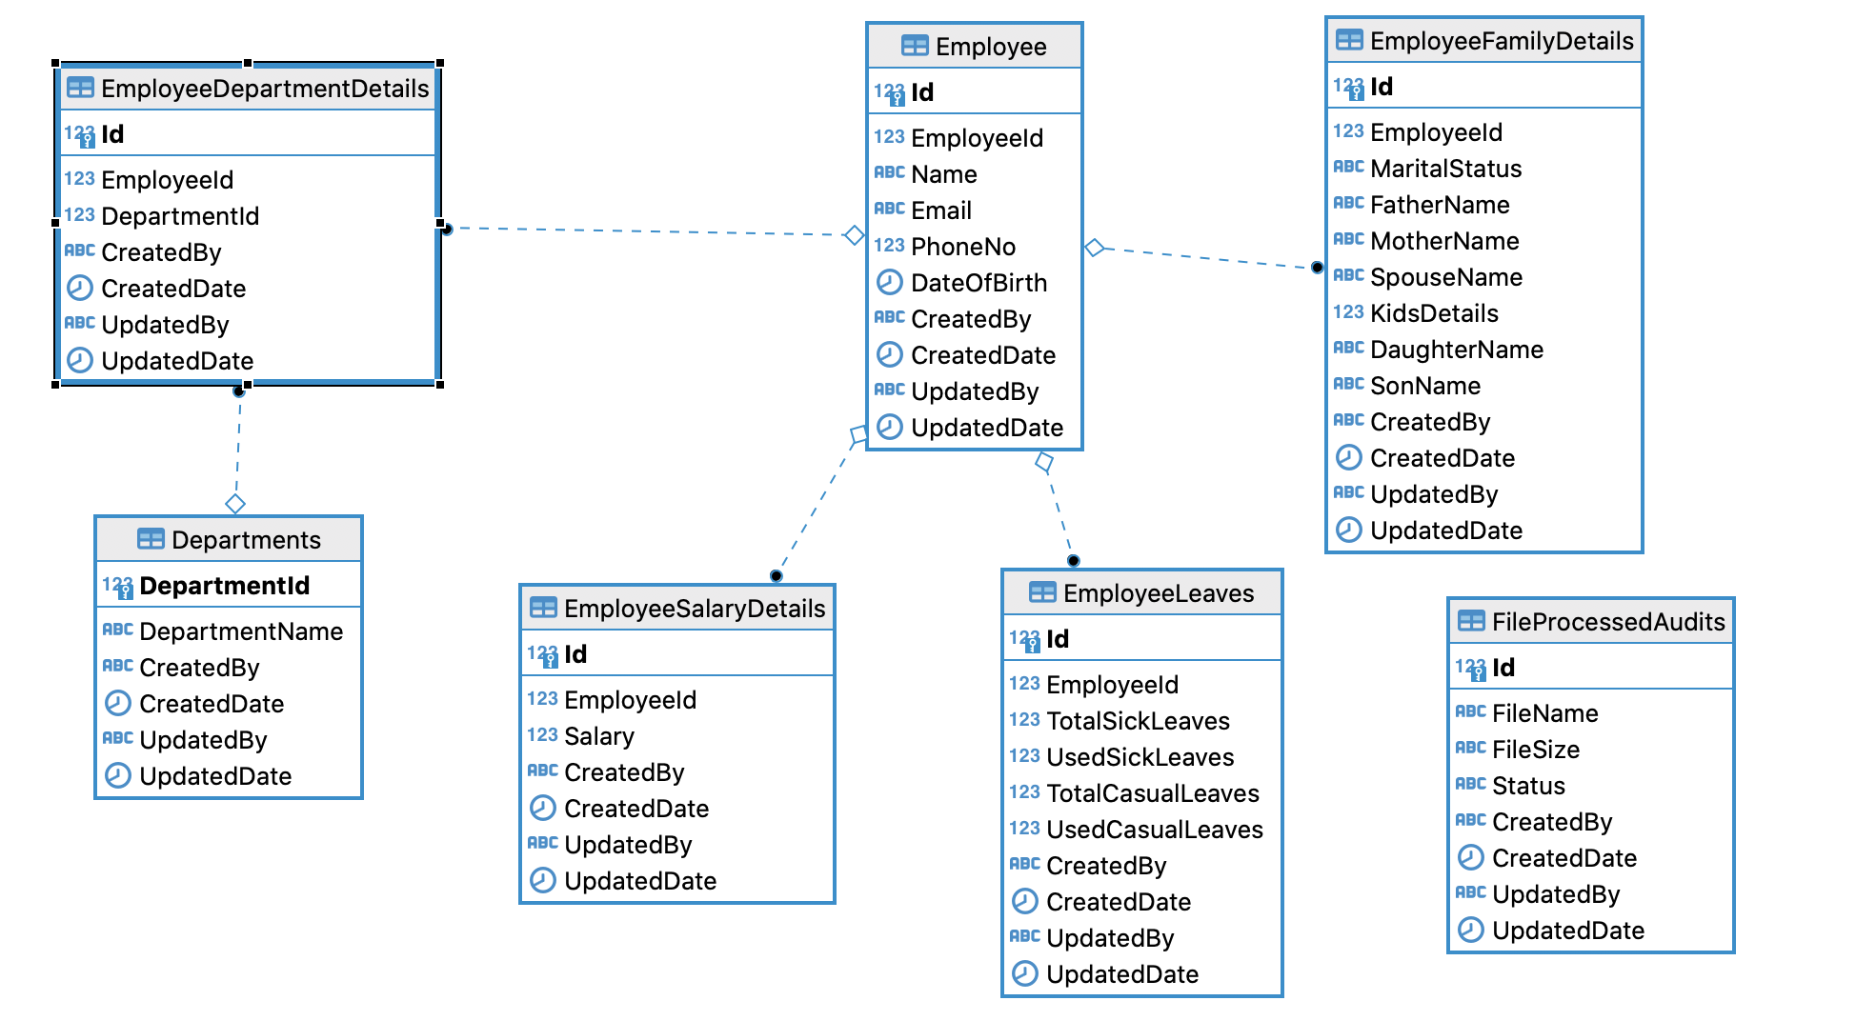

All Other Changes
Database:
- Created EmployeeId index to better performance for MERGE queries
- Added Primary Key relationship
- Added Foreign Key relationship

Application:
- Used Multi thread approach for better performance
- Used camel streams to avoid memory issues

High Level Design

File Service

- Employee file should be copied to local directory
- Apache camel poler will pick the file
- Copies the file to backup directory
- Reads the file content into streams (To avoid memory issues) and converts objects using camel-bindy library
- Insert/Update data into Employee and sub tables based on Employee Id
- File status will be updated in FileStatusAudits table

File Format
Below is the file format

Sample file will be available in GIT REPO: https://github.com/ashaloka/file-service/files/EmployeeData_1.txt

Low Level Design

Flow Chart Diagram
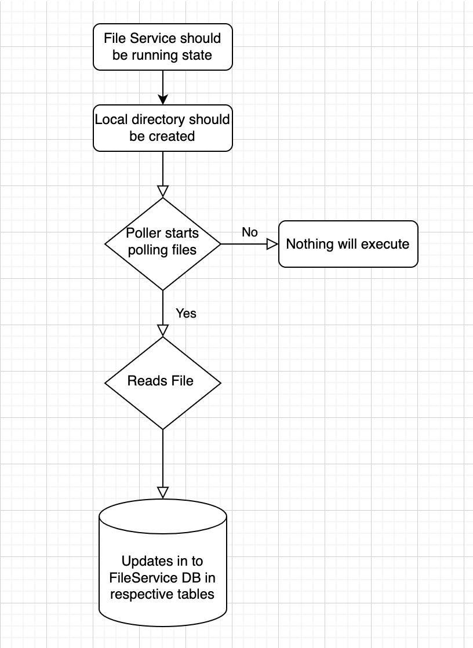

Class Diagram
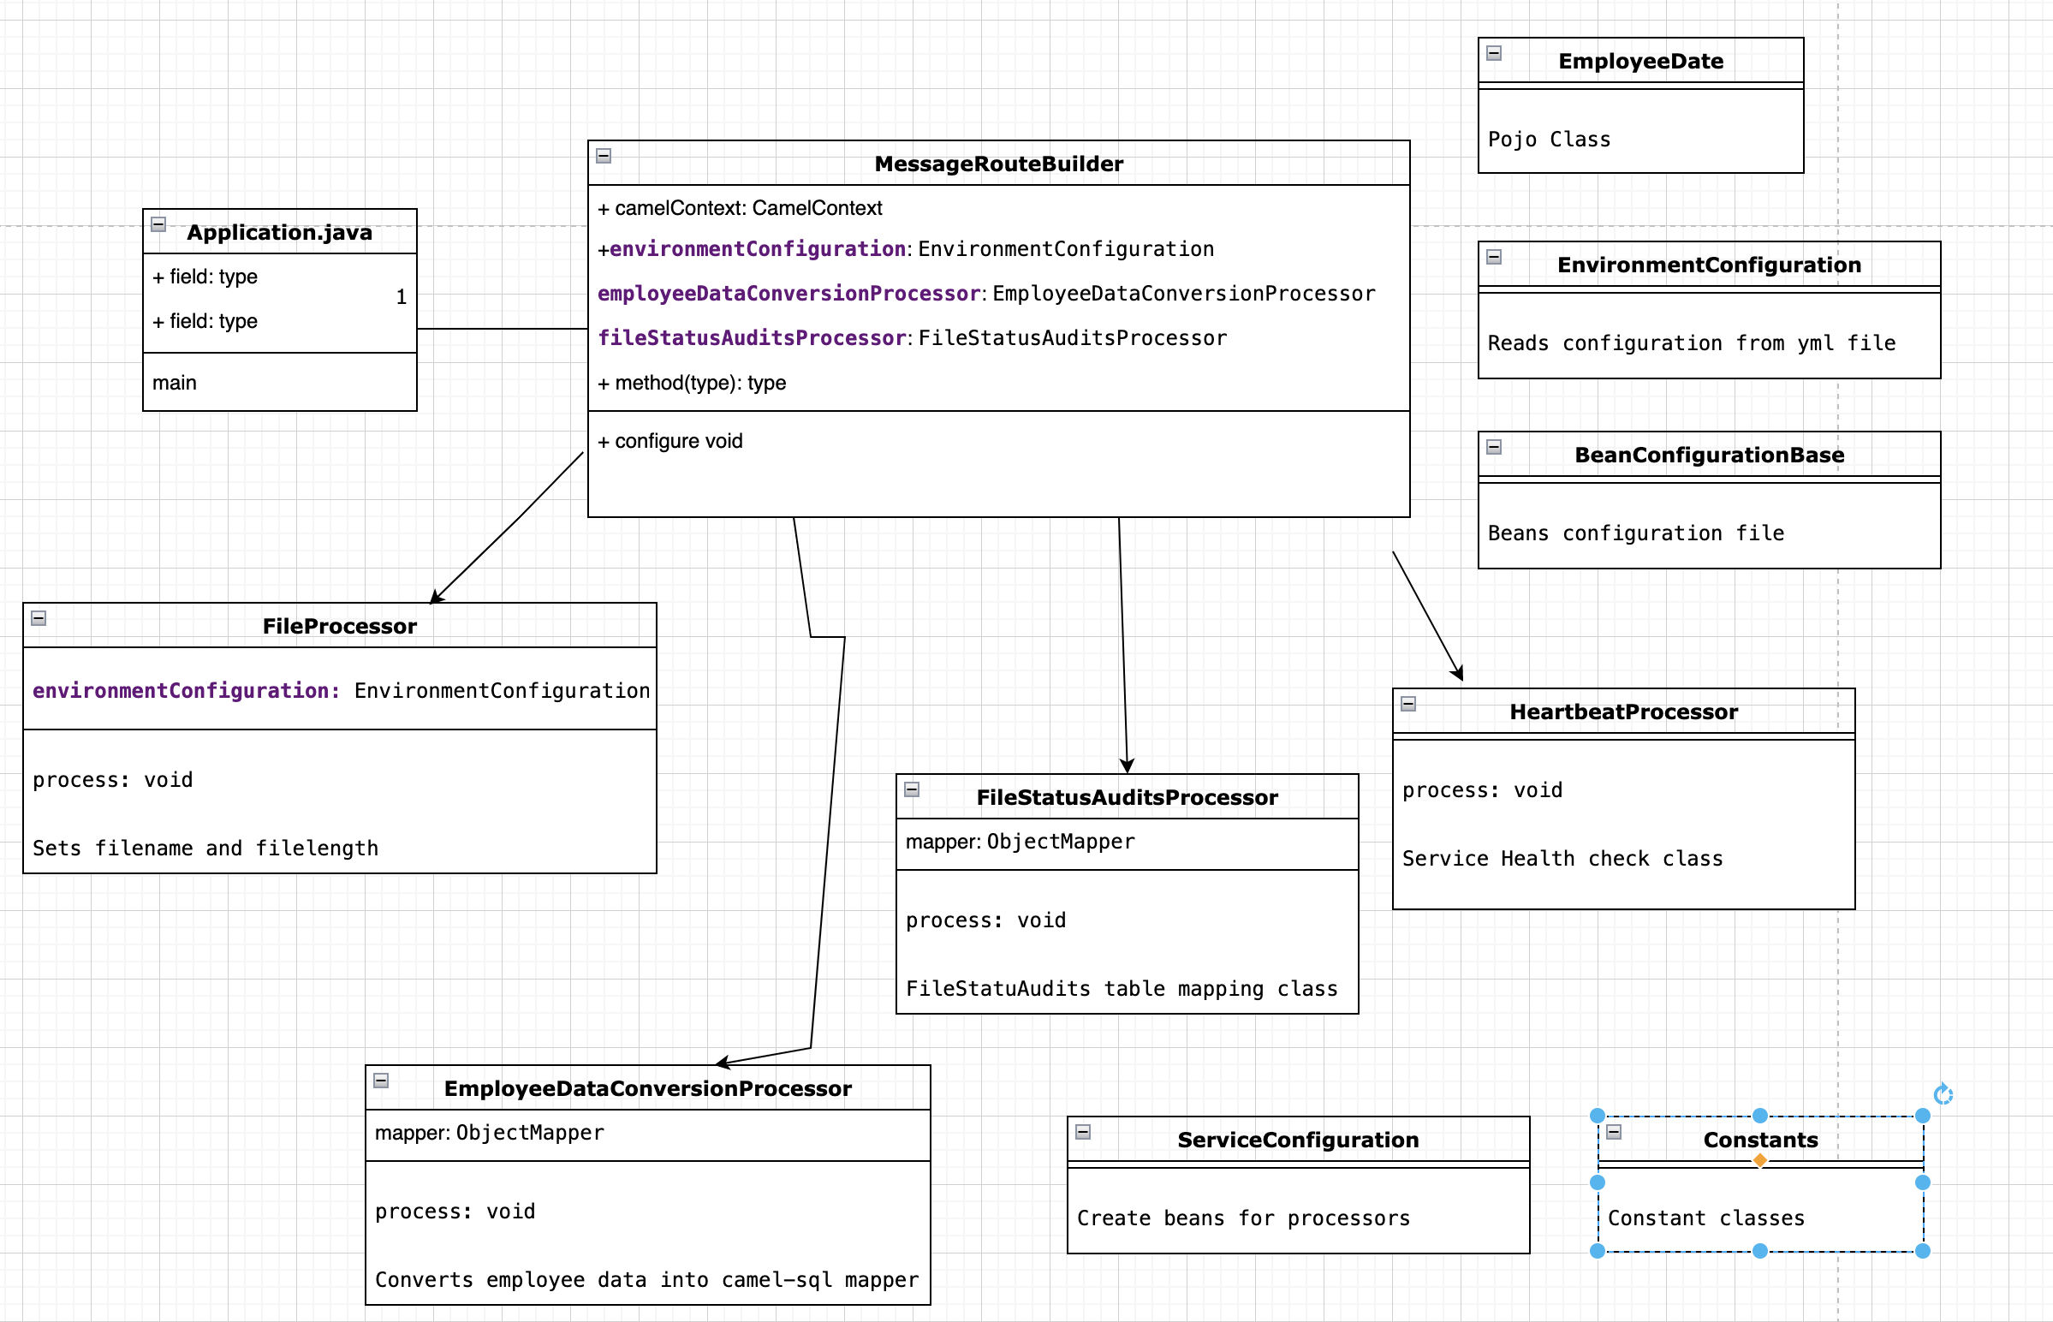

File Service Process
- Spring Boot Application initializes Application class and starts the service.
- MessageRouterBuilder initiates by camel framework and initiates routes.
- File poler route will start polling files from configured directory.
- Max threads configured 3 and based on service memory we can increase the threads.
- At a time poler will read 3 files and starts the process.
- First copies the file into backup directory which configured in yml file.
- Reads the file content into streams (based on configuration 10000 we can increase or decrease) and pushes the data into FileService database into respective tables.

Apache Camel:
- Apache camel supports file reading from NAS drive/AWS/Local directory
- We need to add respective maven dependencies.
- We need to configure poler configuration based on file system.
- Example: NAS drive (smb://), AWS (aws://), Local system (file://)

Performance
- Parallel threads will increase the better performance.
- Streams will avoid the memory issues.

