CCT College Dublin
Assessment Cover Page
Modules Title: | Advanced Data Analytics  Big Data Storage and Processing
Assessment Title: | MSC_DA_BD_ADAv6
Lecturers Name: | David McQuaid  Muhammad Iqbal
Student Full Name: | Alaa Shammary
Student Number: | SBA23361
Assessment Due Date: | 23/05/2025 11.59pm
Date of Submission: | 23/05/2025 11.59pm

Declaration

By submitting this assessment, I confirm that I have read the CCT policy on Academic Misconduct and understand the implications of submitting work that is not my own or does not appropriately reference material taken from a third party or other source. I declare it to be my own work and that all material from third parties has been appropriately referenced. I further confirm that this work has not previously been submitted for assessment by myself or someone else in CCT College Dublin or any other higher education institution.

Contents
Introduction 3
Big Data Processing and Storage 3
Data Sources and Initial Preparation 3
Data Storage 3
Data Processing Environment 4

Introduction
This project investigates how public sentiment expressed on Twitter interacts with daily stock market movements and whether the two sources of information can be fused to improve short horizon price forecasts. The study combines 10 000 stock tagged tweets and one year of daily price data for large companies. After preprocessing, each tweet is scored for polarity; the resulting sentiment time series are aggregated to the ticker day level and joined to the corresponding market data.

Big Data Processing and Storage
This section outlines the integration and processing of stock market and tweet datasets using distributed big data tools, specifically Cassandra, MongoDB, and Apache Spark.

Data Sources and Initial Preparation
Two main datasets were used:
Tweet Dataset (stocktweet.csv): 10,000 entries containing tweet ID, timestamp, stock ticker, and tweet content.
Stock Prices Dataset (5 CSVs for AAPL, AMZN, MSFT, NVDA, TSLA): Each containing daily prices with columns including date, open, high, low, close, adjusted close, and volume.
The datasets were read using Pandas and a ticker column was added to each stock data frame for identification during merging and processing.
In this project, I implemented a robust pipeline for storing and processing large scale financial and social media data using modern Big Data technologies, with a focus on Cassandra, MongoDB, and Apache Spark. The rationale for the architecture and tool selection was guided by the nature of the data, scalability requirements, and the objective of performing real time and batch analytical operations efficiently.

Data Storage
Stock Market Data (Structured Data):
The historical stock prices for companies such as AAPL, TSLA, MSFT, AMZN, and NVDA were stored in Cassandra, a NoSQL, distributed and highly scalable database optimised for time series data. Cassandra's schema was designed with a composite primary key (ticker, date) to enable fast queries by stock symbol and date range.
Justification: Cassandra was chosen for its high write throughput, fault tolerance and excellent support for time-based queries, which is ideal for stock price data that grows continuously over time.
Tweet Data (Semi-structured Text Data):
Tweets related to the selected stock tickers were stored in MongoDB, a flexible document-oriented database. Each tweet was inserted as a JSON-like document into a collection.
Justification: MongoDB was selected for its natural fit with semi structured data such as tweets, and its dynamic schema enabled quick ingestion and retrieval of diverse text entries.

Data Processing Environment
Apache Spark:
Data processing, transformation and feature engineering were conducted using Apache Spark, specifically through PySpark. Spark was configured to read stock data from Cassandra and tweet data from MongoDB via appropriate connectors.

Key processing activities:
- Handling missing values (e.g., lagged values in stock data).
- Generating lagged close prices and future price columns (e.g., close_t_plus_1, close_t_plus_3).
- Creating new features such as daily returns and moving averages using Spark SQL functions and windowing operations.
- Performing aggregations to understand stock activity over time per ticker.

Justification: Spark was used for its in-memory distributed computing capabilities, which allow for fast processing of large datasets across clusters. Spark's integration with both Cassandra and MongoDB made it a natural choice for centralising processing without data migration.

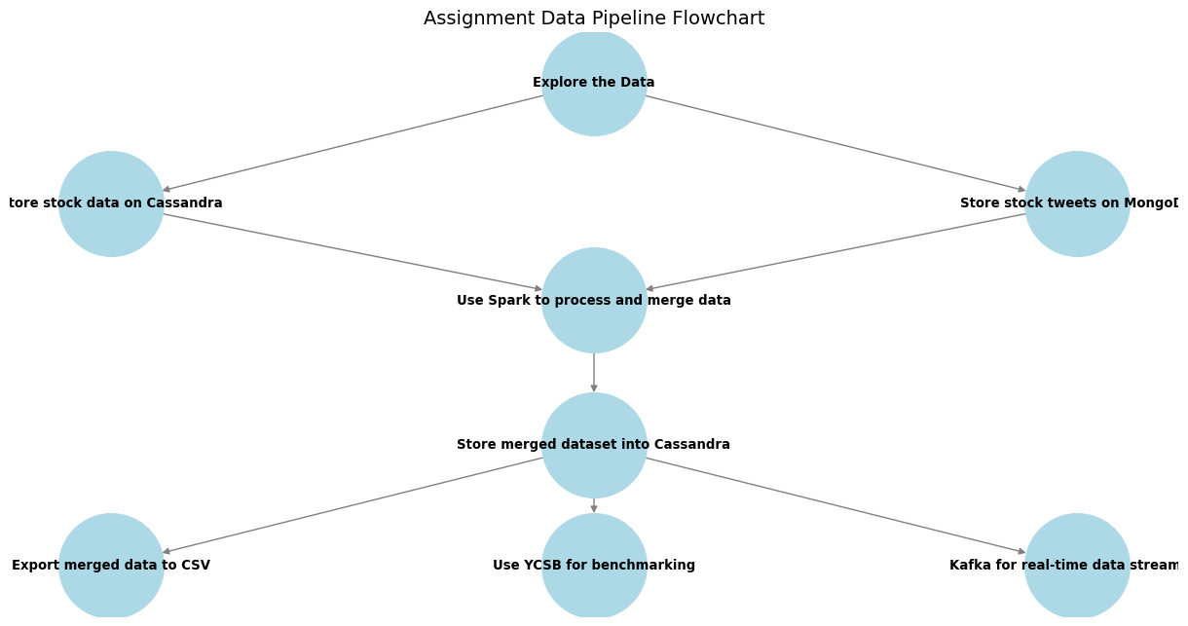

Comparative Analysis – Workload A (50% Read, 50% Update)
To benchmark the performance of a relational database (MySQL) against a NoSQL database (MongoDB), the YCSB tool was used with Workload A, which represents a balanced mix of 50% reads and 50% updates. The results indicate that MongoDB significantly outperformed MySQL across all key metrics. MongoDB achieved a throughput of 254.12 operations per second, compared to 73.60 ops/sec for MySQL. Additionally, MongoDB demonstrated lower latencies in both read and update operations, with an average read latency of 853.42 µs versus 1508.91 µs in MySQL, and an average update latency of 6924.21 µs compared to 12865.35 µs. The 95th and 99th percentile latencies for reads were also lower in MongoDB, reflecting more consistent performance under load. These results suggest that MongoDB handles mixed workloads more efficiently, likely due to its document-based architecture and more flexible write model.

