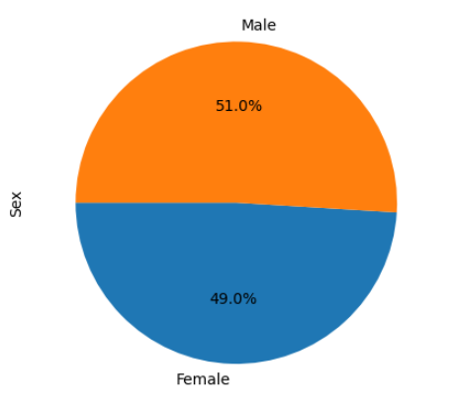

In terms of the gender of tested mice, they were almost the same. However, the population size of the male mice was slightly higher than the female (i.e. Male 51%, and female 49%).

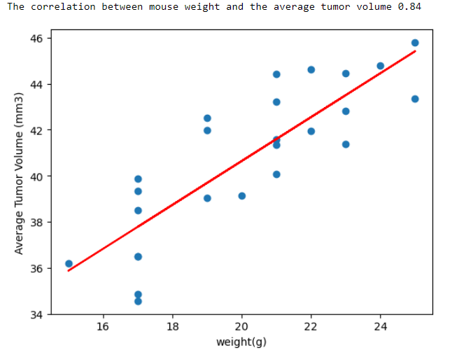

The average tumor volume and eight are highly correlated (i.e, 0.84 which is greater than 0.7). it is also shown in the figure.

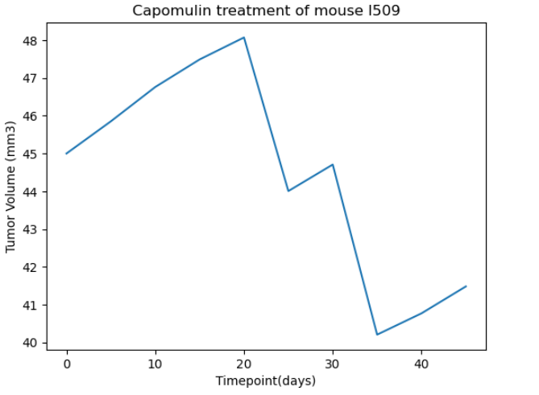

in spite of increasing the tumor volume using Capomulin treatment, the tumor volume dropped down while time passed, which was a good sign that showed the Capomulin was an effective treatment method.