Development of an ultralow-power battery-operated data logger

Project Progress Report –

Hardware
• Component Sourcing: 98%
• Ultra Low Battery Hardware: 100% (Complete)
• Working Prototype: 100% (Complete)
• PCB Design: 10%

Firmware
• Accurate Temp/Humidity Measurement: 100% (Complete)
• Data Storage on Flash (Little FS): 100% (Complete)
• Low Power Sleep Mode (4-7uA sleep, 16-22uA active): 100% (Complete)
• Data Retrieval: 100% (Complete)
• Device Config Without Reflash: 50%
• Fail Safe (RTC/Watchdog/Battery-Based Interval): 20%

Finalized Block Diagram –

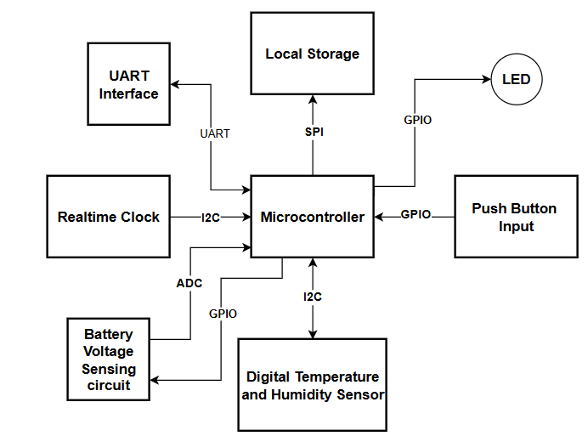
Figure 1: Block Diagram of the System
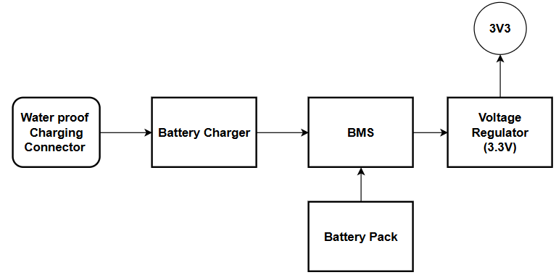
Figure 2: Block Diagram of the power supply

