Battery Voltage Measurement - ADC Calibration

The MCP3021 (12-bit) ADC was used to measure the battery voltage in the custom ESP32-H2 data logger hardware.
- Device Under Test (DUT): Custom PCB with ESP32-H2 and MCP3021 ADC
- Reference Instrument: Digital Multimeter (DMM, ±25mV at range (9.999V))
- Voltage Source: Bench DC power supply
- Measurement Range: 3300–4300 mV

Measurement Data:
Multiple voltages measured (Supplied from Bench power supply in range 3.3V to 4.3V) simultaneously by the DMM and ADC (uncalibrated firmware output).

Table 1.1: Reference Voltage and ADC computed Voltage in mV
Reference Voltage (mV) [±25 mV] | ADC Measurement (mV)
3302 | 3317
3401 | 3409
3501 | 3506
3601 | 3606
3701 | 3703
3804 | 3802
3903 | 3899
4001 | 3999
4102 | 4098
4201 | 4201
4304 | 4294

Linear Regression Model
A linear model was fitted to relate the ADC reading (input) to the true reference voltage,
$$V_{Calibrated}=a ×V_{ADC}+b$$

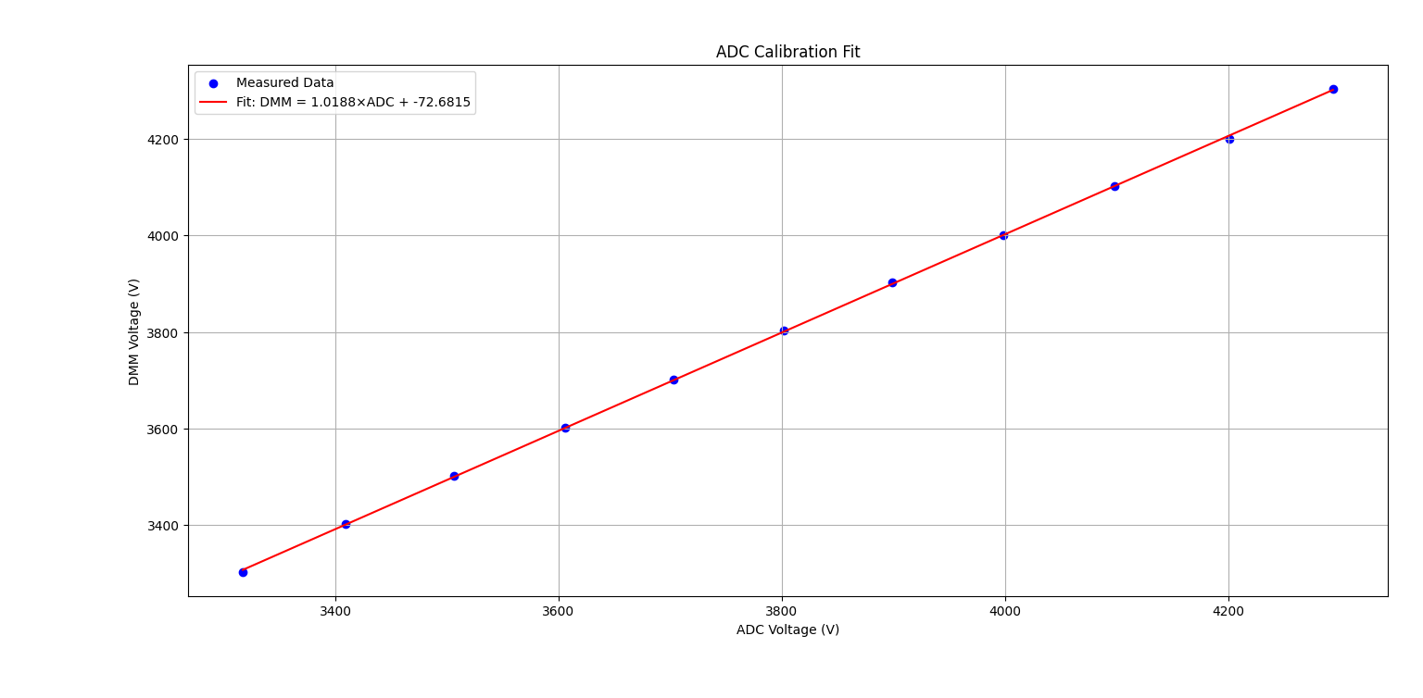
Best-fit parameters:
- Slope (a): 1.0188
- Offset (b): –72.6815 mV
- Coefficient of determination (R²): 0.999917

Residual statistics
- Mean residual: ≈ $4.5×{10}^{-13}$mV → effectively 0 mV
- Standard deviation: 2.89 mV
- Maximum absolute residual: 6.3 mV (at 4201 mV point)
Note: -
After calibration, the ADC readings follow the model with max error ≈ ±6.3 mV, but the absolute accuracy is limited by the DMM’s ±25 mV.

Fitted model with uncertainty:
$$V_{Calibrated }\left(mV\right)=1.0188 ×V_{ADC}(mV)-72.6815 ±25 mV$$

