Temperature and Humidity Sensor Calibration

The temperature calibration of the SHT45 sensor was performed at an ISO/IEC 17025 accredited laboratory (IMC, Sri Lanka). Five calibration points were evaluated across the operating range of the sensor. The reference thermometer uncertainty is incorporated into the expanded uncertainty reported by the lab.
- Device Under Test (DUT): Temperature and Humidity Logger (SHT45 Sensos)
- Reference Instrument: Digital thermometer with Pt1000 sensor (Reg No:(7424)362-0191A)
- Measurement Range: Temperature :10°C to 50°C , Humidity: 55.00 %RH and 72.00 %RH

Measurement Data (Provided by Laboratory):
i)Temperature Measurement

Reference Temperature (°C) | Device Reading (°C) | Correction (°C) | Expanded Uncertainty, U (°C)
9.79 | 10.33 | −0.54 | ±0.20
19.60 | 20.06 | −0.46 | ±0.20
29.67 | 29.91 | −0.24 | ±0.20
39.90 | 40.35 | −0.45 | ±0.20
49.89 | 50.28 | −0.39 | ±0.20

ii) Relative Humidity Measurement

Reference Humidity (%) | Device Reading (%) | Correction (%) | Expanded Uncertainty, U (%)
55.00 | 53.21 | 1.79 | ±3
72.00 | 73.15 | -1.15 | ±3

i) Temperature calibration

A linear regression was performed to relate Device temperature reading to true reference temperature,
Performed linear regression to model:
${ T}_{Corrected}=m ×T_{device}+b$

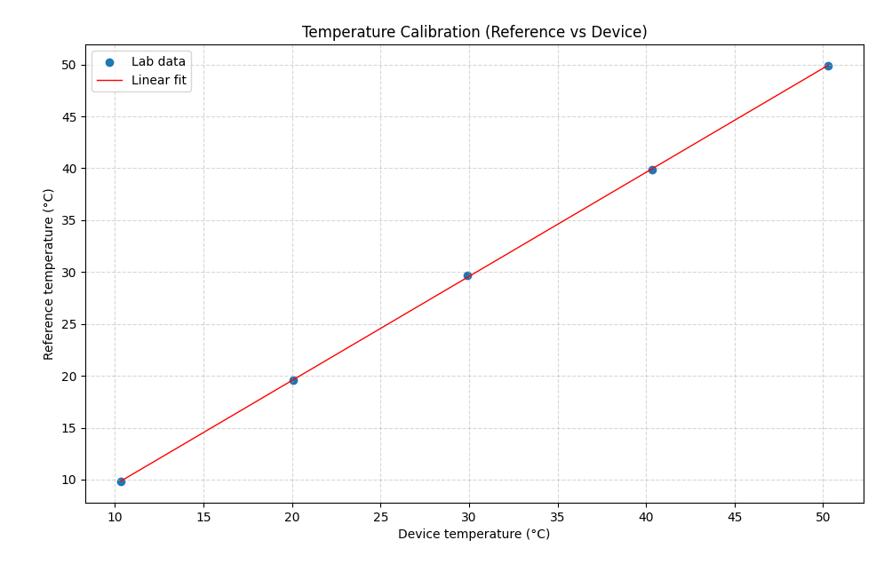
Best-fit parameters:
- Slope (a): 1.00302
- Offset (b): -0.5073 °C
- Coefficient of determination (R²): 0.9999
Residual statistics
- Mean residual: 0 °C
- Standard deviation: 0.101167 °C
- Maximum absolute residual: 0.176835 °C
Uncertainty Calculation

The lab guarantees the reference temperature is correct within ±0.20 °C with 95% confidence. [multiplying the combined standard uncertainty by a coverage factor k = 2]

Therefore, Lab Reference standard uncertainty = 0.10°C

Calibration model Uncertainty (S.D of residuals) = 0.101167 °C

The Lab reference uncertainty and model fitting uncertainty are independent.

Combine them using root-sum-of-squares (RSS):
$$u_{c}=\sqrt{u_{lab}^{2}+u_{modle}^{2}}$$
Where, $u_{lab}= 0.1$°C$, u_{modle}=0.101167 °C$

Substitute values:
$$u_{c}=0.1414 °C$$

Therefore, uncertainty expanded (k=2 for 95% confidence) $U=2 ×0.1414 °C=0.2828°C$

Fitted model with uncertainty:
$${ T}_{Corrected}(°C)=(1.00302 ×T_{device }(°C)-0.5073 ) ±0.28°C$$

ii) Relative Humidity calibration
The accredited laboratory provided only two calibration points,

Since only two points were provided, a 2-point linear calibration was derived as ,
${ RH}_{Corrected}=m ×{RH}_{device}+b$
The slope m and intercept b were calculated directly using,
$$m=\frac{R_{2-}R_{1}}{D_{2}-D_{1}}=0.8525$$
$$b=R_{1}-m×D_{1}=9.6354$$

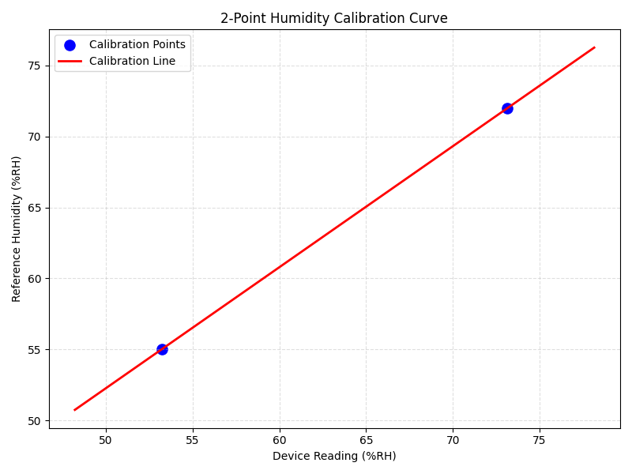

Uncertainty Calculation

The lab guarantees the reference relative humidity is correct within ±3 %RH with 95% confidence. [multiplying the combined standard uncertainty by a coverage factor k = 2]

Therefore, Lab Reference standard uncertainty = 1.5 % RH

The fitted model itself contributes no statistically estimable additional uncertainty (u_fit ≈ 0 %RH, artefact of 2-point line).

Therefore , Calibration model Uncertainty (S.D of residuals) = 0 % RH

The Lab reference uncertainty and model fitting uncertainty are independent.

Combine them using root-sum-of-squares (RSS):
$$u_{c}=\sqrt{u_{lab}^{2}+u_{modle}^{2}}$$
Where, $u_{lab}= 1.5 \% RH , u_{modle}=0 \% RH$

Substitute values:
$$u_{c}=1.5 \% RH$$

Therefore, uncertainty expanded (k=2 for 95% confidence) $U=2 ×1.5 \% RH=3 \% RH$

Fitted model with uncertainty:
$${ RH}_{Corrected}(\%RH)=(0.8525×{RH}_{device }(\%RH)+9.6354) ±3\% RH$$

