Development of an Ultralow-Power Battery-Operated Temperature and Humidity Data Logger
M.A. Pathiraja (2024AE17)

Current Progress
I have developed a compact, ultra-low-power environmental data logger consuming less than 25 µA in deep-sleep mode. It reliably records timestamped temperature and humidity data and can be easily configured, downloaded, and analyzed using a PC tool.

Objectives & Progress
- Logn lasting operation on single battery charge (More than one month) – 100% (Projected more than one year)
- Accurate temperature & humidity logging with timestamps. – 100%
- RTC fail safe mechanism - 100%
- Retrieve data from device to PC – 100%
- Change device configuration without re-flashing the firmware. – 100%
- Outdoor‑ready waterproof design. – 100%

- Major Achievements

- Low-Power Optimized Prototype – Fully functional hardware designed for ultra-low energy consumption.
- Measured Deep-Sleep Current: ~20.48 µA (verified using Nordic PPK2)
- ULP-Optimized Firmware – Includes deep-sleep mode, RTC-based wake-up, CSV data logging.
- Data Retrieval & Config mode – Download stored data and config device settings via UART configuration interface.
- PC GUI Tool – Supports device configuration, data download and formatting, data visualization and analysis
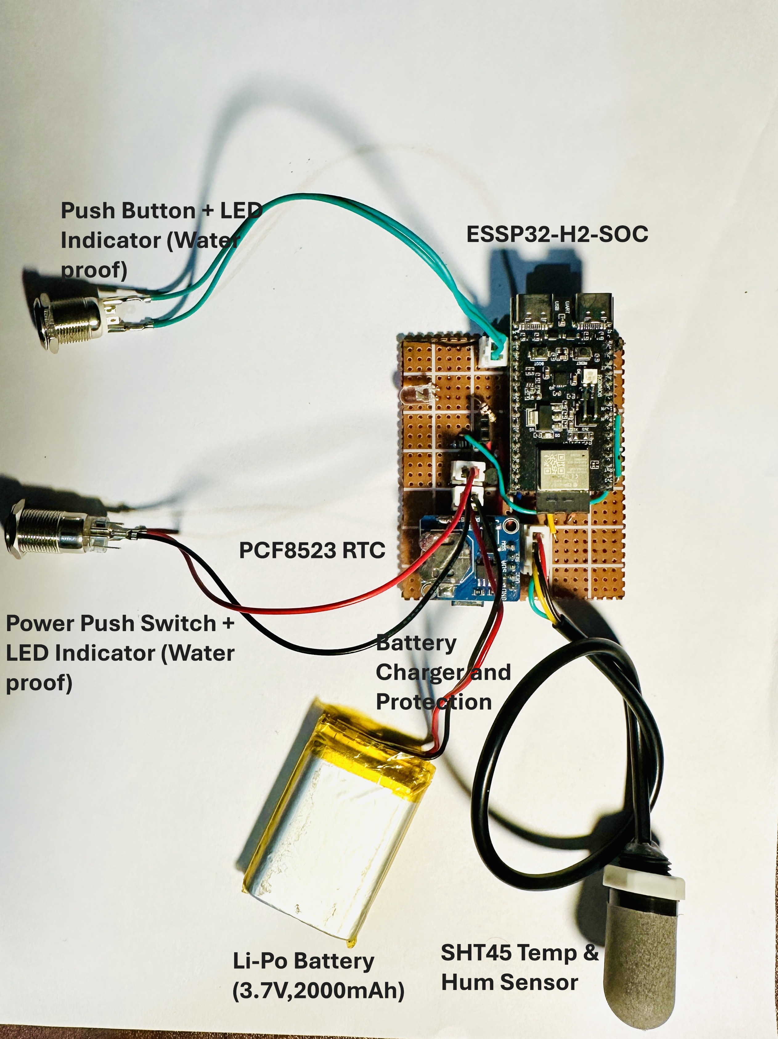
Figure 1: Current Prototype Without Enclosure

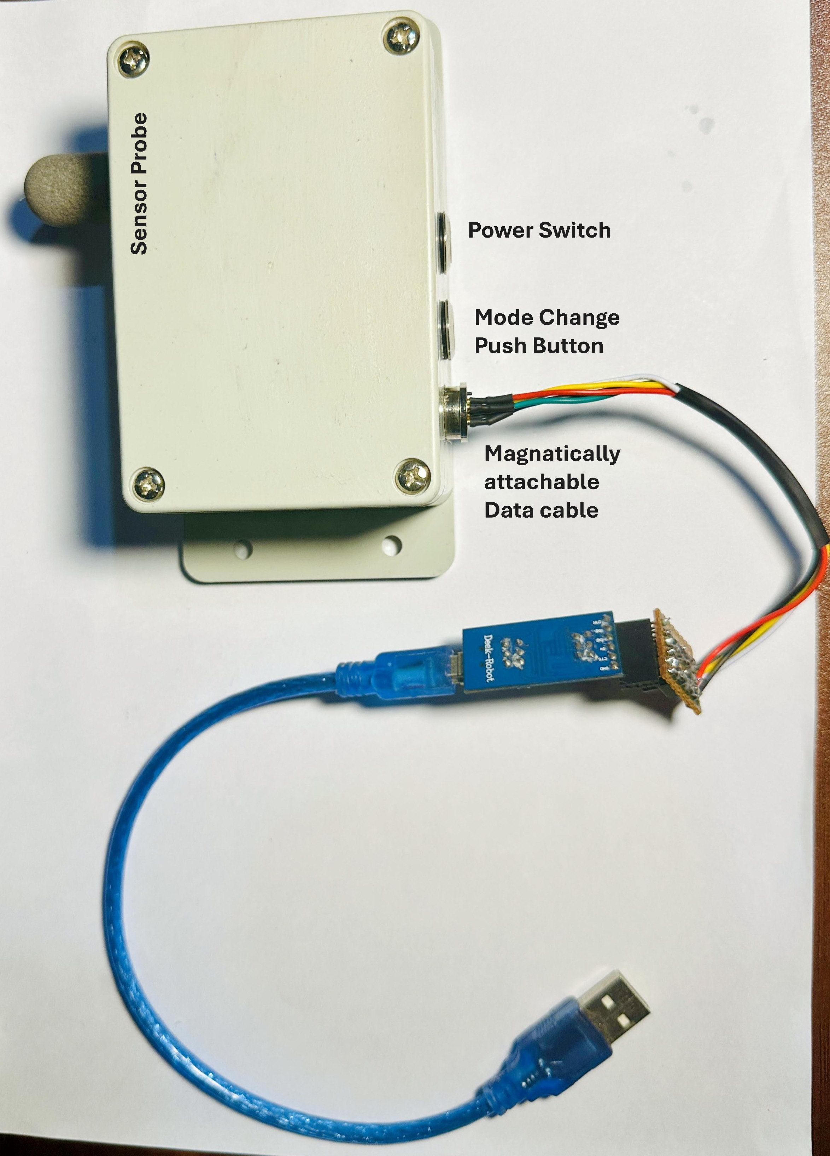
Figure 2: Assembled Prototype in Enclosure

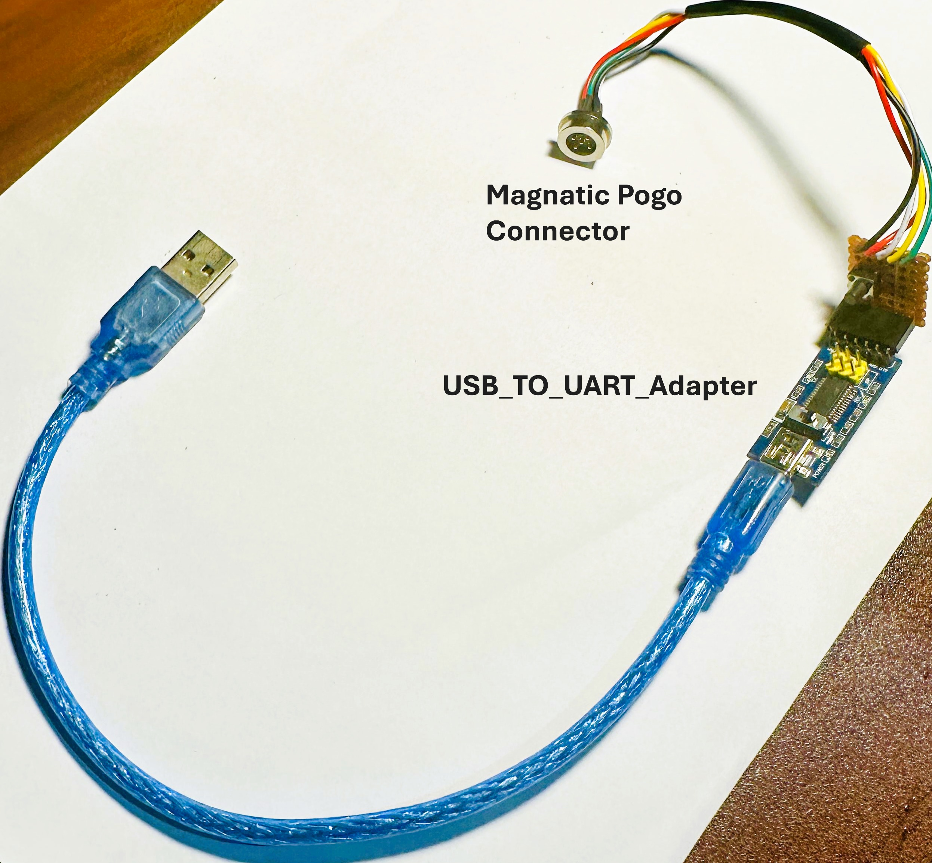
Figure 3: Magnetically attachable data cable

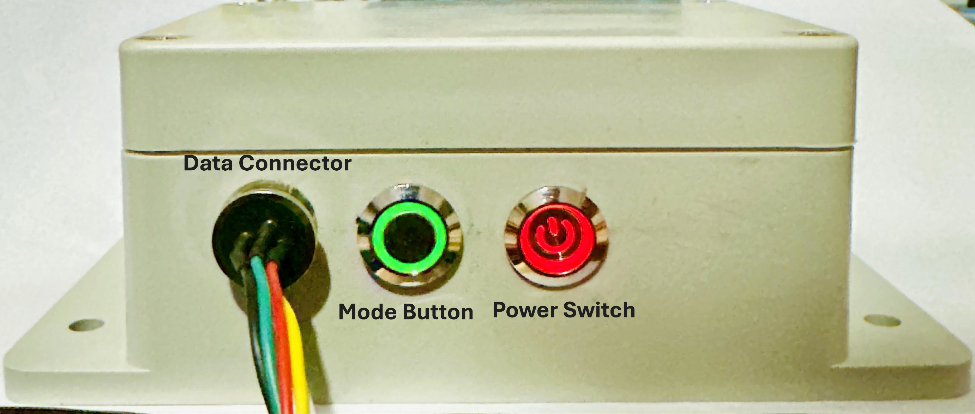
Figure 4: Prototype Front Panel view (Indicator LED’s ON)

2. Hardware Overview
2.1 Current Hardware Specifications
- MCU: ESP32-H2 (RISC-V) with integrated BLE
- Sensor: SHT45 (Temperature and Humidity)
- RTC: PCF8523 (Version 1)
- Storage: LittleFS file system on internal flash memory SPIFFS partition.
- Power Supply: 3.7 V Li-Po battery with built-in charging and protection circuit
- I/O Interface: Magnetic pogo-pin connector
- Enclosure: IP65-rated waterproof housing

2.2 Planned Hardware Improvements (Already Implemented in final prototype PCB)
- Precision ULP ADC for battery measurement (improves SoC accuracy).
- RV3028 temperature‑compensated RTC (±1 ppm).
- External SPI flash (16 Mbit) for extended logging capacity.
- Dedicated power‑path controller for seamless USB/battery switching.
- Commercial grade PCB design.
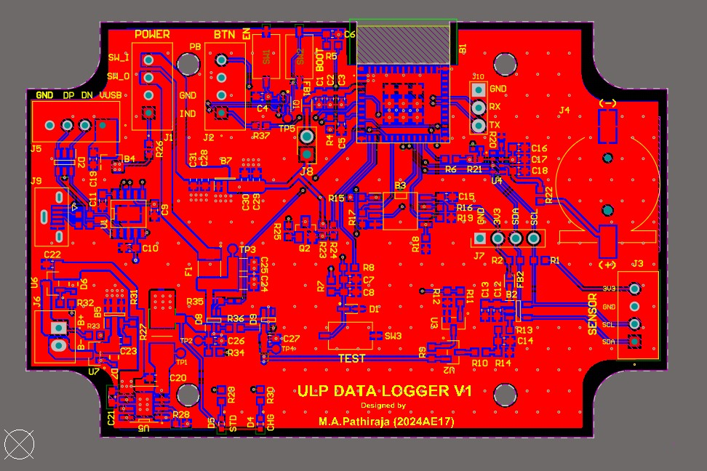
Figure 5: Datalogger PCB design Layout (with improved hardware features)
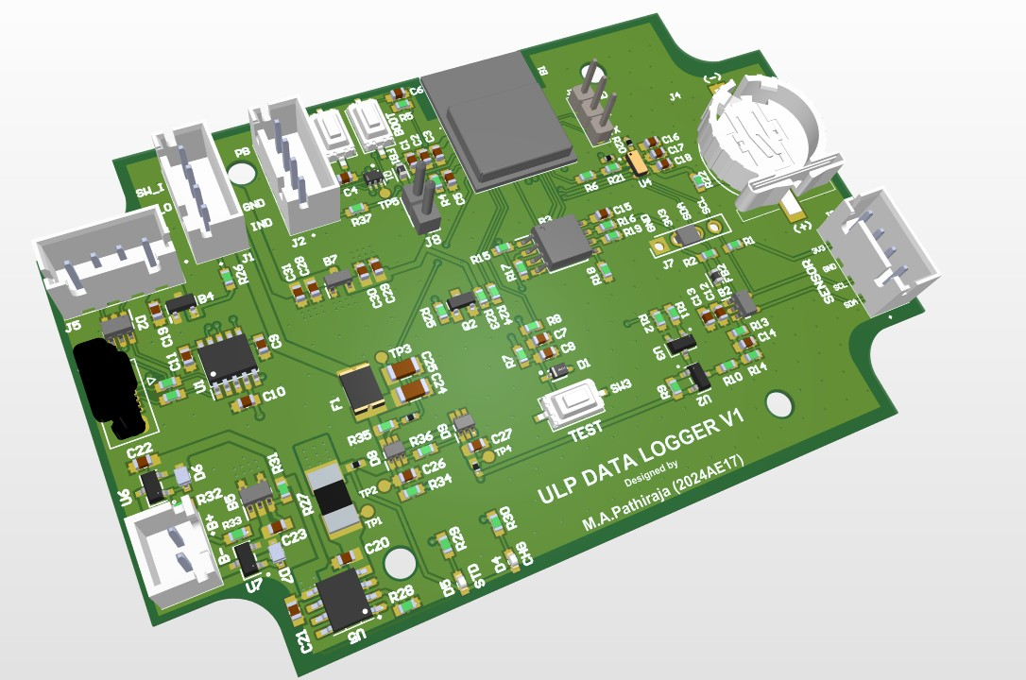
Figure 6: Datalogger PCB design 3D view
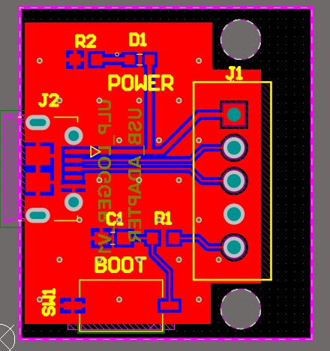
Figure 7: USB adapter PCB design Layout

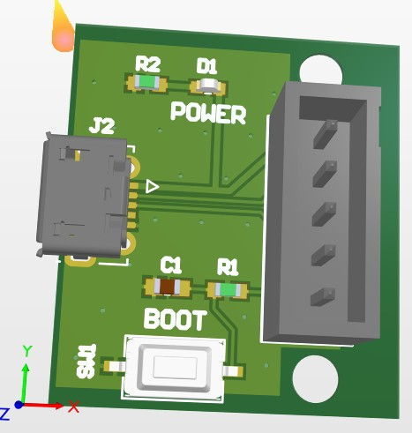
Figure 8: USB adapter PCB design 3D view

- Firmware Status & Roadmap

3.1 Current Firmware specifications
- Deep Sleep Operation – Minimizes power consumption during idle periods.
- CSV Logging – Stores timestamped data records in CSV format and create new csv file for each day.
- RTC Fail safe Operation – If RTC failed calculate the time from last record.
- UART Configuration – Allows device setup and parameter adjustment via serial interface.
- Data Retrieval – Easily view stored records and download to PC.
- Persistent Settings – Retains user configurations across power cycles.
- LED Control – Provides visual status indication through programmable LED behavior.

3.2 Planned Firmware Improvements
- BLE Data and Configuration – Enables wireless data transfer and device setup via Bluetooth Low Energy.
- External Flash Storage– Supports continuous data logging combining external flash memory.
- Battery Runtime Estimation and Adaptive Sampling – Adjusts sampling rate for estimating battery capacity.

4. PC GUI Tool
A PC-based GUI tool was developed for easy configuration and analysis of the data logger. It enables users to adjust settings, synchronize the RTC, view live data, and download or manage stored logs. The interface features automatic COM detection and real-time plotting for quick and intuitive operation.

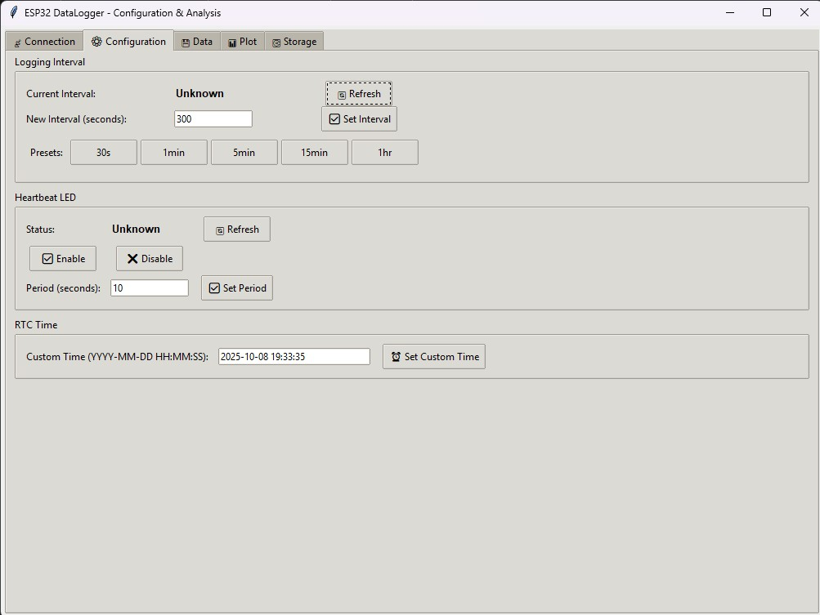
Figure 9: Connection/Configuration UI
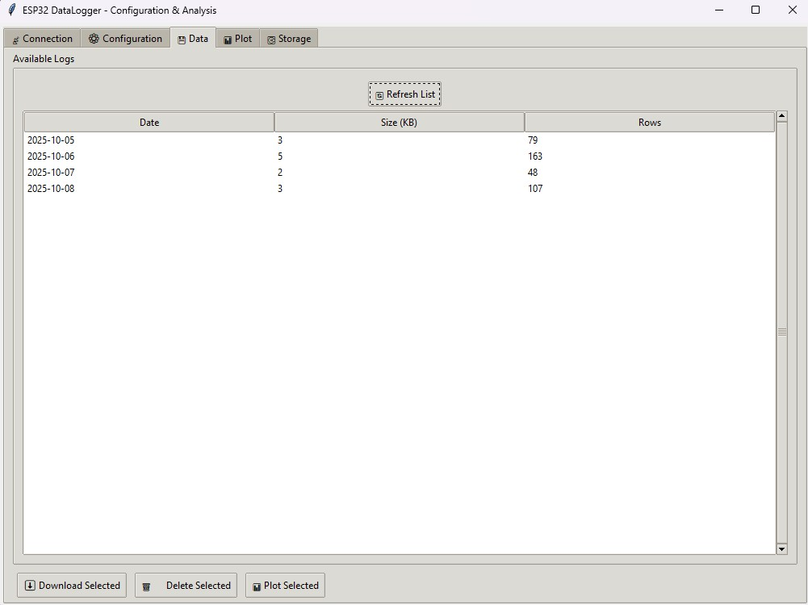
Figure 10: Data Management UI
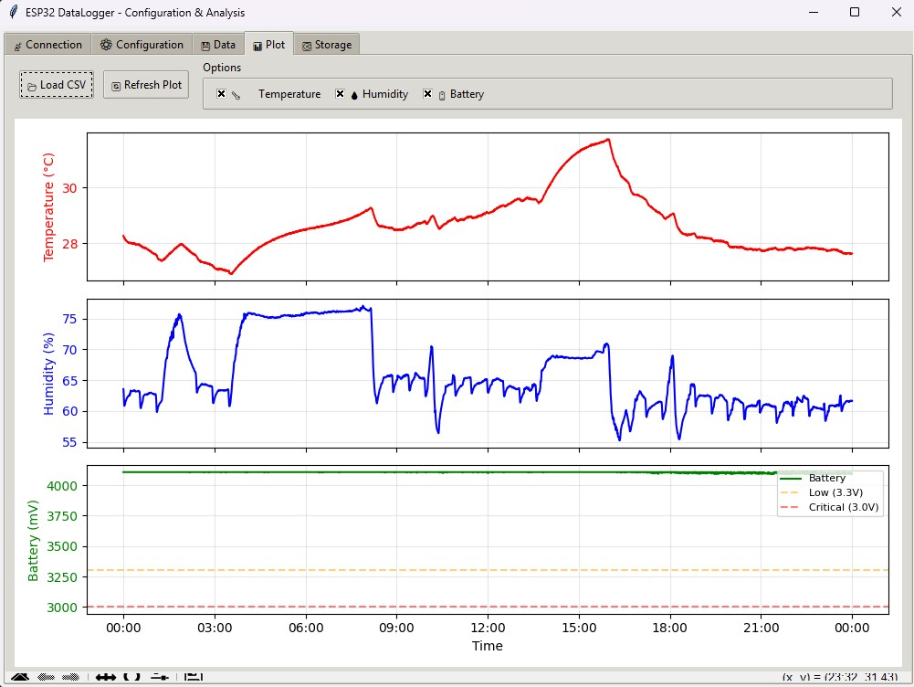
Figure 11: Visualization (Temp/RH/VBAT)

Those are the implemented GUI Features,
- Automatic COM Port Detection – Identifies connected devices instantly.
- Live Status Monitoring – Displays real-time device activity and connection state.
- Firmware, Battery, and Storage Information – Shows system version, battery level, and memory usage.
- Set Logging Interval – Adjust data recording frequency as needed.
- RTC Synchronization – Sync device time with PC for accurate timestamps.
- LED Control – Enable or disable status LED indication.
- Save Configuration Parameters – Store user-defined settings permanently.
- List and Download Logs – Browse and retrieve recorded data files.
- Format Storage – Clear or reinitialize internal memory.
- Real-Time Plotting – Visualize live sensor data on PC.

5. Power Consumption
Measurement tool: Nordic PPK2 (source mode , Voltage = 3.7 V).
- Deep‑sleep: ~20.48 µA (max ~22.28 µA).
- Active logging (1 s every 5 min): average ~8.05 mA across the cycle.

Projected battery life (2000 mAh , 10‑min interval): ≈ 1.4 years (theoretical).
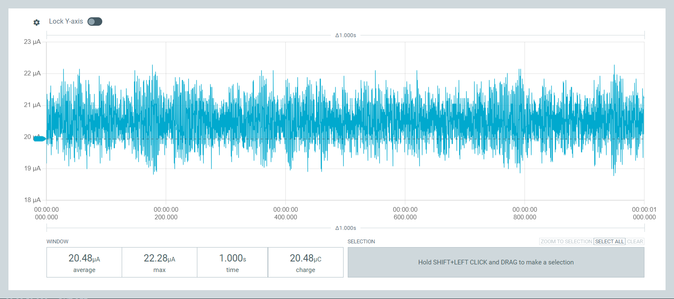
Figure 12: Deep‑Sleep Current Profile

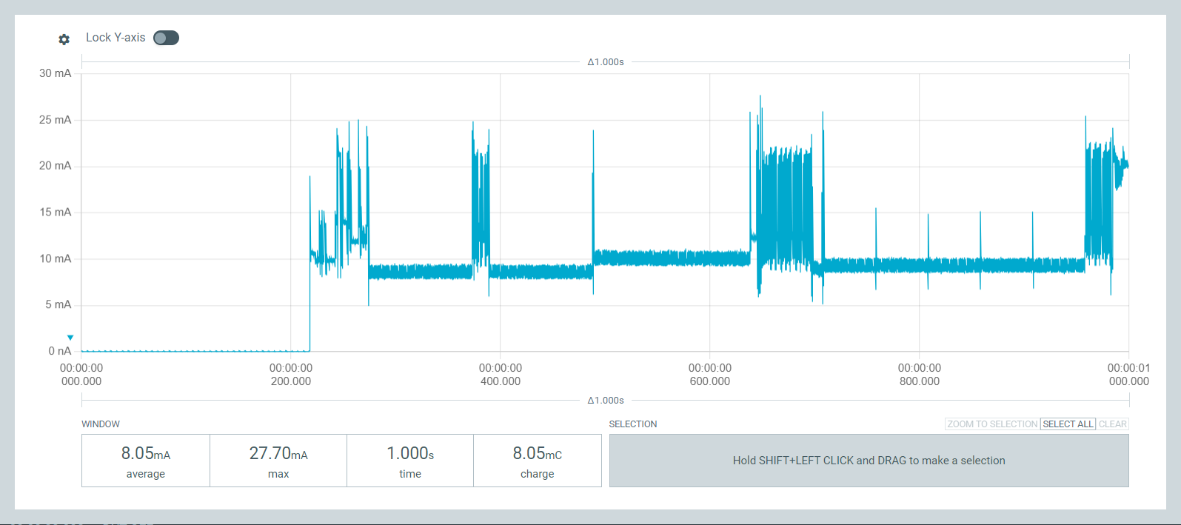
Figure 13: Active Logging Profile
6. Data Storage & Runtime
- Average record size: ≈ 24 bytes
- One-day CSV (10 min sampling): ≈ 3.5 KB
- LittleFS capacity: ≈ 1.38 MB
- Estimated retention: ≈ 395 days (with 5 % safety margin)
- Maximum possible: ≈ 415 days continuous logging before full

