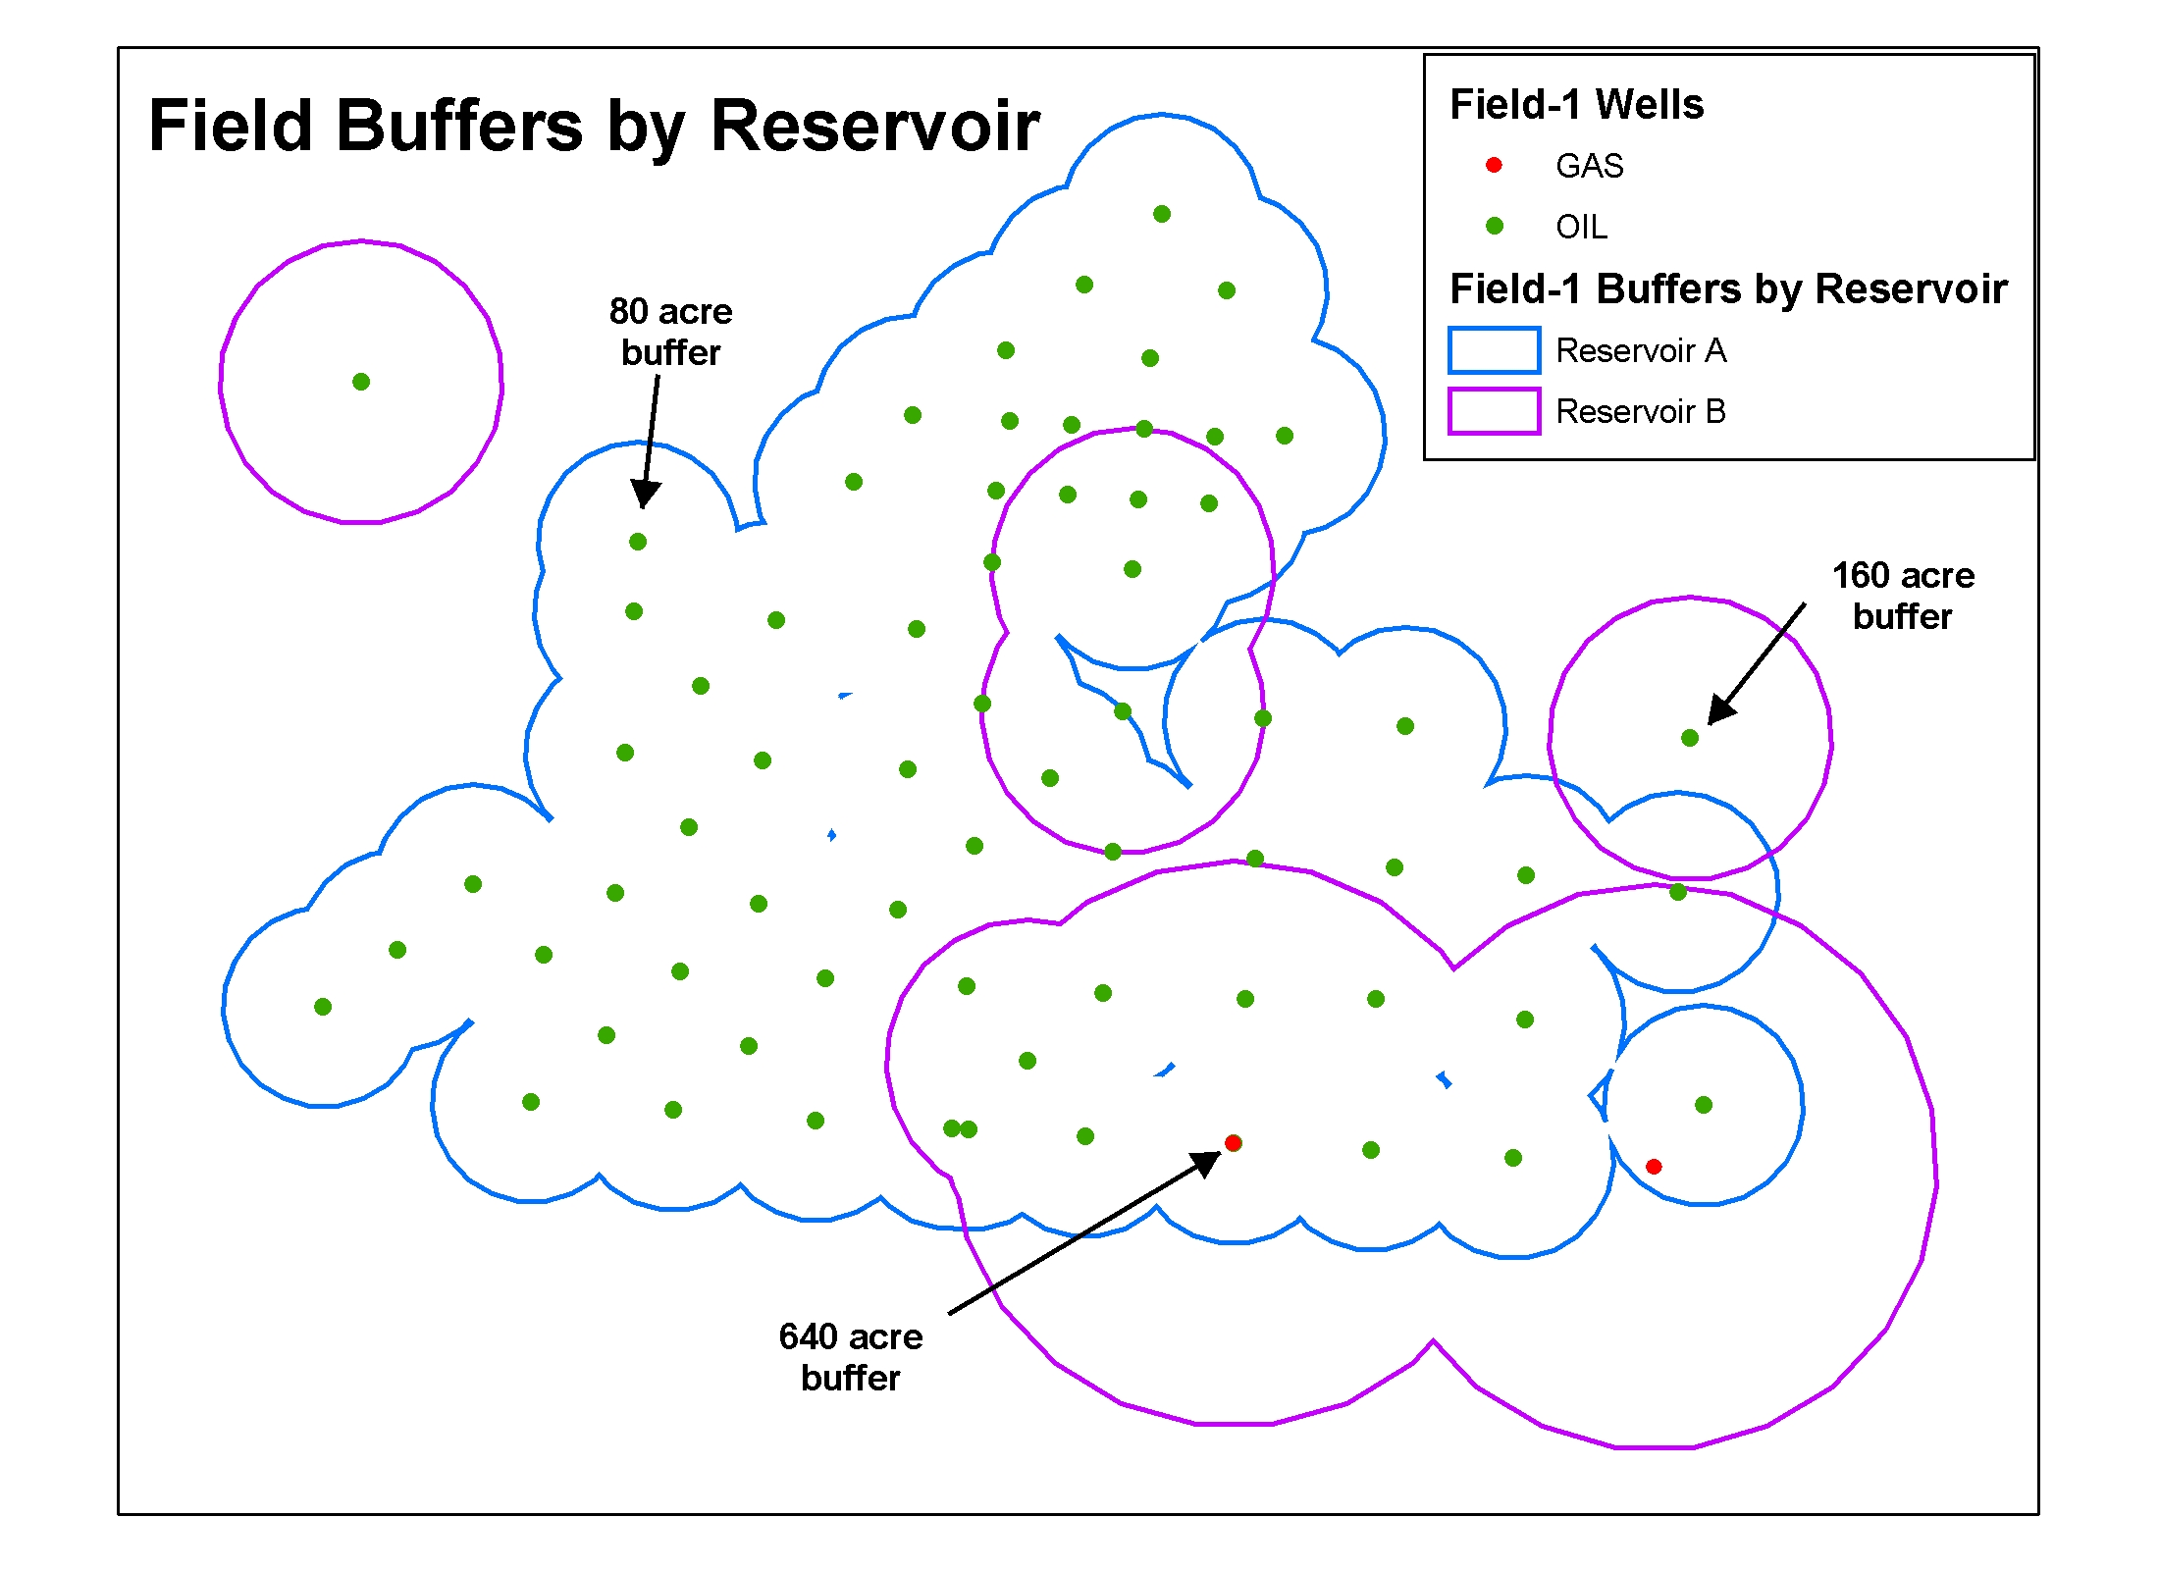
OIL & GAS FIELD OUTLINES FROM BUFFERED WELLS

The VBA Code below builds oil & gas field boundary outlines (polygons) from buffered wells (points). Input well points layer must be a feature class (FC) with the following attributes:
- Field_name
- Buffer distance (can be unique for each well to represent reservoirs with different drainage radii) …see figure below.

Copy the code into a new module.

Inputs:
- In ArcMap, data frame named “Task 1”
- Well FC as first layer (layer 0).

Output:
Polygon feature class in same GDB as the well points FC, with one polygon field record (may be multiple polygon rings) per field_name. Overlapping buffers for the same field name are dissolved and unioned (see figure below). Adds an attribute PCTFEDLAND which can be populated using the VBA code in PCT_FED_ LAND.doc
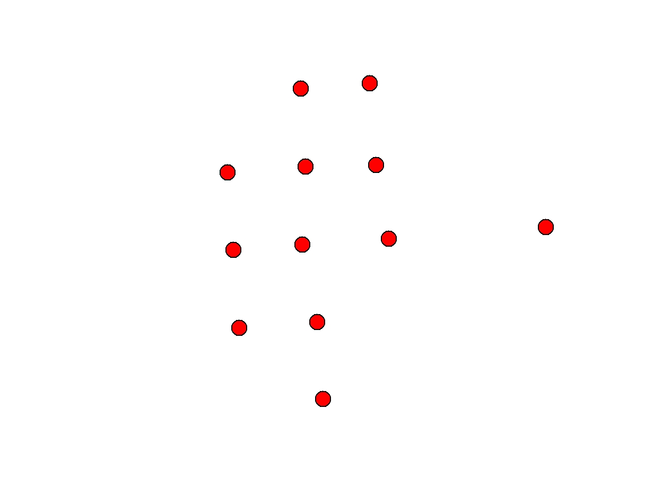
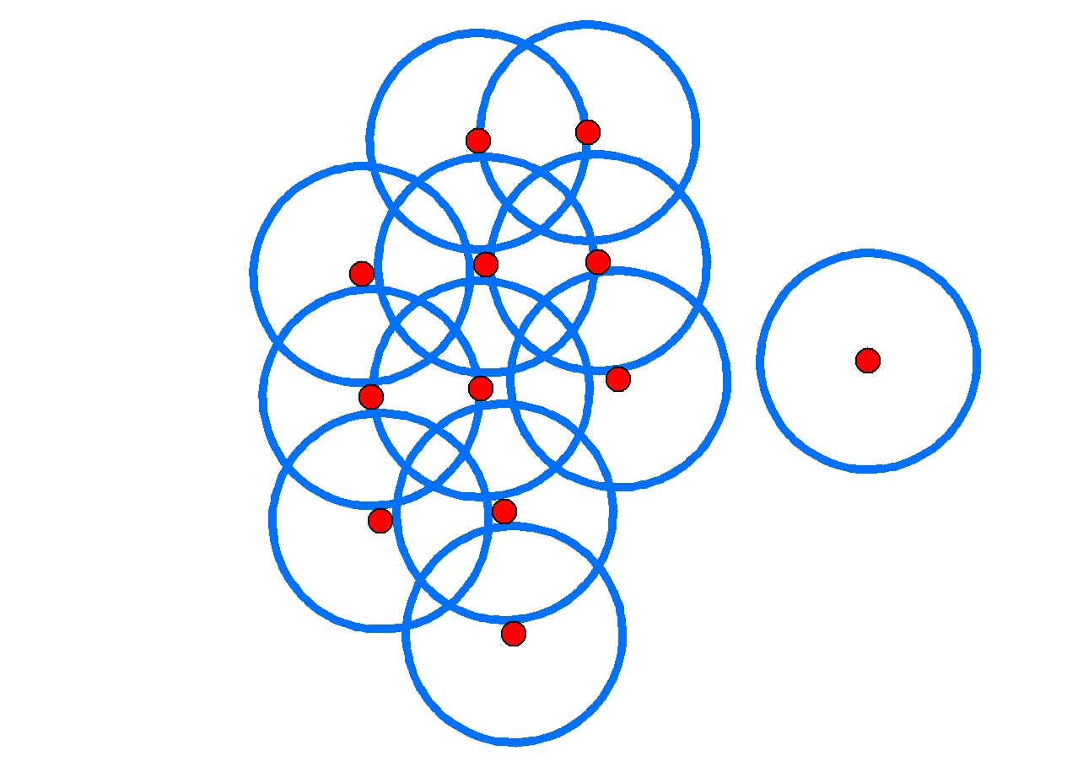
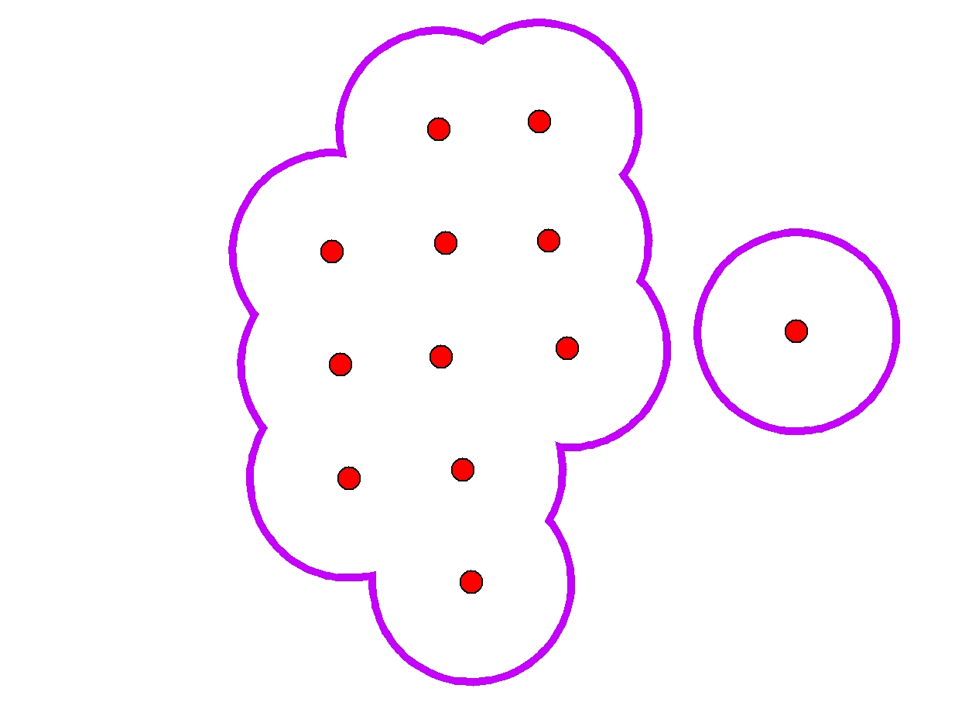
V

Examples of buffers by reservoir (below) and unioned together as one field (next page).

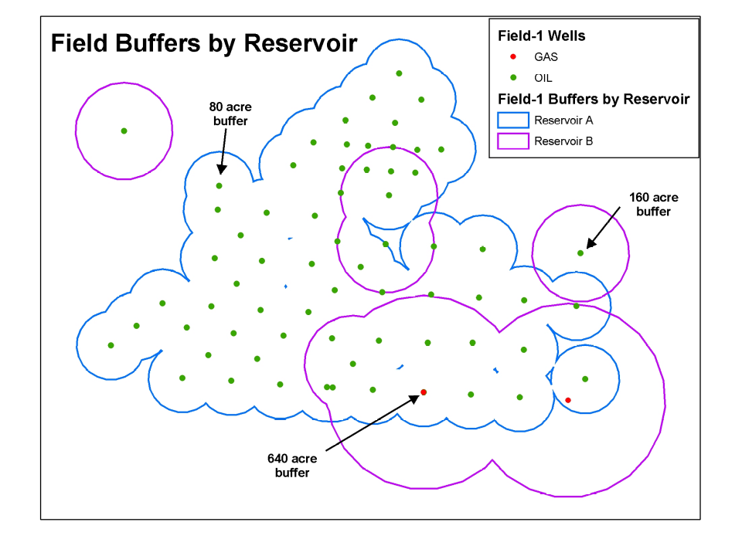
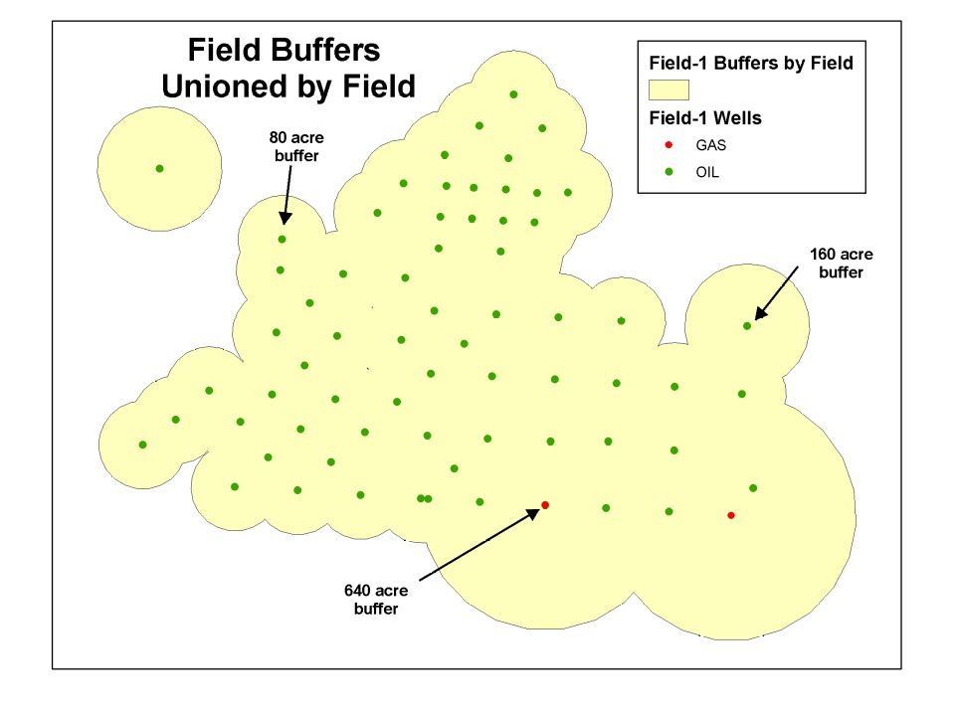
Code by Kirk Kuykendall, AmberGIS; text by Sam Limerick, Z, Inc.
===================================================================
Option Explicit
Const cFEETPERMETER As Double = 3.281
'
' deviation factor is applied to the buffer distance
' so with a buffer distance of 100 and factor of 0.05 the
' resulting linear piecewise buffer would deviate from the
' original circular buffer by no more than 5 units
' The buffer distance could be increased slightly
' so that the linear piecewise buffer area is closer to the
' circle, currently this area is always smaller.
'
Const cMAXDEVIATIONFACTOR As Double = 0.01

Sub Task1()
' inputs: Well point featureclass in Layer (0)

' outputs: Polygon featureclass with one polygon for each
' oil & gas field. Where each well in the field has been
' buffered by its buffer distance attribute and
' unioned together.
'
Dim pMxDoc As IMxDocument
Set pMxDoc = ThisDocument

Dim pMap As IMap
Set pMap = GetMap("Task 1")

Dim pWellFLayer As IFeatureLayer
Set pWellFLayer = pMap.Layer(0)

' get the column name that has the oil & gas field names
Dim sOilFldColName As String
sOilFldColName = GetColumn(pWellFLayer.FeatureClass, _
"Choose the Column that holds Oil Field Names in " & pMap.Layer(0).Name, _
"FLDNM_HST")
If sOilFldColName = "" Then Exit Sub
Debug.Print sOilFldColName

' get the column that has the buffer distances
Dim sBuffDistColName As String
sBuffDistColName = GetColumn(pWellFLayer.FeatureClass, _
"Choose the column that has the buffer distance", _
"BUFFER")

' get the output that we'll use (set by reference)
Dim pOutFWS As IFeatureWorkspace, sOutFCName As String
GetOutPut pOutFWS, sOutFCName, "Save output as ..."
If pOutFWS Is Nothing Then Exit Sub

Dim pSR As ISpatialReference
Set pSR = GetSR(pWellFLayer.FeatureClass)

Dim pWellFC As IFeatureClass
Set pWellFC = pWellFLayer.FeatureClass

Dim pOilFldNameFld As IField
Set pOilFldNameFld = pWellFC.Fields.Field(pWellFC.FindField(sOilFldColName))

Dim pColumns As IFields
Set pColumns = MakeColumns(pOilFldNameFld, pSR)
If pColumns Is Nothing Then Exit Sub

Dim pUID As New UID
pUID.Value = "esriCore.Feature"

Dim pOutFC As IFeatureClass
Set pOutFC = pOutFWS.CreateFeatureClass(sOutFCName, pColumns, _
pUID, Nothing, esriFTSimple, _
"Shape", "")

Dim pFSO As New Scripting.FileSystemObject
Dim pTxtStream As Scripting.TextStream
Set pTxtStream = pFSO.OpenTextFile(GetWSDir(pOutFWS) & "\" & sOutFCName & "BufferErrorLog.txt", ForWriting, True)
BufferFeatClass pWellFLayer, sOilFldColName, sBuffDistColName, pOutFC, pTxtStream

pTxtStream.Close
If pOutFC Is Nothing Then
MsgBox "unable to create output : " & sOutFCName
End If
Application.StatusBar.Message(0) = "Task 1 finished"
End Sub

Function GetWSDir(pWorkspace As IWorkspace) As String
Dim l As Long
l = InStrRev(pWorkspace.PathName, "\")
GetWSDir = Mid(pWorkspace.PathName, 1, l - 1)
End Function

Sub BufferFeatClass(pWellFLayer As IFeatureLayer, sOilFldColName As String, _
sBuffDistColName As String, pOutFC As IFeatureClass, _
Optional pTxtStream As Scripting.TextStream = Nothing)

Dim pDispTable As IDisplayTable
Set pDispTable = pWellFLayer

Dim pQF As IQueryFilter

Application.StatusBar.Message(0) = "sorting " & pWellFLayer.FeatureClass.AliasName & "..."
Dim pInFCur As IFeatureCursor
Set pInFCur = GetSortedCur(pWellFLayer.FeatureClass, _
pDispTable.SearchDisplayTable(pQF, False), _
sOilFldColName)

Dim pWellFC As IFeatureClass
Set pWellFC = pWellFLayer.FeatureClass

Dim lOilFld As Long
lOilFld = pWellFC.FindField(sOilFldColName)

Dim lBuffFld As Long
lBuffFld = pWellFC.FindField(sBuffDistColName)

Dim sOilField As String
sOilField = ""

Dim pOutGeom As ITopologicalOperator2
Dim pOutFCur As IFeatureCursor
Set pOutFCur = pOutFC.Insert(True)

Dim pFBuff As IFeatureBuffer
Set pFBuff = pOutFC.CreateFeatureBuffer

Dim lWellCount As Long, lWellCountFld As Long
lWellCountFld = pOutFCur.FindField("WellCount")
If lWellCountFld = -1 Then
MsgBox "Wellcount column not found on " & pOutFC.AliasName
Exit Sub
End If
lWellCount = 0

Dim lAcreageFld As Long
lAcreageFld = pOutFCur.FindField("Acreage")
If lAcreageFld = -1 Then
MsgBox "Acreage column not found on " & pOutFC.AliasName
Exit Sub
End If

Dim pInFeat As IFeature, lBadUnions As Long, lTry As Long, lTries As Long
lBadUnions = 0
lTries = 3 ' number of times to re-try unioning
Dim pDict As New Scripting.Dictionary

Dim lFeat As Long, lFeats As Long
lFeat = 0
'lFeats = pDispTable.DisplayTable.RowCount(pQF) bug
lFeats = GetRowCount(pDispTable, pQF)
For lFeat = 1 To lFeats
Set pInFeat = pInFCur.NextFeature
If pInFeat.Value(lOilFld) <> sOilField Or lFeat = lFeats Then
If Not pOutGeom Is Nothing Then
' insert the feature
If pDict.Count > 0 Then
For lTry = 1 To lTries
TryAgain pOutGeom, pDict, lTry, sOilField
If pDict.Count = 0 Then Exit For
Next lTry
End If
If pDict.Count > 0 Then
lBadUnions = lBadUnions + pDict.Count
WriteErrors pDict, pTxtStream, sOilField, lTries
pDict.RemoveAll
End If
InsertFeature pOutFCur, pOutGeom, pFBuff, _
lWellCountFld, lWellCount, lAcreageFld, pDict
Application.StatusBar.Message(0) = sOilField
Else
' nothing to insert yet
End If
sOilField = pInFeat.Value(lOilFld)
Set pOutGeom = BufferShape(pInFeat.ShapeCopy, pInFeat.Value(lBuffFld) / cFEETPERMETER)
CopyColumns pFBuff, pInFeat
lWellCount = 1
Else
Dim pGeom As IGeometry
Set pGeom = BufferShape(pInFeat.ShapeCopy, pInFeat.Value(lBuffFld) / cFEETPERMETER)
Dim pUnionGeom As IGeometry
On Error Resume Next
Set pUnionGeom = pOutGeom.Union(pGeom)
If Err.Number <> 0 Then
pDict.Add pInFeat.OID, pGeom
Else
Set pOutGeom = pUnionGeom
End If
On Error GoTo 0
lWellCount = lWellCount + 1
End If
Application.StatusBar.Message(0) = lFeat & " of " & lFeats & ", " & _
sOilField & "," & lWellCount & _
", errorcount: " & pDict.Count
Next lFeat

If lBadUnions > 0 Then
MsgBox lBadUnions & " written to error log "
End If
End Sub

Function GetRowCount(pDispTable As IDisplayTable, pQF As IQueryFilter) As Long
'
' Apparently there is a bug in pDispTable.DisplayTable.RowCount(pqf).
' so this is a workaround.
'
Dim pFCur As IFeatureCursor
Set pFCur = pDispTable.SearchDisplayTable(pQF, False)
Dim l As Long
Dim pFeat As IFeature
Set pFeat = pFCur.NextFeature
Do Until pFeat Is Nothing
l = l + 1
Set pFeat = pFCur.NextFeature
Loop
GetRowCount = l
End Function

Sub WriteErrors(pDict As Scripting.Dictionary, pTxtStream As Scripting.TextStream, _
sOilField As String, lTries As Long)
Debug.Print pDict.Count & " still bad after " & lTries & " attempts for " & sOilField
Dim vOID As Variant
For Each vOID In pDict.Keys
If Not pTxtStream Is Nothing Then
pTxtStream.WriteLine sOilField & CStr(vOID)
End If
Next vOID
End Sub

Sub TryAgain(pOutGeom As IGeometry, pDict As Scripting.Dictionary, _
lTry As Long, sOilField As String)
Dim vOID As Variant, lFixed As Long
lFixed = 0
Dim lTotal As Long, lStillBroken As Long
lStillBroken = 0
lTotal = pDict.Count
For Each vOID In pDict.Keys
Simplify pOutGeom

Dim pInGeom As IGeometry
Set pInGeom = pDict.Item(vOID)
Simplify pInGeom

Dim pTopoOp As ITopologicalOperator
Set pTopoOp = pOutGeom

Dim pUnionGeom As IGeometry
On Error Resume Next
Set pUnionGeom = pTopoOp.Union(pInGeom)
If Err.Number = 0 Then
lFixed = lFixed + 1
Set pOutGeom = pUnionGeom
pDict.Remove vOID
Else
lStillBroken = lStillBroken + 1
End If
On Error GoTo 0
Application.StatusBar.Message(0) = lFixed & " of " & lTotal & _
" fixed for " & sOilField & _
", " & lStillBroken & " still broken"
Next vOID
End Sub

Sub InsertFeature(pOutFCur As IFeatureCursor, pOutGeom As IGeometry, _
pFBuff As IFeatureBuffer, lWellCountFld As Long, _
lWellCount As Long, lAcreageFld As Long, _
pDict As Scripting.Dictionary)
Set pFBuff.Shape = pOutGeom
pFBuff.Value(lWellCountFld) = lWellCount
pFBuff.Value(lAcreageFld) = GetAcreage(pOutGeom)
pFBuff.Value(pFBuff.Fields.FindField("ErrorCount")) = pDict.Count
pOutFCur.InsertFeature pFBuff
End Sub

Sub CopyColumns(pFBuff As IFeatureBuffer, pFeat As IFeature)
'
' copy all editable non-geometry fields from pFeat to
' pFBuff, based on matching column name
'
Dim l As Long
For l = 0 To pFBuff.Fields.FieldCount - 1
If pFBuff.Fields.Field(l).Editable And _
pFBuff.Fields.Field(l).Type <> esriFieldTypeGeometry Then
Dim lInFld As Long
lInFld = pFeat.Fields.FindField(pFBuff.Fields.Field(l).Name)
If lInFld <> -1 Then
pFBuff.Value(l) = pFeat.Value(lInFld)
End If
End If
Next l
End Sub

Function GetAcreage(pArea As IArea) As Double
Dim lSqFeetPerAcre As Long
lSqFeetPerAcre = 43560

Dim dFeetPerMeter As Double
dFeetPerMeter = 3.2808

GetAcreage = (pArea.Area * 3.2808 * 3.2808) / lSqFeetPerAcre
End Function

Function BufferShape(pTopoOp As ITopologicalOperator, dDist As Double) As IPolygon
Dim pPolyCurve As IPolycurve
Set pPolyCurve = pTopoOp.Buffer(dDist)
pPolyCurve.Densify pPolyCurve.Length, dDist * cMAXDEVIATIONFACTOR
Set BufferShape = pPolyCurve
Simplify BufferShape
End Function

Private Sub Simplify(pTopoOp2 As ITopologicalOperator2)
pTopoOp2.IsKnownSimple = False
pTopoOp2.Simplify
End Sub

Function GetSortedCur(pFC As IFeatureClass, pFCur As IFeatureCursor, _
sFldName As String) As IFeatureCursor
Dim pTS As ITableSort
Set pTS = New TableSort
Set pTS.Table = pFC
Set pTS.Cursor = pFCur
pTS.Fields = sFldName
pTS.Ascending(sFldName) = True
pTS.Sort Nothing
Set GetSortedCur = pTS.Rows
End Function

Function GetSR(pFC As IFeatureClass) As ISpatialReference
' get the spatial reference from the geometry column
Set GetSR = pFC.Fields.Field(pFC.FindField(pFC.ShapeFieldName)).GeometryDef.SpatialReference
End Function

Function MakeColumns(pOilFldName As IField, pSR As ISpatialReference) As IFields
' define the columns that will be on the output featureclass
Dim pFldsEdit As IFieldsEdit
Set pFldsEdit = New Fields
pFldsEdit.AddField pOilFldName
pFldsEdit.AddField MakeColumn("FLDCD_DOE", esriFieldTypeDouble)

Dim pGeomDef As IGeometryDef
Set pGeomDef = MakeGeomDef(esriGeometryPolygon, pSR)
pFldsEdit.AddField MakeColumn("ObjectID", esriFieldTypeOID)
pFldsEdit.AddField MakeColumn("Shape", esriFieldTypeGeometry, 0, pGeomDef)
pFldsEdit.AddField MakeColumn("Acreage", esriFieldTypeDouble)
pFldsEdit.AddField MakeColumn("WellCount", esriFieldTypeInteger)
pFldsEdit.AddField MakeColumn("ErrorCount", esriFieldTypeInteger)
pFldsEdit.AddField MakeColumn("PctFedLand", esriFieldTypeDouble)
Set MakeColumns = pFldsEdit
End Function

Function MakeGeomDef(lType As esriGeometryType, pSR As ISpatialReference) As IGeometryDef
Dim pGeomDefEdit As IGeometryDefEdit
Set pGeomDefEdit = New GeometryDef
Set pGeomDefEdit.SpatialReference = pSR
pGeomDefEdit.GeometryType = lType
Set MakeGeomDef = pGeomDefEdit
End Function

Function MakeColumn(sName As String, fType As esriFieldType, _
Optional lLen As Long = 0, Optional pGeomDef As IGeometryDef)
Dim pFldEdit As IFieldEdit
Set pFldEdit = New Field
pFldEdit.Name = sName
pFldEdit.Type = fType
If lLen <> 0 Then
pFldEdit.Length = lLen
End If
If fType = esriFieldTypeGeometry Then
Set pFldEdit.GeometryDef = pGeomDef
End If
Set MakeColumn = pFldEdit
End Function

Sub GetOutPut(pWS As IWorkspace, sName As String, sTitle As String)
Set pWS = Nothing
sName = ""

Dim pGxDialog As IGxDialog
Set pGxDialog = New GxDialog
Set pGxDialog.ObjectFilter = New GxFilterPolygonFeatureClasses
pGxDialog.Title = sTitle
If pGxDialog.DoModalSave(0) Then
Dim pGxDatabase As IGxDatabase

If TypeOf pGxDialog.FinalLocation Is IGxDataset Then
Set pGxDatabase = pGxDialog.FinalLocation.Parent
Else
Set pGxDatabase = pGxDialog.FinalLocation
End If

Dim pDS As IDataset
Set pDS = OpenFC(pGxDatabase.Workspace, pGxDialog.Name)
If Not pDS Is Nothing Then
If MsgBox("Overwrite existing featureclass " _
& pGxDialog.Name & "?", vbYesNoCancel) <> vbYes Then
Exit Sub
Else
If pDS.CanDelete Then
pDS.Delete
Else
MsgBox "unable to delete " & pDS.Name
End If
End If
Set pDS = Nothing
End If
Set pWS = pGxDatabase.Workspace
sName = pGxDialog.Name
End If

End Sub
Function OpenFC(pFWS As IFeatureWorkspace, sName As String) As FeatureClass
On Error GoTo EH
Dim pFC As IFeatureClass
Set pFC = pFWS.OpenFeatureClass(sName)
Set OpenFC = pFC
Exit Function
EH:
Set OpenFC = Nothing
End Function

Function GetColumn(pFC As IFeatureClass, sTitle As String, _
Optional sDefault As String = "") As String
Dim pLstDlg As IListDialog
Set pLstDlg = New ListDialog

Dim l As Long, lDefault As Long
For l = 0 To pFC.Fields.FieldCount - 1
pLstDlg.AddString pFC.Fields.Field(l).Name
If sDefault <> "" Then
If UCase(pFC.Fields.Field(l).Name) = UCase(sDefault) Then
lDefault = l
End If
End If
Next l
If pLstDlg.DoModal(sTitle, lDefault, 0) Then
GetColumn = pFC.Fields.Field(pLstDlg.Choice).Name
Else
GetColumn = ""
End If
End Function

Function GetGxObj(pGxFilter As IGxObjectFilter, sTitle As String) As IUnknown
Dim pGxDialog As IGxDialog
Set pGxDialog = New GxDialog
pGxDialog.Title = sTitle
Set pGxDialog.ObjectFilter = pGxFilter
pGxDialog.AllowMultiSelect = False
Dim pEnumGxObj As IEnumGxObject
If pGxDialog.DoModalOpen(0, pEnumGxObj) Then
Dim pGxObj As IGxObject
Set pGxObj = pEnumGxObj.Next
If TypeOf pGxObj Is IGxDatabase Then
Dim pGxDatabase As IGxDatabase
Set pGxDatabase = pGxObj
Set GetGxObj = pGxDatabase.Workspace
ElseIf TypeOf pGxObj Is IGxDataset Then
Dim pGxDataset As IGxDataset
Set pGxDataset = pGxObj
Set GetGxObj = pGxDataset.Dataset
Else
MsgBox "GetGxObj can't handle this object: " & pGxObj.Name
End If
Else
Set GetGxObj = Nothing
End If
End Function

