The VBA code provided at the bottom of this document is an updated version (from ArcGIS 9.0 to ArcGIS 9.2) of the polygon smoothing algorithm described below. A bug that occurred when multiple wells had the same location was also fixed.

SMOOTH OIL & GAS FIELD OUTLINE POLYGONS

MADE FROM BUFFERED WELLS

Why smooth buffered field outlines? See the issues in the figure below:
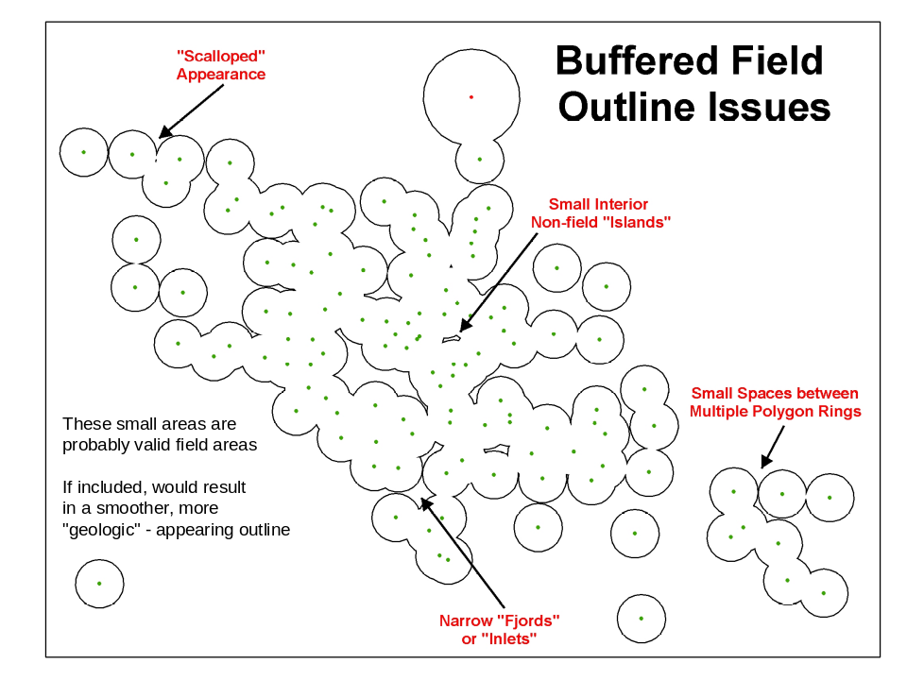

The smoothing application provided as VBA code below does the following:
- Adds area to the concave portions; doesn’t add area to convex portions to maintain buffer spacing
- Fills in non-field “islands” smaller than buffer size
- Joins separate polygon rings with a “bridge” if sufficiently close
- Minimizes increase in total field area

Methodology: creates trapezoids between neighboring wells within an oil/gas field. Wells are considered neighbors if the distance between them is less than or equal to 2.5x the average of their radii (see figure below of “rules”).

Creates a new "smoothed" polygon feature class (FC) from the second layer in the map. The new FC is in the same workspace as the original FC, but with "_smu" suffix added to name.

The first layer must contain the well points originally used to create the unsmoothed field outlines (which are in the second layer).

The original polygon outline is used to optimize the "unioning" step. If a trapezoid falls entirely within the original field outline then it is omitted since it will not change the outline.

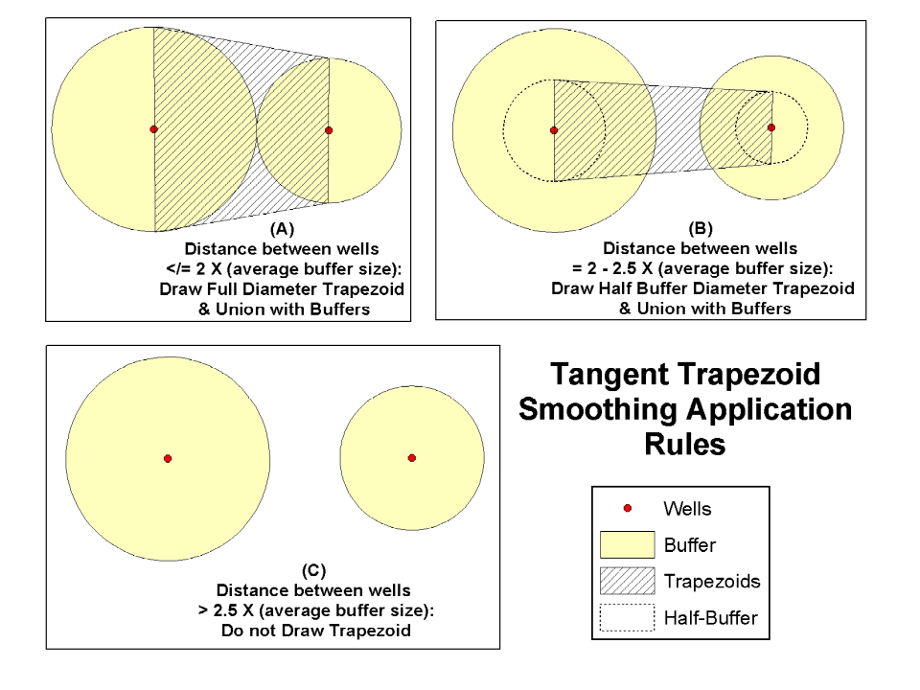

Results of smoothing application as applied to the unsmoothed above example:
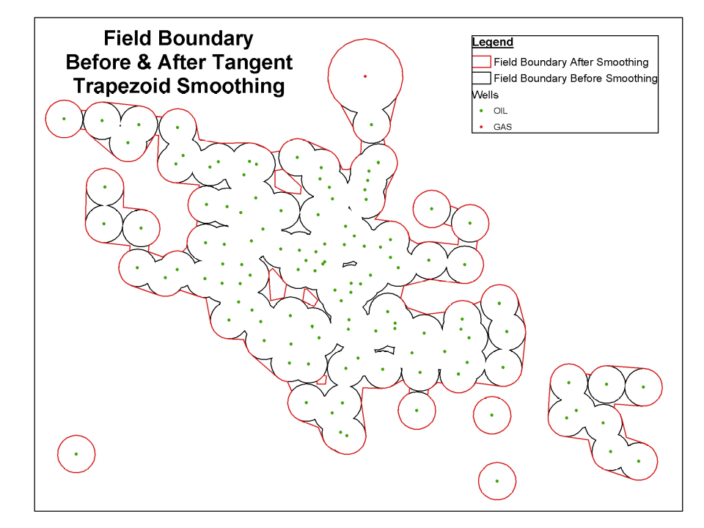

Copy the code into ThisDocument or a module.
Set up a UIControl button to run the code.

Inputs:
- Layer (0) is the well points used to make the field outline
- Layer (1) is unsmoothed buffered field outlines

Output: Smoothed outlines with suffix ”_smu” in the same workspace as unsmoothed outlines.

Code by Kirk Kuykendall, AmberGIS; text by Sam Limerick, Z, Inc.
==============================================================

Option Explicit
Private m_TC As ITrackCancel
Private Declare Function GetTickCount Lib "kernel32" () As Long
Sub Smooth()
'
' Creates a new "smoothed" polygon featureclass from the second
' layer in the TOC(which is an "unsmoothed" polygon)in the map.
' The new featureclass is created in the same workspace as the
' original featureclass, but with a "_smu" suffix. You can use
' shapefiles or GDB feature classes.
'
' The first layer in the TOC must contain the points originally used
' to create the unsmoothed polyon in layer 2(layer 2 created by buffering
' the points with a radius and unioning the resultant polygons).
'
' The approach involves creating trapezoids between neighboring
' wells. Wells are considered neighbors if the distance between
' them is less than or equal to 2.5x the average of their radii.
'
' The original polygon outline is used to optimize the "unioning"
' step. If a trapezoid falls entirely within the original field
' outline then it is omitted since it will not change the outline
' any.
'
' Watch the lower left corner task bar for some progress reports
' that the processing is indeed happening.
'
On Error GoTo EH
Dim pMxDoc As IMxDocument
Set pMxDoc = ThisDocument

Dim pMC As IMouseCursor
Set pMC = New MouseCursor
pMC.SetCursor 2

Dim lTicks As Long
lTicks = GetTickCount

' get the wells point layer
Dim pWellFLayer As IFeatureLayer
Set pWellFLayer = pMxDoc.FocusMap.Layer(0)
If pWellFLayer.FeatureClass.ShapeType <> esriGeometryPoint Then
MsgBox "first layer must be a point layer"
Exit Sub
End If

' make sure the required columns are present on the wells featureclass
Dim vFld As Variant
For Each vFld In Array("buffer", "field")
If pWellFLayer.FeatureClass.FindField(vFld) = -1 Then
MsgBox vFld & " column not found on " & pWellFLayer.Name
Exit Sub
End If
Next vFld

' get the layer with the unsmoothed field outlines
Dim pBufferLayer As IFeatureLayer
Set pBufferLayer = pMxDoc.FocusMap.Layer(1)
If pBufferLayer.FeatureClass.ShapeType <> esriGeometryPolygon Then
MsgBox "second layer must be a polygon layer"
Exit Sub
End If

' make sure the required columns are present on the field outline
' featureclass.
For Each vFld In Array("field")
If pBufferLayer.FeatureClass.FindField(vFld) = -1 Then
MsgBox vFld & " column not found on " & pBufferLayer.Name
Exit Sub
End If
Next vFld

' if there are selected field outlines, then just process those,
' otherwise process all features in the unsmoothed layer.
Dim pInFCur As IFeatureCursor
Dim pFSel As IFeatureSelection
Set pFSel = pBufferLayer
If pFSel.SelectionSet.Count = 0 Then
Set pInFCur = pBufferLayer.FeatureClass.Search(Nothing, False)
Else
pFSel.SelectionSet.Search Nothing, False, pInFCur
End If

' create a new featureclass that has same columns as the unsmoothed
' featureclass, overwriting it if it already exists.
' (also adds a "PctChange" field)
Dim pOutFC As IFeatureClass
Set pOutFC = CreateFC(pBufferLayer.FeatureClass, _
pBufferLayer.FeatureClass.AliasName & "_smu")

If pOutFC Is Nothing Then
MsgBox "no output featureclass created"
Exit Sub
End If
If pOutFC.FindField("PctChange") = -1 Then
MsgBox "new featureclass is missing PctChange field"
Exit Sub
End If

Set m_TC = New CancelTracker
m_TC.CancelOnKeyPress = True

Dim pOutFCur As IFeatureCursor
Set pOutFCur = pOutFC.Insert(True)

Dim pBufferFeat As IFeature
Set pBufferFeat = pInFCur.NextFeature
Do Until pBufferFeat Is Nothing
' put the name of the field being processed in the caption, that
' way if there is a crash, we can select that field and
' step through the program and debug it more easily.
Application.Caption = pBufferFeat.Value(pInFCur.FindField("field"))

' make a smoothed field outline using the unsmoothed outline
' plus the wells belonging to the oilfield.
Dim pFieldOutline As IPolygon
Set pFieldOutline = MakeFieldOutline(pWellFLayer.FeatureClass, _
pBufferFeat)
If Not m_TC.Continue Then Exit Do
If Not pFieldOutline Is Nothing Then

' compute percent change
Dim dPctChange As Double
dPctChange = GetArea(pFieldOutline) / GetArea(pBufferFeat.Shape)

Dim pFeatBuff As IFeatureBuffer
Set pFeatBuff = pOutFC.CreateFeatureBuffer
Set pFeatBuff.Shape = pFieldOutline
' copy all column values
CopyColumns pFeatBuff, pBufferFeat

' moved to avoid problems if pctchange is present in original featclass
pFeatBuff.Value(pFeatBuff.Fields.FindField("PctChange")) = dPctChange
pOutFCur.InsertFeature pFeatBuff
Else
Debug.Print "nothing written for field " & _
pBufferFeat.Value(pBufferFeat.Fields.FindField("Field"))
End If
Set pBufferFeat = pInFCur.NextFeature
Loop
pOutFCur.Flush

If m_TC.Continue Then
' wake up the user
Beep
Application.Caption = ""
lTicks = GetTickCount - lTicks
MsgBox "Done seconds = " & lTicks / 1000
Else
MsgBox "canceled"
End If
Set m_TC = Nothing
Exit Sub
EH:
MsgBox "error in Smooth: " & Err.Description & ", " & Err.Number
Set m_TC = Nothing
End Sub

Function MakeFieldOutline(pWellFC As IFeatureClass, _
pBufferFeat As IFeature) As IPolygon
On Error GoTo EH
Dim sField As String
sField = pBufferFeat.Value(pBufferFeat.Fields.FindField("Field"))

Dim sWhere As String
sWhere = "field = '" & sField & "'"

Dim cSubFieldIDs As Collection
Set cSubFieldIDs = GetSubFields(pWellFC, sWhere)

Dim l As Long
Dim pOutPolygon As IPolygon
For l = 1 To cSubFieldIDs.Count
Dim pPolygon As IPolygon
Set pPolygon = MakeSubFieldOutline(pWellFC, pBufferFeat, sField, cSubFieldIDs.Item(l))
If pOutPolygon Is Nothing Then
Set pOutPolygon = pPolygon
Else
Dim pTopoOp As ITopologicalOperator
Set pTopoOp = pOutPolygon
Set pOutPolygon = pTopoOp.Union(pPolygon)
End If
If Not m_TC.Continue Then Exit Function
Next l
Set MakeFieldOutline = pOutPolygon
Exit Function
EH:
MsgBox "error in MakeFieldOutlines: " & Err.Description & ", " & Err.Number
End Function

Function GetSubFields(pWellFC As IFeatureClass, sWhere As String) As Collection
'
' return a collection of unique subField ID values.
'
Dim pOutColl As Collection
Set pOutColl = New Collection

Dim lFld As Long
lFld = pWellFC.FindField("SubField")
If lFld = -1 Then
' no subfield column so just add one id (0)
pOutColl.Add -1
Set GetSubFields = pOutColl
Exit Function
End If

Dim pQF As IQueryFilter
Set pQF = New QueryFilter
pQF.WhereClause = sWhere
Dim pFCur As IFeatureCursor
Set pFCur = pWellFC.Search(pQF, False)
Dim pDict As Scripting.Dictionary
Set pDict = New Dictionary

Dim pFeat As IFeature
Set pFeat = pFCur.NextFeature
Do Until pFeat Is Nothing
Dim lSubFieldID As Long
lSubFieldID = pFeat.Value(lFld)
If pDict.Exists(lSubFieldID) Then
pDict.Item(lSubFieldID) = pDict.Item(lSubFieldID) + 1
Else
pDict.Add lSubFieldID, 1
End If

Set pFeat = pFCur.NextFeature
Loop
Dim vID As Variant
For Each vID In pDict.Keys
pOutColl.Add vID
Next
Set GetSubFields = pOutColl
End Function

Function MakeSubFieldOutline(pWellFC As IFeatureClass, _
pBufferFeat As IFeature, _
ByVal sOilFieldName As String, _
ByVal lSubFieldID As Long) As IPolygon
'
' union more trapezoids with pBufferFeat.Shape to and
' return the unioned polygon. Such that the trapezoids are formed
' by pairs of neighboring wells.

' find max buffer radius
On Error GoTo EH
Dim sWhere As String
If lSubFieldID > -1 Then
sWhere = "field = '" & sOilFieldName & "' and Subfield = " & lSubFieldID
Else
sWhere = "field = '" & sOilFieldName & "'"
End If

Debug.Print "finding all wells " & sWhere

' make a hashtable of radii keyed by OID, and maxradius
Dim dMaxRadius As Double
Dim pRadiusDict As Scripting.Dictionary
GetRadii pWellFC, sWhere, pRadiusDict, dMaxRadius
If dMaxRadius < 0 Then Exit Function
If Not m_TC.Continue Then Exit Function

Dim lFld As Long
lFld = pWellFC.FindField("buffer")

Dim pPntDict As Scripting.Dictionary
Set pPntDict = LoadDictionary(pWellFC, sWhere)

' Its called a matrix since it can be thought of as a symmetric binary
' sparse matrix.

' populate pOIDDict with potential neighbors, later we will cull some
' of the neighbors.
Dim pOIDDict As Scripting.Dictionary
Set pOIDDict = MakeMatrix(pRadiusDict, dMaxRadius, pWellFC, sWhere, pPntDict)
If Not m_TC.Continue Then Exit Function

' make a collection of trapezoids based on neighbor relationships
' defined in the matrix. Trapezoids contained entirely within the old
' unsmoothed outline are tossed.
Dim cTrapezoids As Collection
Set cTrapezoids = MakeTrapezoids2(pPntDict, pOIDDict, pRadiusDict, _
pWellFC, sWhere, pBufferFeat.ShapeCopy)
If Not m_TC.Continue Then Exit Function

Debug.Print cTrapezoids.Count & " trapezoids created"
' union the collection of trapezoids with the original field outline
' and return that geometry
Set MakeSubFieldOutline = UnionTrapezoids(cTrapezoids, _
pBufferFeat.ShapeCopy)
Exit Function
EH:
MsgBox "error in MakeFieldOutlines: " & Err.Description & ", " & Err.Number
End Function

Sub GetRadii(pFC As IFeatureClass, ByVal sWhere As String, _
ByRef pDict As Scripting.Dictionary, _
ByRef dMaxRadius As Double)
'
' fill up pDict with radii from the featureclass's "buffer" field
'
' (return the max radius also.)
On Error GoTo EH
dMaxRadius = -1
Set pDict = New Scripting.Dictionary

Dim pQF As IQueryFilter
Set pQF = New QueryFilter
pQF.WhereClause = sWhere
Dim lFld As Long
lFld = pFC.FindField("buffer")
If lFld = -1 Then
MsgBox "GetMaxRadius cannot find buffer column"
Exit Sub
End If
Dim pFCur As IFeatureCursor
Set pFCur = pFC.Search(pQF, True)
Dim pFeat As IFeature
Set pFeat = pFCur.NextFeature
Do Until pFeat Is Nothing
Dim dRadius As Double
' convert feet to meters
dRadius = pFeat.Value(lFld) * 0.3048
If dRadius > dMaxRadius Then
dMaxRadius = dRadius
End If
If Not m_TC.Continue Then Exit Sub
pDict.Add pFeat.OID, dRadius
Set pFeat = pFCur.NextFeature
Loop
Exit Sub
EH:
MsgBox "error in GetRadii: " & Err.Description & ", " & Err.Number
End Sub

Function MakeMatrix(ByVal pRadiusDict As Scripting.Dictionary, _
ByVal dMaxRadius As Double, _
ByVal pFC As IFeatureClass, _
ByVal sWhere As String, _
ByRef pPntDict As Scripting.Dictionary) As Scripting.Dictionary
'
' populate pOIDDict keys of OIDs and list of
' features that are within dMaxRadius
' also populate pPntDict with the points
Dim pOIDDict As Scripting.Dictionary
Set pOIDDict = New Scripting.Dictionary

'
' e.g. pOIDDict.Item(22) might contain "32,34,25" which
' means that features whose oids are 32,34 and 25 are within
' 2.5x avgradius of feature whose OID is 22.
'

' pRadiusDict is already populated and used as a lookup
' table for finding radii.
'
On Error GoTo EH
Dim pQF As IQueryFilter
Set pQF = New QueryFilter
pQF.WhereClause = sWhere

Dim lFld As Long
lFld = pFC.FindField("buffer")
If lFld = -1 Then
MsgBox "makematrix cannot find buffer column"
Exit Function
End If
Dim pFeatIndex As IFeatureIndex2
Set pFeatIndex = New FeatureIndex
Set pFeatIndex.FeatureClass = pFC
Set pFeatIndex.FeatureCursor = pFC.Search(pQF, False)
Application.StatusBar.Message(0) = "indexing " & pFC.AliasName
pFeatIndex.Index Nothing, GetExtent(pFC)
Dim pIQ As IIndexQuery2
Set pIQ = pFeatIndex
Application.StatusBar.ShowProgressBar "building matrix", 0, _
pRadiusDict.Count, 1, True
Application.StatusBar.ProgressBar.Position = 0

Set pOIDDict = New Scripting.Dictionary
Set pPntDict = LoadDictionary(pFC, sWhere)

Dim pFCur As IFeatureCursor
Set pFCur = pFC.Search(pQF, False)
Dim pFeat As IFeature
Set pFeat = pFCur.NextFeature
Do Until pFeat Is Nothing
Dim pTopoOp As ITopologicalOperator
Set pTopoOp = pFeat.Shape

Dim pPoint1 As IPoint
Set pPoint1 = pFeat.Shape

Dim dRad1 As Double
dRad1 = pRadiusDict.Item(pFeat.OID)
Dim c As Collection
Set c = New Collection

Dim vOIDs As Variant
pIQ.IntersectedFeatures pTopoOp.Buffer(dMaxRadius * 3#), vOIDs
Dim vOID As Variant
For Each vOID In vOIDs
Dim pPoint2 As IPoint
Set pPoint2 = pPntDict.Item(vOID)

Dim dRad2 As Double
dRad2 = pRadiusDict.Item(vOID)
Dim dAvgRadius As Double
dAvgRadius = (dRad1 + dRad2) / 2#

Dim dist As Double
dist = GetDist(pPoint1, pPoint2)
If dist <= (3# * dAvgRadius) And vOID <> pFeat.OID Then
c.Add vOID
End If
Next vOID

pOIDDict.Add pFeat.OID, c
' Debug.Print pFeat.OID & " has " & c.Count & " neighbors"
Application.StatusBar.ProgressBar.Step
If Not m_TC.Continue Then Exit Function
Set pFeat = pFCur.NextFeature
Loop
Application.StatusBar.HideProgressBar
Debug.Print pPntDict.Count & " points in memory"
Set MakeMatrix = pOIDDict
Exit Function
EH:
MsgBox "error in MakeMatrix: " & Err.Description & ", " & Err.Number
End Function

Function LoadDictionary(pFC As IFeatureClass, sWhere As String) As Scripting.Dictionary
Dim pPntDict As Scripting.Dictionary
Set pPntDict = New Scripting.Dictionary
Dim pQF As IQueryFilter
Set pQF = New QueryFilter
pQF.WhereClause = sWhere

Dim pFCur As IFeatureCursor
Set pFCur = pFC.Search(pQF, False)

Dim pFeat As IFeature
Set pFeat = pFCur.NextFeature
Do Until pFeat Is Nothing
pPntDict.Add pFeat.OID, pFeat.ShapeCopy
Set pFeat = pFCur.NextFeature
Loop
Set LoadDictionary = pPntDict
End Function

Function MakeTrapezoids2(ByVal pPntDict As Scripting.Dictionary, _
ByVal pOIDDict As Scripting.Dictionary, _
ByVal pRadiusDict As Scripting.Dictionary, _
ByVal pFC As IFeatureClass, _
ByVal sWhere As String, _
ByVal pPolygon As IPolygon) As Collection
'
' returns a collection of trapezoids that fill in the gaps between
' closely neighboring wells.
'
'
' create trapezoids based on the matrix (pOIDDict)
' which describes what OIDs are near other OIDs
'
Simplify pPolygon

' pFC is the wells featureclass.

' Create a spatial index that allows us to more quickly determine
' if a trapezoid falls completely within pPolygon, in which case
' we can omit it.
Dim pSpatialIndex As ISpatialIndex
Set pSpatialIndex = pPolygon
pSpatialIndex.AllowIndexing = True
pSpatialIndex.Invalidate
Dim pRelOp As IRelationalOperator
Set pRelOp = pSpatialIndex

On Error GoTo EH
Set MakeTrapezoids2 = New Collection
Application.StatusBar.ShowProgressBar "making trapezoids", 0, _
pPntDict.Count, 1, True
Application.StatusBar.ProgressBar.Position = 0

Dim pQF As IQueryFilter
Set pQF = New QueryFilter
pQF.WhereClause = sWhere
Dim pFCur As IFeatureCursor, pFeat As IFeature
Set pFCur = pFC.Search(pQF, False)
' loop through each well point
Set pFeat = pFCur.NextFeature
Do Until pFeat Is Nothing
Dim pPoint1 As IPoint
Set pPoint1 = pPntDict.Item(pFeat.OID)
Dim dRadius1 As Double
dRadius1 = pRadiusDict.Item(pFeat.OID)

Dim cNeighbors As Collection
Set cNeighbors = pOIDDict.Item(pFeat.OID)
' Debug.Print pFeat.OID & " has " & cNeighbors.Count & " neighbors"
If pFeat.OID = 80 Then
Debug.Print "ok"
End If
Dim l As Long
For l = 1 To cNeighbors.Count
Dim lOID As Long
lOID = cNeighbors.Item(l)
If lOID > pFeat.OID Then
Dim pTrapezoid As IPolygon
Set pTrapezoid = _
MakeTrapezoid3(pPntDict.Item(pFeat.OID), pRadiusDict.Item(pFeat.OID), _
pPntDict.Item(lOID), pRadiusDict.Item(lOID))
If Not pTrapezoid Is Nothing Then
If Not pRelOp.Contains(pTrapezoid.Envelope) Then
If Not pRelOp.Contains(pTrapezoid) Then
Application.StatusBar.ProgressBar.Message = _
"making trapezoids (" & MakeTrapezoids2.Count & ")"
' add the trapezoid to the collection for later use.
MakeTrapezoids2.Add pTrapezoid
End If
Else
'Debug.Print "skipping "
' the trapezoid falls completely within the original
' field outline, so there's no need to keep it.
End If
End If
Else
' its a symmetric matrix, so don't worry about
' this half (otherwise duplicates would be created
End If
If Not m_TC.Continue Then Exit Function
Next l
Application.StatusBar.ProgressBar.Step
Set pFeat = pFCur.NextFeature
Loop
Application.StatusBar.HideProgressBar
Exit Function
EH:
MsgBox "error in MakeTrapezoids2: " & Err.Description & ", " & Err.Number
End Function

Function MakeTrapezoid3(pPoint1 As IPoint, dRadius1 As Double, _
pPoint2 As IPoint, dRadius2 As Double) As IPolygon
'
' Makes a trapezoid that connects two wells, based on how close
' they need to be.
'
Dim pOutTrapezoid As IPolygon
Set pOutTrapezoid = Nothing

Dim dAvgRadius As Double
dAvgRadius = (dRadius1 + dRadius2) / 2#
Dim dDist As Double
dDist = GetDist(pPoint1, pPoint2)
' Jack says:
' "How about using the full diameter trapezoid for all
' pairs with < =2 distance and the ½ for all
' from >2 to 2.5. So those buffers that overlap or touch
' would get a tangent from the full diameter and those
' that are separated (but <= 2.5) would get a 'neck'
' based on a smaller circle (radii)."
If dDist < (dAvgRadius * 2.5) And dDist > 0# Then
Dim pTrapezoid As IPolygon
Dim dRadiusFactor As Double
If dDist > (2# * dAvgRadius) Then
dRadiusFactor = 0.5
Else
dRadiusFactor = 1#
End If

' make a trapezoid based on the two points and the radii
Set pTrapezoid = MakeTrapezoid(pPoint1, dRadiusFactor * dRadius1, _
pPoint2, dRadiusFactor * dRadius2)
Simplify pTrapezoid
Set pOutTrapezoid = pTrapezoid
Else
' the two points are close, but not close enough
' no trapezoid created
End If
Set MakeTrapezoid3 = pOutTrapezoid
End Function

'Function UnionTrapezoids(cTrapezoids As Collection, _
' pPolygon As IPolygon) As IPolygon
' On Error GoTo EH
' Dim pWSF As IWorkspaceFactory
' Set pWSF = New FileGDBWorkspaceFactory
'
' Dim pFWS As IFeatureWorkspace
' Set pFWS = pWSF.OpenFromFile("C:\Projects\EIA\Kirk_Smooth3\Scratch.gdb", 0)
'
' Dim pDS As IDataset
' On Error Resume Next
' Set pDS = pFWS.OpenFeatureClass("Trapezoids")
' If Err.Number = 0 Then
' pDS.Delete
' End If
' Err.Clear
' On Error GoTo EH
'
' Dim pFlds As IFieldsEdit
' Set pFlds = New esrigeodatabase.Fields
' pFlds.AddField MakeField("ObjectID", esriFieldTypeOID)
' pFlds.AddField m_outFC.Fields.Field(m_outFC.FindField(m_outFC.ShapeFieldName))
'
' Dim pFC As IFeatureClass
' Set pFC = pFWS.CreateFeatureClass("Trapezoids", pFlds, m_outFC.CLSID, Nothing, esriFTSimple, "Shape", "")
'
' Dim pFCur As IFeatureCursor
' Set pFCur = pFC.Insert(False)
'
' Dim l As Long
' For l = 1 To cTrapezoids.Count
' Dim pFBuff As IFeatureBuffer
' Set pFBuff = pFC.CreateFeatureBuffer
' Set pFBuff.Shape = cTrapezoids.Item(l)
' pFCur.InsertFeature pFBuff
' Next l
' pFCur.Flush
' Exit Function
'EH:
' MsgBox "error in UnionTrapezoids: " & Err.Description & ", " & Err.Number
'End Function

Function UnionTrapezoids(cTrapezoids As Collection, _
pPolygon As IPolygon) As IPolygon
On Error GoTo EH
Application.StatusBar.ShowProgressBar "unioning trapezoids", 0, _
cTrapezoids.Count, 1, True
Application.StatusBar.ProgressBar.Position = 0

' ITopologicalOperator.Union was found to raise an error
' occasionally, so the code below relies on a workaround.
'
' The workaround involves keeping a list of bad trapezoids and
' also a backup polygon. When a trapezoid causes an error, it
' is added to the list and processing starts over at the last
' savepoint.
'
Simplify pPolygon
Dim pBackup As IPolygon
Set pBackup = Clone(pPolygon)

Dim pBadOnes As New Scripting.Dictionary

Dim pTopoOp As ITopologicalOperator
Set pTopoOp = Clone(pPolygon)
Dim l As Long
l = 1
Dim lBackupID As Long
lBackupID = 1
Do While l < cTrapezoids.Count + 1

Dim pTrapezoid As IPolygon
Set pTrapezoid = cTrapezoids.Item(l)
If pBadOnes.Exists(l) Then
Debug.Print "moving bad trapezoid" & l & _
" attempt " & pBadOnes.Item(l)
Dim pTrans2D As ITransform2D
Set pTrans2D = pTrapezoid
' move 10 centimeters
pTrans2D.Move 0.1, 0.1
End If

On Error Resume Next
Set pTopoOp = pTopoOp.Union(pTrapezoid)
If Err.Number = 0 Then
l = l + 1
' every 100 steps make a backup
If l Mod 100 = 0 Then
Set pBackup = Clone(pTopoOp)
lBackupID = l
Debug.Print l
End If
Application.StatusBar.ProgressBar.Step
Else
Application.StatusBar.ProgressBar.Message = _
"errorcount: " & pBadOnes.Count
If Not pBadOnes.Exists(l) Then
pBadOnes.Add l, 1
Else
' a repeat offender !
Debug.Print "repeat offender encountered"
pBadOnes.Item(l) = pBadOnes.Item(l) + 1
End If
l = lBackupID
Set pTopoOp = pBackup
Application.StatusBar.ProgressBar.Position = l
End If
If Not m_TC.Continue Then Exit Function
On Error GoTo EH
Loop
Application.StatusBar.HideProgressBar
Set UnionTrapezoids = pTopoOp
Exit Function
EH:
MsgBox "error in UnionTrapezoids: " & Err.Description & ", " & Err.Number
End Function

Function GetExtent(pGDS As IGeoDataset) As IEnvelope
Set GetExtent = pGDS.Extent
End Function

Function GetDist(pProxOp As IProximityOperator, pGeom As IGeometry) As Double
Dim pPCS As IProjectedCoordinateSystem
Set pPCS = pGeom.SpatialReference
Dim d As Double
d = pProxOp.ReturnDistance(pGeom) * pPCS.CoordinateUnit.MetersPerUnit

GetDist = d
End Function

Function MakeTrapezoid(pPoint1 As IPoint, dDist1 As Double, _
pPoint2 As IPoint, dDist2 As Double) As IPointCollection
On Error GoTo EH

' create a new polygon based on points and distances
Set MakeTrapezoid = New Polygon

Dim pLine As ILine
Set pLine = New esriGeometry.Line
pLine.PutCoords pPoint1, pPoint2

Dim pCPoint As IConstructPoint, dDist As Double

Set pCPoint = New Point
pCPoint.ConstructOffset pLine, esriNoExtension, 0#, True, dDist1
MakeTrapezoid.AddPoint pCPoint
pCPoint.ConstructOffset pLine, esriNoExtension, 1#, True, dDist2
MakeTrapezoid.AddPoint pCPoint
pCPoint.ConstructOffset pLine, esriNoExtension, 1#, True, -dDist2
MakeTrapezoid.AddPoint pCPoint
pCPoint.ConstructOffset pLine, esriNoExtension, 0#, True, -dDist1
MakeTrapezoid.AddPoint pCPoint

Exit Function
EH:
MsgBox "error in MakeTrapezoid: " & Err.Description & ", " & Err.Number
End Function

Sub Simplify(pTopoOp2 As ITopologicalOperator2)
pTopoOp2.IsKnownSimple = False
pTopoOp2.Simplify
End Sub

Function Clone(pClone As IClone) As IClone
Set Clone = pClone.Clone
End Function

Function GetArea(pArea As IArea) As Double
GetArea = pArea.Area
End Function

Sub CopyColumns(pFBuff As IFeatureBuffer, pInFeat As IFeature)
' copy all field values from pInFeat to pFBuff based
' on field names. Skip the geometry and non-editable fields
Dim lOutFld As Long
For lOutFld = 0 To pFBuff.Fields.FieldCount - 1
If pFBuff.Fields.Field(lOutFld).Editable Then
If pFBuff.Fields.Field(lOutFld).Type _
<> esriFieldTypeGeometry Then
Dim lInFld As Long
lInFld = pInFeat.Fields. _
FindField(pFBuff.Fields.Field(lOutFld).Name)
If lInFld > -1 Then
pFBuff.Value(lOutFld) = pInFeat.Value(lInFld)
End If
End If
End If
Next lOutFld
End Sub

Function MakeField(sName As String, lType As esriFieldType, _
Optional lLen As Long) As esrigeodatabase.IField
' make a new field
Dim pFldEdit As IFieldEdit
Set pFldEdit = New esrigeodatabase.Field
pFldEdit.Name = sName
pFldEdit.Type = lType
If lLen > 0 Then
pFldEdit.Length = lLen
End If
Set MakeField = pFldEdit
End Function

Function CreateFC(pInFC As IFeatureClass, sName As String) As IFeatureClass
'
' create a featureclass identical to pInFC and in the
' same workspace as pInFC, but named sName
'
Dim pFWS As IFeatureWorkspace
Set pFWS = GetWS(pInFC)
Dim pDS As IDataset
On Error Resume Next
Set pDS = pFWS.OpenFeatureClass(sName)
If Err.Number = 0 Then
Debug.Print "deleting " & pDS.Name
pDS.Delete
Else
Err.Clear
End If
On Error GoTo EH

Dim pFldsEdit As IFieldsEdit
Set pFldsEdit = Clone(pInFC.Fields)
If pInFC.FindField("PctChange") = -1 Then
pFldsEdit.AddField MakeField("PctChange", esriFieldTypeDouble)
End If

Set CreateFC = pFWS.CreateFeatureClass(sName, pFldsEdit, _
pInFC.CLSID, Nothing, _
esriFTSimple, _
pInFC.ShapeFieldName, "")
Exit Function
EH:
MsgBox "error in CreateFC: " & Err.Description & ", " & Err.Number
End Function

Function GetWS(pDS As IDataset) As IWorkspace
Set GetWS = pDS.Workspace
End Function

