Source-Sink Inversions
Jaime Ashander, Collin Edwards, Kathy Hughes, and Kailin Kroetz
Final Paper 200a

Introduction
Changes to the amount, type, or quality of habitat can impact the population dynamics of species in the habitat. In this paper we investigate one potential consequence of habitat disturbance: a source-sink inversion. We begin by defining a source-sink inversion and outlining potential causes. We develop motivation for blue tits as a case study for theoretical modeling. We develop a “strategic” model that aims to describe the qualitative dynamics behind source-sink inversions. Finally, through simulations we explore the conditions that result in a source-sink inversion.

Source-Sink Inversions
Pulliam (1996) proposed a theoretical model called a “source-sink” model to describe how populations respond to habitat heterogeneity. Heterogeneity in habitat type enters a Pulliam-type model in terms of habitat quality (e.g. good versus bad). But in the real world, quality can vary based on habitat type (e.g. deciduous oak vs. evergreen oak). This leads to a source-sink model where heterogeneity in habitat type drives source-sink dynamics. The source is the higher quality habitat, or the habitat to which the majority of the species are adapted. In the source habitat the average replacement rate is greater than one, i.e., the population is more than able to replace itself. Sinks, on the other hand, have replacement rates less than one and cannot persist on their own. In the typical source-sink model individuals disperse from the source habitats to the sink habitats.

Source-sink inversions happen when the former sink becomes a source, and the former source becomes a sink. Inversions can occur over varying time scales. Johnson (2004) suggests that an inversion can occur slowly at an evolutionary time scale, or on a very short time scale due to rapidly fluctuating environmental factors. The causes of inversions are linked to the time frames over which the inversion occurs, and can also vary. Donahue, Holyoak, and Feng (2003) identify five potential causes of source sink inversion:

- Succession leading to habitat quality/type changes (Pulliam 1996);
- Habitat degradation (Doak 1995);
- Transition of psuedosinks to sources (Boughton 1999);
- Changes in relative frequency of source and sink populations and subsequent adaptation (Dias 1996); and
- Transfer (subsidy) of resource (e.g. prey, detritus, or nutrients) from one habitat to the other.
There are few documented examples of source-sinks inversions. The two commonly cited inversions are the blue tit inversion (described in the following section), and a pseudo-sink inversion in butterfly populations identified by Boughton (1999). Boughton (1999) found that colonization of source patches by the butterflies is sensitive to frost. In particular, early frosts occurred in the source patches inhibiting the ability for occupying butterflies to reproduce. The former source patches were then recolonized by members of the former pseudo-sinks. Thus the former pseudo-sink had become a source.

Blue Tit Case-Study
Around 7500 BP, forests on the island of Corsica were predominantly comprised of deciduous oaks. However, the evergreen holm oak invaded in 3000-4000 BP and now comprises almost half of the broad-leaved trees on the island. During this time there is thought to have been a source-sink inversion (Dias 1996) in which the blue tit (Parus caeruleus) population became adapted to the evergreen forest and maladapted to the remaining small patches of deciduous forest on the island of Corsica.

The mainland near Corsica is still predominately comprised of deciduous oaks and contains some evergreen oak areas, providing a point of comparison for the dynamics occurring on Corsica. Previous studies have shown differences in the breeding biology of blue tits between mainland (deciduous) and Corsican (evergreen) populations. Blue tits in evergreen habitats delay laying eggs one month later than those in the deciduous habitat, which appears to correspond with the delay in the leafing out of the trees (Blondel et al 1993). In addition, the peak in abundance of the blue tits’ primary food source in this region, caterpillars, is roughly one month later in the Corsican evergreen habitat (Blondel et al 1993). Therefore there appears to be a matching of breeding and egg laying times for both habitats. Further research has found a genetic basis for the differences in blue tit laying dates between the mainland (deciduous) population and the Corsican (evergreen) population (Blondel et al 1990).

Dias and Blondel (1996) argue that source-sink dynamics are functioning in both regions, maintaining maladapted populations in the less common habitat type. The sinks are maintained via gene flow from the source populations, resulting in a mismatch of breeding and egg-laying times in the sink habitat thereby preventing utilization of peak food availability. Since Corsica was historically comprised mostly of deciduous oaks, a plausible explanation for the current pattern is a shift in specialization from the deciduous habitat to the evergreen habitat.

We use this system as the motivation for our source-sink inversion model in an effort to answer the question, as asked by Dias and Blondel (1996), “at which threshold of frequency of habitat types and population sizes will the selection regime shift from specialization to one habitat type to specialization to the other type?”

Model
We develop a model inspired by blue tits living in two habitat types, deciduous (D) and evergreen (E) woodlands. In developing this model, our aim is not to exhaustively describe the biology underlying this system, but rather to qualitatively capture the dynamics behind source-sink inversions. Our model population includes individuals that are better adapted to deciduous as well as individuals better adapted to evergreen. The habitat types have different areas, which translate to different carrying capacities: K_{D} for deciduous and K_{E} for evergreen. See Table 1 for a summary of notation.

In accordance with our goal of developing a qualitative model, we make simplifying assumptions about genetics and demography. In particular, we assume haploid genetics underlie adaptation to either deciduous or evergreen woodland. We also assume blue tits are semelparous and that offspring produced in each generation are pooled and then randomly re-distributed into the habitats. We assume that an ideal despotic distribution where the offspring distribute themselves preferentially into “source” habitat before filling “sink” habitat. The definitions of source and sink used in distributing offspring, however, must be relative to the genetics of the population. We choose to define the source relative to the average adaptedness of the population, i.e., when the frequency of the d allele in dispersers exceeds 0.5, (p′ > 0.5) then deciduous habitat is the preferred habitat.

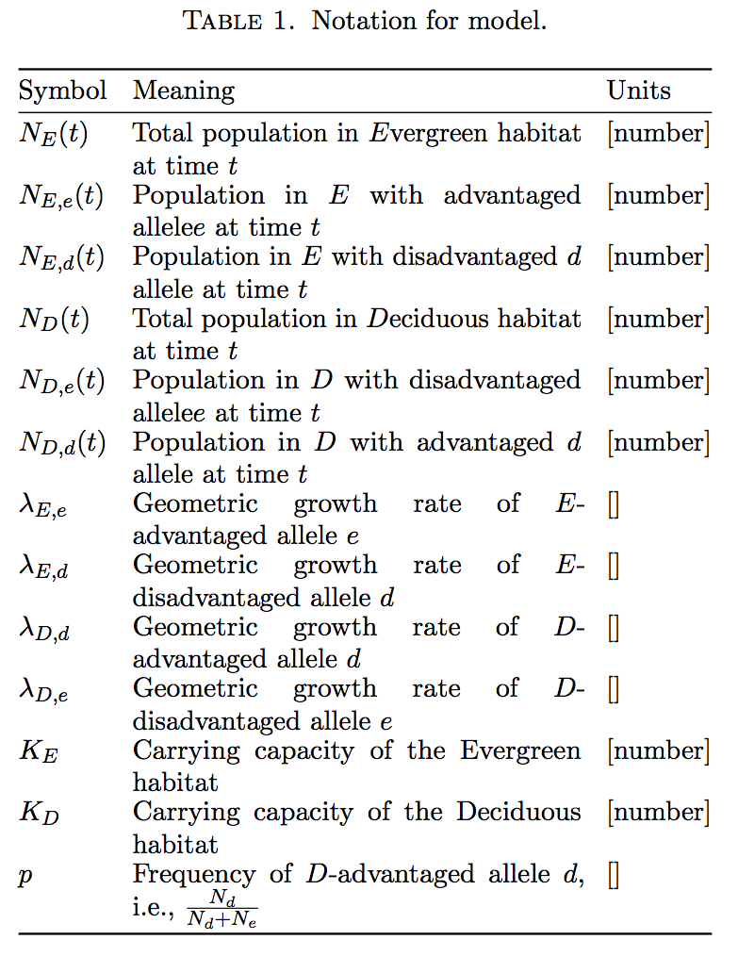
These assumptions allow us to define the number of offspring of each genotype from reproduction across all habitats as given in Equations (1a) and (1b). Furthermore, we define dispersal (the number of offspring distributed to each habitat type in the next generation) in Equations (2a), (2b), (3a), and (3b).
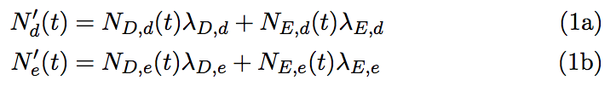
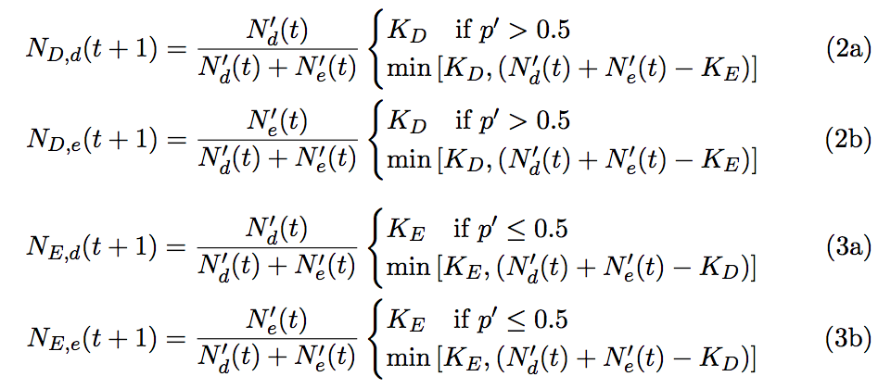
We are now able to explore the source-sink dynamics. We define “net import” and “export” by looking at proportions of dispersers relative to available habitat. The ratio of dispersers originating from deciduous habitat to those coming from evergreen habitat is given in Equation (4).
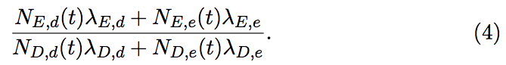
By comparing this ratio to the ratio of habitat available, i.e. K_{E}/K_{D}, we define the source-sink criterion in Equation (5).
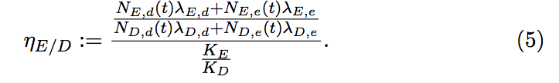
By this definition, when η_{E/D} > 1, deciduous habitat is a source and when η_{E/D} < 1, deciduous habitat is a sink. Accordingly, our criterion for inversion is a crossing of the line η_{E/D} = 1.

Simulation
To simulate our model we defined two patches and two genotypes. We assume that each genotype has an average geometric growth rate that exceeds unity in its adapted habitat type, and is less than unity in the other type of habitat. This means that the favored patch for one genotype is the unfavored patch for the other genotype.

We simulate stepwise operations of reproduction (Equations (1a) and (1b)). We then combine the offspring into the common offspring pool. Dispersal is simulated such that the patch that favors the more common genotype is filled first, and then the second patch is filled (Equations (2a), (2b), (3a), and (3b)). Finally, we record the relative frequency of the two genotypes, and calculate η_{E/D} as a means of defining inversions. Simulations were conducted in R (R Core Development Team 2005). Code is available (https://github.com/ashander/ss-inversion).

Results
Transient Dynamics
For given habitat sizes K_{D} and K_{E}, the long-run status of deciduous and evergreen habitat is classified as either a source or sink based on the geometric growth rates of the various genotypes. The model (1) and (2) displays transient dynamics as shown in Figure 1, eventually equilibrating to a value dependent on the habitat sizes and geometric growth rates. As shown, transient dynamics from certain initial conditions may result in an “inversion” in time before equilibration (dotted line).

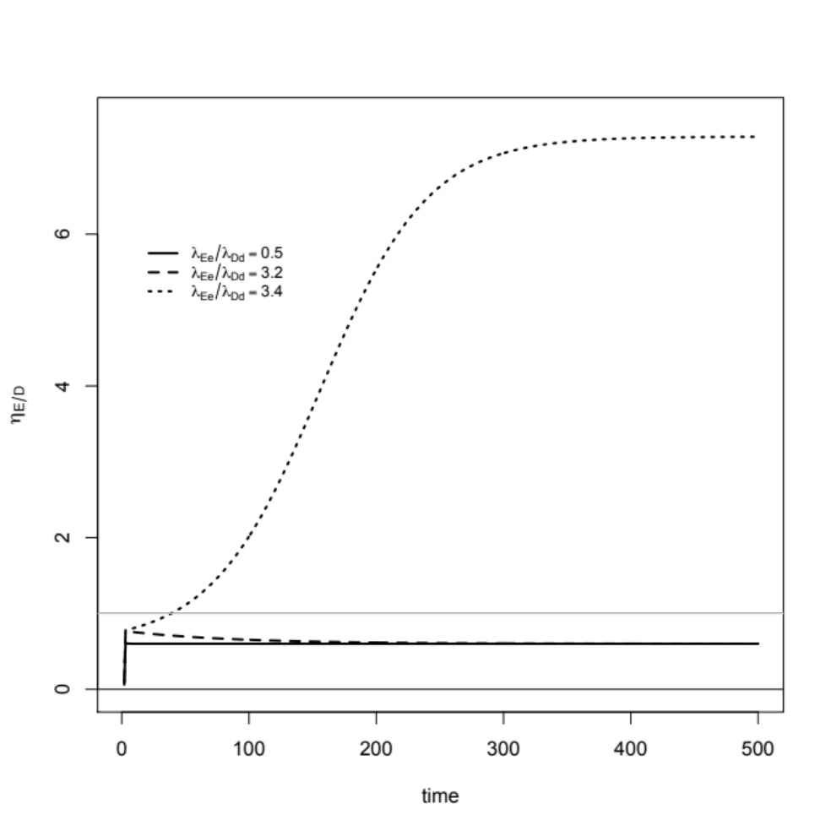
Figure 1: The source-sink criterion η_{E/D} plotted against time (generations) for various ratios of geometric growth rates of deciduous-advantaged to evergreen-advantaged populations. Parameters were K_{E} = 100, K_{D} = 200, λ_{Dd} = 1.5, λ_{Dd} = .7, λ_{Ed}=.9, and with λ_{Ee} as given by the ratios printed in the legend. The initial proportion of d alleles was fixed at 10%. The gray line is η_{E/D} = 1.

“Equilibrium” Dynamics

Changes in the ratio of habitat sizes, KE/KD, can alter the expected equilibrium outcome of the system for given geometric growth rates of the various genotypes. Thus, changes in the ratio of habitat sizes that are slow relative to the genetic-demographic dynamics of model (1) and (2) can result in an inversion. This effect is shown in Figure 2, which demonstrates that the source-sink criterion after 100 generations is a non-linear function of the ratio of habitats KE/KD. At a critical value of this ratio, an inversion occurs (demonstrated by crossing of the line η_{E/D} = 1).

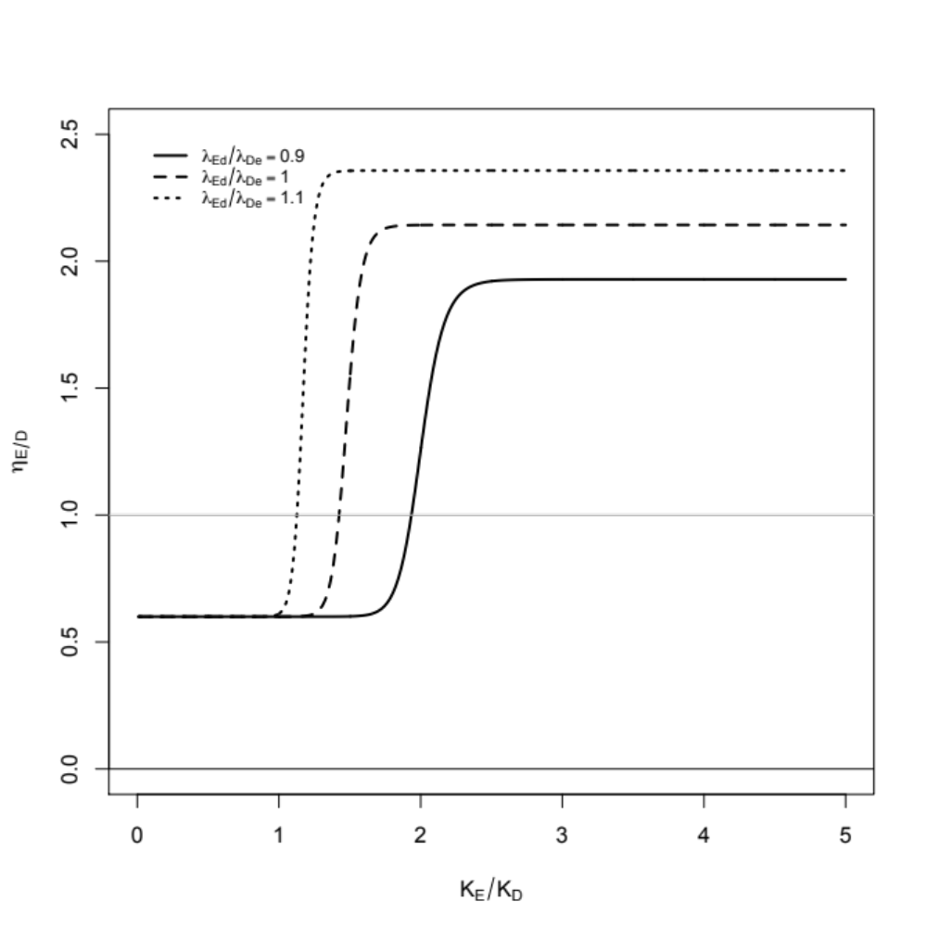
Figure 2: The source-sink criterion η_{E/D} (at generation 100) plotted against the ratio in habitat-type sizes for deciduous to evergreen habitat for various ratios of geometric growth rates of deciduous-advantaged to evergreen-advantaged populations. Size of evergreen was fixed at K_{E} = 100 and deciduous K_{D} was varied from 10 to 5000. Geometric growth rates were fixed at λ_{Dd} = 1.5, λ_{Dd} = .7, λ_{Ed}=.9, and with λ_{De} as given by the ratios printed in the legend. The initial proportion of d alleles was fixed at 10% and dynamics were run for 100 generations, at which time invasion criterion was determined. The gray line is η_{E/D} = 1.

Conclusion

Our model demonstrates source-sink inversion behavior with changes in the ratio of habitat type. Thus, as a formerly less-common habitat type becomes the dominant habitat type, the subpopulations in the less-common habitat switch from sinks to sources (vice versa for those subpopulations in the other habitat type). This occurs as the frequencies of individuals adapted to the two habitats equilibrate relative to the frequencies of the habitats. In our model, this behavior relies critically on the existence of a fraction of the population that is initially better adapted to the less-common habitat type.

As our results demonstrate, the precise ratio of habitat types at which inversion occurs (Figure 2) depends on the geometric growth rates of the various genotypes. Our method of simulation did not find the actual equilibrium value of this "critical ratio" at which inversion occurs. The demonstration of inversion with changing habitat ratio (Figure 2) combined with the result that equilibrium value of the source-sink criterion depends on geometric growth rates of the various genotypes (Figure 1), indicates the possibility of bi-stability in this system. An analytical study would be needed to fully explore this possibility.

Our model and results support the notion that a source sink-inversion could explain the historical shift in blue tit adaptation from deciduous oak to evergreen oak woodlands in the blue tit population on the island of Corsica. This possible inversion would have occurred as evergreens invaded Corsica and shifted the ratio of evergreen to deciduous habitat. This shift in habitat could have selected on standing variation or a beneficial mutation in the blue tit population, and eventually changed the sink evergreen habitat to source habitat.

Next Steps
The model we presented in this paper makes a number of simplifying assumptions, and our exploration of model dynamics was limited to simulation studies. In principle, the model dynamics could be understood by analytical means as well. For example, solving for equilibria might permit an analytical determination of the relationship between the ratio of habitat sizes and source-sink inversion. Such analysis, however, might not be useful in a model of such limited realism. Further a full analytical treatment would be difficult due to the dispersal model.

There are numerous ways to add realism to our model and allow for better understanding of the drivers of source-sink inversion in the blue tit case:
- Limit the degree of migration. In the current model all individuals are dispersed from a common pool. We think it would be useful to add the option that some individuals born in a patch necessarily remaining in the patch.
- Include more realistic demography, e.g. iteroparity.
- Extend the model to diploid populations.
- Calibrate the model to actual population parameters.
- Test the sensitivity of the model results to the parameters.
- Describe the timing mis-match hypothesized in blue tits as a quantitative trait.

References
Blondel J., Perret P., and M. Maistre. 1990. On the genetical basis of laying date in an island population of Blue Tit. Journal of Evolutionary Biology 3: 469-475.

Blondel J., Dias P.C., and M. Maistre. 1993. Habitat heterogeneity and life history variation of Mediterranean Tits. Auk 110: 511-520.

Boughton, D. A. 1999. Empirical Evidence for Complex Source-Sink Dynamics with Alternative States in a Butterfly Metapopulation. Ecology 80:2727-2739.
Dias, P.C. 1996. Sources and sinks in population biology. Trends in Ecology & Evolution 11, no. 8: 326–330.

Dias, P.C. and J. Blondel. 1996. Local specialization and maladaptation in the Mediterranean blue tit (Parus caeruleus). Oecologia 107: 79-86.

Donahue, M.J., Holyoak, M. & C. Feng. 2003. Patterns of Dispersal and Dynamics among Habitat Patches Varying in Quality. The American Naturalist, Vol. 162, No. 3 (Sep., 2003), pp. 302-317.
Doak, D. F. 1995. Source-sink models and the problem of habitat degradation: general models and applications to the Yellowstone grizzly. Conservation Biology 9: 1370-1379.
Johnson, D. M. 2004. Source-sink dynamics in a temporally heterogeneous environment. Ecology 85:2037–2045.

Polis, G. A., W. B. Anderson, and R. D. Holt. 1997. Toward an integration of landscape and food web ecology: the dynamics of spatially subsidized food webs. Annual Re-view of Ecology and Systematics 28:289-316.
Pulliam, H.R. 1996. Sources and sinks: empirical evidence and population consequences. Pages 45-69 in O. E. Rhodes, Jr., R. K. Chesser, and M. H. Smith, eds. Population dynamics in ecological space and time. University of Chicago Press, Chicago.

R Development Core Team (2005). R: A language and environment for statistical computing, reference index version 2.11.1. R Foundation for Statistical Computing, Vienna, Austria. ISBN 3-900051-07-0, URL http://www.R-project.org.

A true sink is unable to replace itself and therefore cannot exist on its own. A pseudo-sink appears to be a sink in that it accepts migrants and has a population above its carrying capacity. However, a pseudo-sink can actually sustain itself and exist on its own (at lower levels than the observed levels when in-migration occurs).

