**A Project On**

**Access Control System**

**in**

**Century Rayon**

**(under the Management & Operation of Grasim Industries Ltd.)**

**A Summer Intern Report**

Submitted by

**Ashutosh Nayan Dhondkar**

**Studying**

**In**

**S.I.E.S.**

**Graduate School Of**

**Technology, Nerul**



**Affiliated to**

**Mumbai University**

**Introduction**

Century Rayon is one of the finest industry in India. Century Textiles and Industries is a textile ,cement ,paper manufacturing and export company based in Mumbai. The main business involves manufacturing of Cotton textiles ,yarn ,denim ,viscose filament rayon yarn ,tire-cords ,caustic soda ,Sulphuric Acid , Salts ,cement ,pulp and paper. The company also has a substantial dominance in international textile market and exports its product to almost 45 countries across the world . Also the Government of India has awarded it with “*Three Star Export House*” status.

**History**

* The company established as Century Textile Limited in 1897 and listed on BSE with its registered office in Mumbai.
* The company operated only one cotton textile mill till 1951 in Mumbai.
* In 1956 the company began its Rayon division in Kalyan, near Mumbai to manufacture Viscose Filament Rayon Yarn.
* The Company started its cement production by establishing it’s first cement plant at Baikunth , near Raipur in 1974.
* Due to increase in operating cost, the Company stopped it’s production in Mumbai in 2006.
* The new plant in Jhagadia became functional in 2009 with the name
* ‘Birla Century’ and is producing only finer fabrics in 100% cotton fabrics.
* The company has it’s exclusive showrooms in Mumbai, Delhi, Jaipur, Kota, Ahmedabad, etc.

|  |  |
| --- | --- |
| **Century Textile and Industries Ltd** | |
| [Centlogo.jpg](https://en.wikipedia.org/wiki/File:Centlogo.jpg) | |
| Type | **Public company (**[**BSE**](https://en.wikipedia.org/wiki/Bombay_Stock_Exchange)**:**[**500040**](https://www.bseindia.com/stock-share-price/x/y/500040/)[**NSE**](https://en.wikipedia.org/wiki/National_Stock_Exchange_of_India)**:**[**[1]**](https://www.nseindia.com/live_market/dynaContent/live_watch/get_quote/GetQuote.jsp?symbol=)**)** |
| Industry | **Textiles, Cement & Paper** |
| Founded | **1897** |
| Headquarters | [**Mumbai**](https://en.wikipedia.org/wiki/Mumbai)**, Maharashtra, India** |
| Key people | **Mr.**[**B. K. Birla**](https://en.wikipedia.org/wiki/B._K._Birla)**, Chairman,**[**Kumar Mangalam Birla**](https://en.wikipedia.org/wiki/Kumar_Mangalam_Birla)**,**[**AGM**](https://en.wikipedia.org/wiki/Assistant_general_manager)**RK Dalmia, president** |
| Products | **fabrics, designer wear, denim, cosmetics & toiletries, engineering files & tools, prophylactics and air charter services** |
| Revenue | **Increase45,431.8 million(US$680 million) (2009–2010)** |
| Net Income | **Increase3,394.7 million(US$51 million) (2009–2010)** |
| Parent | **Birla Group** |
| Subsidiaries | [**Birla Century**](https://en.wikipedia.org/w/index.php?title=Birla_Century&action=edit&redlink=1) |
| Website | **http://www.centuryrayon.co.in/** |

**Preface**

**Century Rayon** is one of the leading producers of Rayon in this competitive world of industries.

The topic which I have selected for my internship project is:

**Access Control System in Centruy Rayon,Shahad**

**Disciplinary actions taken by the Company for worker’s entry into Company :-**

* The company blacklists the workers who do not follow the norms of Company.
* The blacklisted worker is not allowed to enter in Company’s premises.
* The blacklisted worker then have to submit the written application for whatever reasons he was not able to follow Company’s norms.
* If the reason is valid then he is given warning and allowed entry in Company.
* But if the reason is not valid then he is blocked for some days depending on the mistake he has performed.

**ACKNOWLEDGEMENT**

I have taken efforts in this project. However it would not have been possible without SIES Graduate School of Technology’s kind help and support. I would like to extend my sincere thanks to **The Principal of SIES Graduate School of Technology - Mr. Vikram Patil** Sir for granting me permission to do internship in my vacation period. I am highly indebted to **Century Rayon** for their guidance and constant supervision and providing me the necessary information related to my project. I would like to express my gratitude towards my **parents and members of Century Rayon** for their kind co-operation and encouragement which helped me in completion of this project. I would like to express special gratitude and thanks to industry persons for giving me such attention and time**. I would also like to thanks Mr. Bhalchandra Bhoir and other related people for explaining me the Access Control System in Century Rayon, Shahad.**

**CENTURY RAYON**



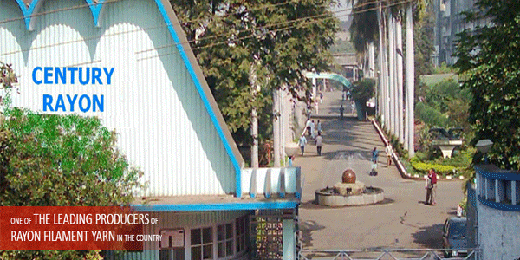

**Company Profile**

Recently, in terms of agreement signed between the Board of Directors of Century Textiles and Industries Limited( a flagship company of Mr. B.K.Birla Group) and Grasim Industries Limited(one of the major group companies of Aditya Birla Group), the management and operation of Century Rayonhad been given to Grasim Industries Limited for a period of 15 years beginning from 1st February,2018 or such other earlier date as defined in the agreement.

By virtue of this agreement Century Rayon, a leading player in Viscose Filament Yarn Business in India is now under the Management and Operation of Grasim Industries Limited belonging to Aditya Birla Group(ABG).

The group has diversified interest in textile,cement, metals, carbon black, financial services, insurance, chemicals, fertilizers, insulators and telelophony,etc.

Century Rayon contributes to the Viscose Filament Yarn(VFY) business in the group and has the distinct of being the largest producers of the product in India.

**LIST OF DEPARTMENT**

1. Personnel and Administration.
2. Accounts and Finance.
3. Purchase and Stores.
4. Gardening and Civil.
5. Total Quality Management
6. Safety
7. Management Information System
8. Production and Maintenance.

**Rayon Division**

1. Viscose (Production & Maintenance)
2. Spin Bath (Production & Maintenance)
3. Spinning (Production & Maintenance)
4. After Treatment (Production & Maintenance)
5. Textile (Production & Maintenance)
6. Laboratory

**Tyre Cord Division**

1. Viscose (Production & Maintenance)
2. Spin Bath (Production & Maintenance)
3. Spinning (Production & Maintenance)
4. Textile (Production & Maintenance)
5. Laboratory

**Auxiliary**

1. CS2 (Production & Maintenance)
2. H2so4 (Production & Maintenance)
3. ETP (Production & Maintenance)

**Chemicals**

**Power House (Production & Maintenance)**

**Water Plant**

**Pilot Plant**

**Biometric Attendance System**

* Biometric attendance system has brought more precise system to measure the individual’s activities and attendance as well.
* Biometric attendance machine captures your unique biological or physical feature such as hand or finger print, iris pattern and sometimes even your voice as a record for identity verification and allows you to perform something that you are authorized to do.
* Biometric time attendance machines also count employee’s work schedule, like what he did and at what time he do it, etc.
* Biometric System is a full proof technology to ensure the accuracy of attendance and is useful to the ones who deal with large number of employees.

***How biometric System actually works?***

* Biometric fingerprint scanner works effectively and quickly.
* For fingerprint identification process, a biometric system works on two basic principles :

1. First it takes the image of the finger.
2. Then finger scanner saves specific characteristics of every unique finger and saves it in the form of biometric encrypt key

* Actually fingerprint scanner never saves images of a finger only series of binary code for verification purpose as shown in figure.

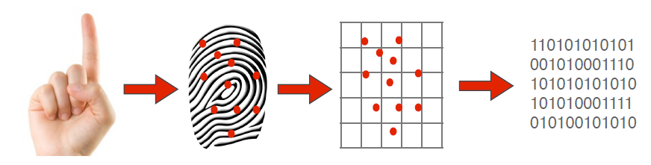

* No one can change the algorithm into an image so it is totally impossible to duplicate your fingerprints so no need to worry about it.
* Secondly the biometric attendance system determines whether the pattern of ridges and valleys in the image matches matches the pattern of ridges and valleys in pre-scanned images.
* So now fingerprint scanner is operational and you can easily manage employee’s attendance and every aspect related to time.

**Advantages of using Biometric System**

1. Installation system of biometric attendance system is easy.
2. Biometric time attendance system works very quickly and it’s user interface is also very friendly.
3. Accuracy rate of biometric attendance system is very high.
4. No one can fake or create replica of your finger prints.
5. Attendance by biometric finger scanner is fast process and it hardly takes 1 to 5 seconds only.
6. Attendance by biometric scanner gives you always accurate data record.
7. Biometric attendance system can easily reject an unauthorized person within no time.
8. Companies with the help of biometric attendance system can check worker clock in and clock out time.
9. System helps you to control labour cost by reducing over payments.
10. You don’t need to calculate separately vacation, sick leaves and extra timing hours.