Q7 What is the percentage growth of state given internet and computer as amenities print result in descending order of percentage growth and sum of internet and computer in the state?

ANS:

WITH cte1  
     AS (SELECT state_code,  
                i,  
                c,  
                ( i + c ) AS sum_u  
         FROM   (SELECT state_code,  
                        *Sum*(households_with_internet) AS i,  
                        *Sum*(households_with_computer) AS c  
                 FROM   utilities  
                 GROUP  BY ( state_code )  
                 ORDER  BY state_code)t)  
SELECT s.state_name,  
       sum_u                    AS sum_internet_computer,  
       *Round*(sum_u * 100 / t.s) AS total_growth_percentage  
FROM   cte1 c  
       CROSS JOIN (SELECT *Sum*(sum_u) AS s  
                   FROM   cte1) t  
       JOIN state s  
         ON c.state_code = s.state_code  
ORDER  BY sum_internet_computer DESC,  
          total_growth_percentage DESC

Output:

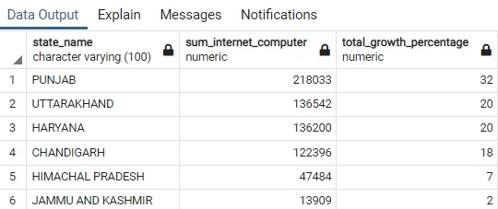

Q8 What is total population of male and female in country?

SELECT *Sum*(total_male_in_district)   AS total_male_in_country,  
       *Sum*(total_female_in_district) AS total_female_in_country  
FROM   (SELECT d.district_code,  
               *Sum*(male)   AS total_male_in_district,  
               *Sum*(female) AS total_female_in_district  
        FROM   district d  
               JOIN population po  
                 ON d.district_code = po.district_code  
        GROUP  BY d.district_code  
        ORDER  BY d.district_code)t

Output:

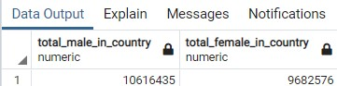

Q9 What is state wise number of total agricultural workers and total Cultivator workers in descending order of sum of all the agricultural and cultivator ?

SELECT s.state_name,  
       *Sum*(agricultural_workers) AS total_agriculture_worker_in_state,  
       *Sum*(cultivator_workers)   AS total_cultivator_workers  
FROM   profession ps  
       JOIN state s  
         ON ps.state_code = s.state_code  
GROUP  BY s.state_name  
ORDER  BY total_cultivator_workers DESC,  
          total_agriculture_worker_in_state DESC

Output:

