Q7

WITH cte1  
     AS (SELECT state_code,  
                i,  
                c,  
                ( i + c ) AS sum_u  
         FROM   (SELECT state_code,  
                        *Sum*(households_with_internet) AS i,  
                        *Sum*(households_with_computer) AS c  
                 FROM   utilities  
                 GROUP  BY ( state_code )  
                 ORDER  BY state_code)t)  
SELECT state_code,  
       sum_u,  
       sum_u * 100 / t.s AS total  
FROM   cte1  
       CROSS JOIN (SELECT *Sum*(sum_u) AS s  
                   FROM   cte1) t

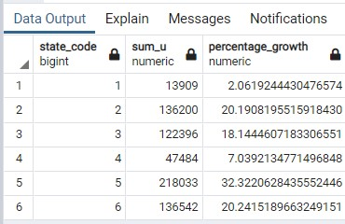

Q8

SELECT *Sum*(total_male_in_district)   AS total_male_in_country,  
       *Sum*(total_female_in_district) AS total_female_in_country  
FROM   (SELECT d.district_code,  
               *Sum*(male)   AS total_male_in_district,  
               *Sum*(female) AS total_female_in_district  
        FROM   district d  
               JOIN population po  
                 ON d.district_code = po.district_code  
        GROUP  BY d.district_code  
        ORDER  BY d.district_code)t

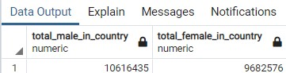

Q9

SELECT s.state_code,  
       *Sum*(agricultural_workers) AS total_agriculture_worker_in_state,  
       *Sum*(cultivator_workers)   AS total_cultivator_workers  
FROM   profession ps  
       JOIN state s  
         ON ps.state_code = s.state_code  
GROUP  BY s.state_code  
ORDER  BY s.state_code

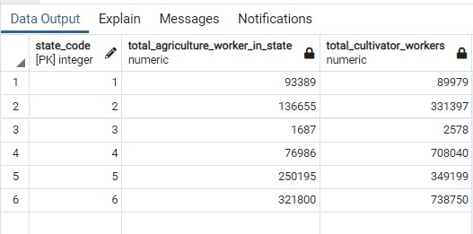

Q7 Extra same as Q7 just total sum of household according to state

SELECT s.state_code,  
       *Sum*(households_with_internet) AS total_internet_in_state,  
       *Sum*(households_with_computer) AS total_computer_in_state  
FROM   utilities u  
       JOIN state s  
         ON u.state_code = s.state_code  
GROUP  BY s.state_code  
ORDER  BY s.state_code

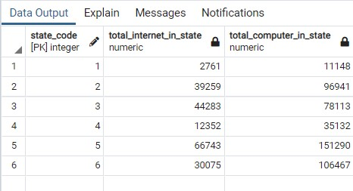

Q8 Extra same as q8 just total given by district

SELECT d.district_code,  
       *Sum*(male)   AS total_male_in_district,  
       *Sum*(female) AS total_female_in_district  
FROM   district d  
       JOIN population po  
         ON d.district_code = po.district_code  
GROUP  BY d.district_code  
ORDER  BY d.district_code

