CONTENTS AT A GLANCE

An introduction …………………09-12
  - Background……………………………………………10
  - Objective……………………………………………11
  - Purpose & Scope ………………………….12
    - Purpose
    - Scope

Survey of Technologies………………………….13-16
2.1. Java
2.2. NetBeans
2.3 My SQL

Requirements and Analysis …………………………..17-36
  - Problem Definition………………………17-18
    - Post Office Service
    - Fax Service
    - Telephone Service
    - E-mailing Service
  - Requirement Specification……………………...19-22
    - A Server Computer
    - Client Computers
    - JVM
    - Network Environment
    - Interface Requirement
    - User Requirement
  - Project Planning and Scheduling…………………23-25
    - Objectives
    - Specific Product to be Delivered
    - Activities and Milestones
      - Activities
    - Resource Required
    - Scheduling
      - Gantt Chart
      - Pert Chart
  - Software and Hardware Requirements………26-29
  - Preliminary Product Description …………..…30
  - Conceptual Models…………………………….31-36
    - DFD
      - Context Level DFD
      - 1- Level DFD
    - ER- diagram
    - Data Dictionary

Future Scope and Further Enhancement of the Project…...37

References ………………………………………………38

- An introduction

This project brings forth current methods and techniques used in the Requirement Specification of information systems. The highlight here has been the use of various models to define: system scope, domain analysis, functional behavior and object definition & design.

The problem in building information systems is dealing with the balance between Clients design and a Server design. Designing / building the Clients and designing / building the Server are often treated as separate processes. In this project we explore how these two sides of the coin can be coordinated. Also emphasis has been given to managing software project. A strict vigilance on time schedules and estimations is followed to mitigate time overrun for development and deployment. To accomplish the objectives, I have attempted to create a reasonably sized application consisting of a Server and Clients. There is also a database used to store the information of Clients which are designed using an ‘Entity-Relationship’ approach. The application has be built using the Data Flow Diagram (DFD).

A chat server allows its user to transfer real time text between two or more computers. The Chat Server application is used for sending messages from one client to other clients. In this, server takes a message from clients. If any client wants to join the chatting then he enters the login name and hits the login button and start chatting with every client. If any client joins the chatting system then the message “username has logged in” comes on the message list box of every client window. Same like this if any client exit from the chatting then the message “username has logged out” comes on the message list box of the client window.

  - Background

Today, we are living in modern age, where Information technology giving a major rolls in development. If a person is seating in India and want to read a book from a library of America then he can do quickly with just a click of mouse. If a person wants to talk with his friend, who is abroad then easily can talk with mobile phone or with teleconferencing system. Like these systems, I am proposing a system “Chat Server” which will help to communicate two or more than two persons at a time. Computers & communication combines to give Information Technology (IT), by which the information becomes far more efficient. This more efficient use of information can affect society & management. IT is one of the most pervasive technologies, & hence, has affects on practically everything we do.

Let us consider the affects of IT on our Industries. Computers have made a direct impact on our industries concern, as computer has become an integral part of this system. In fact it has revolutionized the management of industries. Computers have remarkable capabilities of storing, processing, & transmitting information & thus it has transformed the traditional manual ways of management into automated one, which is based on the concept of co-ordination.

The basic idea behind the development of this project was to develop an attitude towards computerization & the benefits so derived. In this approach, we have identified three distinct computer initiatives, which we have tried to incorporate into this project.
The project Chat Server has been developed on the basis of “Client- Server Architecture”.

1.2. Objective

The basic idea of developing of the project Chat Server is to create a portal where a person and communicate with another person by their computers if these are in network (LAN or WAN). The project Chat Server has been developed on the basis of “Client- Server Architecture”. There will be a Server and a number of Clients. When two persons want to communicate to each other using this system them they have to use client application both sides. When a client sends any message to another client then message will go to another client via Server. The main object of the proposed system Chat Server is pointed bellow…

- Develop a Swing based application which can be used by any one easily around the world.
- Develop an application, which license will be public and open source.
- Develop an application which can connect two peoples who are far from each other.
- Develop an application through which communication can be made with real time text transfer.
- Save the money which is used to invest on phone.
- Provide a better system than e-mail system.
- Develop a Chat Server and Client using Socket in java.

1.3. Purpose & Scope

1.3.1. Purpose:-

The purpose to develop this application is not something special for any client but based on my personal passion of choosing any real life topic and to solve them using proposing a software system. The topic is related with the fast growing of information technology where people can communicate to each other without paying any type of money and the should be the fastest service in communication technology for transferring the text in real time . The main purpose is to connect people who are abroad and provide totally free service to communicate with real time text transfer system.

1.3.2. Scope:-

The scope of this Swing based application is related with the field of communication technology where two or more than two persons can communicate to each other any time transferring the real time text. The methodology used in the application makes easy chatting. Methodology of work is as- first login the client with a general information and then a portal will be displayed where client can see the list of already logged in users and can chat with any one by given text area where he can write the text and send as a real time to the user.
The assumption made in the system is that the client has two types one is registered client and another is unregistered client. A registered client can login the system using login id and password while unregistered user have to fill all the general information every time when he want to chat using this system. The main function of this application is to give customer facilities such as online registration and using further this system with login id and password. This application can be used by a company or organization also because it can be run on the LAN also and makes secure communication within the organization.

- Survey of Technologies

The proposed system Chat Server is a network based application which can be run an LAN, MAN or WAN. This Chat Server application is totally swing based and using internally the concept of Socket programming. For this I have chosen JAVA technology to develop this application which is the best and robust technology of current time. I have selected a database technology also in this project to store the records of registered users and provide security to the system. So, for this purpose I have chosen My SQL as a backend because My SQL is also a powerful database provided by Sun Microsystems totally free. For developing the application I have selected an environment NetBeans IDE which is also a free ware and a powerful technology for developing Swing based, Web based and Mobile based applications easily and quick with an interactive and GUI environment. There are given bellow the details of all the used technology in my proposed system Chat Server …

  - Java

Java is the most popular, general purpose, object oriented, programming language developed by Sun Microsystems of USA in 1991. Java technology was developed as a computer programming tool in a small, secret effort called “the Green Project” at Sun Microsystems. The secret (Green Team) team fully staffed at 13 people and led by James Gosling, locked themselves away in an anonymous office on Sand Hill Road in Menlo Park, but off all regular communications with Sun, and worked around the clock for 18 months. The java platform is the ideal platform for network computing. Running across all the platforms from Servers to Cell Phone to Smart Cards. Java technology unifies business infrastructure to create a seamless, secure, networked platform for our business. We can find Java technology in cell phone, on laptop computers, on the Web and even trackside at Formula One Grand Prix races. The fact is today, we can find Java Technology everywhere. Java is an Object Oriented programming language. Swing of Java provides fastest & easiest way to create application for Windows platform, whether we are an experienced professional or amateurs in windows programming. Swing provides us with a complete set of tools to simplify rapid application development.
Whether our goal is to create a small utility for our work group, a large enterprise wide system, or even distributed applications spanning the globe via Internet, Java has the tool we need.
JDBC APIs allow us to create database, front-end applications, & scalable server-side components for most popular database formats, including My SQL, Microsoft SQL Server, Oracle, Sybase, Microsoft Access & other components level databases.
We can even automate applications & objects created using the professional or enterprise edition of Java using J2EE.
Internet capabilities make it easy to provide access to documents & applications across the internet or intranet from within our application & also to create Internet server applications.
Our finished application is a true exe file that uses a Java Virtual Machine that we can freely distribute.

The Event-Driven Model

In traditional or ‘procedural’ applications, the application itself controls which portion of code to be executed & in what sequence. Execution starts with the first line of code & follows a predefined path through out the application, calling procedures as needed. In an event-driven application, the code doesn’t follow a predefined path. It executes different code sections in response to events. Events can be triggered on the source by the user’s action, by message from the system or other applications, or even from the application itself. The sequence of these events determines the sequence in which the code executes, thus the path through the applications code differs each time the program runs.

An Event-Driven Application Works

An event is an action recognized by a form or control. Event-Driven applications execute basic code in response to an event. Each from & control in Swing has a predefined set of events. If one of these events occurs, & there is code in associated Listeners, Java invokes that code.
The other region for choosing Java technology is that Java is totally free and can be downloaded from “http://www.sun.com".
I will use the following topics of Java in my proposed application Chat Sever…

- Multithreading
- AWT
- Swing
- Event Handling
- I/O Stream
- Collection
- Networking
- JDBC

  - NetBeans

NetBeans IDE is an integrated development environment (IDE) for writing, compiling, testing, and debugging desktop applications and web applications for the Java TM platform. NetBeans IDE includes a full-featured text editor with syntax highlighting and error checking, visual design tools, Ant support, version control system support, and many other features.
The other region for choosing NetBeans IDE is that NetBeans is totally free and can be downloaded from “http://www.sun.com".

  - My SQL

My SQL is powerful database and also free version, can be downloaded from “http://www.sun.com" with the bundle of NetBeans 6.1. Like all the databases My SQL also support SQL queries to insert, update & manage relational databases. SQL query is a query through which we can manage our data in database and also define and create data structure for storing our data in proper manner. We can use Structured Query Language to query, update & manage relational databases in My SQL like other databases support.
The other region for choosing My SQL database as backend is that My SQL is totally free and can be downloaded from “http://www.sun.com".

- Requirements and Analysis

  - Problem Definition

In the modern age where all the persons making communications to each other either they are stay out of city, out of state or out of country. Our communication technology is growing fast and fast to connect the people. In this there are many types of technology and services used to communicate such as Post Office Service, Telephone Service, Fax Service, E-mailing system etc. But in this there is not any service which can connect two people as a real time system in which they can communicate with written text, image, audio and video at same time. Each of the available services described below…

    - Post Office Service

This is the our oldest service which provide making communication peoples through letters. But if we want to send information to a person who is abroad then if we are using this service then it can be taken minimum two or three days in arriving the information by letter. In this case suppose an event happened and want to inform immediate that person then can not be done.
So, Post Office service is not reliable to make communication immediately.

    - Fax Service

Fax service is also used to send information. But through Fax we can send only text format data. Fax service is faster than post office service. Using Fax machine we can send our text to another Fax machine and the destination Fax machine will print out the matter. Thus we can receive information. But using Fax service the receiver can not receive soft copy of data. We can not send soft copy. Using Fax service we can not send images, audio and video file.

    - Telephone Service

Telephone Service is good for real time communication and more reliable also. But through Telephone we can talk means that only audio type data can be send but Text, Image and Video all are cannot be sent at the same time. Telephone Service is very costly. So, if we want to make communication for a long time then it will be very costly.

3.1.4. E-mailing Service:-

E-mailing service is also good and reliable but through this service we can not communicate in real time. We can send all things text, audio, images and video but not in real time. If we send any type of data using this system then data goes in the mailbox of the receiver end as a mail. When receiver end user opens their mailbox then he will get the mail. After receiving he can reply. But if we want at the same receiver receives the data and send back reply also as in real time system then it can not be done by using this service.

  - Requirements Specification

Requirement analysis of this application is done in this way so we emphasize on all the requirements regarding Chatting, like User Requirement, Interface Requirement, Hardware & Software Requirement and Database Requirements.
The system Chat Server is totally network based. There is not any benefit if this system if we run Chat Server and Clients on the same computer but can be run, there will be not any problem to run, but there will not a live things which is my target to connect the people who are at different- different location can communicate by my proposed system Chat Server without paying of charge to anyone. So, there will be need a LAN, MAN or WAN environment to run this application. There is listing bellow all the requirements of the system…

    - A Server Computer

There must be a need of a server computer. I am not required any special type of server to run my application because Server for my application Chat Server developed by me also. There will be need of only a good hardware configured PC and an operating system. There is not any boundation of operating system also because this application will be platform independent. There can be used any Windows operating system, Linux operating system, Mac operating system or Sun Solaris operating system to run this application but all should be JVM enabled. On the Server computer the Server application the project will be run.

    - Client Computers

Computers for client application should be two or more than two computers. Both client computers run the client application and communicate to each other via Server. Such as given in the figure…

Server

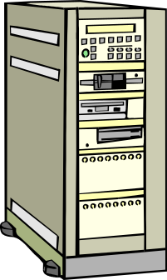

Client1
Client2


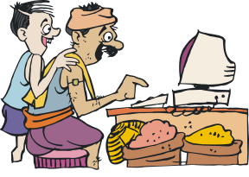

Figure: Connecting the Clients with the Server.

3.2.3. JVM

There must be the need of JVM (Java Virtual Machine) because all the java application can run only in JVM container. Generally all the operating systems have Java Virtual Machine. If they not have then easily can be downloaded from the site “http://www.sun.com” and installed in the operating system.

3.2.4. Network Environment

There should be network environment to connect computers each other because the application Chat Server is totally network based. Network may be any kind LAN, MAN or WAN.

3.2.5. Interface Requirement

Interface Requirements includes the following:

- Easy to follow, more interactive and user friendly.
- Few amounts of graphics should be used as possible.
- No hidden buttons.
- There must be facility for relevant message and alerts.

3.2.6. User Requirement

In this application, there are two types of user…

- Unregistered User: - This user can use this without registration also but some necessary information has to fill every time when he will use this system. There will be provided a link to make registration if he wants then can register to him for life time in the system.

- Registered User: - The Registered user can quickly login in the system with the entering of their provided username and password only.

  - Project Planning and Scheduling

As we know that the project planning is the one of the main crucial issue in the development cycle of any project. In this phase we plan all the issues related to project such as Objectives, Specific product to be delivered, Activities & milestones, Resource needed to achieve the goals, Proper Scheduling using various scheduling techniques available and budgetary estimate of the project

    - Objectives

In the planning objective is related with to achieve the system objective. The objective of the system is related with the objective discussed above in earlier topics.

    - Specific Product to be Delivered

The specific product that will be delivered may be summarized as follows-
- The tested system and network.
- The Server
- The client workstations.
- A robust database management server to manage database.
- Any other third party software such as various web browsers, JDK, JRE etc. (if needed).

    - Activities and Milestones

      - Activities:- The activities in the system, after including the provisions for security are as follows-
- The verification of the registered users (at both side of login).
- The Validation and verification of form field data during Registration of the new User.
- The Validation and verification of form field data during unregistered user using this system.
- When a User Name already exists then the dialog information is shown to user for avoid duplicate user.
- The data validation and the database handling.
- Transferring the information from one end to another end.
- The session validation of user that is currently login for chatting.
- The information gathering by users.
- The various navigations discussed above earlier.

    - Scheduling

Scheduling is the one of the most important process in project development. The two techniques Gantt Chart and PERT chart for the system is as-

      - Gantt Chart:- An alternate planning and scheduling tool

GANTT chart definitions and symbols
- The Gantt chart is a simple bar chart.
- Each bar represents a project task.
- Task has the same meaning in both PERT and Gantt chart.
- On a Gantt chart, the horizontal axis represents time. Because Gantt charts are used to schedule tasks, the horizontal axis should include dates.
- The tasks are listed vertically in the left-hand column.
- Gantt charts clearly depict the overlap of scheduled tasks.

The complete Gantt chart will be produced in Project Report.

.
      - Pert Chart: - Will be produced in Project Report.

  - Software and Hardware Requirements

ABSTRACT

Front End : Java (Swing)

Back End : My SQL

Platform : Microsoft Windows XP sp2

Hardware Specification for Developing the Application:

CPU: P4 class processor or above.

RAM: 1 GB

Hard Disk (free space): 30 GB

Display Device: VGA Monitor

Input Device: Keyboard, Mouse

Network Device: Hub/ Switch

Software Specification for Developing the Application:

Programming Language: Java

Tool: JDK 1.6

Compiler: javac

Run Time Environment: Java Virtual Machine

IDE: NetBeans6.1

Database: My SQL

Operating System: MS XP SP2

Documentation Tools: MS Office 2003, Corel Draw 12

Hardware Requirements for Running the Application:

Server:

CPU: P4 class processor or above.

RAM: 256 MB

Hard Disk (free space): 20 GB

Display Device: VGA Monitor

Input Device: Keyboard, Mouse

Network Device: Hub/ Switch

Client:

CPU: Pentium class processor or above.

RAM: 128 MB

Hard Disk (free space): 10 GB

Display Device: VGA Monitor

Input Device: Keyboard, Mouse

Network Device: Hub/ Switch

Software Requirements for Running the Application:

Server:

Operating System: Windows 98/2000/2003/XP/Vista/
Linux/Unix/ Sun Solaris (any one)

Database: My SQL

Run Time Environment: JVM

Client:

Operating System: Windows 98/2000/2003/XP/Vista/
Linux/Unix/ Sun Solaris (any one)

Run Time Environment: JVM

Note: - Hardware configuration is decided with several considerations in mind like speedy processing, easy availability, high efficiency, hardware requirements of operating system and other software tools used in the project, cost considerations, easy maintainability etc.

  - Preliminary Product Description

The first step in system development life cycle is the Identification of a need. This is a user’s request to change, improve, or enhance an existing system. Because there is likely to be a stream of such requests, standard procedures must be established to deal with them. The preliminary investigation is one way of handling this. The objective is to determine whether the request is valid and feasible before a recommendation is reached to do nothing, improve or modify the existing system, or build a new one. A request to receive assistance from information systems can be made for many reasons, but in each case someone such as a manager, an employee, or a system specialist initiates he request. When the request is made for the first system activity, the preliminary investigation begins.
The product Chat Server transfers the text as a real time. In the first version of product chatting can be done by only with the text transfer and in the next version of the application Chat Server I will implement chatting with image, video and audio transfer with the Chat Server in real time. Work flow of the Chat Server is described in the Conceptual Models.

3.6. Conceptual Models

3.6.1.
Data Flow Diagram (DFD)

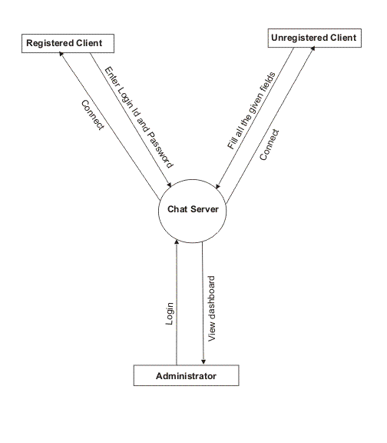
3.6.1.1. Context Level DFD:-

3.6.1.2. 1- Level DFD:-

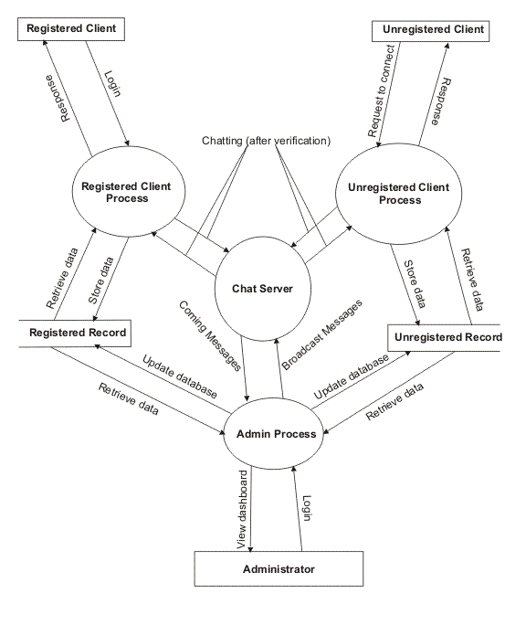

ER-Diagram (ERD)
3.6.2.

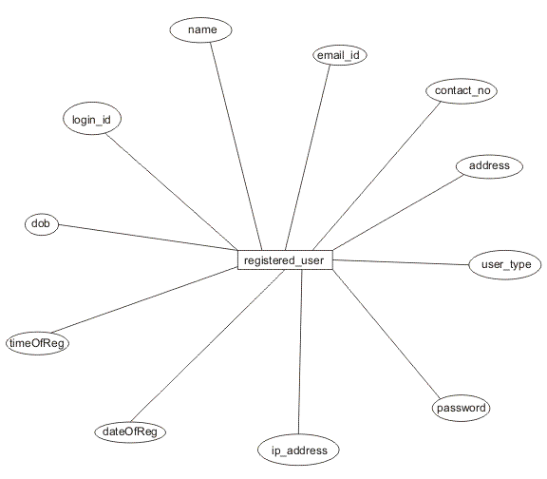

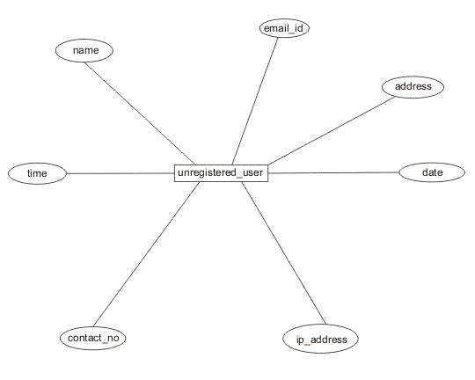

3.6.3. Data Dictionary

A data dictionary is a structured repository of data about data. It is a set of rigorous definition of all DFD data elements and data structures. A data dictionary has many advantages. The most obvious is documentation; it is a valuable reference in any organization. Another advantage improving analyst/user communication by establishing consistent definitions of various elements, terms, and procedures. Data dictionary is an important step in building data base. Most data base management systems have data dictionary as standard feature.

Table: registered_user

Field Name | Data Type | Size | NULL | Description
login_id | varchar | 20 | Not | Login ID for registered user.
name | varchar | 30 | Not | Name of the registered user.
user_type | int | 2 | Not | Describe the user is client or Administrator.
dob | date | 10 | Not | Date of Birth of user.
address | varchar | 200 | Not | Address
contact_no | varchar | 10 | Yes | Contact number.
email_id | varchar | 30 | Yes | E – mail ID
dateofreg | date | 10 | Not | Date of Registration.
timeofreg | time | 5 | Not | Time of Registration.
ip_address | varchar | 15 | Not | IP address of user machine which will be stored internally.

Table: unregistered_user

Field Name | Data Type | Size | NULL | Description
name | varchar | 30 | Not | Name of the registered user.
address | varchar | 200 | Not | Address
contact_no | varchar | 10 | Yes | Contact number.
email_id | varchar | 30 | Yes | E – mail ID
date | date | 10 | Not | Date of Registration.
time | time | 5 | Not | Time of Registration.
ip_address | varchar | 15 | Not | IP address of user machine which will be stored internally.

4. Future Scope and Further Enhancement of the Project

My future panning about my project “Chat Server” is to enhance the facility of as a conferencing system which can transfer voice & video as well as text. I want to enhance my project via internet which can de used to talk with any one who is abroad and also can see the real image of that each other. This type of system can save the money of client who wants to talk a person who is abroad.
Thus, I want to enhance my project as a general purpose project which can perform all the activity of “Tele Conferencing System” and provide a user friendly environment to use so that any one can handle my application easily.

5. References

Book Title Author Publication

Swing Matthew Robinson, Dreamtech Povel Voroiev

Core Java Cay S. Horstmann, Pearson
Gary Cornell

Head First Java Kathy Sierra, Bert Bates O’reilly

SQL & PL/SQL Ivan Bayross BPB
using Oracle

Java Server Kogent Solutions Inc. Dreamtech
Programming

Oracle SQL * Security Theriault SPD

Oracle Utilities Mishra SPD
Pocket Reference

NetBeans: The Boudreau SPD
Definitive Guide

Java Database Jordan SPD
Object

www.google.com
www.sun.com
www.wikipedea.com

