Calculator Application | Ashley Kuipers | T00713040 | Comp 2161 | Fall 2022

# Documentation

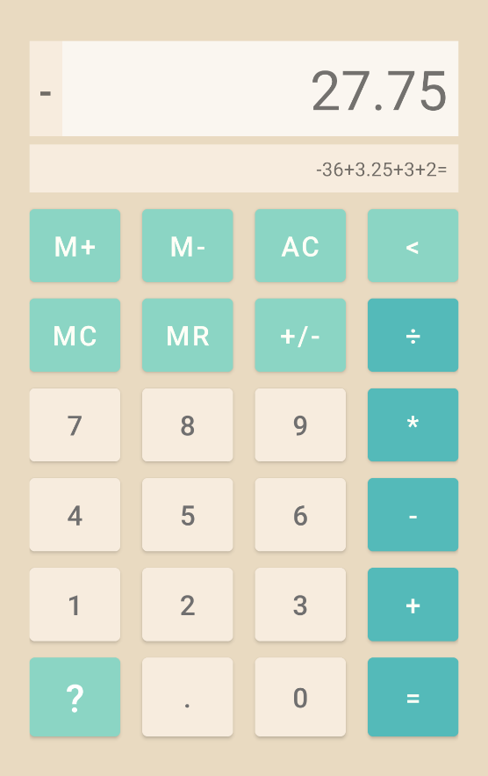

This is a basic calculator android app with memory functions created for COMP 2161 – Mobile App Development. It supports numbers from -999,999,999,999 to 999,999,999,999 or 12 digits of precision. Other than the basic functionality defined in the brief, there are three extra features added to the project as outlined below. In order to display both a running total and a history of operations, a second field was added below to display the history or other text as needed. The only libraries used to complete this were ones already included with Java such as BigDecimal from the Math library, or ArrayLists from utils. BigDecimal, specifically, was used to have accurate calculations and to round the results to fit within the calculator screen.

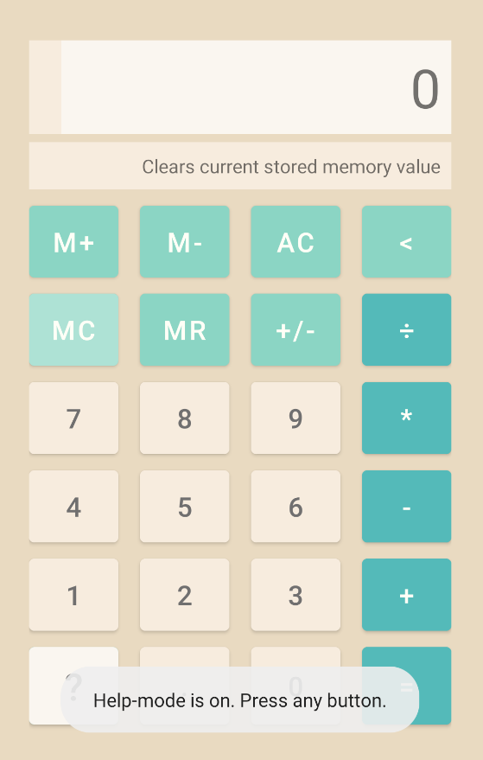

Figure 1. The basic layout of the Calculator App.

## Special Features

#### Help Mode

When you tap the question mark button in the bottom, help mode is activated. When in help mode, you can tap on any button on the calculator to learn what it does. This is helpful if people are confused by the symbols on the calculator. The button turns white while in help mode so the user can easily see when it is on/off, and on the first use of the mode, a toast comes up explaining that the button turned help mode on or off.

#### AC/CE Button

Figure 2. Demonstrating entering into help mode and learning the function of the MC button.

The clear button has dual functions on this calculator. While typing in a number, the button displays CE, and pressing it once will clear only the current number being entered. After pressing it once and clearing the current number, the button text will change to AC and pressing it again will clear the entire operation history.

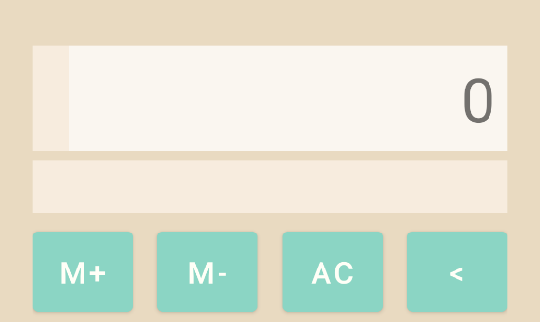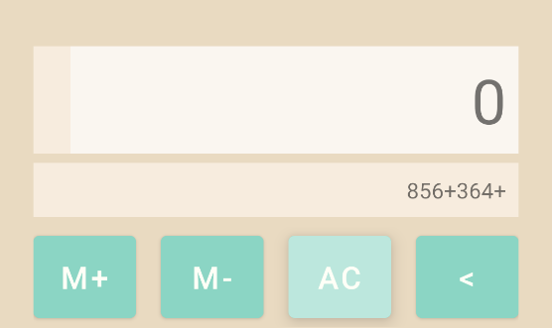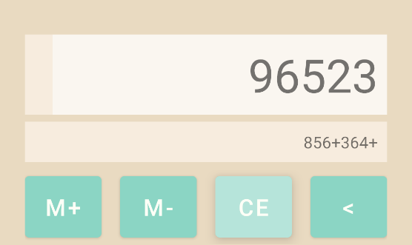

Figure 3. The first image shows the CE button while being pressed, and the second image shows the result of that which is clearing the current number entered (but not the history) and the button text changing to AC. In the second image, the AC button is being pressed, and the third image shows the result of that, which is clearing the history and calculator field.

#### Welcome Screen

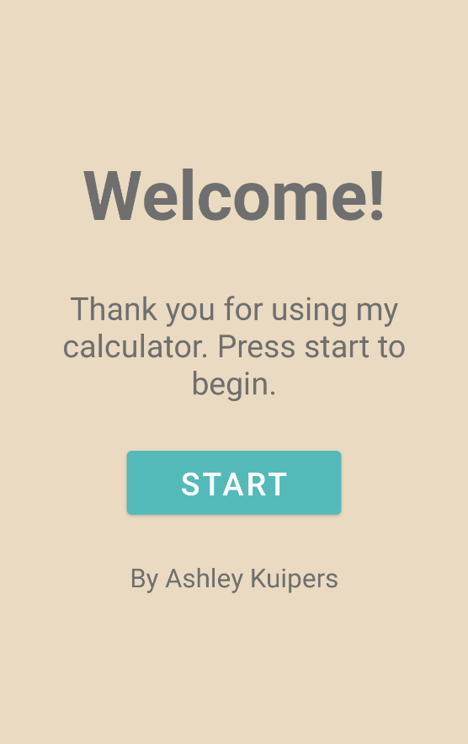

On opening a fresh version of the application, a welcome screen is shown to the user. Pressing the start button will bring the user into the application.

Figure 4. The welcome screen shown to users when opening the application.